Maker learning project reflection
Maker learning depends on iteration cycles to yield growth — both among students developing projects and also among teachers honing their craft. Use this tool when following up on projects and structuring conversations around continuous improvement.

Before getting started
What were the learning outcomes you were targeting with this project?

Examine the evidence
How did students articulate their own understanding of the things they made — not just artifacts but the decisions, mistakes, and breakthroughs they made as well — during and after this project?

What evidence did you identify, including anecdotes and questions that students asked
throughout the project, that demonstrated students’ thinking through the learning goals?

How did student-made artifacts provide evidence of the students’ engagement with
the learning goals?

Iterate and improve
For which students was this project most successful? For which students was this project
least successful? Why?

Place this project in context:
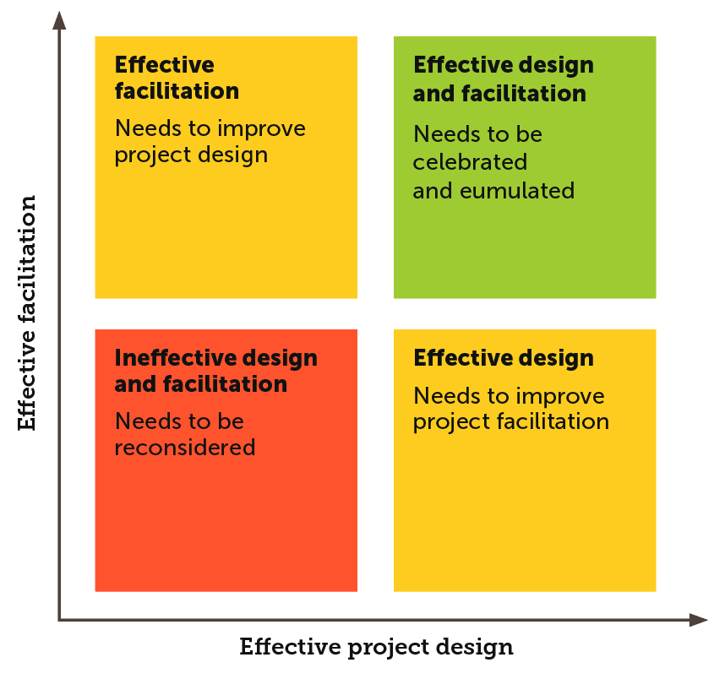

What challenges did you face in terms of facilitation?

What challenges did you face in terms of project design?

What resources do you need to improve the design and facilitation of this project for all
students in its next iteration?

How would students redesign this project if they could do it over again?

