Moderator Guide for Virtual Edcamps

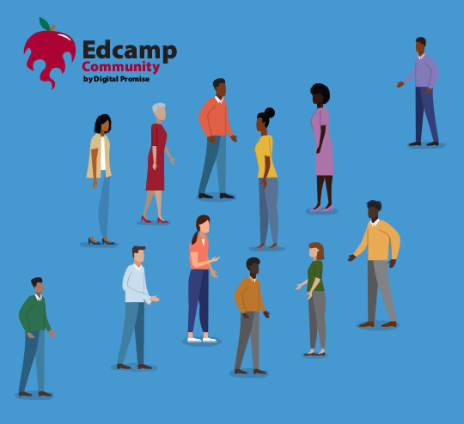

Overview
This guide is intended to assist moderators of local online Edcamps with keeping the conversations flowing in breakout rooms so that everyone has a chance to be heard.
Thank you for volunteering to moderate an online Edcamp discussion! As a moderator, we ask that you:
- Arrive 5-10 minutes early to your session’s online platform.
- Include an asterisk (*) in your screen name so meeting hosts can easily identify you as a moderator. Please place the asterisk before your name (e.g., “*Ima Educator”).
- Delegate a notetaker in your breakout room.
- Keep the conversation going in your breakout room.
What to Expect
We’ve watched more and more organizers move to online Edcamps, and we have observed that Zoom is the most popular platform because it allows for breakout rooms to encourage smaller group discussions. We all know that part of the Edcamp magic is that it allows for educators to come together and have the space to speak up and share out with others.
How Online Edcamps Work
Since in-person Edcamps are not recommended at this time due to COVID-19, organizers have pivoted to hosting Edcamps online. Not only does this continue to provide a platform for participant-driven professional development for teachers by teachers, but it allows for continued networking and resource sharing. Online Edcamps allow educators to “get together” regardless of geographic location!
Online Edcamps typically create their digital session board in advance, sourcing topics from participants on the registration form. (This is different from in-person Edcamps, where session boards are built together on the event day.)
Once a session board is ready, we recommend organizers assign a unique online meeting room for each topic and add its link to the digital session board. This will help moderators and participants gather easily in the right online space, and allow participants to move from room to room using “the rule of two clicks,” also known as “the rule of two feet.”
Each breakout room should have at least one moderator who will help keep the conversation going. If your room has more than one moderator, please determine which moderator can take notes. For large groups, you may want to designate separate moderators for spoken and written (chat) conversations. It can be challenging for one person to do both!

Your Role as a Moderator
Please arrive 5-10 minutes early to connect with your lead organizer before the session starts.
Please note that you do not need to be an expert in the topic to moderate. We also ask that you do not prepare a presentation for your group. Edcamps are meant to be organic experiences for educators, whereby anyone in a session can speak and share experiences.
As moderator, your role may have multiple parts:
Allowing participants to enter the meeting area (ask your lead organizer about this)
Delegating a notetaker
Keeping the conversation going
Delegating a notetaker
When you enter the breakout room, introduce yourself as the moderator and ask for a volunteer to take notes during the discussion. (If you have more than one moderator, one of the moderators should take notes.) If your Organizers have created a Padlet or similar “slow chat” space corresponding to your session topic, the notetaker can take notes in that portal or transfer their notes to it once the discussion ends.
Keeping the conversation going
Edcamps are designed to be discussion-based and participatory. As a moderator, your role is to keep the conversation going. Below are guiding questions to help you steer the conversation:
- Who’s in the room? (Ask participants to introduce themselves)
- Why did you pick this topic?
- What are you hoping to learn today?
- What are you hoping to share today?
- What are some challenges or successes you have experienced related to this topic?
- How does this topic intersect with issues of equity?
- What resources, tools, or insight may help others dealing with this topic?
- What additional questions do you have about this topic?
You are welcome to come up with questions of your own, but please do not prepare a presentation to share with your group. Please also be mindful that no expertise is necessary to contribute to the discussion. Encourage participants to share their own questions they may have about the topic and brainstorm how these questions may be explored further.
As you moderate, please keep in the following in mind:
- Make sure all voices are heard in the conversation.
- Be mindful of your own unconscious biases in communicating.
- Give ample wait time for people to respond to a question or comment.
- Remind participants to stay muted when they are not speaking.
- Remind participants to use the chat feature or reactions (like a thumbs up icon) to share quick responses with the group.
Zoom Tips
If your Edcamp will be hosted on Zoom, make sure you have a user account before the event. (You can sign up for free at Zoom.us.) You may also want to skim their tutorials and resources, like “Best Practices for Securing Your Virtual Classroom.”
When you join the meeting room, add an asterisk to your screen name so that you can be found easily (e.g., “*Ima Educator”). You can do that by opening the “Participants” tab at the bottom of the Zoom window and “renaming” yourself by choosing the “Rename” option in the drop-down menu under “More.”
