Additional Tools
Evidence Checklist Activity
Daily Lesson Plan

Lesson Summary
In this lesson, students will evaluate evidence. Students should have already completed a working claim and a draft of reasons and evidence by the start of the session. Throughout the session, students will collaborate to evaluate the efficacy of their evidence using the Evidence Checklist. The session will end with the students having clear feedback on their evidence selections.

- Step 1: Set Purpose/Activate Prior Knowledge—Students view video on evidence selection.
- Step 2: You Do It Together—Students use the Evidence Checklist to review the selected evidence.
Later, during revision, students will revise evidence selections to improve their writing.
Objective
Students will support claims using credible and relevant evidence.
Engagement Strategies
- Pair and Share: Students will partner and collaborate through discussion.
- Collaborating to Evaluate Evidence: Students will work in pairs or small groups to find and evaluate evidence using the Evidence Checklist.
For information on implementing these strategies through remote learning, see Topeka’s professional learning resource Remote Learning with Topeka.
Scaffolding Strategies
- Note-Taking During Video Viewing: Note-taking activity provides a graphic organizer for students to use while taking notes on the video.

Key Vocabulary
- Claim
- Reasons
- Evidence
- Reasoning
- Counterargument

See bolded words and definitions throughout the lesson's text.
Materials
- Presentation
- Evidence Video
- Evidence Note-Taking Handout
- Evaluating Evidence Checklist
Standards Addressed in this Lesson
- Write arguments to support claims in an analysis of substantive topics or texts using valid reasoning and relevant and sufficient evidence. (CCSS.ELA-LITERACY.CCRA.W.1)
- Draw evidence from literary or informational texts to support analysis, reflection, and research. (CCSS.ELA-LITERACY.CCRA.W.9)

Lesson Steps
Step 1: Set Purpose/Activate Prior Knowledge
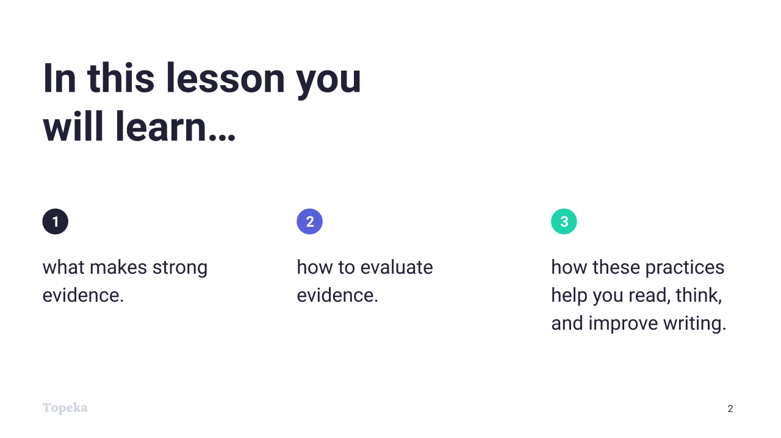
Slide 2
Teacher | Students
Teachers sets the purpose for the direct instruction by describing learning objectives for class.
Today we’re going to watch a short video to help review what makes strong evidence; how to evaluate evidence; and how these practices help you read, write, and think. Then we’ll work with others to evaluate the evidence selections you have already made. Later you’ll use that evaluation when you revise your essay.

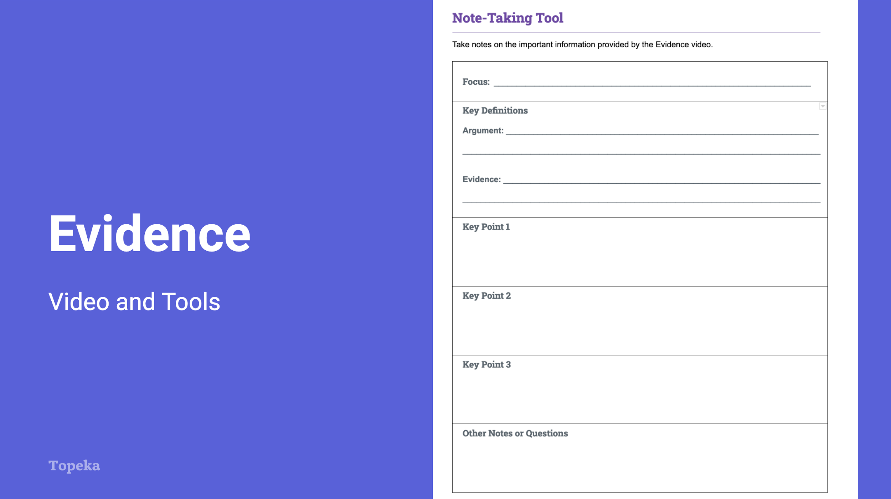
Slide 3
Teacher | Students
Teacher has students complete the note-taking activity while viewing the evidence video.  Use the note-taking handout to organize your notes on the video. | Students view the video and take notes.
Upon completion, teacher invites students to Pair and Share with a classmate to discuss their answers.  Discuss your understanding of what makes strong evidence with your neighbor.  For information on implementing Pair and Share via remote learning, see Remote Engagement: Pair and Share or the guide to Remote Learning with Topeka. | Students partner with a classmate and compare answers.

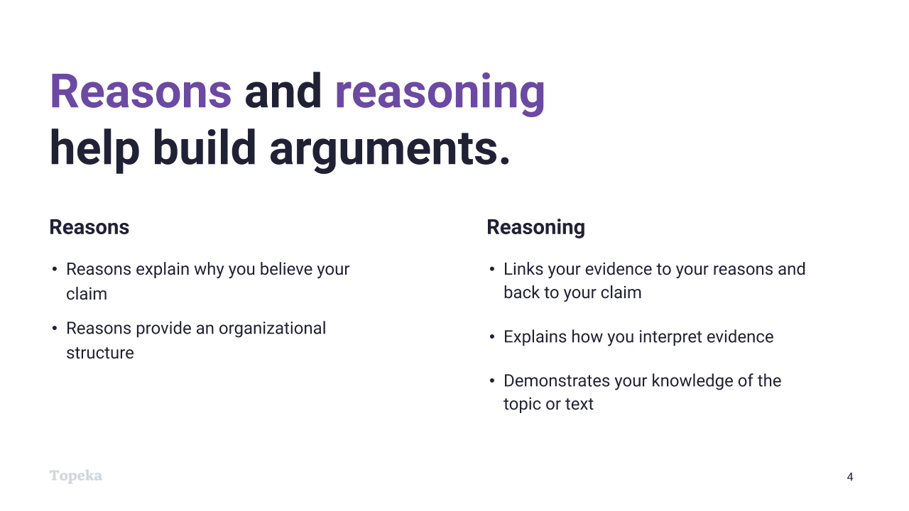
Slide 4
Teacher | Students
Teacher leads whole group debrief of the video, inviting students to share what they wrote for the focus and key points. Teacher invites students to ask questions. | Students share findings with larger group
Teacher explains reasons and reasoning as they relate to evidence.  The video reviewed the criteria we should use to select evidence. Since selecting evidence is closely related to reasons and reasoning, let’s review those terms as well.  Reasons explain why you believe your claim. For example, imagine I were making this claim: “Schools should set aside time during the school day for students to read independently.”  My reasons might be that independent reading makes students into better readers and independent reading is an enjoyable activity for students.  Reasoning is an explanation of how your reason (and the evidence you’ll add) connect to your claim.  Reasons and reasoning are very important in writing arguments—these are the building blocks of the support you'll give your claim. Without the reasoning to organize and support your use of evidence, the evidence and the argument aren't as strong. | Students listen as the teacher highlights reason and reasoning.

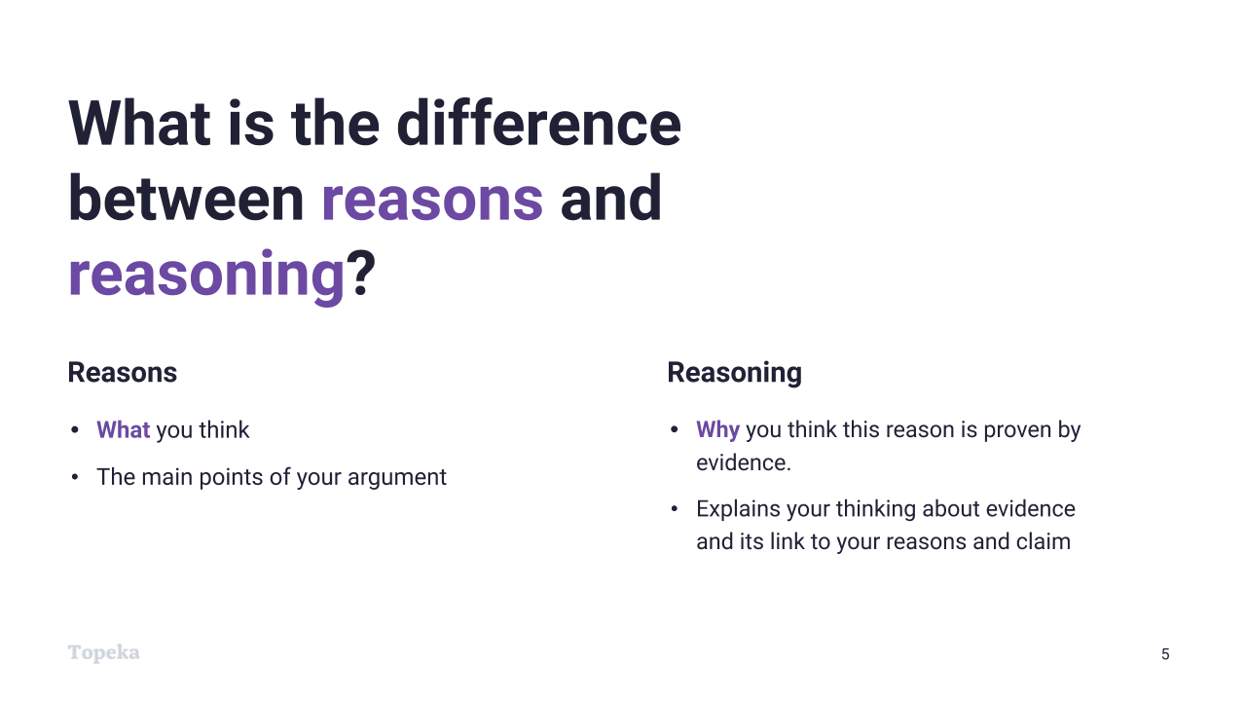
Slide 5
Teacher | Students
Teacher continues to contrast reasons and reasoning.  Reasons are what you think  Reasoning is an explanation of how your evidence is relevant to your claim. | Students listen and take notes.

Step 2: You Do It Together
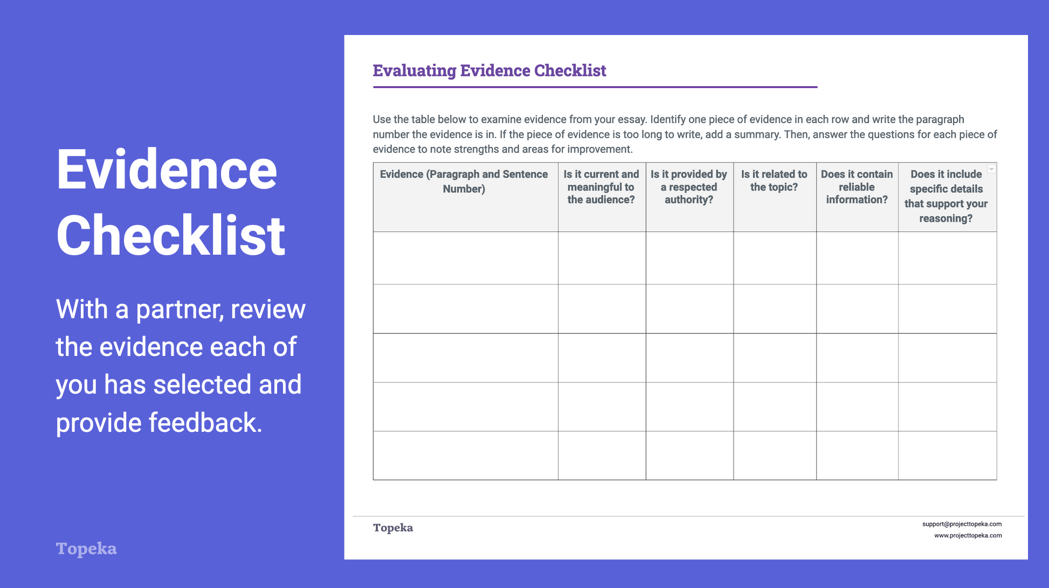
Slide 6
Teacher | Students
Explain that students will work together to evaluate each other’s evidence selection.  When writing arguments, we use evidence to show that our reasons are valid—to prove that our argument should be accepted. Together, you will work to evaluate the evidence you have selected, and give feedback to help each other strengthen your evidence selection.  For information on implementing Small Group Collaboration via remote learning, see Remote Engagement: Small Groups or the guide to Remote Learning with Topeka. | Students listen and then work together to complete evaluation with the Evidence Checklist Activity.
Teacher explains that students will work alone to complete revisions.  When it’s time to revise your essay, consider the feedback your partner provided, and review your evidence selections critically to determine if the evidence is effective and sufficient. Where changes are needed, also consider the impact of reasons and reasoning in positioning the evidence. | Students complete revisions of evidence using feedback from peers.

