Pre-Writing
Introducing Highlighting
and Annotating Text
Lesson Plan (Minimum Time: One 45-Minute Session)

Lesson Summary
In this lesson, students and teacher will engage with a prompt and passage to identify evidence for and against a position on an issue. Students will learn why and how to take notes while reading, and how reading closely assists in the writing process.

- Step 1: Set Purpose/Activate Prior Knowledge—Students will analyze a writing prompt to establish the purpose for reading the text provided within the lesson.
- Step 2: I Do It/We Do It Together—Using an excerpt, teacher will model highlighting and annotating process.
- Step 3: You Do It Together—Students will work together to highlight and annotate text with the purpose of supporting school uniform policies.
- Step 4: Independent Application—Students will work individually to highlight and annotate text with the purpose of arguing against school uniform policies.

Objective
Students will highlight and annotate a text to gather evidence in response to a prompt.

Engagement Strategies
- Pair and Share: Students will work with a partner and collaborate through discussion. See also, Remote Engagement: Pair and Share.
- Collaborating to Find Evidence: Students will annotate a text in pairs or small groups to gather evidence that will help develop a response to a prompt. See also, Remote Engagement: Small Groups.
Links to information for remote learning are also provided in the lesson steps below. A complete list can be found in Appendix B.

Scaffolding Strategies
The scaffolding strategies listed below are optional supports included in the lesson’s activities. These tools may be used or ignored based on students’ needs.
- Vocabulary Support: Students, particularly students who are also English Learners, can use or even translate these words to support comprehension.
- Sentence Stem Bank: Students can use sentence stems to articulate their critical thinking and generate ideas about key issues in the debate. Have students make statements about the evidence they have highlighted using these stems.
- Issues Organizer: Students can use the organizer to deliberately record their thinking about each image or detail they plan to discuss.

Remote Learning Strategies
With careful advanced planning, Topeka lessons can be easily moved to a remote modality. Links to specific engagement strategies are included throughout this lesson plan. See Topeka’s professional learning resource Remote Learning with Topeka for additional suggestions for each stage of the typical Topeka lesson.

Key Vocabulary
- Annotate
- Highlight
- Claim
- Prove
- Focus
- Issue

See bolded words and definitions throughout the lesson's text.

Materials
- Presentation—Introducing Highlighting and Annotating Text
- Entry Ticket—Prompt Analysis
- Activity—Annotating Text
- Group Model Excerpt—“The Drawbacks of Uniforms”

Standards Addressed in this Lesson
- Write arguments to support claims in an analysis of substantive topics or texts using valid reasoning and relevant and sufficient evidence. (CCSS.ELA-LITERACY.CCRA.W.1)
- Produce clear and coherent writing in which the development, organization, and style are appropriate to task, purpose, and audience. (CCSS.ELA-LITERACY.CCRA.W.4)
- Draw evidence from literary or informational texts to support analysis, reflection, and research. (CCSS.ELA-LITERACY.CCRA.W.9)

Lesson Steps

Step 1: Set Purpose/Activate Prior Knowledge
Teacher | Students
Teachers have students complete a prompt analysis as an Entry Ticket. Set the purpose by engaging students in a discussion about the prompt.  An increasing number of schools are implementing uniform policies for students. Should there be a uniform policy at your school? Use specific details and examples to write an argument to convince others to support your position.  Ask students to Pair and Share to discuss how understanding the writing task can help establish a purpose for reading and engaging with text.  For information on implementing Pair and Share via remote learning, see Remote Engagement: Pair and Share or the guide to Remote Learning with Topeka.  Ask selected students to share their thoughts about reading with a purpose. | Students use the entry ticket handout to analyze a prompt.  - What is the subject that I’ll be writing about?  - What is my purpose for writing?  - What possible stances could I take?  - What details will I look for as I read?  Students turn and discuss answers with a classmate  Students engage in large group debrief.

Slide 3
Teacher | Students
Teacher sets the purpose for the direct instruction by describing learning objectives for class.  Today we’re going to talk about engaging with text by highlighting and annotating as we read. We will learn why we take notes; one method of highlighting and annotating text, and how these practices help you read, think, and write. | Students listen and take notes.

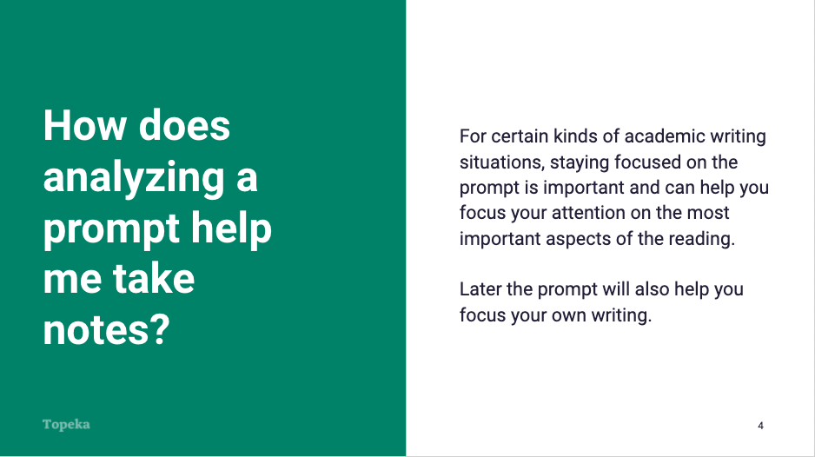
Slide 4

Teacher | Students
Teacher introduces the purpose for analyzing a prompt. Consider pre-recording this portion of the lesson for remote delivery. See the guide to Remote Learning with Topeka for more details.  How does analyzing a prompt help me take notes?  For certain kinds of academic writing situations, staying focused on the prompt is important and can help you focus your attention on the most important aspects of the reading.  Later the prompt will also help you focus your own writing. | Students listen and respond as needed.

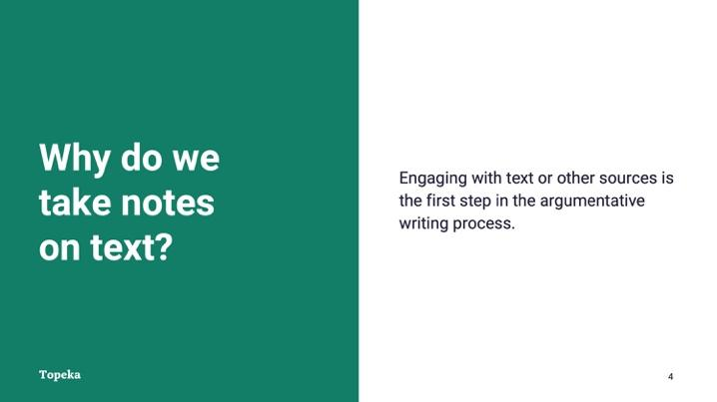
Slide 5
Teacher | Students
Teacher introduces the purpose for taking notes and highlights key vocabulary terms.  Why do we take notes on text? Engaging with text or other sources is the first step in the argumentative writing process.  When you’re making an argument, you’re responding to something, whether it is a text, video, song—even someone else’s argument. For you to make a really good argument, you need to carefully examine what it is that you’re arguing about. | Students listen and respond as needed.

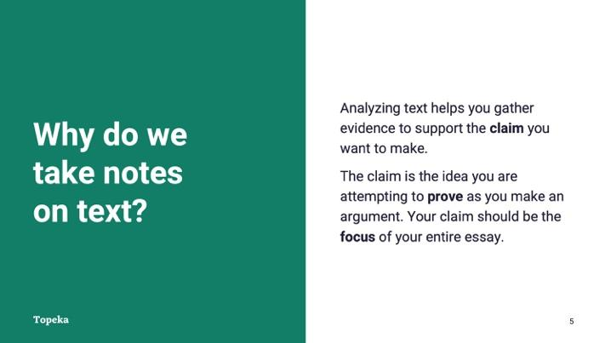
Slide 6
Teacher | Students
Teacher continues.  Analyzing text helps you gather evidence to support the claim you want to make. The claim is the idea you are attempting to prove as you make an argument. Your claim should be the focus of your entire essay. | Students listen and take notes.

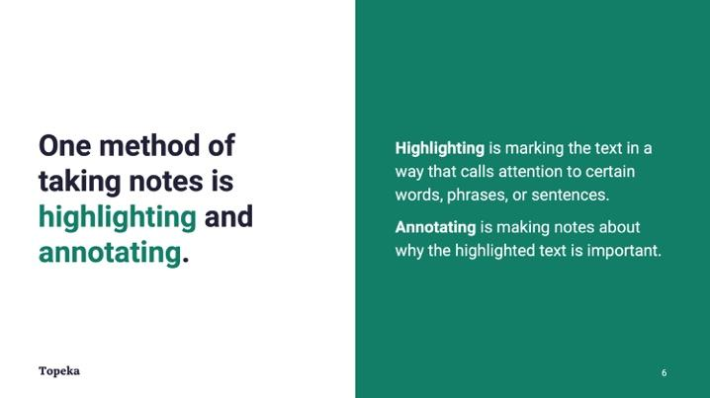
Slide 7
Teacher | Students
Teacher continues.  One method of taking notes is highlighting and annotating. What do I mean by this?  Highlighting is marking the text in a way that calls attention to certain words, phrases, or sentences that you think are important as you read.  What are some ways we can highlight text?  When you highlight text, you should also annotate. Annotating is making notes about why the highlighted text is important. You do this so you can easily remember why you highlighted that part of the text in the first place. | Students suggest ways of highlighting (e.g., underlining, highlighting pens, sticky tabs)

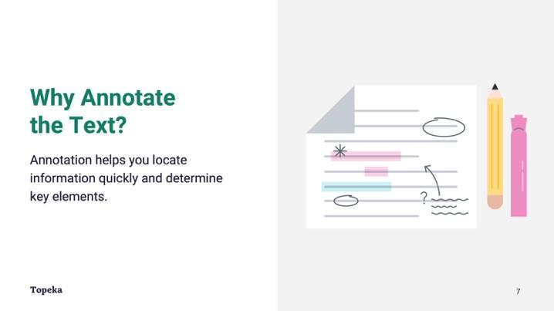
Slide 8
Teacher | Students
Teacher continues.  Annotation helps you locate information quickly and determine key elements—without having to re-read the text every time.  Another reason to annotate is to consider the underlying issues that are driving the argument. Later, you might develop your initial thoughts and annotations more fully into reasons to support your claims in an argument. | Students listen and take notes.

Step 2: I Do It/We Do It Together
Teacher | Students
Teacher explains the purpose and models the steps for annotating a text.  Teacher explains to students that they are going to practice annotating a text to build an argument about whether school uniforms are a good or bad idea.  For information on implementing Note Taking via remote learning, see Remote Engagement: Note Taking or the guide to Remote Learning with Topeka.  Teacher provides an excerpt from an article titled, “The Drawbacks of Uniforms.” | Students listen and watch teacher modeling.

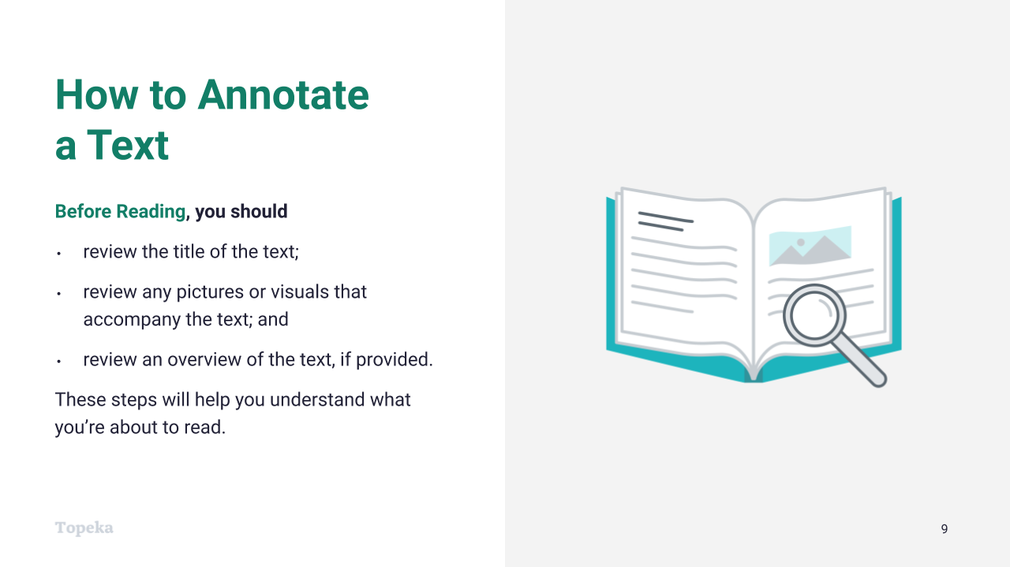
Slide 9
Teacher | Students
Teacher displays the “Before Reading” slide and reviews the steps students should take before reading the text.  Before reading, you should take a moment to  - read the title of the text;  - scan any pictures or visuals that accompany the text; and  - read the overview of the text, if provided.  These three brief steps will help you understand what you’re about to read. | Students listen and take notes.
Teacher asks students to examine the title of the excerpt to get an understanding of what the text is going to be about.  Teacher prompts students to share thoughts with class. | Students examine the title of the text to predict what the text is going to be about.  Students engage in large group debrief.

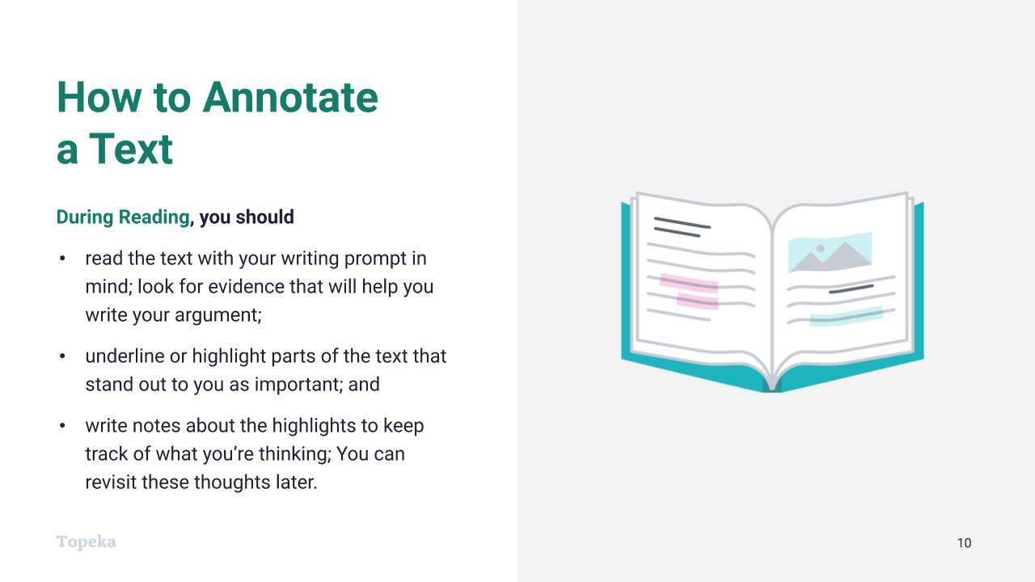
Slide 10
Teacher | Students
Teacher displays the “During Reading” slide and reviews the steps students should take during the reading of the text.  There are things you can do while you’re reading to help you pay close attention to details and to remember later what you read:  - Read the text with your writing prompt in mind. Look for evidence that will help you write your argument.  - Underline or highlight parts of the text that stand out to you as important.  - Write notes about the highlights to keep track of what you’re thinking. You can revisit these thoughts later. | Students listen and take notes.

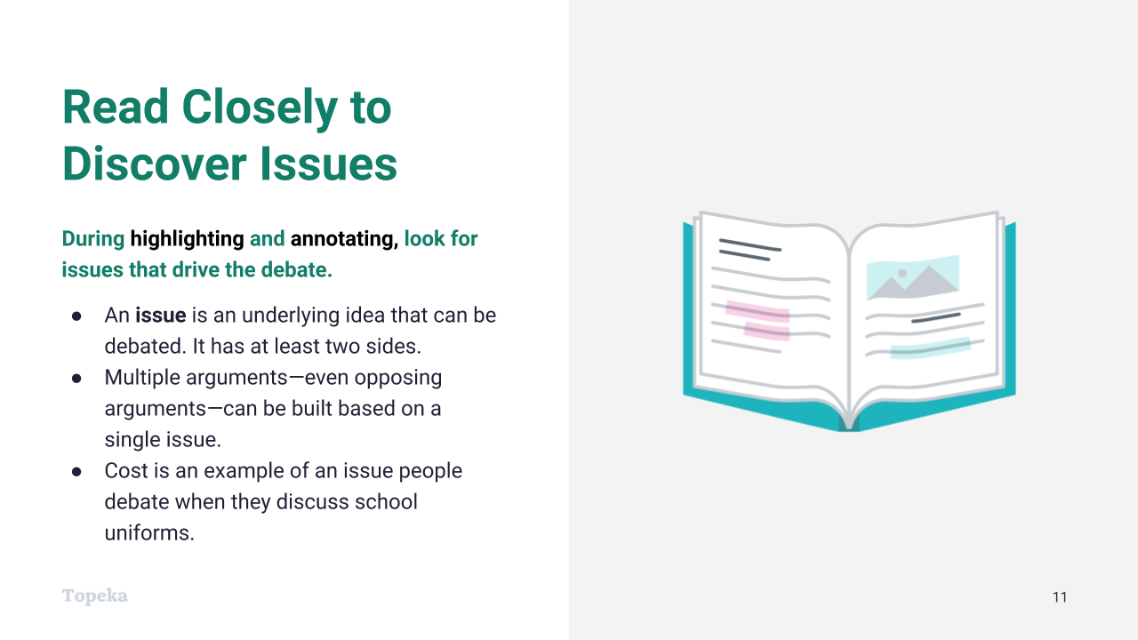
Slide 11
Teacher | Students
Teacher continues.  During highlighting and annotating, readers should look for issues that drive the debate. An issue is an underlying idea that can be debated. It has at least two sides. Multiple arguments can be built from a single issue. Even opposing arguments can be built based on a single issue. An example of an issue people debate when they discuss school uniforms is cost. | Students listen and take notes.

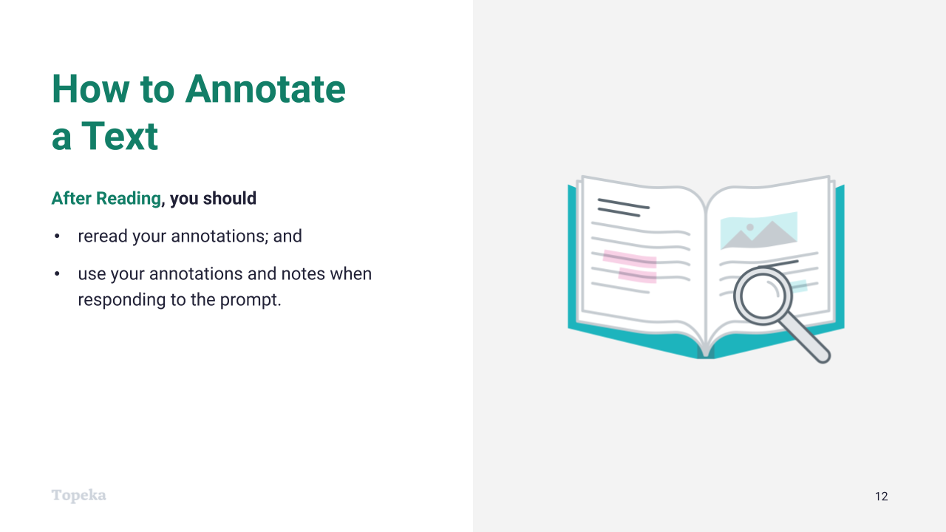
Slide 12
Teacher | Students
Teacher displays the “After Reading” slide and continues.
When you’re finished reading, you should review what you’ve highlighted and the notes you took.
Then use this information when you’re preparing to respond to the writing prompt.

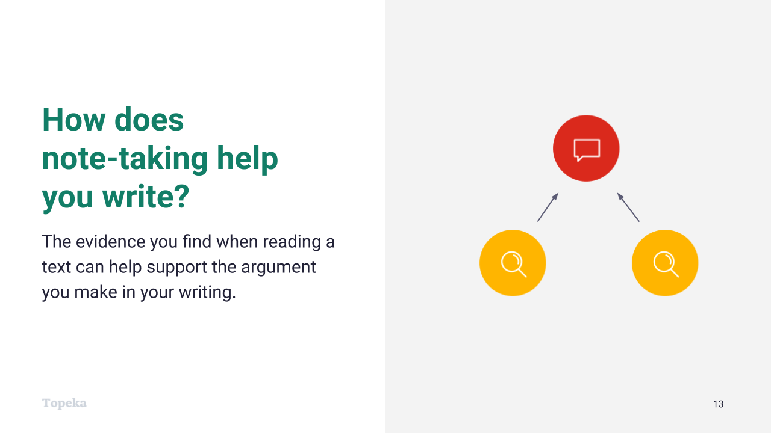
Slide 13
Teacher | Students
Teacher continues.  How does note-taking while reading help you write? The evidence you find when reading can help support the argument you make in your writing.  For example, during the Entry Ticket activity, we looked at what the possible responses to the prompt might be. With those responses in mind, you can review your notes on the reading to help decide what position you can support—or argue against—with more detail from the text. | Students listen and take notes.
Teacher reminds students that they are looking for evidence to determine whether uniforms are a good or bad idea.  In the Entry Ticket activity we examined the writing prompt and discovered our purpose for reading. Can someone remind us of what that purpose was and what the possible stances we can take might be? | Students contribute purpose and possible stances.

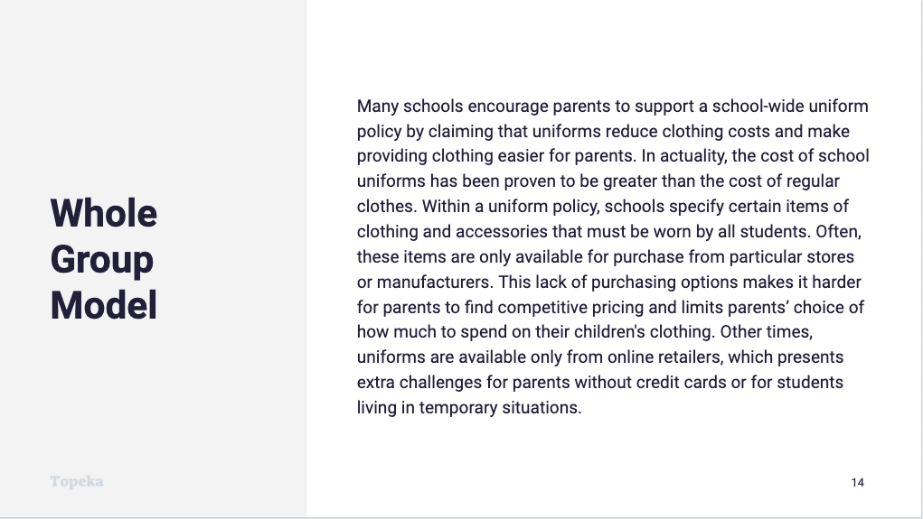
Slide 14
Teacher | Students
Teacher reads excerpt aloud.  Here’s the excerpt:  Many schools encourage parents to support a school-wide uniform policy by claiming that uniforms reduce clothing costs and make providing clothing easier for parents. In actuality, the cost of school uniforms has been proven to be greater than the cost of regular clothes. Within a uniform policy, schools specify certain items of clothing and accessories that must be worn by all students. Often, these items are only available for purchase from particular stores or manufacturers. This lack of purchasing options makes it harder for parents to find competitive pricing, and limits parents’ choice of how much to spend on their children's clothing. Other times, uniforms are available only from online retailers, which presents extra challenges for parents without credit cards or for students living in temporary situations. | Students read along as teacher reads the excerpt aloud.
Teacher thinks aloud.  For information on implementing Think Aloud via remote learning, see Remote Engagement: Think Aloud or the guide to Remote Learning with Topeka.  This paragraph explains a negative aspect of uniforms, which has to do with cost and accessibility, as we predicted from the title.  Now I am going to reread the text to underline a detail that supports why uniforms are a bad idea. Schools specify the clothing and accessories that must be worn by all students” would be important because it explains that parents have to buy what the school tells them. | Students read along with teacher and underline the details as the teacher models.
Teacher thinks aloud.  Now that we have underlined a detail that we think is important, we need to take notes to remind us of our thinking and reason for underlining. Looking at what we underlined, I am going to write, “Parents have to buy what they’re told, no matter the cost.” That will remind me of why I highlighted this detail. | Students listen and watch teacher modeling. Students write notes on their text.
Teacher prompts class to find another key detail and to explain their reason for highlighting the detail.  After the class completes highlighting, teacher notes the issue at hand:  The major issue this piece talks about is cost, but there are other issues in the debate over school uniforms that we will debate later. | Based on the teacher model, the class collaborates to find and underline another key detail from the text that supports the claim.

Step 3: You Do It Together
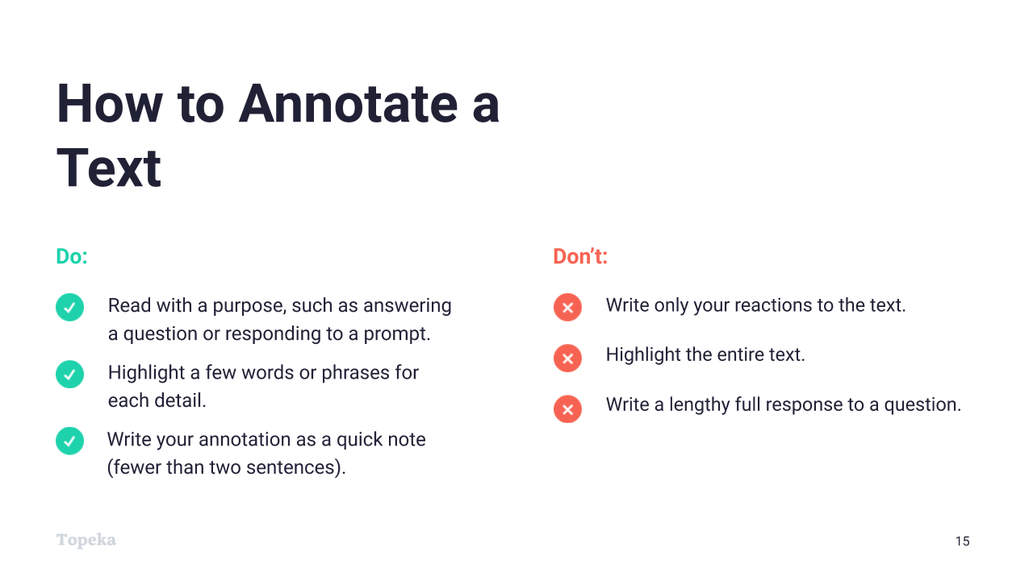
Slide 15
Teacher | Students
Teacher sets expectations for students to collaborate in a close reading and to annotate the text to gather more evidence for their argument.  In a moment we will read another text describing some more pros and cons of school uniform policies. As you work together to read the text closely, there are some key rules to keep in mind:  - Do read with a purpose; know what you’re looking for. Don’t just read and react.  - Do highlight just the important details. Don’t highlight the whole text. When you highlight everything nothing stands out.  - Do write your annotations as quick notes—just enough that you’ll understand your highlight. Don’t write lengthy paragraphs. Try to note the issue that might have prompted you to highlight the text. | Students listen to the expectations as teacher explains them.

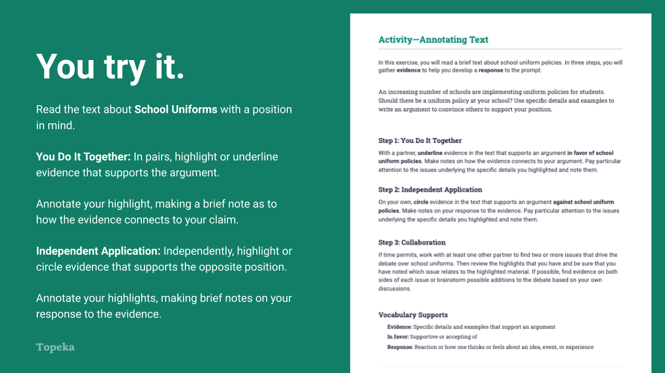
Slide 16
Teacher | Students
Teacher distributes the activity: “Annotating Text” and leads students (or prompts students to perform) an initial read of the brief text “School Uniforms.” | Students read or follow along with the text as the teacher reads aloud.
After class read-aloud, teacher explains that students will work in pairs to annotate the text to gather evidence for an argument in favor of school uniforms.  For information on implementing Small Group Collaboration via remote learning, see Remote Engagement: Small Groups or the guide to Remote Learning with Topeka.  Teacher circulates to support students by providing feedback on their annotations. | Students work collaboratively to annotate the text. When working in pairs, students will  - reread the text about “School Uniforms”;  - highlight or underline evidence that supports the claim that school uniforms are a good policy; and  - annotate the highlights, making brief notes as to how the evidence shows that uniforms are good.

Step 4: Independent Application
Teacher | Students
After students practice annotating the text in pairs, teacher explains that they will work independently to complete Step 2 of the exercise, reading the text with a different purpose and annotating to find evidence that supports an argument against school uniforms. | Students listen and take notes.
Teacher circulates to support students by providing feedback on their annotations. | Students independently  - highlight or circle evidence that supports the claim that school uniforms are a bad policy; and  - annotate the highlights, making brief notes as to how the evidence shows that uniforms are a bad policy.

Step 5 (optional): Collaborate to Find Issues
Teacher | Students
After students complete the highlighting and annotation activity, teacher directs students to collaborate on page 4 of the handout to be sure they have been paying attention to the underlying issues.  For information on implementing Small Group Collaboration via remote learning, see Remote Engagement: Small Groups or the guide to Remote Learning with Topeka.  Alternatively, teacher can direct the whole group to generate a list of issues and designate locations in the classroom to place related evidence. Students can write their evidence on Post-Its and group it according to the given issue. | Students collaborate with partners or groups to identify issues and categorize their evidence on both sides according to the issues.  Students complete the “Issues Organizer,” page 4 of the handout.

Appendix A: Sample Responses

Entry Ticket: Prompt Analysis
Ask | Answer
What is the subject that I’ll be writing about? | School Uniform Policies
What is my purpose for writing? Look for action words like explain, convince, or persuade. | Argue, convince
What possible stances could I take? | Pro school uniforms  Against school uniforms  Pro some parts of the uniform and pro some parts a dress code  Pro dress codes instead of uniforms
What details will I look for as I read? | Evidence for why uniforms help schools or students or families  Evidence for why they would be bad for schools, students, or families  Other ways to solve some of the same problems uniforms were designed to address  Details, statistics, examples, facts, expert quotes

Appendix B: Engagement Strategies Via Remote Learning
The following links provide useful information for implementing this lesson through remote learning:
- Remote Learning with Topeka.
- Remote Engagement: Pair and Share
- Remote Engagement: Small Groups
- Remote Engagement: Note Taking
- Remote Engagement: Think Aloud

