Pre-Writing
Introducing
Organization
Lesson Plan (Minimum Time: One 45-Minute Session)

Lesson Summary
In this lesson, students and teacher will encounter the basic organizational structure of an argumentative essay and will be introduced to the concept of transition words for enhancing organization.
- Step 1: Set Purpose/Activate Prior Knowledge—Students complete Entry Ticket to label parts of an argument, followed by teacher-led debrief.
- Step 2: I Do It/We Do It Together—Teacher presents basic organization concepts and reviews Entry Ticket activity.
- Step 3: You Do It Together—Working in groups, students again label parts of an argument’s organization and identify argument components essential to effective organization.
- Step 4: Independent Application—Working individually, students read a prompt and text and build an outline of an argument in response.

Objective
Students will understand the basic organizational structure of an argumentative essay and be able to outline an organized argument in response to a prompt.

Engagement Strategies
- Pair and Share: Students will work with a partner to collaborate through discussion. See also, Remote Engagement: Pair and Share.
- Collaborating to Identify the Different Parts of an Argument: Students will work in pairs or small groups to identify the different sections of an argument and the transition words or phrases used within it. See also, Remote Engagement: Small Groups.
Links to information for remote learning are also provided in the lesson steps below. A complete list can be found in Appendix B.

Scaffolding Strategies
The scaffolding strategies listed below are optional supports included in the lesson’s activities. These tools may be used or ignored based on students’ needs.
- Vocabulary Support: Students, particularly students who are also English Learners, can use or even translate these words to support comprehension.
- Issues Organizer: Students can use the organizer to deliberately record their thinking about each image or detail they plan to discuss.
- Thinking Stem Bank: Students can use sentence stems to articulate their critical thinking and generate ideas about key issues in the debate. Have students make statements about the evidence they have highlighted using these thinking stems.

Remote Learning Strategies
With careful advanced planning, Topeka lessons can be easily moved to a remote modality. Links to specific engagement strategies are included throughout this lesson plan. See Topeka’s professional learning resource Remote Learning with Topeka for additional suggestions for each stage of the typical Topeka lesson.

Key Vocabulary
- Argument
- Introduction
- Body
- Conclusion
- Summary
- Claim
- Reasons
- Evidence
- Transitions
- Issues

See bolded words and definitions throughout the lesson's text.

Materials
- Presentation—Introducing Organization
- Entry Ticket—Organization
- Organization Group Practice
- Activity—Outline an Argument

Standards Addressed in this Lesson
- Write arguments to support claims in an analysis of substantive topics or texts using valid reasoning and relevant and sufficient evidence. (CCSS.ELA-LITERACY.CCRA.W.1)
- Produce clear and coherent writing in which the development, organization, and style are appropriate to task, purpose, and audience. (CCSS.ELA-LITERACY.CCRA.W.4)

Lesson Steps

Step 1: Set Purpose/Activate Prior Knowledge
Teacher | Students
Teacher has students complete an entry ticket to activate prior knowledge of basic organization concepts. Sample script:  Read the information at the top of the handout and then follow the instructions. | Students complete Entry Ticket activity
Teacher will ask students to Pair and Share to discuss what they labeled each of the sections and why they chose each label.  For information on implementing Pair and Share via remote learning, see Remote Engagement: Pair and Share or the guide to Remote Learning with Topeka. | Students Pair and Share
In large group debrief, teacher selects students to share what labels they placed on each of the paragraphs and why they chose those labels. Explain to students that they will find out if their labeling was correct later in the lesson. | Students engage in large group debrief

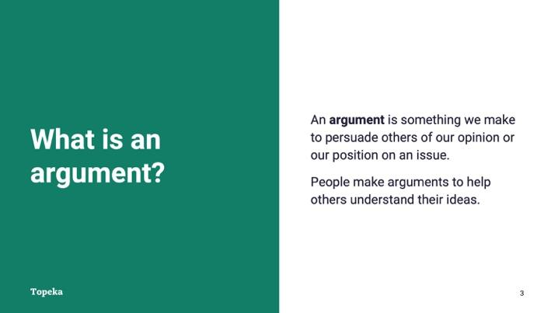
Slide 3

Teacher | Students
Teacher sets purpose for lesson by introducing definition of an argument and discussing the importance of organization within an argument.  Today we’re going to be discussing the basic organizational structure of an argumentative essay. An argument is a position we take on something and all of the details we include to support that position.  When we make arguments, we’re trying to convince the reader to accept our position or take action. So we need to make sure that the argument is clear and well organized for it to be effective. | Students listen and take notes.

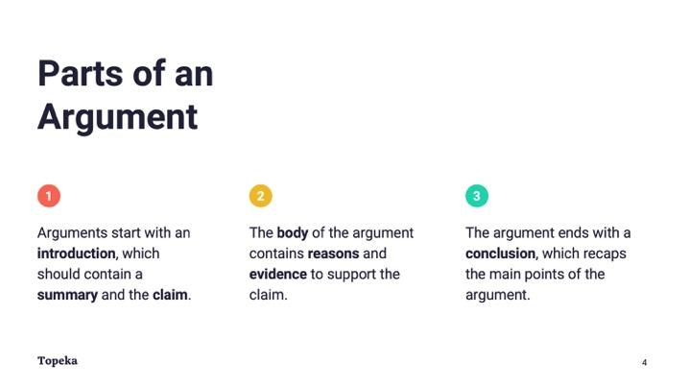
Slide 4
Teacher | Students
Teacher continues.  There are three basic parts to an argument: the introduction, body, and conclusion.  Arguments start with an introduction, which should contain a summary and the claim. The summary sums up the issue that you’re going to discuss, and the claim is your specific stance on that issue.  Next, the body of the argument contains reasons and evidence to support the claim.  After you’ve presented your reasons and evidence in the body, the conclusion recaps the main points of the argument. | Students listen and take notes.

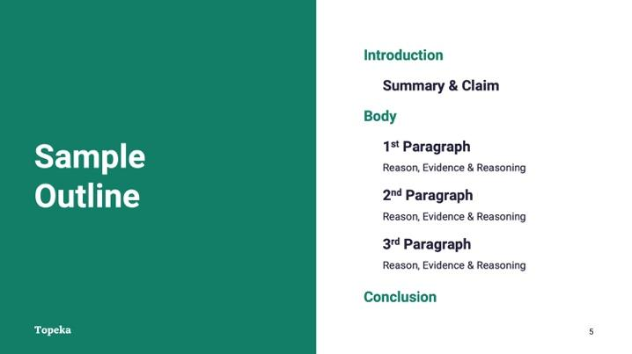
Slide 5
Teacher | Students
Teacher continues.  When you put these parts together into an outline, it looks something like this: The introduction comes first. Then come multiple body paragraphs, each focused on a reason supporting the claim. Finally the conclusion, which wraps up the argument. | Students listen and take notes.

Step 2: I Do It/We Do It Together
Teacher | Students
Teacher looks more closely at each part of the argument.  Consider pre-recording this portion of the lesson for remote delivery. See the guide to Remote Learning with Topeka for more details. | Students  - follow along with teacher;  - participate in class collaboration; and  - make necessary corrections to their entry ticket.

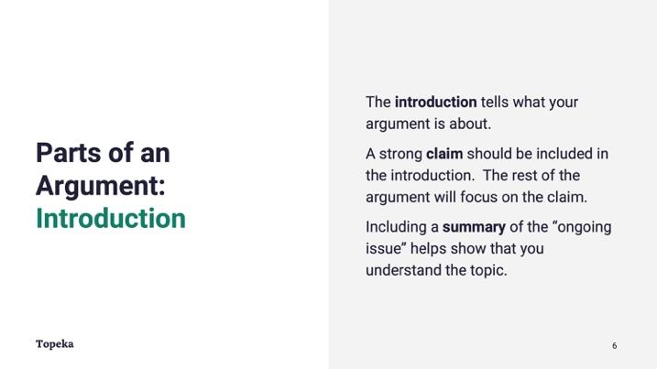
Slide 6
Teacher | Students
Teacher continues.  Let’s look more closely at each of these parts.  Your writing should begin with an introduction, which tells what your argument is about.  Your introduction must contain your claim, which is your stance on the issue. The rest of your argument should remain focused on the claim.  The introduction might also contain a summary of the ongoing issue or other information to help your reader understand the issue and become interested in what you have to say.  Teacher will ask students to share what paragraph from their Entry Ticket would be a part of the introduction.  In the Entry Ticket, which paragraph is the introduction?  “Our school is considering buying the vacant lot next to the school. This lot should be used as a school garden,” would be a part of the introduction in the argument. These sentences tell what the argument is about and introduce the writer’s claim on the topic: “This lot should be used as a school garden.” | Students listen and take notes.

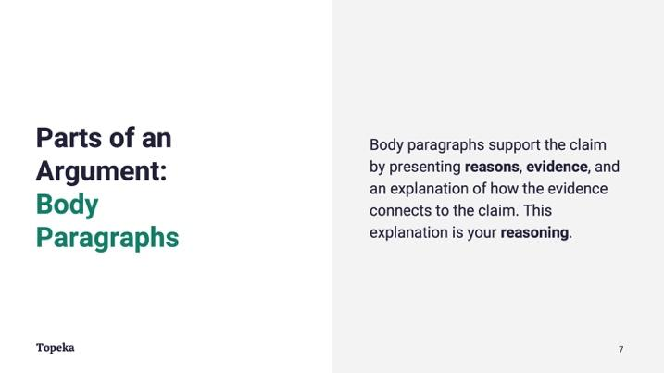
Slide 7
Teacher | Students
Teacher presents explanation of body section.  The body of your essay is the biggest part of the argument.  Every paragraph of the body should be focused on supporting the claim with reasons and evidence. In addition, each paragraph should include an explanation of how the reasons and evidence connect to the claim. This explanation is your reasoning.  Teacher asks students to share what paragraph from their Entry Ticket would be included in the body of an argumentative essay.  Returning to the Entry Ticket, what paragraph would be part of the body of this argument?  “First of all, school gardens have been shown to improve students’ eating habits. Also, teachers see an increase in learning when students can tend a garden.”  These sentences are the reasons for the writer’s claim that the vacant lot should be used for a school garden. A complete argument would contain evidence for each reason and reasoning to explain how it all connects together.  Also note that “first of all” and “also” are transition words that you might have underlined. They help connect the reasons in this paragraph. | Students  - follow along with teacher;  - participate in class collaboration; and  - make necessary corrections to their Entry Ticket.

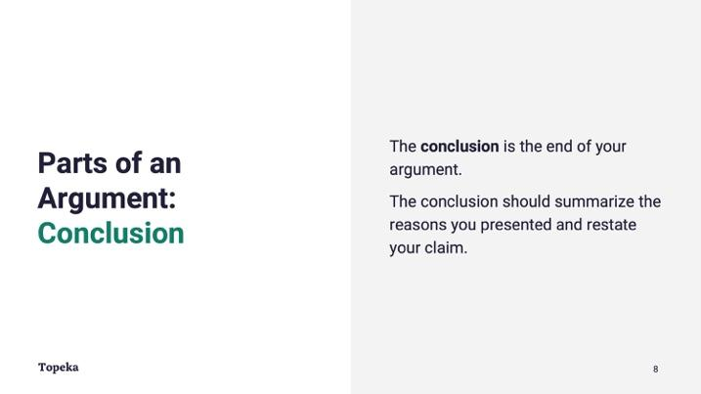
Slide 8
Teacher | Students
Teacher explains the elements of a conclusion within an argument.  Finally, your conclusion ends the argument. In your conclusion you should summarize what you’ve already said and give a closing thought.  Teacher asks students to share what paragraph from their Entry Ticket would be a part of the conclusion.  In the Entry Ticket, what’s left to serve as the conclusion?  “For all these reasons, the vacant lot would be best used as a school garden. Please let the school board know that you support this option,” would be a part of the conclusion in the argument.  These sentences sum up the information used in the argument and also include a call to action for the audience. | Students  - follow along with teacher;  - participate in class collaboration; and  - make necessary corrections to their entry ticket.

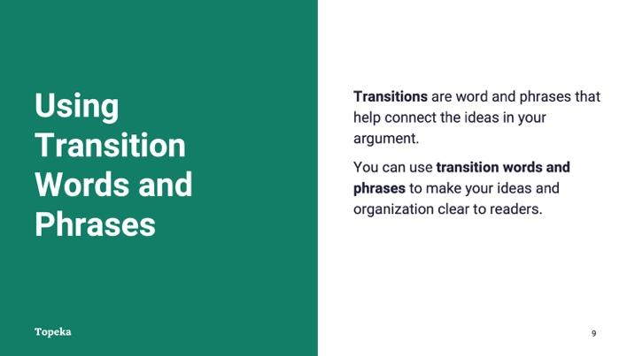
Slide 9
Teacher | Students
Teacher introduces the concept of transition words to help with organization  Within these brief paragraphs of the Entry Ticket, there were words and phrases to help make the organization clear to readers. For example, in the sentence “For all these reasons, the vacant lot would be best used as a school garden,” the words ``For all these reasons” signals a transition into the conclusion of the essay. | Students  - follow along with teacher;  - participate in class collaboration; and  - make necessary corrections to their entry tickets.

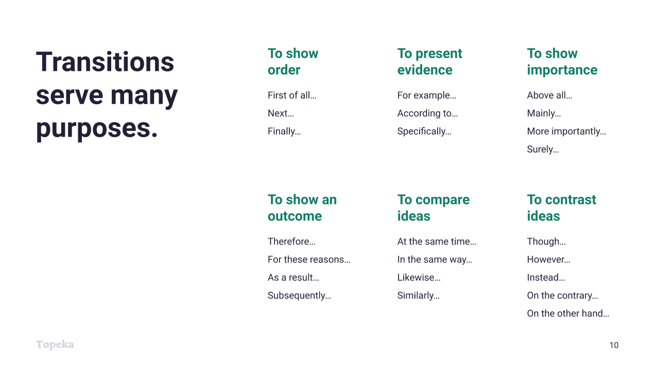
Slide 10
Teacher | Students
Transitions help connect ideas in your argument, and they can serve many purposes
Teacher refers to Slide 10 to offer examples of transition words.
Teacher asks students to share the transition words or phrases that they underlined in their Entry Ticket.
What transition words did you identify in the entry ticket? Did these words help you understand how the argument should be organized?

Step 3: You Do It Together
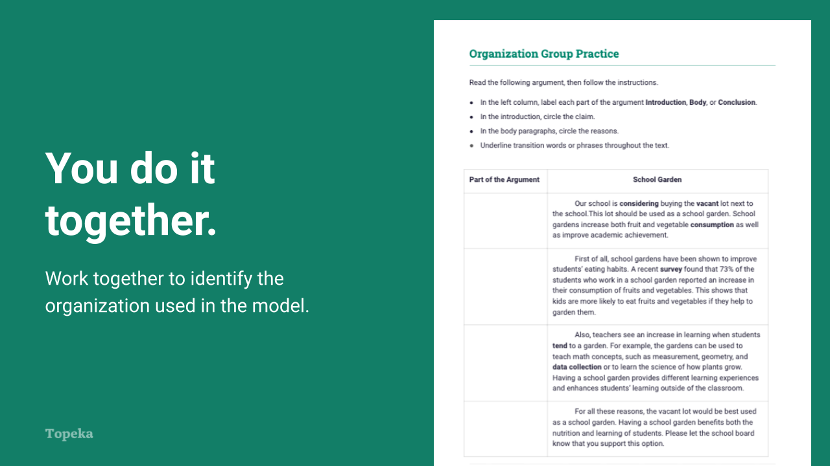
Slide 11
Teacher | Students
Teacher sets expectations for students to collaboratively identify the different parts of a new argument and the transition words or phrases used within it.  For information on implementing Small Group Collaboration via remote learning, see Remote Engagement: Small Groups or the guide to Remote Learning with Topeka. | Students listen and take notes.
Teacher separates students into pairs or small groups and provide instructions.  In your group, you will read the argument and then follow the instructions. You will be labelling each paragraph with Introduction, Body, or Conclusion. You’ll circle the claim within the introduction and the reasons in the body. And you’ll underline the transition words that connect everything together.  Teacher circulates to support students by providing feedback on their labeling of the text. | Students will work in groups to read text. To complete the activity, they  - label the parts of the argument in the left-hand column;  - circle the claim and reasons; and  - underline the transition words and phrases used.
Teacher reconvenes class to debrief the group activity.  When asking students to describe transition words they found, teacher asks students to describe purpose of each transition word. Display Slide 10 again if necessary. | Students will listen and participate as requested.

Step 4: Independent Application
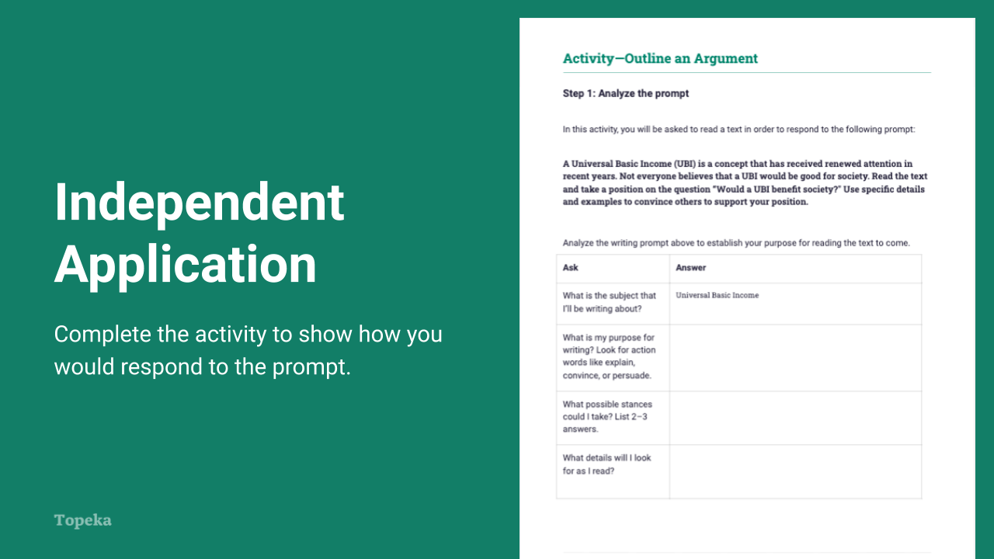
Slide 12
Teacher | Students
Teacher distributes the outlining activity and will instruct students to independently plan an argument responding to the prompt: “Would a Universal Basic Income benefit society?”  Now we’re going to work independently to outline an argument in response to text and prompt. There are three steps to this activity.  - First, read the prompt and answer questions to make sure you understand.  - Next, read the text to gather information for your argument.  - Finally, build the outline for your argument.  In your outline, you do not need to write complete sentences. Just indicate with a few words what you would include in each part of the argument. Imagine that you could later take this outline and use it as a guide to write your actual argumentative essay.  Teacher circulates to support students with the planning of their arguments. | Students  - establish purpose for reading the assigned text;  - read the text “A Universal Basic Income” to gather information to respond to the prompt; and  - use the outline below to plan an organized essay in response to the prompt.

Appendix A: Sample Responses

Entry Ticket: Organization
Conclusion | For all these reasons, the vacant lot would be best used as a school garden. Please let the school board know that you support this option.
Introduction | Our school is considering buying the vacant lot next to the school. This lot should be used as a school garden.
Body | First of all, school gardens have been shown to improve students’ eating habits. Also, teachers see an increase in learning when students can tend a garden.

Organization Group Practice
Part of the Argument | School Garden
Introduction | Our school is considering buying the vacant lot next to the school. This lot should be used as a school garden. School gardens increase both fruit and vegetable consumption as well as improve academic achievement.
Body | First of all, school gardens have been shown to improve students’ eating habits. A recent survey found that 73% of the students who work in a school garden reported an increase in their consumption of fruits and vegetables. This shows that kids are more likely to eat fruits and vegetables if they help to garden them.
Body | Also, teachers see an increase in learning when students tend to a garden. For example, the gardens can be used to teach math concepts, such as measurement, geometry and data collection or to learn the science of how plants grow. Having a school garden provides different learning experiences and enhances students’ learning outside of the classroom.
Conclusion | For all these reasons, the vacant lot would be best used as a school garden. Having a school garden benefits both the nutrition and learning of students. Please let the school board know that you support this option.

Appendix B: Engagement Strategies Via Remote Learning
The following links provide useful information for implementing this lesson through remote learning:
- Introduction to Remote Learning with Topeka.
- Remote Engagement: Pair and Share
- Remote Engagement: Small Groups
- Remote Engagement: Note Taking
- Remote Engagement: Think Aloud
- Remote Engagement: Four Corners Debate

