Pre-Writing
Reading Closely to Make Arguments
Lesson Plan (Minimum Time: One 45-Minute Session)

Lesson Summary
In this lesson, students and teacher will analyze two images to discover how reasons and details can be used to build arguments. Rather than analyzing text for evidence, students will attend to the details of a discussion-worthy image and will respond to a prompt. Teacher will model and students will participate in large and small group collaboration. Finally, students will practice constructing a statement of the message of the image (claim), a reason for making the claim, and details from the image that support the reason (evidence).

- Step 1: Set Purpose/Activate Prior Knowledge—Students will complete an initial analysis of the first image to activate prior knowledge of making arguments.
- Step 2: I Do It/We Do It Together—Teacher will model and then whole class will collaborate to find additional details to support an argument.
- Step 3: You Do It Together—Students will analyze a second image in pairs or small groups. An activity handout will guide the analysis.
- Step 4: Independent Application—Students will use analysis from Step 3 to construct an argument using the provided graphic organizer.

Objective
Students will select evidence to support their ideas about an image or photograph.

Engagement Strategies
- Pair and Share: Students will work with a partner and collaborate through discussion. See also, Remote Engagement: Pair and Share.
- Collaborating to Find Evidence: Students will work in pairs or small groups to find and evaluate evidence while practicing reasoning together. See also, Remote Engagement: Small Groups.
Links to information for remote learning are also provided in the lesson steps below. A complete list can be found in Appendix B.

Scaffolding Strategies
The scaffolding strategies listed below are optional supports included in the lesson’s activities. These tools may be used or ignored based on students’ needs.
- Vocabulary Bank: Students, particularly students who are English Learners, can use or even translate these words to note specific details in the images.
- Sentence Stem Bank: Students can use sentence stems to articulate their critical thinking about key aspects of the image.
- Graphic Organizers: Students can use the organizer to deliberately record their thinking about each image or detail they plan to discuss.

Remote Learning Strategies
With careful advanced planning, Topeka lessons can be easily moved to a remote modality. Links to specific engagement strategies are included throughout this lesson plan. See Topeka’s professional learning resource Remote Learning with Topeka for additional suggestions for each stage of the typical Topeka lesson.

Key Vocabulary
- Claim
- Argument

Materials
- Presentation—Reading Closely to Make Arguments
- Entry Ticket—Analyze an Image
- Activity—Make an Argument about an Image

Standards Addressed in this Lesson
- Write arguments to support claims in an analysis of substantive topics or texts using valid reasoning and relevant and sufficient evidence. (CCSS.ELA-LITERACY.CCRA.W.1)
- Produce clear and coherent writing in which the development, organization, and style are appropriate to task, purpose, and audience. (CCSS.ELA-LITERACY.CCRA.W.4)
- Read closely to determine what the text says explicitly and to make logical inferences from it; cite specific textual evidence when writing or speaking to support conclusions drawn from the text. (CCSS.ELA-LITERACY.CCRA.R.1)
- Determine central ideas or themes of a text and analyze their development; summarize the key supporting details and ideas. (CCSS.ELA-LITERACY.CCRA.R.2)

Lesson Steps

Step 1: Set Purpose/Activate Prior Knowledge

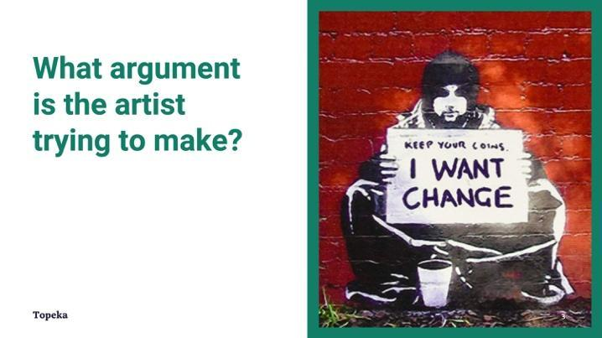
Slide 3
Teacher | Students
Have students complete an Image Analysis activity to activate prior knowledge of making arguments.  Project or pass out the photo of the Banksy piece “I Want Change.” (Slide 3)  Pass out entry ticket “Analyze an Image.” Have students complete Step 1 independently. | Examine the photo and answer the first three questions on the entry ticket.
Direct students to Pair and Share with a classmate to discuss answers and complete Step 2.  For information on implementing Pair and Share via remote learning, see Remote Engagement: Pair and Share or the guide to Remote Learning with Topeka. | Students turn and discuss their answers to the activity.

Step 2: I Do It/We Do It Together

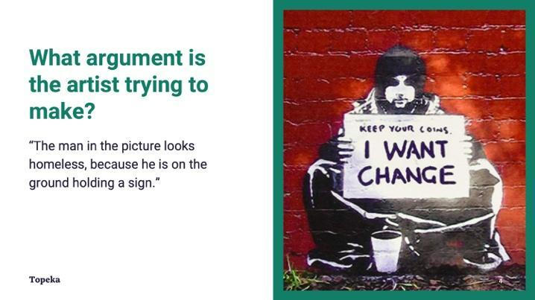
Slide 4
Teacher | Students
Teacher models the process of looking for details in order to make meaning. Consider pre-recording this portion of the lesson for remote delivery. See Remote Engagement: Think Aloud for ideas.  What is the artist trying to convey with this picture? I am going to do a think-aloud so you can hear how I look for details when I start making meaning.  I am noticing the man in the picture looks homeless, because he is on the ground holding a sign. Can you help me find another detail that helps me understand the work of art? | Students listen and watch teacher modeling.  Students examine the photo.  Based on the teacher model, the class collaborates to find another piece of evidence.

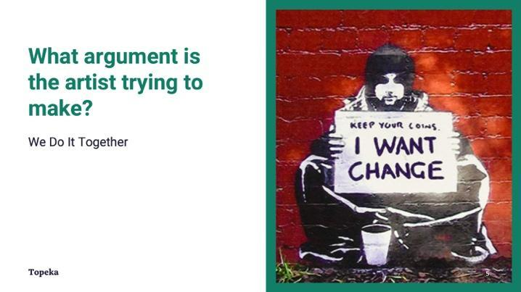
Slide 5
Teacher | Students
Teacher calls on students in large group and asks students to make a claim about the argument that the artist is trying to make.  What else do you see in this picture? What other details support this idea? Can you make a different argument about the artist’s intent?  Teacher asks students to support their answers using details from the photo and to explain how the details suggest that meaning.  Teacher models the necessity of both the detail and the explanation. | Students examine a photo and reflect on details discussed.  Class collaborates to find another piece of evidence.

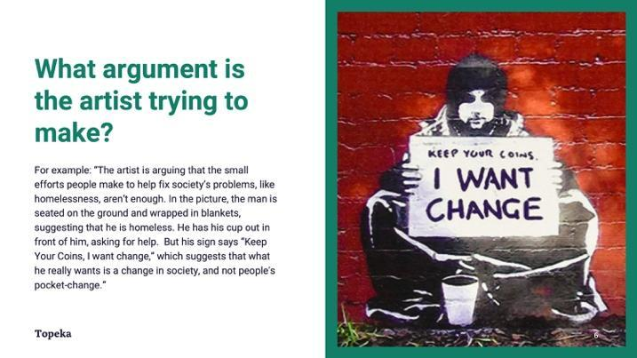
Slide 6
Teacher | Student
Here is a complete argument about the image.
The artist is arguing that the small efforts people make to help fix society’s problems, like homelessness, aren’t enough. (This is the claim.) In the picture, the man is seated on the ground and wrapped in blankets, suggesting that he is homeless. He has his cup out in front of him, asking for help, but his sign says “Keep your coins, I want change.” (These are details.) which suggests that what he really wants is a change in society, and not people’s actual pocket-change. (This is the explanation.)

Step 3: You Do It Together
In this step, students work together to analyze another image. The image used in the presentation is only one suggestion. Feel free to select an image to which your students will respond well. Images from current, local, or historical events are excellent choices. Those that offer a debatable interpretation are best.

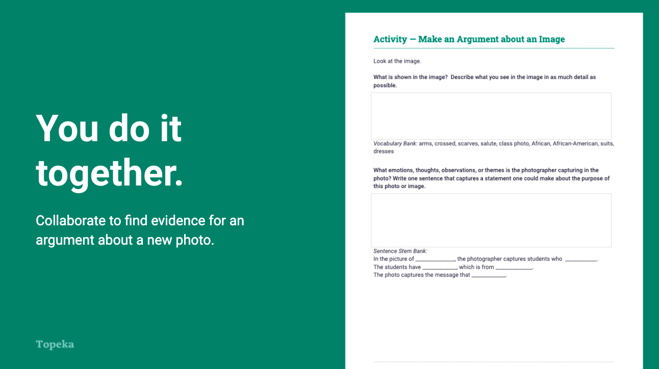
Slide 7
Teacher | Students
Teacher distributes second handout and sets expectations for students to collaboratively analyze another photo.  For information on implementing Small Group Collaboration via remote learning, see Remote Engagement: Small Groups or the guide to Remote Learning with Topeka. | Students collaborate to find evidence.  Students work in pairs or small groups to complete the second Image Analysis handout.

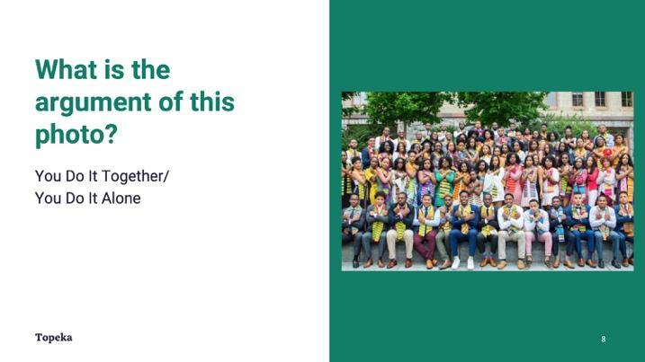
Slide 8
Teacher | Students
Teacher displays or distributes image for analysis.

Step 4: Independent Application
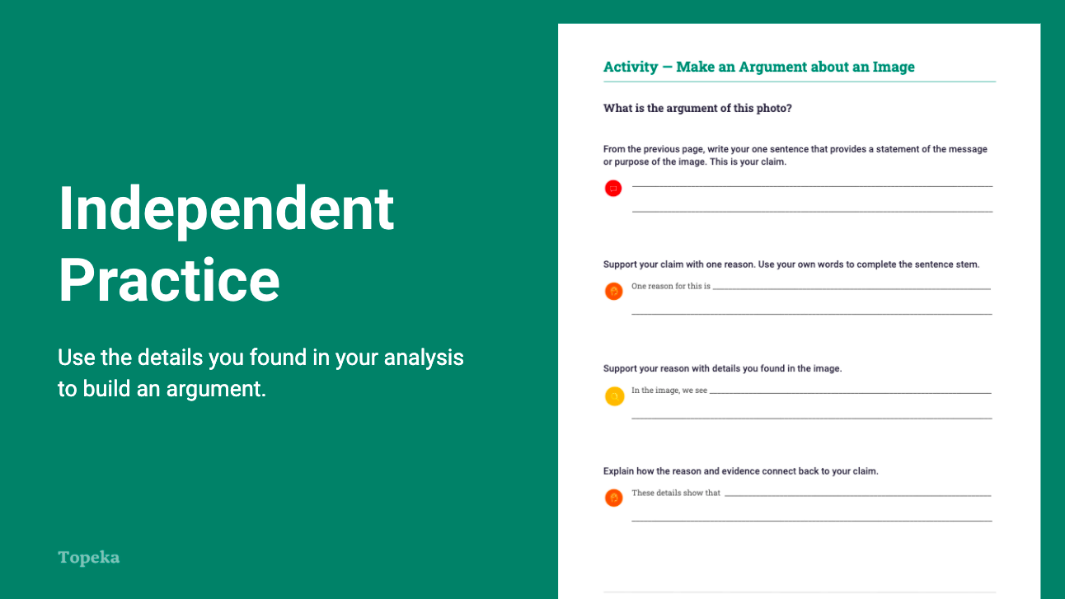
Slide 9
Teacher | Students
Teacher instructs students to use sentence stems provided on the third page of handout to build an argument about the image. Teacher asks students to write a claim and support it with at least one reason and one piece of evidence. | Students take a stance on what is depicted in the image using their notes from the previous step.

Appendix A: Sample Responses

Entry Ticket—Analyze an Image
What is shown in the image? Describe what you see in the image in as much detail as possible.
The man in the image could be protesting homelessness, since he is sitting on the ground, but the sign says that he doesn’t want coins. His coffee cup could be full, suggesting that he is not asking for spare change. Some people see the cup as empty and suggest that he is homeless, asking or begging for coins, and protesting. The primary colors of black, white, and red make it hard to see the details of the person, but the man is sitting against a brick wall, so that also may make a viewer think of him as homeless. The graffiti style art is painted outside on a brick wall, which also makes some people think of protest.

Vocabulary Bank: person, sign, ground, wall, cup, words, face, red, black, begging, asking, change (could refer to coins or transformation), sitting, painted, art, graffiti

What emotions, thoughts, observations, or themes is the artist capturing in the image? Write one sentence that captures a statement one could make about the purpose of this photo or image.
In the picture of a homeless man protesting homelessness, the artist captures the idea that small donations of loose change from people passing by are not going to change the overall situation for homeless people. They need real change that transforms the society.

Using the image of a homeless person painted against a brick wall, the artist shows how many people first see a homeless person, sitting on the ground, begging for change, easy to ignore.

The artist captures the idea that a homeless person is a person who has a voice even though many people would pass by the person and ignore them. The picture shows this man in bold colors, with red, black, and white, making the painting hard to ignore.
Sentence Stem Bank:
In the picture of ____________, the artist captures the idea that ____________.
Using the image of ____________, the artist shows ____________.
The artist captures the idea that ____________. The picture shows this ____________.

Which details from the image support your answer to the question above? Use the organizer to connect your thinking to your background knowledge and experiences. For every detail that you list, briefly describe the thought, feeling, or idea the detail has prompted for you as a viewer.
I saw...  A sign that said, “Keep your coins, I want change.” | Which made me think…  The person doesn’t want spare change, that won’t help much. He wants society to change so homelessness is not an issue.
A coffee cup. | It could be a cup for change that people might donate anyway, or it could be a full cup of coffee that lets people know he is serious about not wanting their spare change.
A graffiti style piece of art painted on a brick wall. | It almost made it look like a real person you could pass on the street, but since it is art and the colors are so extreme and his sign is challenging, it is hard to ignore this person the way people ignore homeless people.

Step 2: Share your findings with a partner and develop a shared claim about the image. Record your claim below.
The graffiti style painting by Banksy challenges viewers to reconsider their treatment of people experiencing homelessness by pointing out that giving people spare change doesn’t change the conditions in society that made the person homeless in the first place.

Activity—Make an Argument about an Image

What is shown in the image? Describe what you see in the image in as much detail as possible.
The image is of a class that looks to be one hundred percent African American. The students are wearing stoles with an African pattern and suits and dresses, suggesting that this is a graduation picture or another important event. Some students have very serious looks on their faces, but others have big smiles. They are all looking at the camera and their salue is the salute from the movie Black Panther. The Wakanda Forever salute represents Black excellence.

What emotions, thoughts, observations, or themes is the photographer capturing in the photo? Write one sentence that captures a statement one could make about the purpose of this photo or image.
In the picture of high school students at an all Black high school, the photographer captures students who are showing Black pride through their dress and their salute.
The students have dress clothes on and are doing the Wakanda Forever salute, which is from the movie Black Panther.
The photo captures the message that students are part of a larger culture of excellence across many fields and have pride in it.

Sentence Stem Bank:
In the picture of ____________, the photographer captures students who ____________.
The students have ____________, which is from ____________.
The photo captures the message that ____________.

Which details from the image support your answer to the question above? Use the organizer to connect your thinking to your background knowledge and experiences. For every detail that you list, briefly describe the thought, feeling, or idea the detail has prompted for you as a viewer.

I saw...  Students in suits, dresses, and stoles made of material with traditional African patterns. | Which made me think…  This was an important occasion, perhaps a graduation for a school with Black students who take pride in celebrating their African heritage.
A school or church in the background. | The adults in their lives support these students in developing and sharing a sense of pride in their community and heritage.
Everyone is doing a Wakanda Forever salute. | Students are linking their experiences with the movie Black Panther. The Wakanda Forever salute is a symbol of Black excellence, so students are showing that they feel connected to that history of excellence and are proud of it.

Share your findings with a partner before moving on to the next step.

What is the argument of this image?

From the previous page, write your one sentence that provides a statement of the message or purpose of the image. This is your claim.
Students from this school are showing their pride in the heritage of Black excellence.

Support your claim with one reason. Use your own words to complete the sentence stem.
One reason for this is the students are wearing suits, dresses, and stoles that appear to be made of traditional African patterns. They appear to be doing the Wakanda Forever salute as well.
Support your reason with details you found in the image.
In the image, we see formal clothes and stoles with bright colors and patterns that look like many of the patterns in traditional African clothing. The students are wearing them as stoles, like the ones graduates wear.
Explain how the reason and evidence connect back to your claim.
These details show that they are wearing these for a graduation or some other important ceremony but they are not wearing the robes that many schools use for graduations. This makes a statement that they are proud of their African heritage and the excellence in the Black community that is symbolized by the Wakanda Forever salute.

Appendix B: Engagement Strategies Via Remote Learning
The following links provide useful information for implementing this lesson through remote learning:
- Introduction to Remote Learning with Topeka
- Remote Engagement: Pair and Share
- Remote Engagement: Small Groups
- Remote Engagement: Think Aloud

