A strong, focused argument has a clear claim and addresses the requirements of the prompt.
Complete steps 1 and 2 below to analyze the writing prompt and your claim for the essay you’ve written. You’ll need a copy of the writing prompt and access to your essay.
Step 1
Use your copy of the writing prompt to do the following:
- Circle the main question you must answer.
- Draw a box around the specific aspects of the main question you must address, breaking them down into as many parts as necessary.
- Underline the actual task to complete.
- Place asterisks next to the specific criteria you must meet in order to complete the task effectively.
Step 2
Write the claim you used in your essay. If your essay does not have a clear claim, draft a claim to add when you revise:

Does your claim… | Explain
...answer the question you circled?
...address the details you placed in boxes?
Need Help Getting Started?
The sample writing prompt below has been analyzed using the instructions provided.

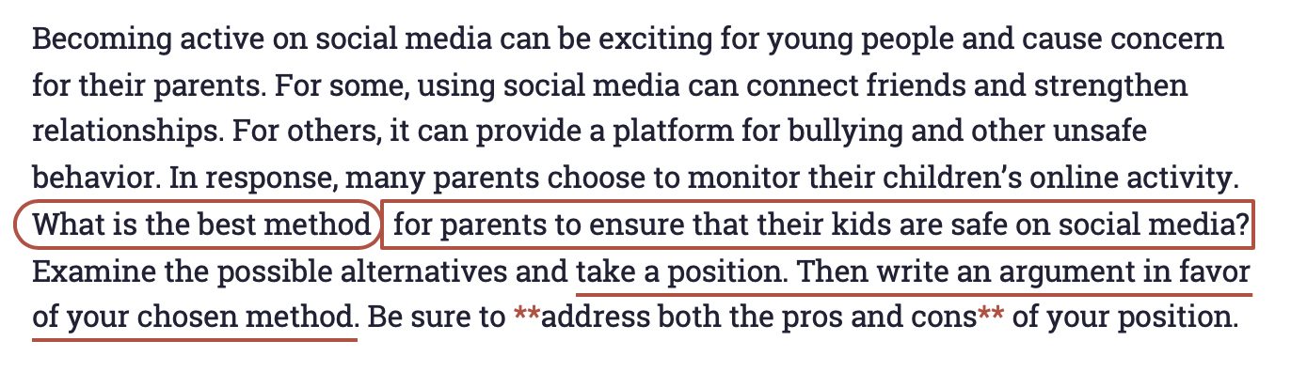
In this example, the question is “what is the best method.” The specific aspects are “for parents to ensure that their kids are safe” and “on social media.” The task is “take a position and write an argument in favor of that position.” The criteria for the task are to “address both the pros and the cons” of the position.

