Read the sample first draft below, which responds to the writing prompt, “Do school uniforms empower students in ways that help them learn?” Using the Revision Strategies Sheet: Claim and Focus, suggest revisions that would strengthen the writer’s achievement in the claim and focus domain.

Student Sample—First Draft

In the text, "Yes to Uniforms," the author points out some advantages and disadvantages to schools that enforce uniform policies. School uniforms help students focus on education.
In the text, “Yes to Uniforms,” the author states, “For one, they (uniforms) cut down on peer-to-peer social problems. When you're in a uniform, there's no pressure to wear trendy clothes.” This empowers students because they are more focused on learning not worrying about what people think of their clothes.
Secondly, in the text it says, “There are all kinds of ways to express ourselves beyond mere fashion. For instance, maybe you're brilliant in math or science. Or maybe you're a painter or a writer. Maybe you tell great stories and jokes.” This shows how uniforms can shift the focus of self-expression away from clothes.
Although uniforms cannot completely eliminate the risk of peer distractions or make students motivated to learn, they do create conditions that decrease peer social problems and encourage self-expression through education.

The annotated essay below notes some areas where the writer can revise to improve the claim and focus.

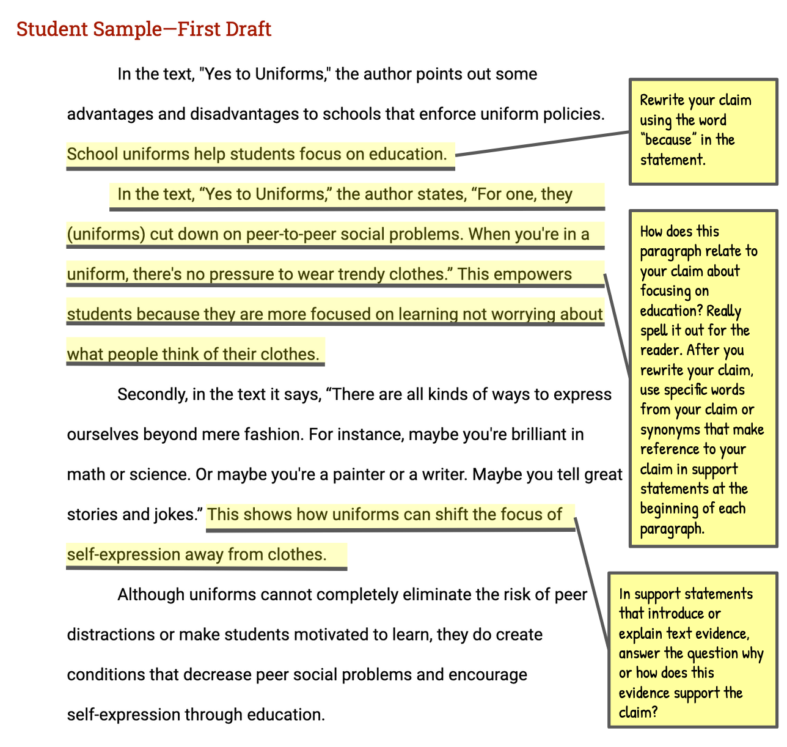

Vocabulary Supports
Argument—an attempt to persuade or convince others to accept an opinion or position on an issue
Claim—an arguable position on an issue
Counterclaim—a different position on an issue that opposes the writer’s claim
Evidence—details such as facts, statistics, or quotations that support the writer’s claim
Focus—the set of related ideas used by a writer to support an argument; an argument that lacks focus, presents unrelated ideas, or goes off topic
Prompt—the information and instructions students are responding to when writing an argument
Reason—a statement explaining why a writer takes a particular position in an argument
Reasoning—an explanation of how a reason and its supporting evidence connect to the claim

