Exemplar Lesson
Exploring Exemplars for Revising Claim and Focus
Lesson Plan (Minimum Time: One 45-Minute Session)

Lesson Summary
In this lesson, the teacher and students will analyze a sample first draft, sample feedback, and a sample revision of an argumentative essay. The teacher will model suggesting revision strategies, and students will participate in large and small group collaboration to suggest revisions. Students will then review the impact of revisions in a sample revision.

- Step 1: Set Purpose/Activate Prior Knowledge—Students will review the Revision Strategies: Claim and Focus, and complete an initial analysis of the first draft of a sample argumentative essay.
- Step 2: I Do It/We Do It Together—Teacher will model analyzing claim and focus revision opportunities using the revision strategies sheets to select a good revision step, and then the whole class will collaborate to find additional steps to revise the argument.
- Step 3: You Do It Together—Students will apply additional revision strategies to suggest revisions or to revise the essay, and will share work with small or large groups, explaining why the revisions have a positive impact on the essay.
- Step 4: I Do It/We Do It Together—Teacher will review an exemplar revision and discuss the impact of key revisions on the essay.
After completion of the lesson, students can use the revision strategies sheets along with feedback from signal checks and conferences to revise their essays for stronger claim and focus.

Objective
Students will understand and be able to apply revision strategies to improve proficiency in the claim and focus domain.

Engagement Strategies
- Pair and Share: Students will work with a partner and collaborate through discussion. See Remote Engagement: Pair and Share.
- Collaborating to Determine Revisions: Students will work in pairs or small groups to find and evaluate opportunities to apply revision strategies. See Remote Engagement: Small Groups.
Links to information for remote learning are also provided in the lesson steps below.

Scaffolding Strategies
The scaffolding strategies listed below are optional supports included in the lesson’s activities. These tools may be used or ignored based on students’ needs.
- Vocabulary Supports: Students can use vocabulary supports for comprehension.
- Revision Strategies Sheet: Students can utilize revision strategies to look for ways to improve in this domain. See Revision Strategies: Claim and Focus for a printable handout of strategies needed for this lesson.

Remote Learning Strategies
With careful advanced planning, Topeka lessons can be easily moved to a remote modality. Links to specific engagement strategies are included throughout this lesson plan. See Topeka’s professional learning resource Remote Learning with Topeka for additional suggestions for each stage of the typical Topeka lesson.

Key Vocabulary
- Claim
- Focus
- Argument

Materials
- Presentation: Introducing Exemplars: Claim and Focus
- Revision Strategies: Claim and Focus
- Claim and Focus Exemplar: Before Revision
- Claim and Focus Exemplar: After Revision
- Conference form

Standards Addressed in this Lesson
- Develop and strengthen writing as needed by planning, revising, editing, rewriting, or trying a new approach. (CCSS.ELA-LITERACY.CCRA.W.5)
- Write arguments to support claims in an analysis of substantive topics or texts using valid reasoning and relevant and sufficient evidence. (CCSS.ELA-LITERACY.CCRA.W.1)
- Produce clear and coherent writing in which the development, organization, and style are appropriate to task, purpose, and audience. (CCSS.ELA-LITERACY.CCRA.W.4)

Lesson Steps

Step 1: Set Purpose/Activate Prior Knowledge

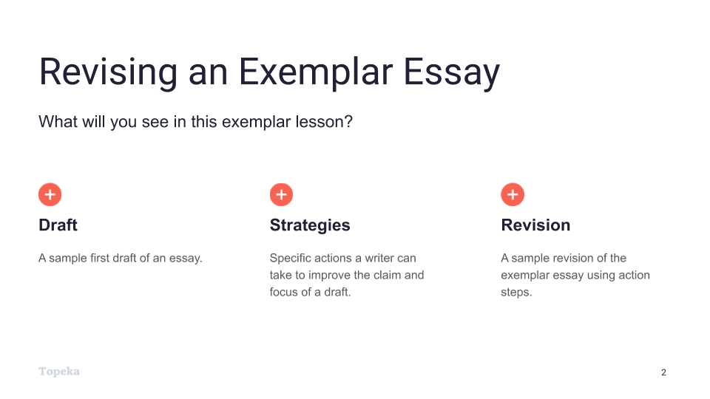
Slide 2
Teacher | Students
Teacher will set the purpose for the lesson by describing what students will encounter.  In this lesson, we’re going to look at the process of revising an essay to improve performance in the claim and focus domain.  First, we will look at a sample first draft alongside the revision strategies for this domain. You will use the strategies sheet to make suggestions for improving the sample first draft.  Then, we’ll look together at specific revision steps a teacher suggested for this essay, and we’ll try to implement those steps for the sample essay.  Finally, we’ll see a sample revision to see how the writer used those specific action steps to improve the claim and focus of the draft. | Students listen and take notes.

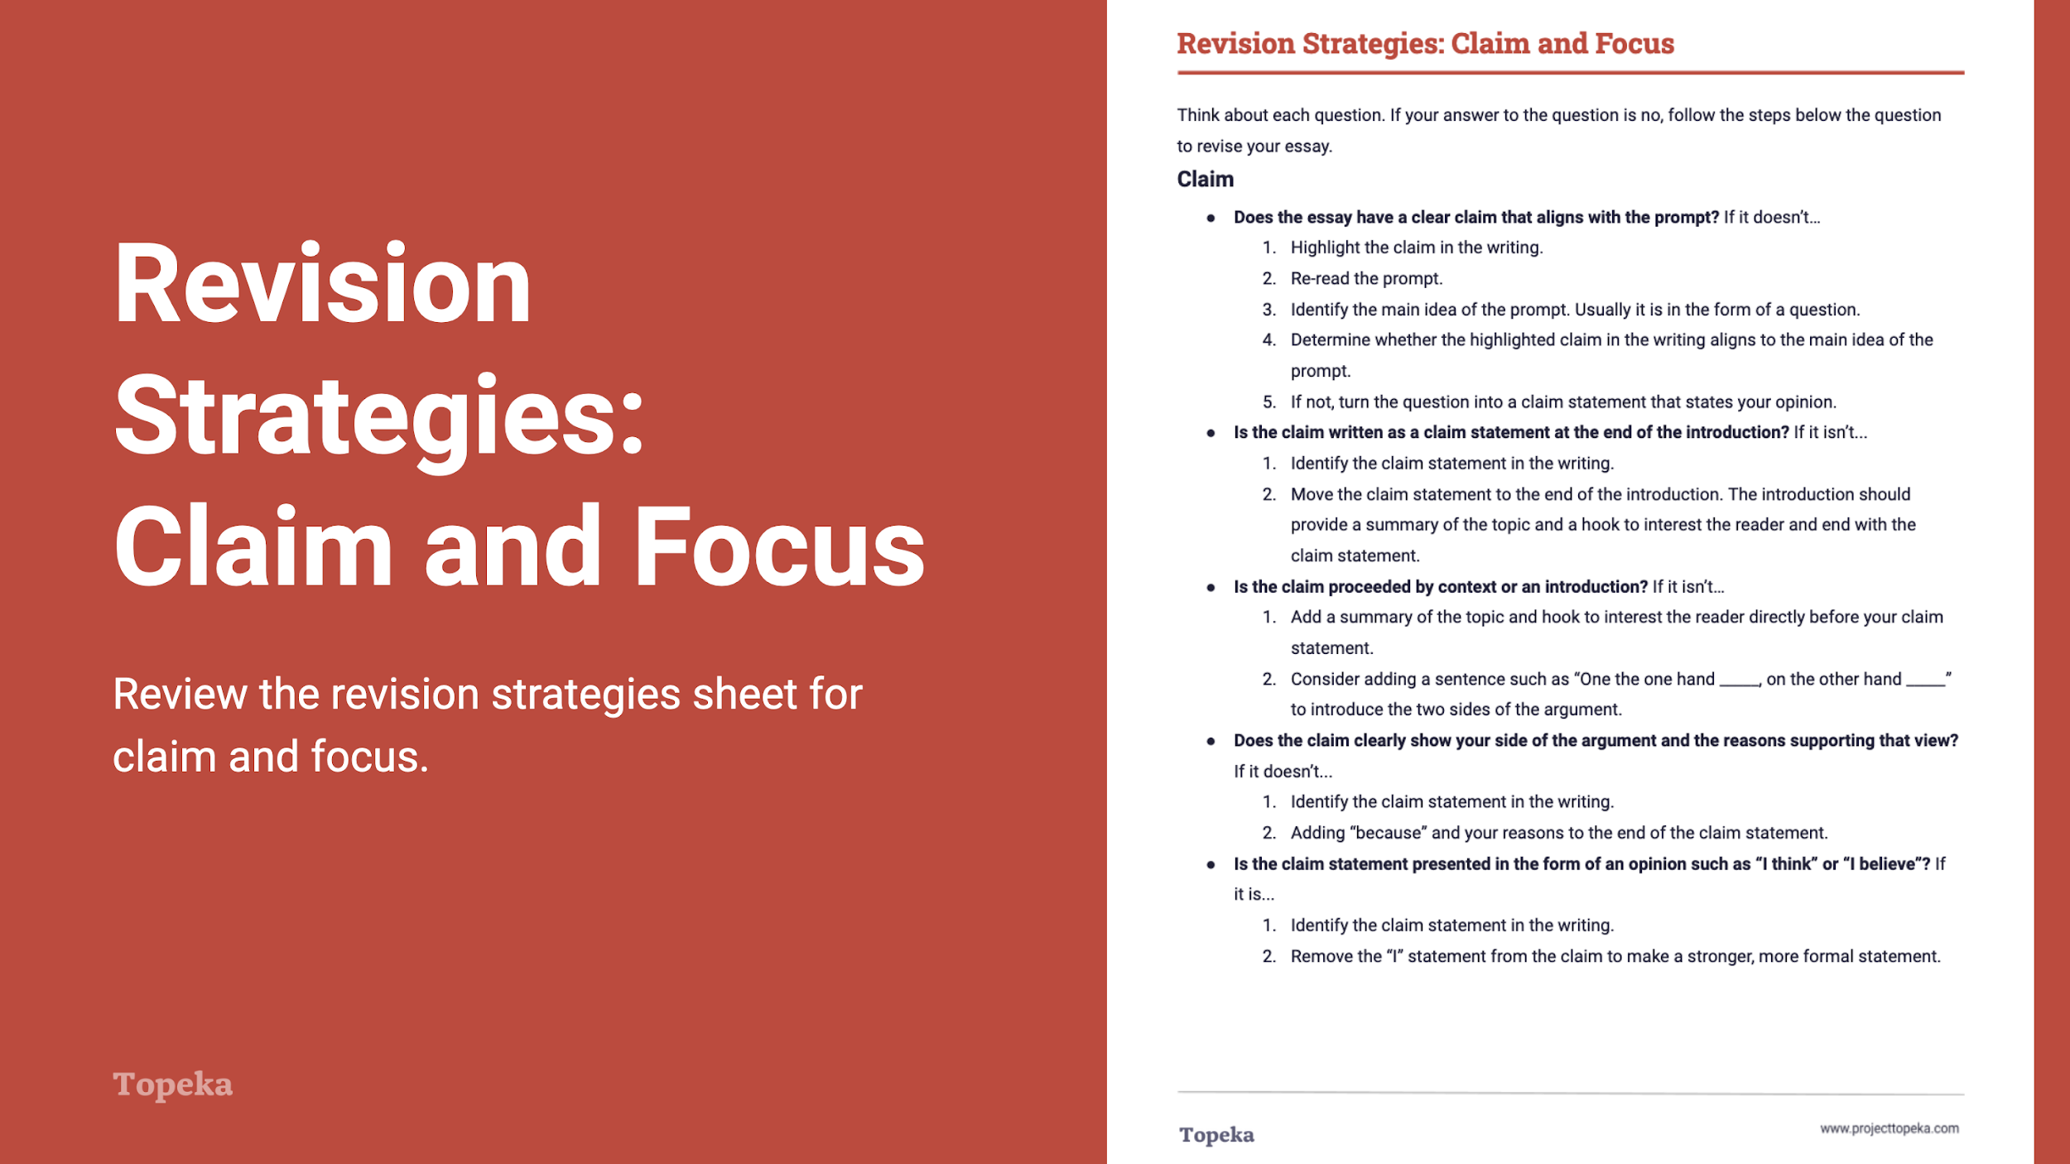
Slide 3
Teacher | Students
Teacher distributes Revision Strategies: Claim and Focus.  Take a moment to review the revision strategy sheet for claim and focus. Think back to what you know about claim and focus—about what makes a strong claim, and how a strong claim helps focus an essay.  Teacher has students Pair and Share with a classmate to confirm their understanding of what claim and focus means and how it is evaluated.  (For information on implementing Pair and Share via remote learning, see Remote Engagement: Pair and Share or the guide to Remote Learning with Topeka.) | Students refresh their memories of strong claim and focus by reviewing and discussing the revision strategies sheet.
Teacher distributes the handout Claim and Focus Exemplar: Before Revision. Teacher directs students to look at the first page.  Here is an example of a student writing about school uniforms. The question the student is answering is whether or not uniforms empower students in ways that help them learn.  Using the revision strategies for claim and focus, suggest revisions that would strengthen the writer’s achievement in the claim and focus domain. Annotate the draft to show your suggestions and your explanation. | Students use the “before” exemplar essay and the revision strategies sheet to suggest ways for the writer to improve the essay.
When students complete the review, teacher has students partner with others to compare the suggested changes. Have students explain their suggestions.  How do these changes increase student achievement on the claim and focus section of the rubric? Why do you think the revised essay will be better?  (For information on implementing Pair and Share via remote learning, see Remote Engagement: Pair and Share or the guide to Remote Learning with Topeka.) | Students partner to share their suggestions for revisions and their explanations for how these revisions would improve claim and focus in the essay.

Step 2: I Do It/We Do It Together
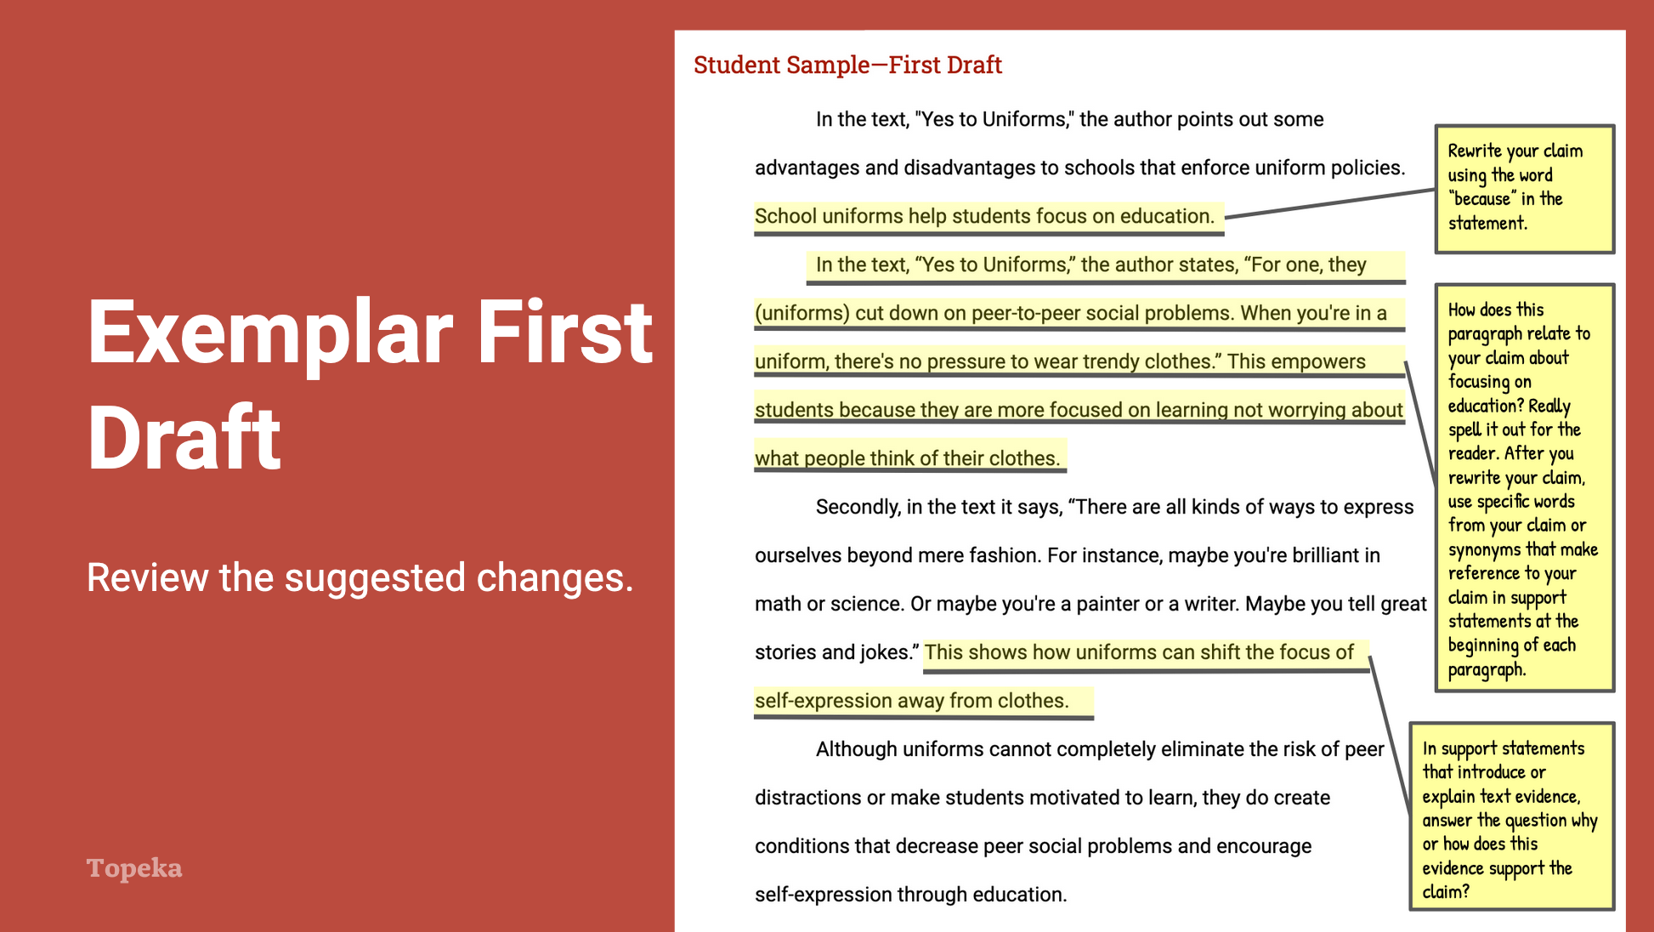
Slide 4
Teacher | Students
Teacher directs students to the second page of the Claim and Focus Exemplar: Before Revision handout and explains the annotations.  After reviewing this piece of writing, I can see that the claim is there and it’s related to the topic, “school uniforms help students focus on education.” But the other paragraphs aren’t always so clear in what they’re trying to prove.  If I look at the revision strategies sheet, I can see that the claim and focus rubric domain can be broken down into two traits: one is claim and the other is focus.  I’m going to ask myself some of these questions to get ideas for how to revise my essay. “Does the claim include both a side of the argument and reasons supporting that view?” I have a claim but it doesn’t include my reasons. Adding the word “because” to the end of the claim would allow the writer to make the claim more specific by indicating the specific reasons that will be discussed in the essay. | Students listen and take notes as appropriate.
Using the annotated first draft, teacher will continue to review the suggested changes, ask students to evaluate their impact, and also answer questions related to the domain’s evaluation criteria.  Do you think these suggestions will help improve claim and focus? Where else do you think the writer can strengthen the essay’s claim and focus? What other suggestions do you think would help this essay, and why would these changes improve the strength of the claim or focus? | Students listen, take notes, and participate as appropriate.

Step 3: You Do It Together

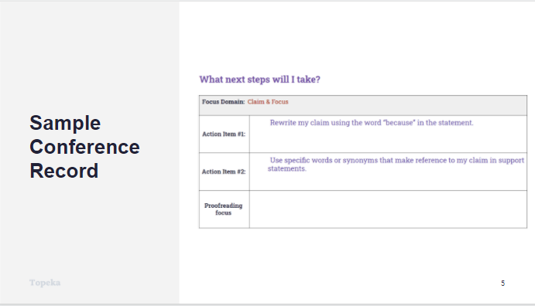
Slide 5
Teacher | Student
Teacher describes how a conference record is used to convey suggested revisions:  Here is an example of a conference record conveying the same strategies the teacher suggested in the annotations.  Teacher continues:  In the top row, we see that the writer is going to concentrate on improving both the claim and the focus traits. Let’s look at again at the revision steps this writer could use.  The first strategy, as we saw in the annotations, is to indicate the reasons why you support your claim directly within your claim statement. So here the first step is to rewrite the claim using the word “because.”  Another strategy is using specific words from the claim. Remember, this helps link reasons within the essay back to the claim statement.  Finally, focusing on answering the question in every support statement, “how or why does this evidence support the claim?”  This reinforces the links between the evidence, the reason, and the claim.  Which two would you choose to focus on?  Teacher directs students to work in small or large groups to review the recommendations and discuss the impact of these revisions. If time allows, students can implement the suggested revisions.  (For information on implementing Small Group Collaboration via remote learning, see Remote Engagement: Small Groups or the guide to Remote Learning with Topeka.) | Students listen and take notes.

Step 4: I Do It/We Do It Together

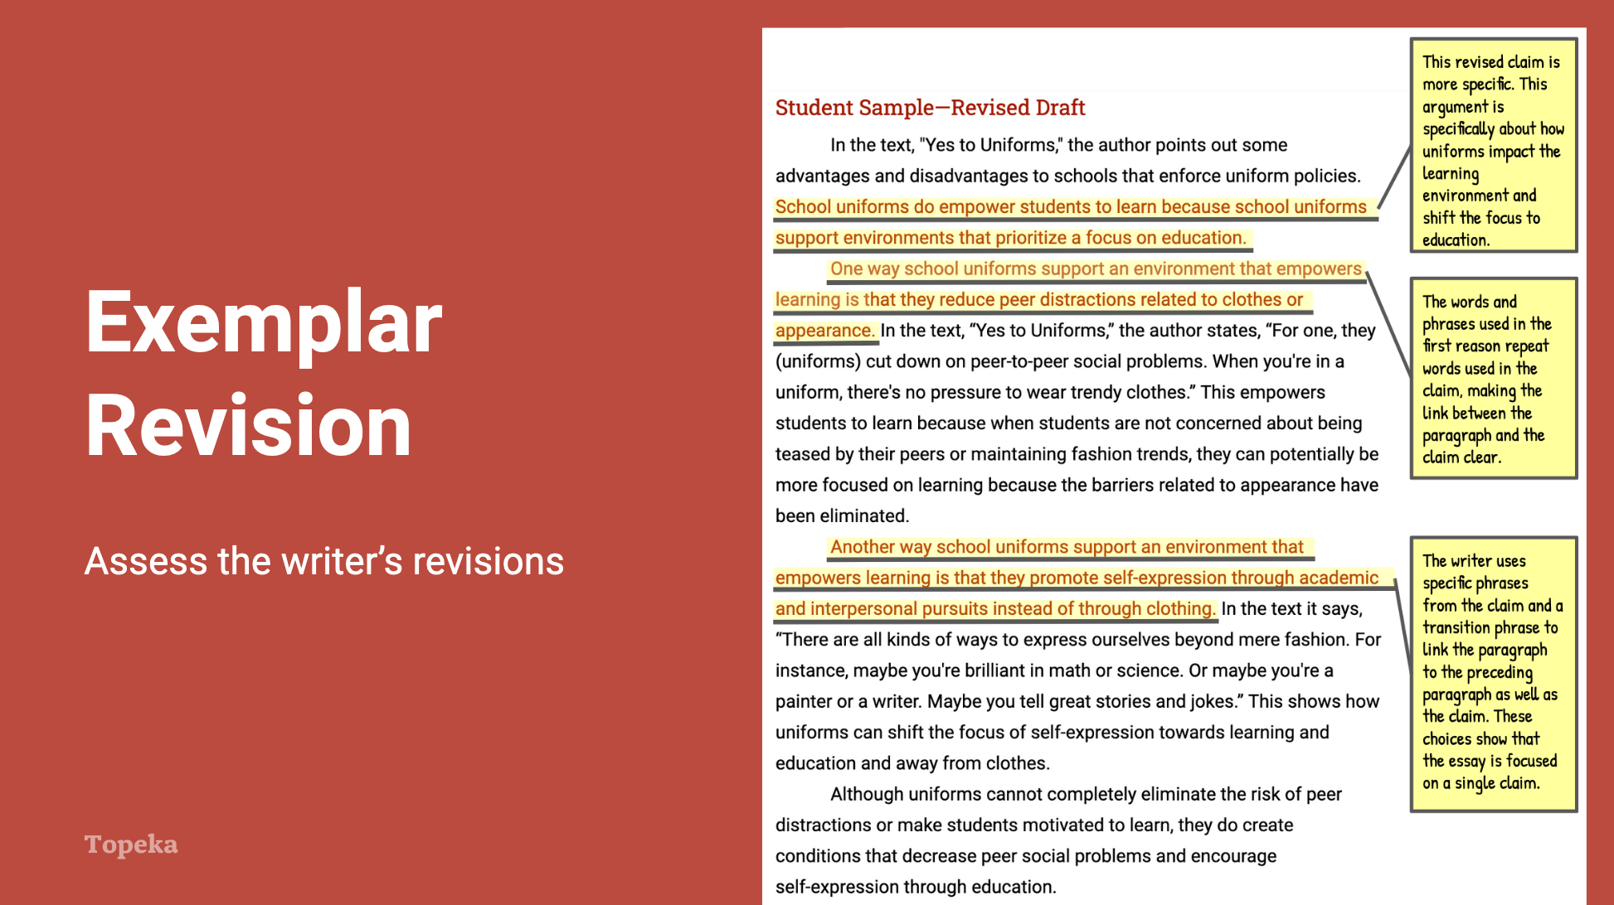
Slide 6
Teacher | Student
Teacher distributes the Claim and Focus Exemplar: After Revision and directs students’ attention to the first page of the revised essay.  In this revised draft, the writer has responded to the action steps the teacher presented in the conference form. This draft models all three possible revisions so you can see how each could be addressed. Review these revisions to see if you understand their impact. Follow the instructions on the handout.  Teacher allows students time to read revised essay and react to the revisions. | Students examine the highlighted revision on unannotated revised essay and note why each revision had a positive impact on the essay.
Teacher directs students to turn attention to the revised essay. Teacher thinks aloud to describe impact of revisions.  What do you notice about the differences in this text based on the highlighted sentences? How have these changes strengthened the essay’s claim and focus?  If you read the sentences highlighted in red, you will see that the claim is now more specific and more arguable. Adding the specific reference to the impact on the environment to help students focus on learning made the claim stronger than it would have been had the writer simply answered the prompt by turning it into a statement.  Later, in each paragraph supporting the claim, reasons link directly back to the claim by referring to “the learning environment.” Reasoning statements that explain evidence are also linked directly back to this idea as they explain why the uniforms support the learning environment by helping students focus on the academic parts of school versus other social elements that can impact students’ experience of school. | Students listen and take notes.
Teacher continues to describe revisions and concludes by reminding students to apply revision strategies to their own essays.  When you’re revising your essay, remember to use these helpful revision strategies to take your essay to the next level. | Students listen and take notes as appropriate.

For more information about modeling student revisions and growth, see the Topeka guide to Supporting Revision with Effective Feedback.

