Intervention Lesson
Claim and Focus
Lesson Plan

Rationale
Post-writing interventions help teachers drill down into common challenges students face in their writing. Not all student performance will fall within the range that these interventions are intended to address, but the skills addressed in this set of activities are fundamental to good writing and will help a broad range of students improve their performance. Rubric domains and skills within them are the drivers behind each of the individual lessons and accompanying activities at each level.
Feedback and data from signal checks are a great source of information for selecting and assigning intervention lessons. See the Planning from Data Guide for additional support for using data and reports to group students, select interventions, and schedule these additional supports into instructional time.
For information on implementing this lesson and accompanying activities via remote learning, see the guide to Remote Learning with Topeka.

How to Select and Use Intervention Lessons
- Step 1: Determine Intervention Needs—Review the reports from the initial writing exercise and select an approach to intervention. See Planning from Data Guide for guidance on using reports to plan instruction. If time allows, use the complementary exemplar lesson and activities to help students understand revision strategies within the domain and to show examples of revisions applied to a sample student essay.
- Step 2: Present Intervention Lesson and Engage Students in Personalized Intervention Activities— Use the activities and instruction included in this lesson to facilitate leveled interventions for planning a revision.
- Step 3: Individual Activity—Have students apply to their own essays the leveled instructions for a revision based on criteria of an individual rubric category.

Claim and Focus
Proficiency in the category of claim and focus is demonstrated by introduction of a clear claim, based on the topic or text(s). The essay mostly maintains a focus on the purpose and task, but may not develop the claim evenly throughout the essay while addressing the demands of the prompt.

Standards Addressed in this Lesson
- Write arguments to support claims in an analysis of substantive topics or texts using valid reasoning and relevant and sufficient evidence (CCSS.ELA-LITERACY.CCRA.W.1)
- Produce clear and coherent writing in which the development, organization, and style are appropriate to task, purpose, and audience (CCSS.ELA-LITERACY.CCRA.W.4)
- Develop and strengthen writing as needed by planning, revising, editing, rewriting, or trying a new approach (CCSS.ELA-LITERACY.CCRA.W.5)

Lesson Steps

Step 1: Determine Intervention Needs
There are several ways to group students and provide interventions based on data. For more details on how to use Topeka reports to plan instruction, see Planning from Data with Project Topeka.
Class Level Intervention: Reteaching
At a class level, teachers may choose to reteach a skill or concept based on the class level average, focusing on the area of performance with the lowest level of achievement. For example, the class, as a whole, had the lowest rating in the claim and focus domain. The teacher reteaches these concepts at a whole class level, even though individual students may be at different starting points in terms of actual achievement.
Small Group Intervention: Performance Area Intervention
At a group level, teachers may choose to reteach a skill or concept based on the shared needs associated with a particular area of performance, while individual interventions may be at different levels.
Personalized Intervention: Performance Area Intervention
For individual students, teachers may choose to reteach a variety of skills or concepts based on the needs associated with a particular area of performance.
Pre-Intervention Level | Next Level Growth Goal
Emerging:  The essay does not clearly make a claim, or the claim is overly simplistic or vague. The essay does not maintain focus on purpose and task, or remain objective. | Developing:  The essay introduces a claim, based on the topic or text(s), but it may be somewhat unclear or not maintained throughout the essay. The essay may not fully address the demands of the prompt or stay focused on the purpose and task. The writing may stray significantly off topic at times and introduce the writer's bias occasionally, making it difficult to follow the central claim at times.
Developing:  The essay introduces a claim, based on the topic or text(s), but it may be somewhat unclear or not maintained throughout the essay. The essay may not fully address the demands of the prompt or stay focused on the purpose and task. The writing may stray significantly off topic at times and introduce the writer's bias occasionally, making it difficult to follow the central claim at times. | Proficient:  The essay introduces a clear claim, based on the topic or text(s). The essay mostly maintains a focus on the purpose and task, but may not develop the claim evenly throughout the essay while addressing the demands of the prompt.
Proficient:  The essay introduces a clear claim, based on the topic or text(s). The essay mostly maintains a focus on the purpose and task, but may not develop the claim evenly throughout the essay while addressing the demands of the prompt. | Advanced:  The essay introduces a clear, arguable, and specific claim, based on the topic or text(s). The essay maintains strong focus on the purpose and task, using the whole essay to support and develop the claim while thoroughly addressing the demands of the prompt.

If time allows, prior to completing Step 2 below, present the exemplar lesson for the claim and focus domain, which complements this lesson. If the entire lesson is not feasible, have students review just the annotated exemplar essay to see how revision strategies can be applied in practice.

Step 2: Focused Intervention Lesson Presentation and Activities
In this step, teachers review fundamental concepts and assessment criteria found in rubric. Students collaborate to practice one or more skills necessary for student revision.

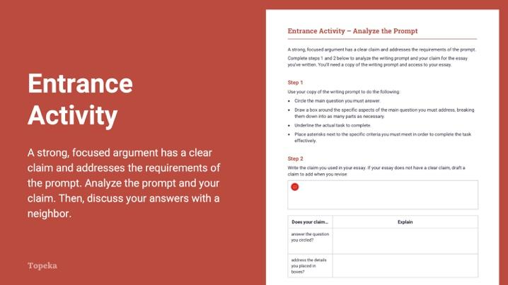
Slide 2
Teacher | Students
Teachers set the purpose for the class with an entry ticket to activate prior knowledge.  Teacher provides the following:  - Entry ticket handout  - Printout of the prompt for the assigned Revision Assistant essay  - Access to a draft of the student’s completed essay  Teacher circulates to offer assistance. (Note that a sample prompt analysis is provided at the back of the handout.) | Students complete an analysis of the assigned essay prompt. Students recall the claim they used in their draft, and reflect on the manner in which their claim addresses the prompt.
Teacher invites students to Pair and Share with a classmate to discuss their answers.  For information on implementing Pair and Share via remote learning, see Remote Engagement: Pair and Share or the guide to Remote Learning with Topeka.  Take a moment to talk to your neighbor about the main question you circled in the writing prompt. Explain to your partner how your claim answers the question—or how you think you might change your claim to make it answer the question.  Teacher circulates to offer assistance. | Students turn to a neighbor and share their prompt analysis answers and will reflect on how their claim answers the question presented by the writing prompt.

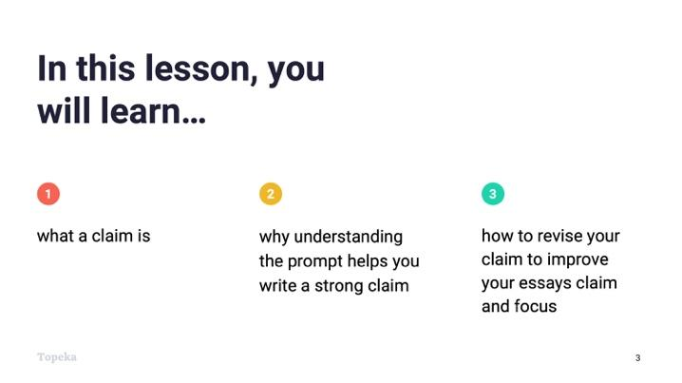
Slide 3
Teacher | Students
Teacher sets purpose for the day by explaining the objectives.  Today we are going to revisit the concept of writing a strong claim to improve the essay you’ve already written. You’ve just completed an entry ticket that had you analyze the writing prompt you used to write your essay. We’ll talk briefly about claims and then you’ll each plan a revision to see if you can improve the claim and focus of your essay. | Students listen and take notes.

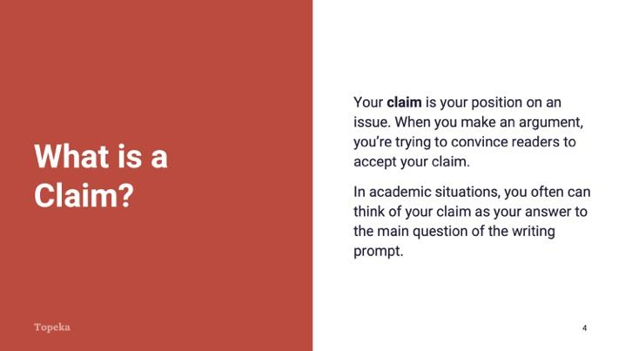
Slide 4
Teacher | Students
Teacher reteaches the concept of claim through direct instruction.  Consider pre-recording this portion of the lesson for remote delivery. See the guide to Remote Learning with Topeka for more details.  Let’s revisit the idea of making a claim. Your claim is your position on an issue or question. When you’re making an argument, you’re trying to convince readers to accept your claim.  Think of your claim as your answer to the main question posed in the writing prompt, boiled down into one statement. | Students listen, review their entry ticket activity, and take notes as needed.

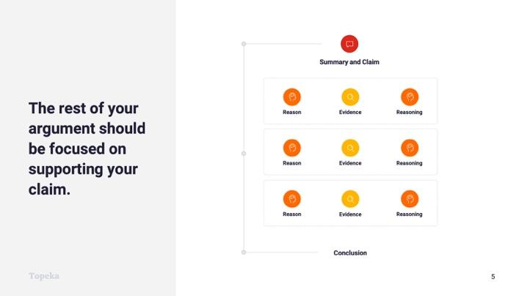
Slide 5
Teacher | Students
Teacher continues:  The rest of your argument should be focused on supporting the claim.  Each of your reasons will provide support for the claim. You’ll prove your reasons are valid using evidence from the text and you’ll explain how your evidence supports your reasons and connects to the claim. This explanation is your reasoning.  It's much easier to write good support when you have a good claim. | Students listen and take notes.

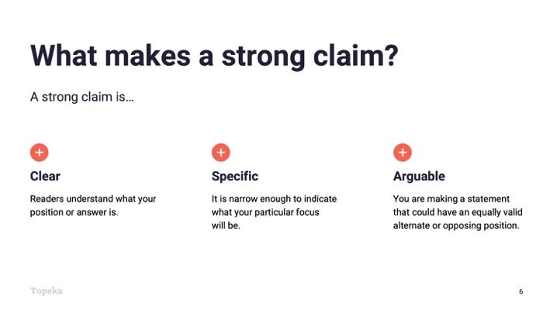
Slide 6
Teacher | Students
Teacher continues:  So what makes a strong claim? A strong claim is clear, specific, and arguable.  - When your claim is clear, readers understand what your position or answer is.  - When your claim is specific, it is narrow enough to indicate what your particular focus will be.  - When your claim is arguable, you are making a statement that could have an equally valid alternate or opposing position. That means someone else could reasonably disagree with your stance. | Students listen and take notes.

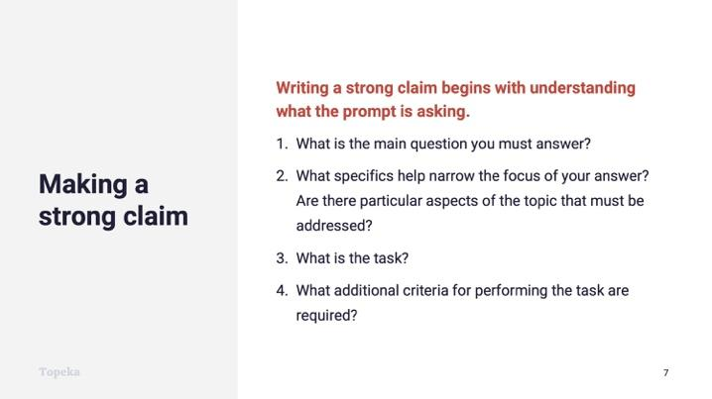
Slide 7
Teacher | Students
Teacher explains how a strong claim in academic writing addresses the demands of the writing prompt.  A strong claim is also answering the question posed in the prompt, which means it’s really important for you to understand the question. In order to know if you are answering the question, you must start by understanding the prompt.  - What is the main question you must answer?  - What specifics help narrow the focus of your answer? Are there particular aspects of the topic that must be addressed?  - What is the task?  - What additional criteria for performing the task are presented?  These questions are the questions you answered when you did your prompt analysis in the entry ticket. | Students listen and take notes.
Teacher leads class through a debrief of the prompt analysis from the entry ticket, asking students to contribute what they circled, boxed, underlined, and asterisked.  Teacher prepares students for activity presented in next step.  In a moment, you will receive instruction to help you plan a revision of your essay. As you read the instructions and revise your claim, keep in mind what you learned from this prompt analysis. | Students listen and contribute to discussion, making notes and updating entry ticket.

Step 3: Independent Revision Practice
In this step, students return to their essays and approach a revision with instruction and support selected in response to each student’s individual score report.

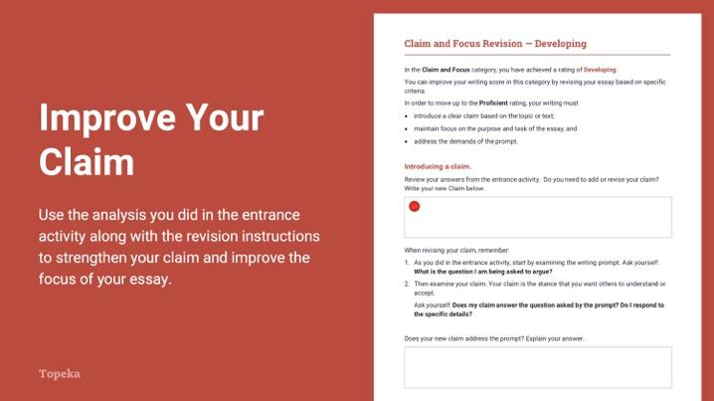
Slide 7
Teacher | Students
Teacher distributes leveled revision instructions to students according to their individual score report.  Students will have access to their essays.  Teacher instructs students to use the revision instructions to guide a revision of their claim and to evaluate the focus.  Teacher circulates to support students through their individual revision process, sandwiching areas for improvement between positive elements. | Students receive and read the instructions specific to their original score report.  Students plan a revision of essays according to this leveled guidance.

Appendix A: Vocabulary Supports for Prompts

Cell Phones Prompt Vocabulary:
Cell Phone (noun): mobile device that communicates through cellular networks, rather than through landlines
Position (noun): a particular opinion or stance on an issue

Graffiti Prompt Vocabulary:
Art (noun): a creative work expressing the creator’s feelings, thoughts, or ideas
Position Statement (noun): a document that outlines an argument and reasons to support that argument
Vandalism (noun): destruction of property

Screentime Prompt Vocabulary:
Interacting (verb): working with
Portable (adj.): able to be carried around
Devices (noun): objects made for a particular purpose; especially mechanical or electronic equipment
Handheld (adj.): able to be held in one’s hand; usually refers to a type of small electronic device
Potential (adj.): possible
Benefits (noun): positive elements, effects, or outcomes
Recommended (adj.): suggested
Defend (verb): stand up for
Relevant (adj.): related
Acknowledge (verb): affirm or note the existence of
Address (verb): respond to
Counterclaims (noun): arguments against your argument

Appendix B: Sample Student Responses

Is It Art?: Entry Ticket

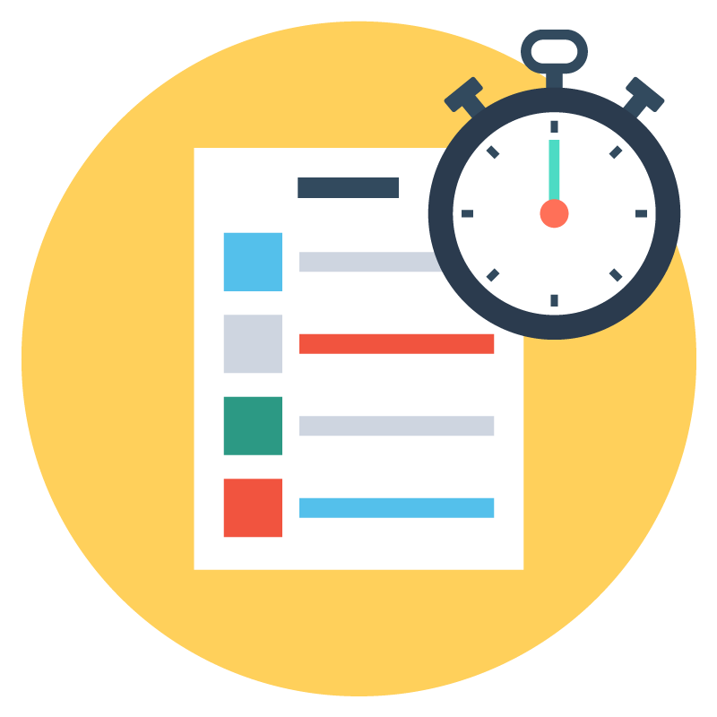Step 1: Prompt Analysis

Does your claim... | Explain
...answer the question you circled?

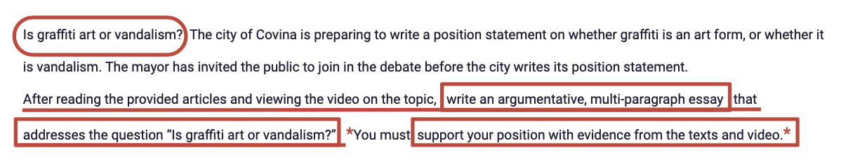

Step 2: Claim Activity

Emerging: Graffiti is a form of art.
Developing: Graffiti is not art because it is destructive to property.
Proficient: Some might say that graffiti is not art because it is often destructive to someone else’s property, but the artwork itself is art regardless of where it is.
Advanced: Depending on the level of skill and artistry involved, some graffiti artists create art and install it in places where it can legally be viewed without destroying other people’s property, in which case, it is as much of a work of art as any other art.

Letter to Your Principal: Entry Ticket

Step 1: Prompt Analysis

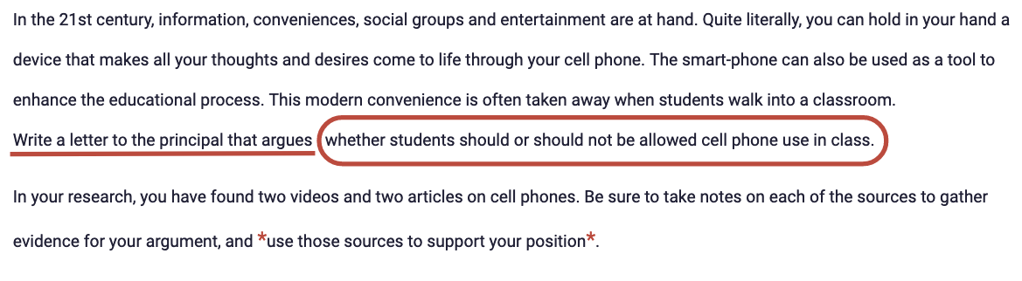Step 2: Claim Activity
Emerging: Students should be allowed to use cell phones in class.
Developing: Students should be allowed to use cell phones in class because it can help kids learn.
Proficient: Despite the dangers of cell phones in class, the benefits outweigh the downsides and should be allowed in class.
Advanced: While many are concerned about the inappropriate use of cell phones and the dangers of screen time, the appropriate and helpful uses of cell phones are greater than the risks and they should be allowed in class.

Screen Time

Step 1: Prompt Analysis

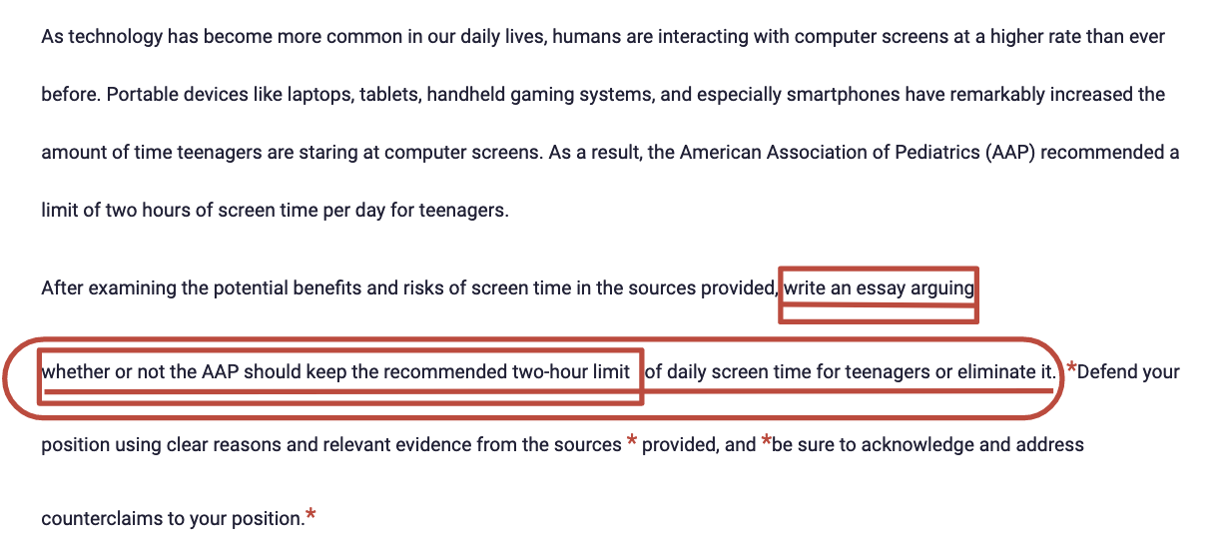

Step 2: Claim Activity
Emerging: The AAP should not keep the recommended daily screen time limit of two hours for teenagers.
Developing: The AAP should not keep the recommended daily screen time limit of two hours for teenagers because technology is how today’s teens socialize.
Proficient: On the one hand, screen time can be dangerous, as many of the sources pointed out. On the other hand, there are worthy reasons for extending screen time, so the AAP should keep the recommended daily screen time limit of two hours for teenagers, for social purposes, but for school or work, there should be different limits.
Advanced: While there are many good arguments for keeping the daily screen time limits for teens, during the pandemic, the AAP cannot possibly limit teens to two hours of screen time because teens have to do school on computers, and as a result, teens have no other way to socialize with their peers.

