Read the sample first draft of the introduction paragraph below, which responds to the writing prompt, “Do school uniform policies and dress codes violate students' rights and undermine important values?” Using the Revision Strategies: Language and Style handout, suggest revisions that would strengthen the writer’s achievement in the language and style domain.

Student Sample—First Draft

The debate about dress codes and uniforms are revisited each year it seems. because the issue is important to everyone . However, you never hear a discussion about why the whole issue of how one dresses is just lame in the first place. In “Freedom of Choice: The Very Best Policy,” the author claims that dress codes and uniform policies limit students’ rights to free speech, self-expression, and individuality. I think that’s just wrong. After a careful review of the text and the author’s claims, it is clear that school uniform policies and dress codes don’t violate students’ rights or undermine important values. In fact, students’ rights are protected.

The annotated paragraph below notes some areas where the writer can revise to improve the language and style.

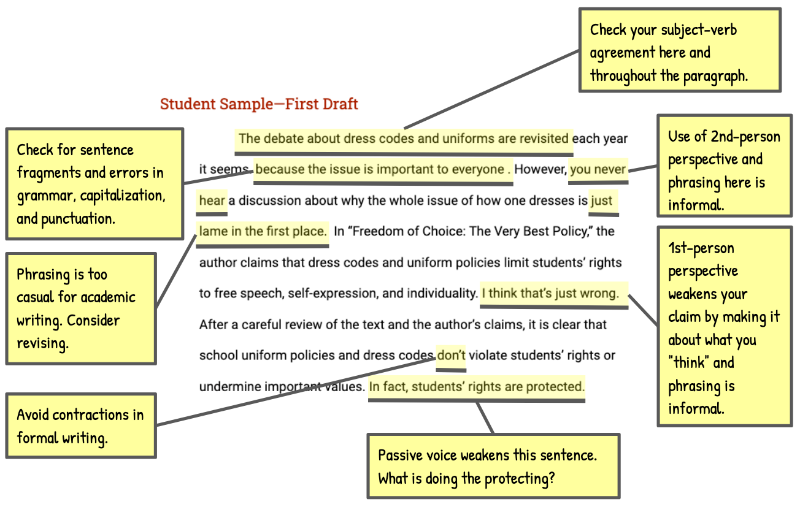

Vocabulary Supports
Argument—an attempt to persuade or convince others to accept an opinion or position on an issue
Claim—an arguable position on an issue
Counterclaim—a different position on an issue that opposes the writer’s claim
Evidence—details such as facts, statistics, or quotations that support the writer’s claim
Focus—the set of related ideas used by a writer to support an argument; an argument that lacks focus, presents unrelated ideas, or goes off topic
Prompt—the information and instructions students are responding to when writing an argument
Reason—a statement explaining why a writer takes a particular position in an argument
Reasoning—an explanation of how a reason and its supporting evidence connect to the claim

