Exemplar Lesson
Exploring Exemplars for Revising Language and Style
Lesson Plan (Minimum Time: One 45-Minute Session)

Lesson Summary
In this lesson, the teacher and students will analyze a sample first draft, sample feedback, and a sample revision of an argumentative essay. The teacher will model suggesting revision strategies, and students will participate in large and small group collaboration to suggest revisions. Students will then review the impact of revisions in a sample revision.

- Step 1: Set Purpose/Activate Prior Knowledge—Students will review Revision Strategies: Language and Style, and complete an initial analysis of the first draft of a sample argumentative essay.
- Step 2: I Do It/We Do It Together—Teacher will model analyzing language and style revision opportunities using the revision strategies sheet to select a good revision step, and then the whole class will collaborate to find additional steps to revise the argument.
- Step 3: You Do It Together—Students will apply additional revision strategies to suggest revisions or to revise essay, and will share work with small or large groups, explaining why the revisions have a positive impact on the essay.
- Step 4: I Do It/We Do It Together—Teacher will review an exemplar revision and discuss the impact of key revisions on the essay.
After completion of the lesson, students can use the revision strategies sheet along with feedback from signal checks and conferences to revise their essays for stronger language and style.

Objective
Students will understand and be able to apply revision strategies to improve proficiency in the language and style domain.

Engagement Strategies
- Pair and Share: Students will work with a partner and collaborate through discussion. See Remote Engagement: Pair and Share.
- Collaborating to Determine Revisions: Students will work in pairs or small groups to find and evaluate opportunities to apply Revision Strategies. See Remote Engagement: Small Groups.
Links to information for remote learning are also provided in the lesson steps below.

Scaffolding Strategies
The scaffolding strategies listed below are optional supports included in the lesson’s activities. These tools may be used or ignored based on students’ needs.
- Vocabulary Supports: Students can use vocabulary supports for comprehension.
- Revision Strategies Sheet: Students can utilize revision strategies to look for ways to improve in this domain. See Revision Strategies: Language and Style for a printable handout of strategies needed for this lesson.

Remote Learning Strategies
With careful advanced planning, Topeka lessons can be easily moved to a remote modality. Links to specific engagement strategies are included throughout this lesson plan. See Topeka’s professional learning resource Remote Learning with Topeka for additional suggestions for each stage of the typical Topeka lesson.

Key Vocabulary
- Audience
- Formal
- Informal

Materials
- Presentation: Introducing Exemplars: Language and Style
- Revision Strategies Sheet: Language and Style
- Language and Style Exemplar: Before Revision
- Language and Style Exemplar: After Revision
- Conferencing Form

Standards Addressed in this Lesson
- Develop and strengthen writing as needed by planning, revising, editing, rewriting, or trying a new approach. (CCSS.ELA-LITERACY.CCRA.W.5)
- Write arguments to support claims in an analysis of substantive topics or texts using valid reasoning and relevant and sufficient evidence. (CCSS.ELA-LITERACY.CCRA.W.1)
- Produce clear and coherent writing in which the development, organization, and style are appropriate to task, purpose, and audience. (CCSS.ELA-LITERACY.CCRA.W.4)

Lesson Steps

Step 1: Set Purpose/Activate Prior Knowledge

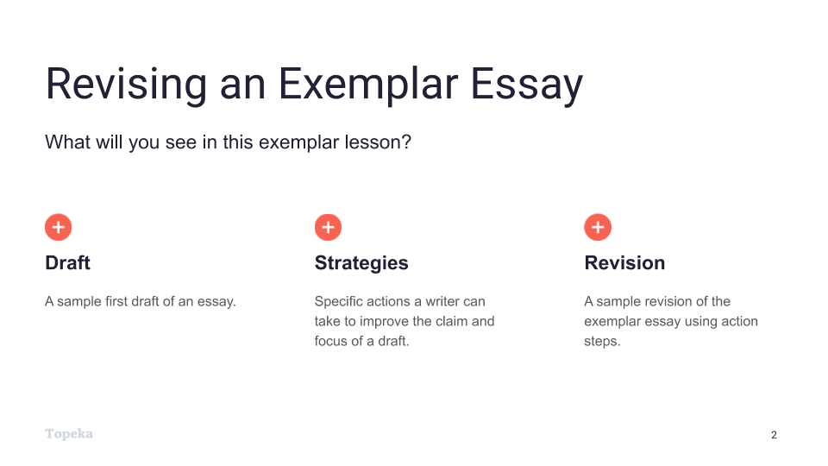
Slide 2
Teacher | Students
Teacher will set the purpose for the lesson by describing what students will encounter.  In this lesson, we’re going to look at the process of revising an essay to improve performance in the language and style domain.  First, we will look at a sample first draft alongside the revision strategies for this domain. You will use the strategies sheet to make suggestions for improving the sample first draft.  Then, we’ll look together at specific revision steps a teacher suggested for this essay, and we’ll try to implement those steps for the sample essay.  Finally, we’ll see a sample revision to see how the writer used those specific action steps to improve the language and style of the draft. | Students listen and take notes.  .

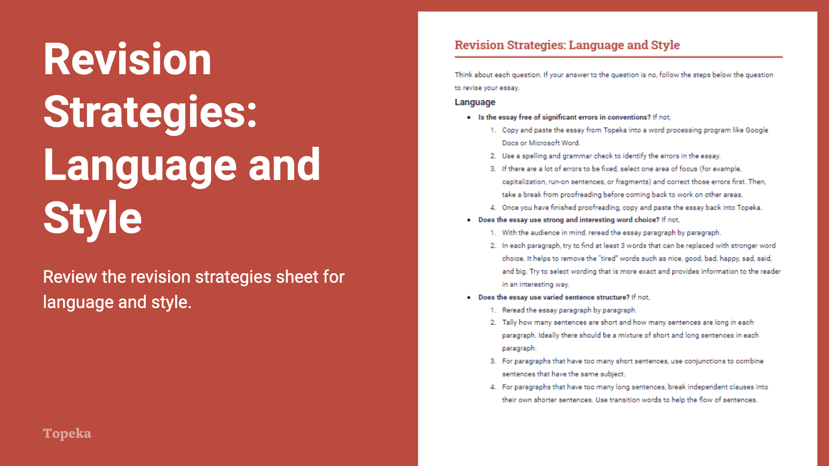
Slide 3
Teacher | Students
Teacher distributes Revision Strategies: Language and Style.  Take a moment to review the revision strategies for language and style. Think back to what you know about language and style—why you should consider your audience, and why it’s important to use formal style in academic writing.  Teacher has students Pair and Share with a classmate to confirm their understanding of what language and style means and how it is evaluated.  (For information on implementing Pair and Share via remote learning, see Remote Engagement: Pair and Share or the guide to Remote Learning with Topeka.) | Students refresh their memories of strong language and style by reviewing and discussing the revision strategies sheet.
Teacher distributes the handout Language and Style Exemplar: Before Revision. Teacher directs students to look at the first page.  Here is an example of a student writing about school uniforms. The question the student is answering is whether or not uniforms and dress codes violate students' rights and undermine important values.  Using the revision strategies for language and style, suggest revisions that would strengthen the writer’s achievement in the language and style domain. Annotate the draft to show your suggestions and your explanation. | Students use the “before” exemplar essay and the revision strategies sheet to suggest ways for the writer to improve the essay.
When students complete the review, teacher has students partner with others to compare the suggested changes. Have students explain their suggestions.  How do these changes increase student achievement on the language and style section of the rubric? Why do you think the revised essay will be better?  (For information on implementing Pair and Share via remote learning, see Remote Engagement: Pair and Share or the guide to Remote Learning with Topeka.) | Students partner to share their suggestions for revisions and their explanations for how these revisions would improve language and style in the essay.

Step 2: I Do It/We Do It Together
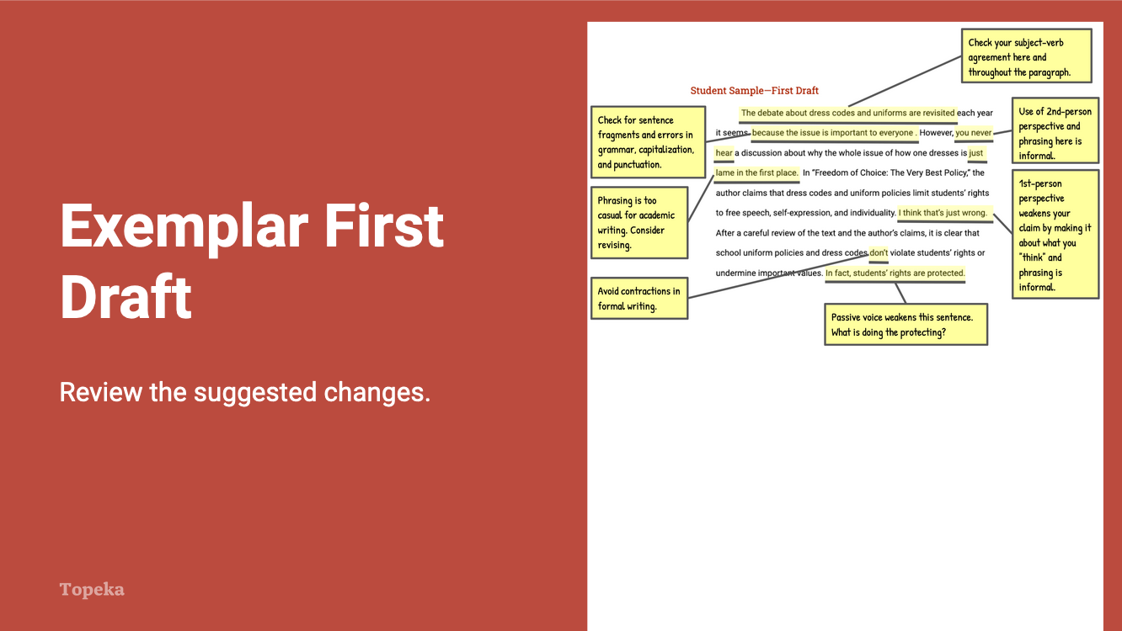
Slide 4
Teacher | Students
Teacher directs students to the second page of the Language and Style Exemplar: Before Revision handout and explains the annotations.  After reviewing this piece of writing, I can see that there is an introduction to an argument, and I can make out the writer’s claim and position on the issue. However, there are problems with the language and style elements of the paragraph that get in the way of what the writer is trying to argue.  If I look at the revision strategies sheet, I can see that the language and style rubric domain can be broken down into two traits: one is language and the other is style.  I’m going to ask myself some of these questions to get ideas for how to revise my essay. “Does the essay use strong and interesting word choice?” The essay can be revised by looking at choices of words and phrasing.  “Is the essay formal and appropriate for the goals of argumentative writing?” The language and style can be improved by maintaining a consistent, formal style and perspective.  “Is the essay free of significant errors in conventions?” Errors in conventions can make essays hard to read. This essay can be improved by correcting errors in conventions (that is, those things that are right or wrong according to the rules of the English language and grammar).  For example, in the very first sentence is a subject-verb agreement error: it should be, ”the debate...is revisited,” not “the debate...are revisited.” So right away, I’m questioning the authority of the writer and the argument that will follow. | Students listen and take notes as appropriate.
Using the annotated first draft, teacher reviews the suggested changes, asks students to evaluate their impact, and also answers questions related to the domain’s evaluation criteria.  Do you think these suggestions will help improve language and style? Where else do you think the writer can strengthen the essay’s language or style? | Students listen, take notes, and participate as appropriate.

Step 3: You Do It Together

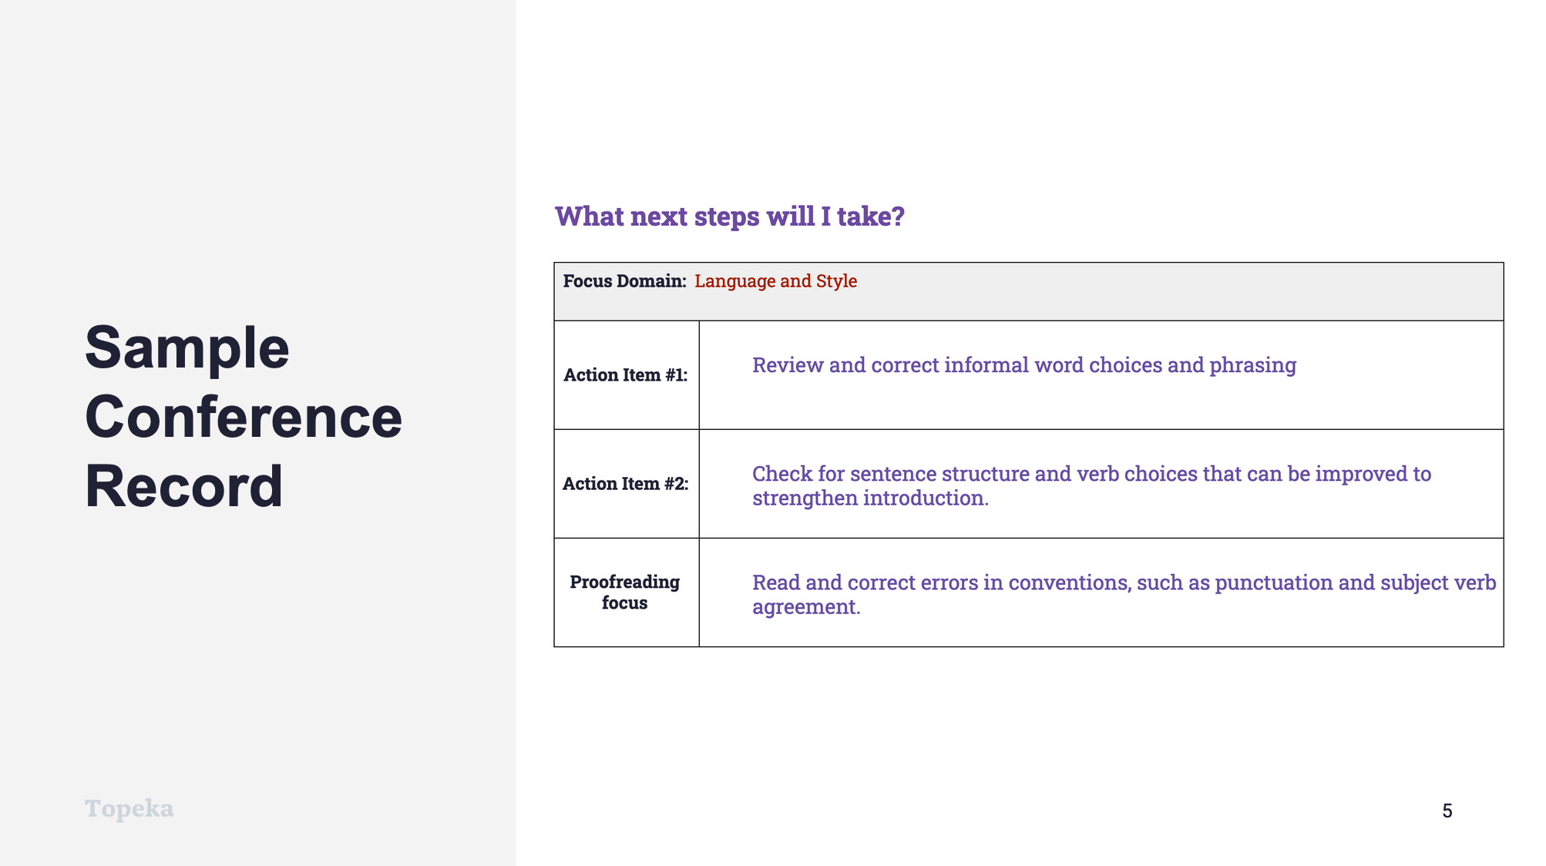
Slide 5
Teacher | Student
Teacher describes how a conference record is used to convey suggested revisions.  Here is an example of a conference record conveying some of the strategies the teacher suggested in the annotations.  Teacher continues:  In the top row, we see that the writer is going to concentrate on improving language and style. Let’s look at again at the revision steps provided to this writer.  The first strategy is to review and correct informal word choices and phrasing. As we saw, there are a number of corrections that can be made following this instruction.  In Step 2, the action item is to review verb choices and sentence structures to strengthen the paragraph. So this is less about correcting errors and more about making style choices that appeal to the audience.  The proofreading focus is to correct errors in conventions, such as punctuation and subject-verb agreement. We saw some errors in conventions as well.  Teacher directs students to work in small or large groups to review the recommendations and discuss the impact of these revisions. If time allows, students can implement the suggested revisions.  (For information on implementing Small Group Collaboration via remote learning, see Remote Engagement: Small Groups or the guide to Remote Learning with Topeka.) | Students listen and take notes.

Step 4: I Do It/We Do It Together

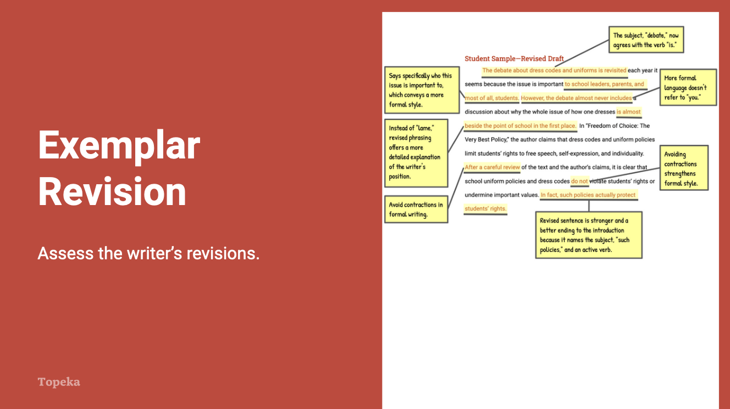
Slide 6
Teacher | Student
Teacher distributes the Language and Style Exemplar: After Revision and directs students’ attention to the first page of the revised essay.  In this revised draft, the writer has responded to the action steps the teacher presented in the conference form. This draft models all three possible revisions so you can see how each could be addressed. Review these revisions to see if you understand their impact. Follow the instructions on the handout. | Students examine the highlighted revision on unannotated revised essay and note why each revision had a positive impact on the essay.
Teacher directs students to turn attention to the revised essay. Teacher thinks aloud to describe impact of revisions.  What do you notice about the differences in this text based on the highlighted sentences? How have these changes strengthened the essay’s language and style?  Let’s look at the very first sentence. Here, the writer has made changes in a couple of ways. The writer combined the first sentence and the sentence fragment that followed it into a single sentence, then corrected errors in conventions, and clarified who “everybody” is. Now this first sentence is a strong opening to the paragraph and establishes the writer’s credibility.  Teacher continues to describe revisions using annotations on the revised sample. | Students listen and take notes.
Teacher concludes by reminding students to apply revision strategies to their own essays.  When you’re revising your essay, remember to use these helpful revision strategies to take your essay to the next level. | Students listen and take notes.

For more information about modeling student revisions and growth, see the Topeka guide to Supporting Revision with Effective Feedback.

