Read the sample first draft below, which responds to the writing prompt, “Do school uniform policies and dress codes violate students' rights and undermine important values?” Using the Revision Strategies: Organization, suggest revisions that would strengthen the writer’s achievement in the organization domain.

Student Sample—First Draft

In “Freedom of Choice: The Very Best Policy,” the author claims that dress codes and uniform policies limit students’ rights to free speech, self-expression, and individuality. After a careful review of the text and the author’s claims, it is clear that school uniform policies and dress codes do not violate students’ rights or undermine important values.
School uniform policies and dress codes do not violate students’ rights and undermine important values because clothes are not the only way that a person can express free speech or individuality. Again the author of this text uses faulty logic and writes, “It's as if we are purposefully being trained to dress alike, think alike, and act alike. But isn't this still a diverse world we live in? To me, the inevitable result of dress codes and uniforms is a student body trained to celebrate conformity and rules as opposed to individuality and innovation. It seems like a contradiction to me. Day in and day out, I hear what a multicultural world we live in. I hear that we must celebrate our differences. Yet it strikes me that the real message of a uniform or dress code policy is ‘celebrate sameness.’" This shows that the author of this text has a narrow view about what constitutes diversity and confines individuality and self-expression to what a person wears, rather than also considering a person’s thoughts, values, ethnicity, or experiences.
School uniform policies and dress codes do not violate students’ rights and undermine important values because they promote good judgment and consideration for oneself and others. The author of this text uses faulty logic to discredit how uniform and dress code policies empower students’ rights and promote important values. Firstly, the text minimizes the sensibility or need for clothing that does not offend others. Secondly, the author claims that uniforms and dress codes stunt self-expression without distinguishing that dress codes promote individual expression with consideration of respect and appropriateness. In the text the author writes, “I know that some people argue that dress codes and uniforms help to foster a more ‘respectful’ school atmosphere by defining ‘appropriate’ clothing choices. But what do those words really mean? How does wearing the same color pants actually help build a more cohesive community?” The example that the author uses about same colored pants equates dress codes and uniforms as the same practice and irrationally asks the audience to reconsider the usefulness of appropriateness and respect without specifically addressing why the terms are not relevant to clothing in school settings.
Despite the fact that school uniforms and dress codes do restrict students’ choices to express themselves through their clothing, these policies also can prepare students for professional or industry-specific fields where certain types of clothes are needed to perform tasks, show unity as a company, or distinguish a business from a competitor. Additionally, students can express themselves through their ideas in the classroom and their contributions to their peers and school community, all of which have nothing to do with the clothes that are on their bodies.

The annotated essay below notes some areas where the writer can revise to improve the organization.

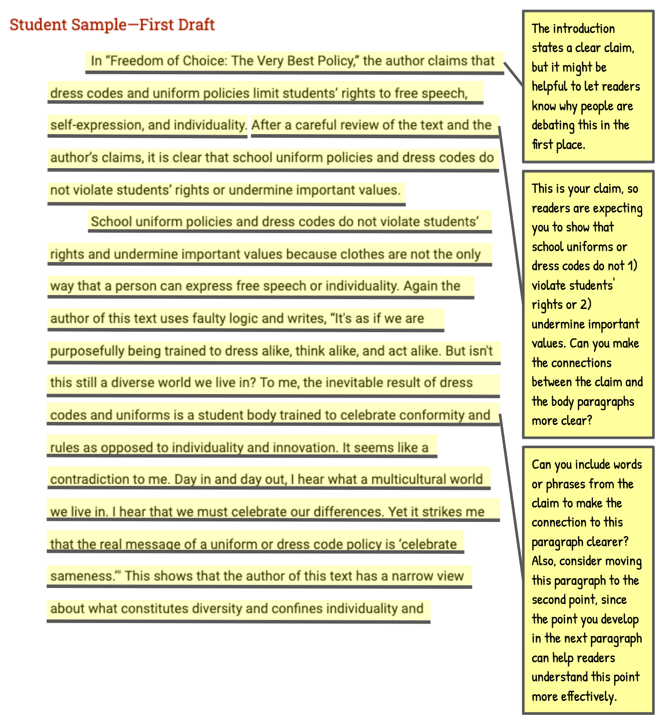

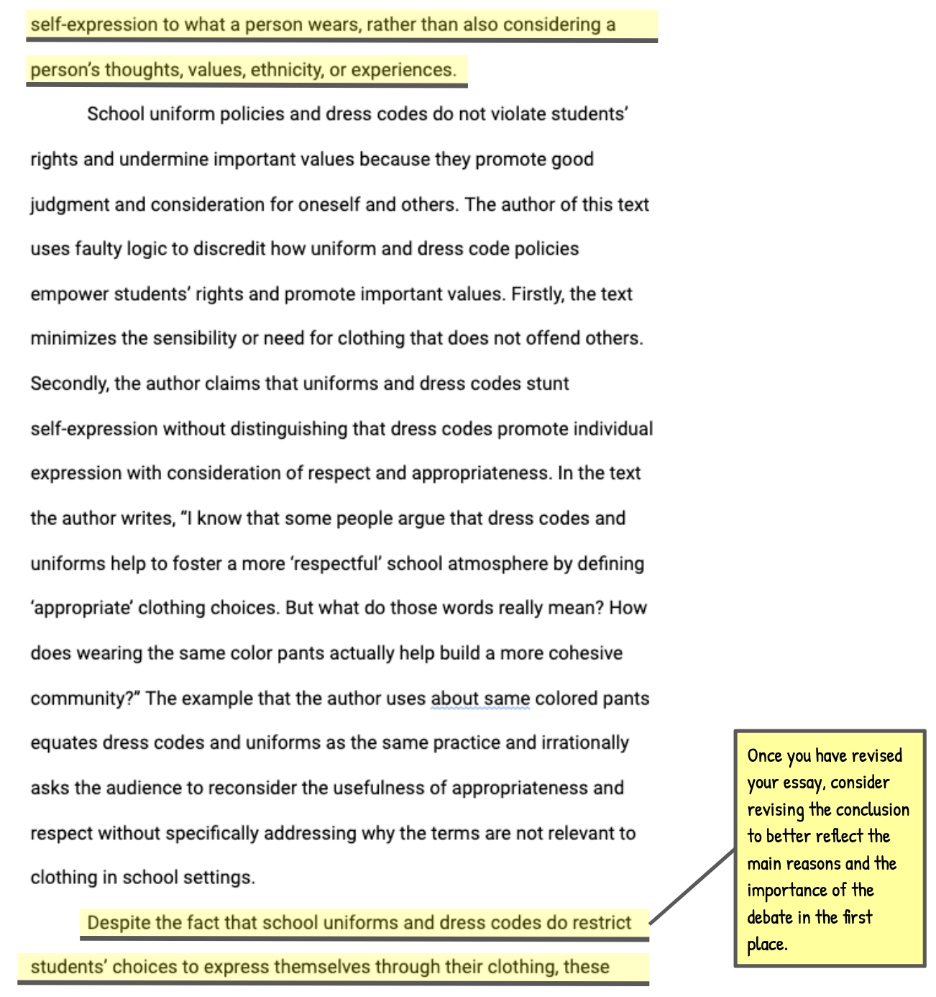
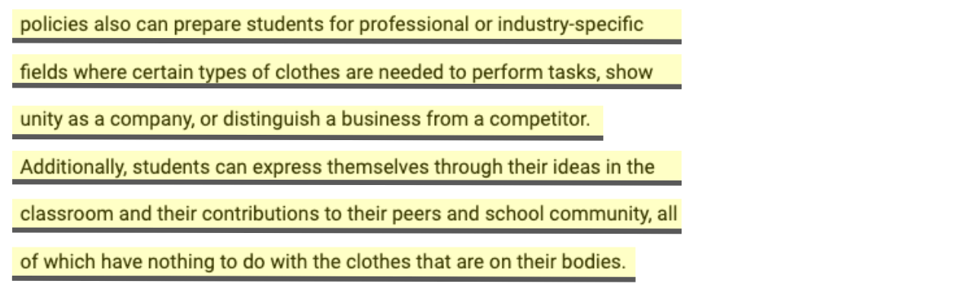

Vocabulary Supports
Argument—an attempt to persuade or convince others to accept an opinion or position on an issue
Claim—an arguable position on an issue
Counterclaim—a different position on an issue that opposes the writer’s claim
Evidence—details such as facts, statistics, or quotations that support the writer’s claim
Focus—the set of related ideas used by a writer to support an argument; an argument that lacks focus, presents unrelated ideas, or goes off topic
Prompt—the information and instructions students are responding to when writing an argument
Reason—a statement explaining why a writer takes a particular position in an argument
Reasoning—an explanation of how a reason and its supporting evidence connect to the claim

