Exemplar Lesson
Exploring Exemplars for Revising Organization
Lesson Plan (Minimum Time: One 45-Minute Session)

Lesson Summary
In this lesson, the teacher and students will analyze a sample first draft, sample feedback, and a sample revision of an argumentative essay. The Teacher will model suggesting revision strategies, and students will participate in large and small group collaboration to suggest revisions. Students will then review the impact of revisions in a sample revision.

- Step 1: Set Purpose/Activate Prior Knowledge—Students will review Revision Strategies: Organization, and complete an initial analysis of the first draft of a sample argumentative essay.
- Step 2: I Do It/We Do It Together—Teacher will model analyzing organization revision opportunities using the revision strategies sheet to select a good revision step, and then the whole class will collaborate to find additional steps to revise the argument.
- Step 3: You Do It Together—Students will apply additional revision strategies to suggest revisions or to revise the essay, and will share work with small or large groups, explaining why the revisions have a positive impact on the essay.
- Step 4: I Do It/We Do It Together—Teacher will review an exemplar revision and discuss the impact of key revisions on the essay.
After completion of the lesson, students can use the revision strategies sheet along with feedback from signal checks and conferences to revise their essays for stronger organization.

Objective
Students will understand and be able to apply revision strategies to improve proficiency in the organization domain.

Engagement Strategies
- Pair and Share: Students will work with a partner and collaborate through discussion. See Remote Engagement: Pair and Share.
- Collaborating to Determine Revisions: Students will work in pairs or small groups to find and evaluate opportunities to apply Revision Strategies. See Remote Engagement: Small Groups.
Links to information for remote learning are also provided in the lesson steps below.

Scaffolding Strategies
The scaffolding strategies listed below are optional supports included in the lesson’s activities. These tools may be used or ignored based on students’ needs.
- Vocabulary Supports: Students can use vocabulary supports for comprehension.
- Revision Strategies Sheet: Students can utilize revision strategies to look for ways to improve in this domain. See Revision Strategies: Organization for a printable handout of strategies needed for this lesson.

Remote Learning Strategies
With careful advanced planning, Topeka lessons can be easily moved to a remote modality. Links to specific engagement strategies are included throughout this lesson plan. See Topeka’s professional learning resource Remote Learning with Topeka for additional suggestions for each stage of the typical Topeka lesson.

Key Vocabulary
- Introduction
- Body
- Conclusion
- Claim
- Reasons
- Evidence
- Reasoning

Materials
- Presentation: Introducing Exemplars: Organization
- Revision Strategies: Organization
- Organization Exemplar: Before Revision
- Organization Exemplar: After Revision
- Conferencing Form

Standards Addressed in this Lesson
- Develop and strengthen writing as needed by planning, revising, editing, rewriting, or trying a new approach. (CCSS.ELA-LITERACY.CCRA.W.5)
- Write arguments to support claims in an analysis of substantive topics or texts using valid reasoning and relevant and sufficient evidence. (CCSS.ELA-LITERACY.CCRA.W.1)
- Produce clear and coherent writing in which the development, organization, and style are appropriate to task, purpose, and audience. (CCSS.ELA-LITERACY.CCRA.W.4)

Lesson Steps

Step 1: Set Purpose/Activate Prior Knowledge

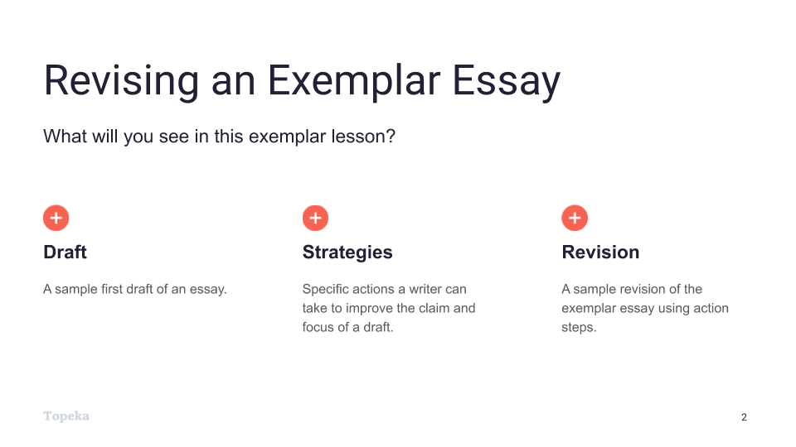
Slide 2
Teacher | Students
Teacher will set the purpose for the lesson by describing what students will encounter.  In this lesson, we’re going to look at the process of revising an essay to improve performance in the organization domain.  First, we will look at a sample first draft alongside the revision strategies for this domain. You will use the strategies sheet to make suggestions for improving the sample first draft.  Then, we’ll look together at specific revision steps a teacher suggested for this essay, and we’ll try to implement those steps for the sample essay.  Finally, we’ll see a sample revision to see how the writer used those specific action steps to improve the organization of the draft. | Students listen and take notes.  .

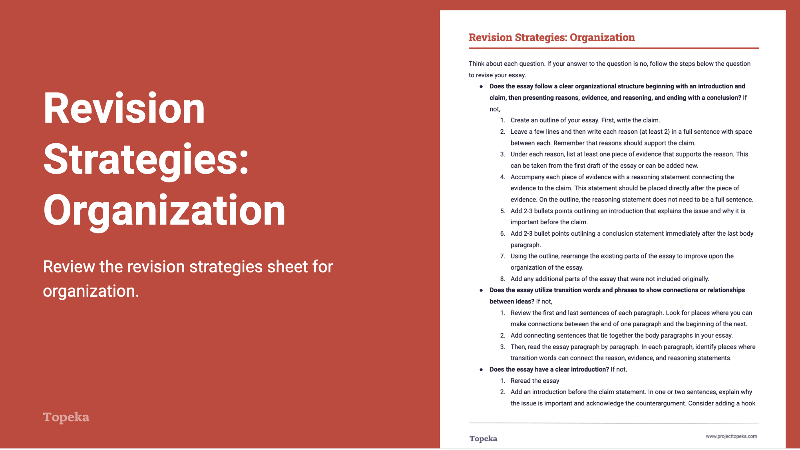
Slide 3
Teacher | Students
Teacher distributes Revision Strategies: Organization.  Take a moment to review the revision strategy sheet for organization. Think back to what you know about organization—how strong arguments are organized.  Teacher has students Pair and Share with a classmate to confirm their understanding of what organization means and how it is evaluated.  (For information on implementing Pair and Share via remote learning, see Remote Engagement: Pair and Share or the guide to Remote Learning with Topeka.) | Students refresh their memories of strong organization by reviewing and discussing the revision strategies sheet.
Teacher distributes the handout Organization Exemplar: Before Revision. Teacher directs students to look at the first page.  Here is an example of a student writing about school uniforms. The question the student is answering is whether or not school uniform policies and dress codes violate students' rights and undermine important values.  Using the revision strategies for organization, suggest revisions that would strengthen the writer’s achievement in the organization domain. Annotate the draft to show your suggestions and your explanation. | Students use the “before” exemplar essay and the revision strategies sheet to suggest ways for the writer to improve the essay.
When students complete the review, teacher has students partner with others to compare the suggested changes. Have students explain their suggestions:  How do these changes increase student achievement on the organization section of the rubric? Why do you think the revised essay will be better?  (For information on implementing Pair and Share via remote learning, see Remote Engagement: Pair and Share or the guide to Remote Learning with Topeka.) | Students partner to share their suggestions for revisions and their explanations for how these revisions would improve organization in the essay.

Step 2: I Do It/We Do It Together
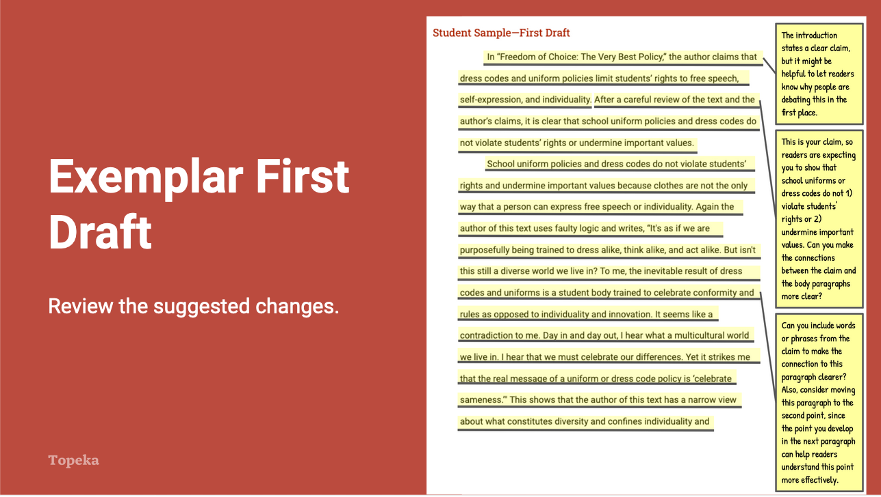
Slide 4
Teacher | Students
Teacher directs students to the second page of the Organization Exemplar: Before Revision handout and explains the annotations.  After reviewing this piece of writing, I can see that there is a basic organization structure to this essay, but the introduction and conclusion could be improved to provide better framing of the body paragraphs, and the progression of reasons in the body paragraphs could be stronger.  If I look at the revision strategies sheet, I can use questions to help me identify revision strategies. “Does the essay follow a clear organizational structure beginning with an introduction and claim, then presenting reasons, evidence, and reasoning, and ending with a conclusion?” I can see that creating or revisiting an outline with the parts of the essay can help make the organization clear and easier to evaluate. Once I see the structure, I can make sure the progression is as strong as it can be.  “Does the essay have a clear introduction?” “Does the essay have a clear conclusion?” Looking at the essay, I notice that the first paragraph is the introduction and the last paragraph is the conclusion. Both paragraphs could be improved.  In between are two body paragraphs. Another question I can ask myself is “Is the order of the evidence and reason paragraphs based on the strength of the arguments?” Looking at the outline, I see that the first body paragraph provides the reason that clothes aren’t the only way for students to express themselves, and the second paragraph is about uniforms and dress codes promoting good judgement and consideration of others. I think changing the order could strengthen the essay. | Students listen and take notes as appropriate.
Using the annotated first draft, teacher will continue to review the suggested changes, ask students to evaluate their impact, and also answer questions related to the domain’s evaluation criteria.  Do you think these suggestions will help improve organization? Where else do you think the writer could improve the organization? What other suggestions do you think would help this essay and why would these changes improve the organization? | Students listen, take notes, and participate as appropriate.

Step 3: You Do It Together

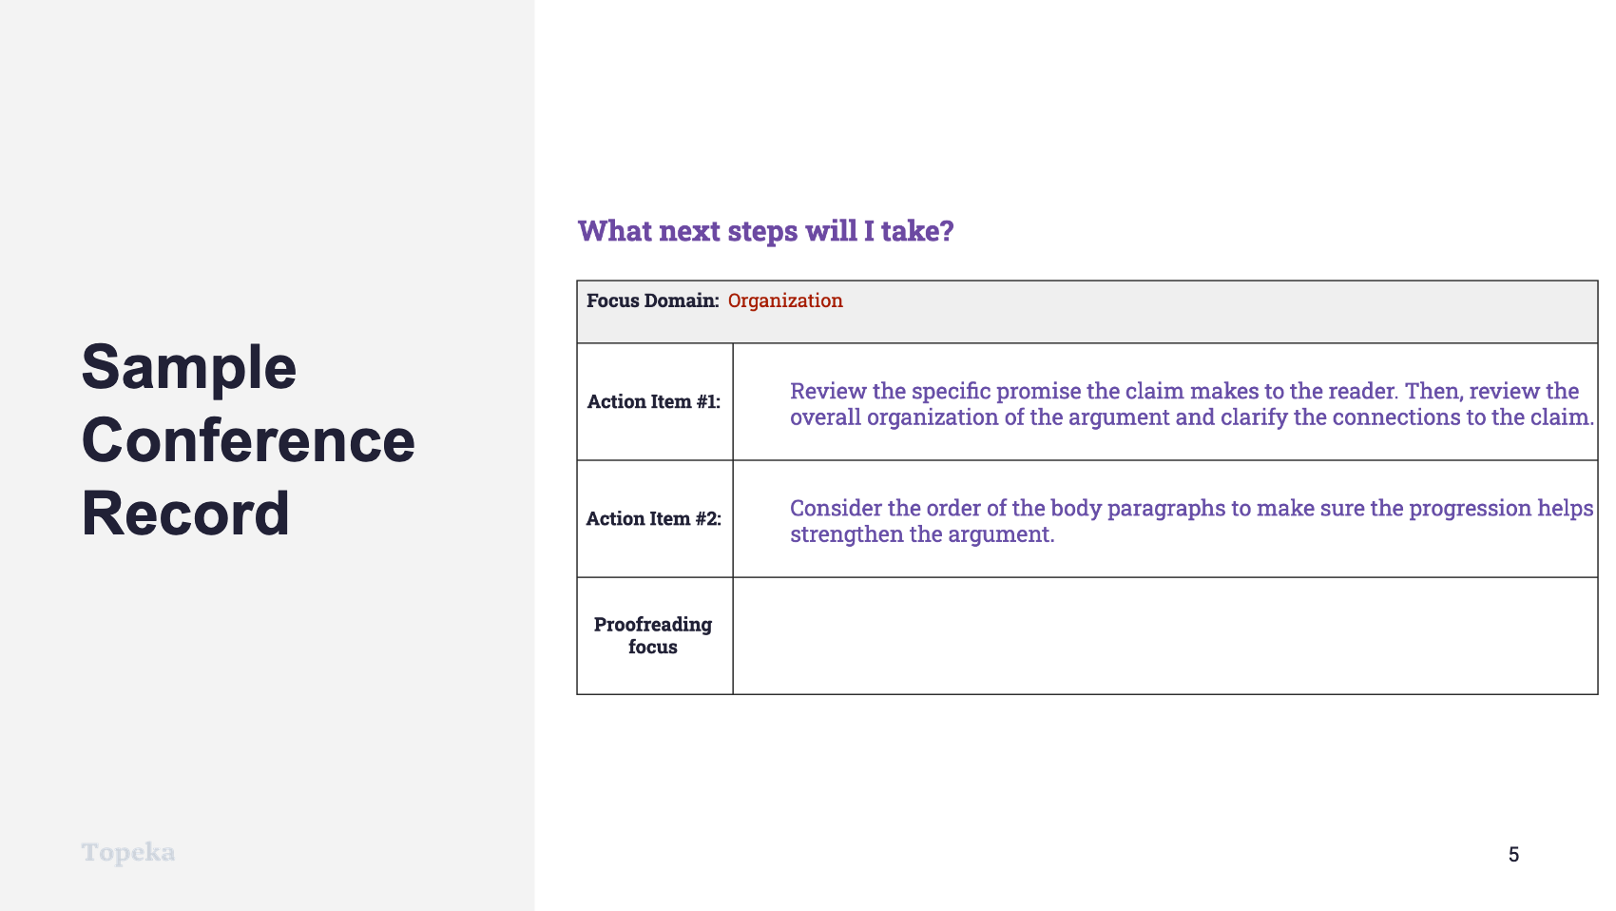
Slide 5
Teacher | Student
Teacher describes how a conference record is used to convey suggested revisions:  Here is an example of a conference record conveying the same strategies the teacher suggested in the annotations.  Teacher continues:  In the top row, we see that the writer is going to concentrate on the organization of the essay. Let’s look at again at the revision steps provided to this writer.  The first step is to review the claim and the overall organization to make sure everything is connected.  The second step is to consider the order of the reason paragraphs to make sure the progression is strong—in other words, that the order helps the argument.  Another possible revision is to develop the introduction and conclusion further to show why the issue is important. Developing these parts of the essay will make their purpose in the structure of the essay clearer to readers.  Which two would you choose to focus on?  Teacher directs students to work in small or large groups to review the recommendations and discuss the impact of these revisions. If time allows, students can implement the suggested revisions.  (For information on implementing Small Group Collaboration via remote learning, see Remote Engagement: Small Groups or the guide to Remote Learning with Topeka.) | Students listen and take notes.

Step 4: I Do It/We Do It Together
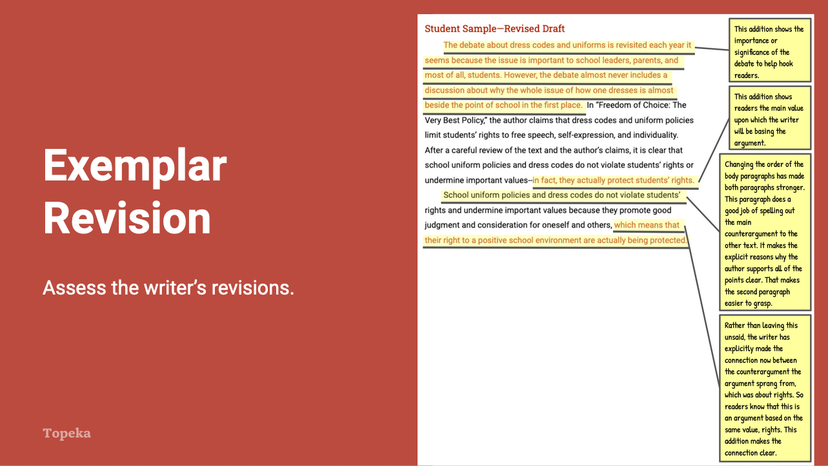
Slide 6
Teacher | Student
Teacher distributes the Organization Exemplar: After Revision and directs students’ attention to the first page of the revised essay.  In this revised draft, the writer has responded to the action steps the teacher presented in the conference form. This draft models all three possible revisions so you can see how each could be addressed. Review these revisions to see if you understand their impact. Follow the instructions on the handout.  Teacher allows students time to read revised essay and react to the revisions. | Students examine the highlighted revision on unannotated revised essay and note why each revision had a positive impact on the essay.
Teacher directs students to turn attention to the revised essay. Teacher thinks aloud to describe impact of revisions.  What do you notice about the differences in this text based on the highlighted sentences? How have these changes strengthened the essay’s organization?  If you read the sentences highlighted in red, you will see the changes the writer made in response to the teacher’s annotations and action steps. For example, in the introduction, the addition of two sentences introduces the issue that the essay is going to discuss, which flows nicely into the sentence presenting the argument of the source text, which then flows nicely into the writer’s own claim. This is now clearly an introduction that will help structure the rest of the argument.  Similarly, by changing the order of the reason paragraphs in the body and adding additional language to connect the reasons back to the claim, the writer has strengthened both of those support paragraphs. | Students listen and take notes.
Teacher concludes by reminding students to apply revision strategies to their own essays.  When you’re revising your essay, remember to use these helpful revision strategies to take your essay to the next level. | Students listen and take notes.

For more information about modeling student revisions and growth, see the Topeka guide to Supporting Revision with Effective Feedback.

