Read the sample first draft below, which responds to the writing prompt, “Do dress codes create a more positive school environment than uniforms or no policy at all? ” Using the Revision Strategies Sheet: Support and Evidence, suggest revisions that would strengthen the writer’s achievement in the support and evidence domain.

Student Sample—First Draft

“Uniform or Dress Code: There’s a Difference” explores the benefits of having a school dress code policy compared to having school uniforms or having no policy at all. According to the text, a dress code can be defined as “a set of guidelines about what you can't wear. A uniform is a set of hard-and-fast rules about what you must wear.” Dress codes create a more positive school environment than uniforms or no policy at all.
Dress codes create a more positive school environment than no policy at all because they create a safe and positive environment for students. In the article the author writes, “...which asks students to follow a few simple rules. These include avoiding any clothing printed with profanity or hateful language...Who needs to see bad language or racist comments coming through the halls? Any gang-related clothing is also prohibited. In many parts of the country, kids have been beaten up or even killed over gang colors or symbols. Both boys' and girls' pants must fit well enough that they aren't falling down, or ‘sagging.’ Visible underwear, strapless shirts or dresses, and anything with a very low-cut neckline are not allowed.”
Dress codes create a more positive school environment because they allow students to have more choices and self-expression.
While it is easier to enforce either having no dress code or having uniforms, dress codes create consistent opportunities to improve decision-making skills related to appropriateness and consideration of others. The critical thinking and learning that come from decisions related to a dress code can be transferred to other important situations in people’s lives.

The annotated essay below notes some areas where the writer can revise to improve the support and evidence.
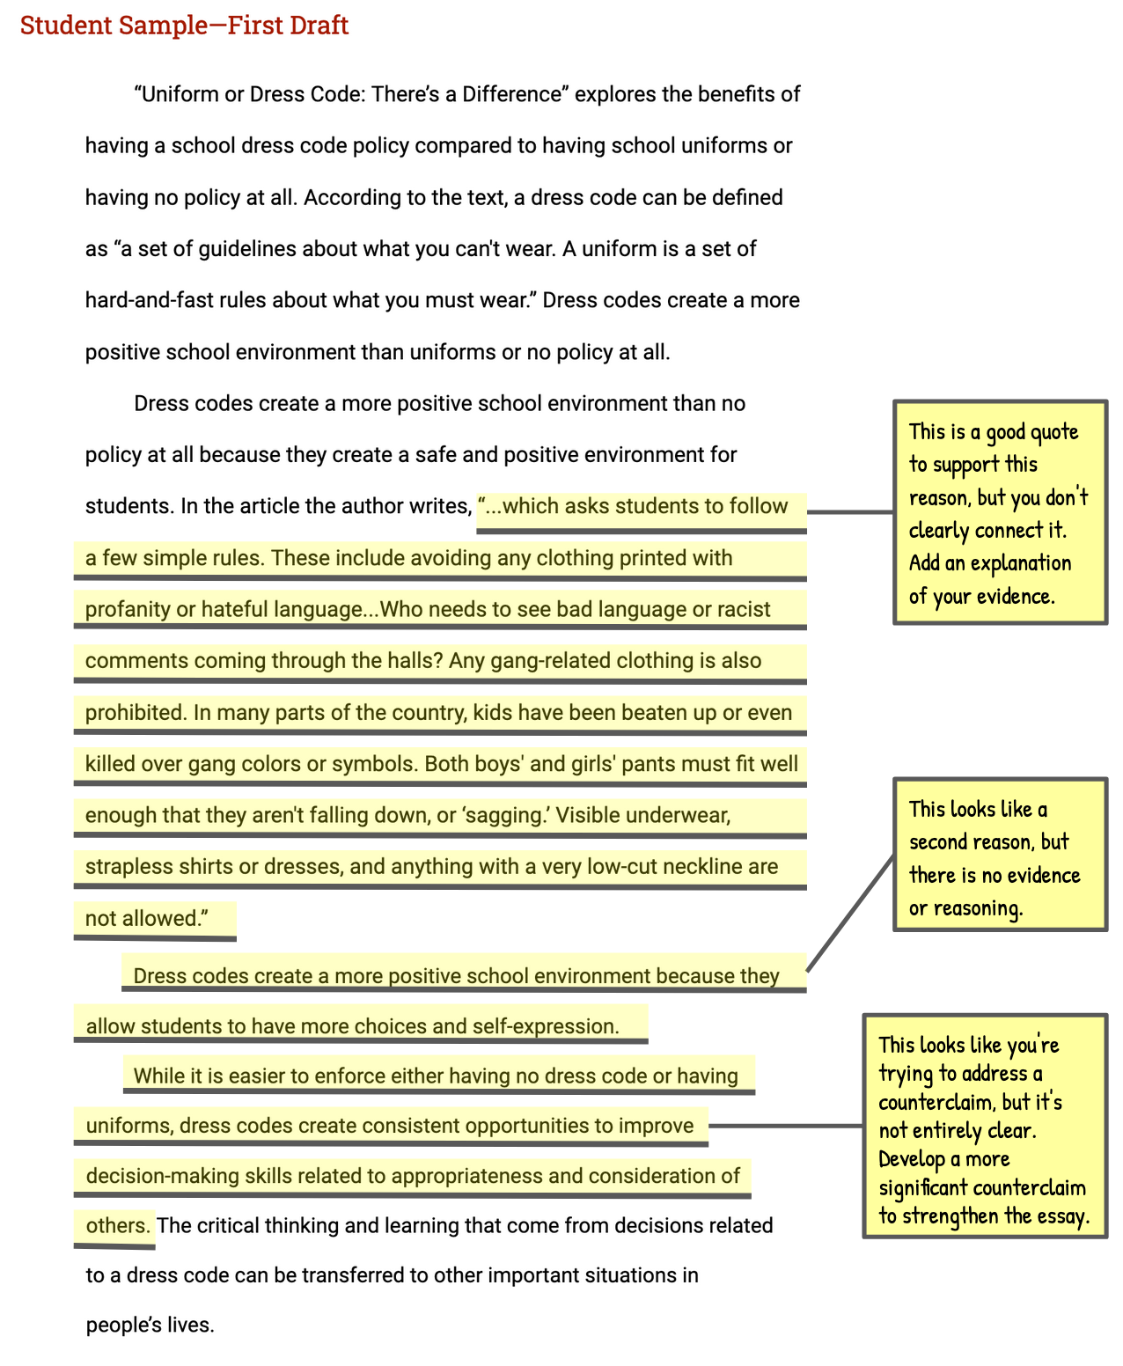
Vocabulary Supports
Argument—an attempt to persuade or convince others to accept an opinion or position on an issue
Claim—an arguable position on an issue
Counterclaim—a different position on an issue that opposes the writer’s claim
Evidence—details such as facts, statistics, or quotations that support the writer’s claim
Focus—the set of related ideas used by a writer to support an argument; an argument that lacks focus, presents unrelated ideas, or goes off topic
Prompt—the information and instructions students are responding to when writing an argument
Reason—a statement explaining why a writer takes a particular position in an argument
Reasoning—an explanation of how a reason and its supporting evidence connect to the claim

