Exemplar Lesson
Exploring Exemplars for Revising Support and Evidence
Lesson Plan (Minimum Time: One 45-Minute Session)

Lesson Summary
In this lesson, the teacher and students will analyze a sample first draft, sample feedback, and a sample revision of an argumentative essay. The teacher will model suggesting revision strategies, and students will participate in large and small group collaboration to suggest revisions. Students will then review the impact of revisions in a sample revision.

- Step 1: Set Purpose/Activate Prior Knowledge—Students will review the Revision Strategies Sheet for Support and Evidence, and complete an initial analysis of the first draft of a sample argumentative essay.
- Step 2: I Do It/We Do It Together—Teacher will model analyzing support and evidence revision opportunities using the revision strategies sheets to select a good revision step, and then the whole class will collaborate to find additional steps to revise the argument.
- Step 3: You Do It Together—Students will apply additional revision strategies to suggest revisions or to revise the essay, and will share work with small or large groups, explaining why the revisions have a positive impact on the essay.
- Step 4: I Do It/We Do It Together—Teacher will review an exemplar revision and discuss the impact of key revisions on the essay.
After completion of the lesson, students can use the revision strategies sheets along with feedback from signal checks and conferences to revise their essays for stronger support and evidence.

Objective
Students will understand and be able to apply revision strategies to improve proficiency in the support and evidence domain.

Engagement Strategies
- Pair and Share: Students will work with a partner and collaborate through discussion. See Remote Engagement: Pair and Share.
- Collaborating to Determine Revisions: Students will work in pairs or small groups to find and evaluate opportunities to apply Revision Strategies. See Remote Engagement: Small Groups.
Links to information for remote learning are also provided in the lesson steps below.

Scaffolding Strategies
The scaffolding strategies listed below are optional supports included in the lesson’s activities. These tools may be used or ignored based on students’ needs.
- Vocabulary Supports: Students can use vocabulary supports for comprehension.
- Revision Strategies Sheets: Students can utilize revision strategies sheets to look for ways to improve in this domain. See Revision Strategies: Support and Evidence for a printable handout of strategies needed for this lesson.

Remote Learning Strategies
With careful advanced planning, Topeka lessons can be easily moved to a remote modality. Links to specific engagement strategies are included throughout this lesson plan. See Topeka’s professional learning resource Remote Learning with Topeka for additional suggestions for each stage of the typical Topeka lesson.

Key Vocabulary
- Claim
- Reasons
- Evidence
- Reasoning
- Counterargument

Materials
- Presentation: Introducing Exemplars: Support and Evidence
- Revision Strategies Sheet: Support and Evidence
- Support and Evidence Exemplar: Before Revision
- Support and Evidence Exemplar: After Revision
- Conferencing Form

Standards Addressed in this Lesson
- Develop and strengthen writing as needed by planning, revising, editing, rewriting, or trying a new approach. (CCSS.ELA-LITERACY.CCRA.W.5)
- Write arguments to support claims in an analysis of substantive topics or texts using valid reasoning and relevant and sufficient evidence. (CCSS.ELA-LITERACY.CCRA.W.1)
- Produce clear and coherent writing in which the development, organization, and style are appropriate to task, purpose, and audience. (CCSS.ELA-LITERACY.CCRA.W.4)

Lesson Steps

Step 1: Set Purpose/Activate Prior Knowledge

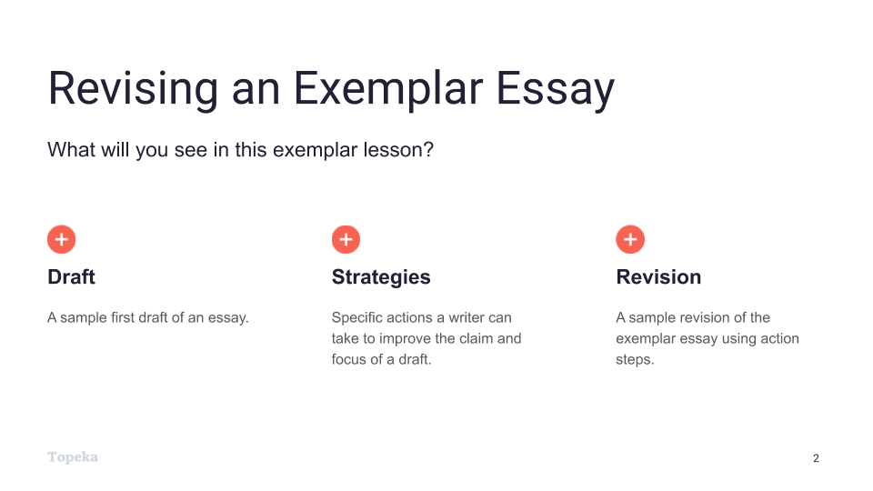
Slide 2
Teacher | Students
Teacher will set a purpose for the lesson by describing what students will encounter.  In this lesson, we’re going to look at the process of revising an essay to improve performance in the support and evidence domain.  First, we will look at a sample first draft alongside the revision strategies for this domain. You will use the strategies sheet to make suggestions for improving the sample first draft.  Then, we’ll look together at specific revision steps a teacher suggested for this essay, and we’ll try to implement those steps for the sample essay.  Finally, we’ll see a sample revision to see how the writer used those specific action steps to improve the support and evidence of the draft. | Students listen and take notes.  .

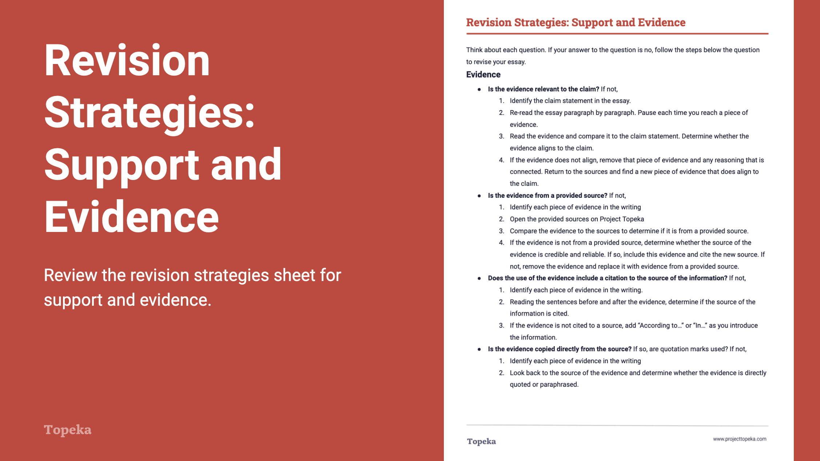
Slide 3
Teacher | Students
Teacher distributes Revision Strategies Sheet: Support and Evidence.  Take a moment to review the Revision Strategy Sheet for Support and Evidence. Think back to what you know about support and evidence—about what reasons and reasoning are, and how good evidence supports your claim.  Teacher has students Pair and Share with a classmate to confirm their understanding of what support and evidence means and how it is evaluated.  (For information on implementing Pair and Share via remote learning, see Remote Engagement: Pair and Share or the guide to Remote Learning with Topeka.) | Students refresh their memories of strong support and evidence by reviewing and discussing the revision strategies sheet.
Teacher distributes the handout Support and Evidence Exemplar: Before Revision. Teacher directs students to look at the first page.  Here is an example of a student writing about school uniforms. The question the student is answering is whether or not dress codes create a more positive school environment than uniforms or no policy at all.  Using the Revision Strategies Sheet: Support and Evidence, suggest revisions that would strengthen the writer’s achievement in the support and evidence domain. Annotate the draft to show your suggestions and your explanation. | Students use the “before” exemplar essay and the revision strategies sheet to suggest ways for the writer to improve the essay.
When students complete the review, teacher has students partner with others to compare the suggested changes. Have students explain their suggestions:  How do these changes increase student achievement on the support and evidence section of the rubric? Why do you think the revised essay will be better?  (For information on implementing Pair and Share via remote learning, see Remote Engagement: Pair and Share or the guide to Remote Learning with Topeka.) | Students partner to share their suggestions for revisions and their explanations for how these revisions would improve support and evidence in the essay.

Step 2: I Do It/We Do It Together
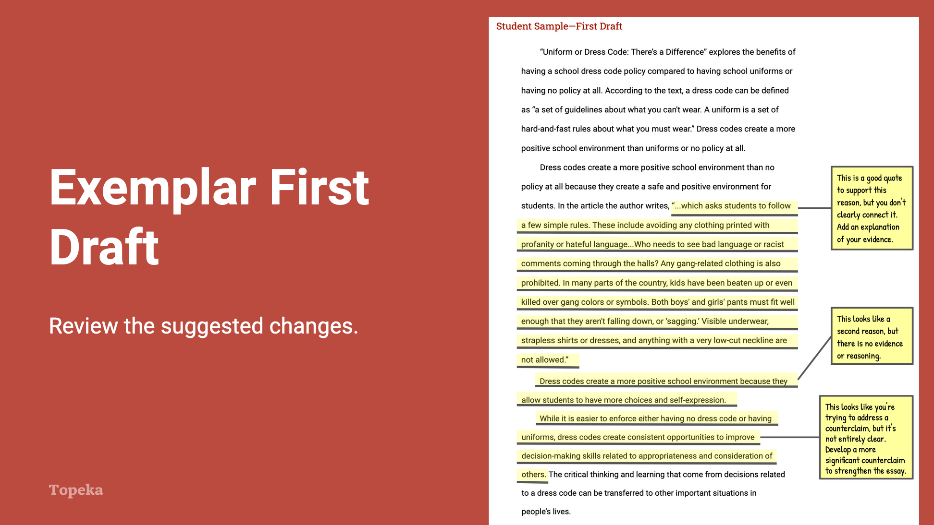
Slide 4
Teacher | Students
Teacher directs students to the second page of the Support and Evidence Exemplar: Before Revision handout and explains the annotations.  After reviewing this piece of writing, I can see that the writer has included reasons and some evidence, but it’s not always complete or clearly connected.  If I look at the revision strategies sheet, I can see that the support and evidence rubric domain can be broken down into three traits: Evidence, Support, and Counterclaims.  I’m going to ask myself some of these questions to get ideas for how to revise my essay. “Is the evidence supported by a reasoning sentence connecting the evidence to the reason and the claim?” I can see in each of these ‘before” revision paragraphs, the writer hasn’t always introduced evidence or explained evidence.  For example, in the first body paragraph the writer gives a reason and a quote, but there is no explanation linking the quote back to the reason and to the claim. So the annotation says that the writer should add a reasoning statement. | Students listen and take notes as appropriate.
Using the annotated first draft, teacher will continue to review the suggested changes, ask students to evaluate their impact, and also answer questions related to the domain’s evaluation criteria.  Do you think these suggestions will help improve the students score on support and evidence? Where else do you think the writer can strengthen the essay’s support and evidence? What other suggestions do you think would help this essay and why would these changes improve the strength of the support? | Students listen, take notes, and participate as appropriate.

Step 3: You Do It Together

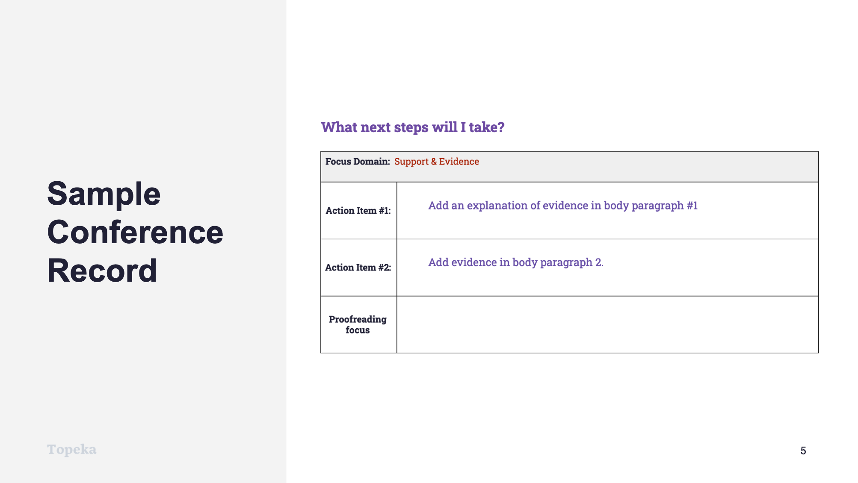
Slide 5
Teacher | Student
Teacher describes how a conference record is used to convey suggested revisions.  Here is an example of a conference record conveying the same strategies the teacher suggested in the annotations.  Teacher continues:  In the top row, we see that the writer is going to address evidence and support. Let’s look again at the revision steps provided to this writer.  The first strategy, as we saw in the annotations is to add an explanation of the evidence in body paragraph 1.  Adding evidence to body paragraph 2 becomes step 2, because there was previously no evidence to support that reason.  Another possible action item is to develop a more significant counterargument.  Which two would you focus on?  Teacher directs students to work in small or large groups to review the recommendations and discuss the impact of these revisions. If time allows, students can implement the suggested revisions.  (For information on implementing Small Group Collaboration via remote learning, see Remote Engagement: Small Groups or the guide to Remote Learning with Topeka.) | Students listen and take notes.

Step 4: I Do It/We Do It Together

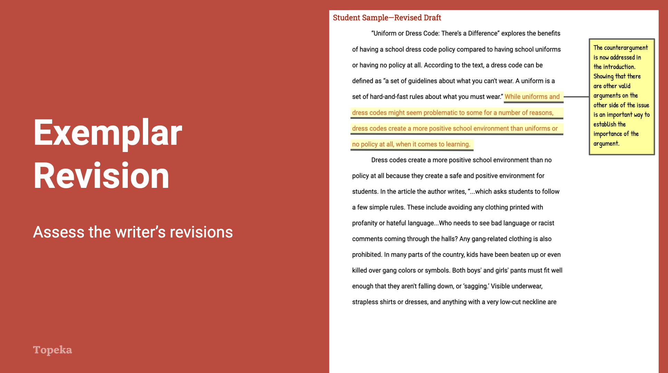
Slide 6
Teacher | Student
Teacher distributes the Support and Evidence Exemplar: After Revision and directs students’ attention to the first page of the revised essay.  In this revised draft, the writer has responded to the action steps the teacher presented in the conference form. This draft models all three possible revisions so you can see how each could be addressed. Review these revisions to see if you understand their impact. Follow the instructions on the handout.  Teacher allows students time to read revised essay and react to the revisions. | Students examine the highlighted revision on unannotated revised essay and note why each revision had a positive impact on the essay.
Teacher directs students to turn attention to the revised essay. Teacher thinks aloud to describe impact of revisions.  What do you notice about the differences in this text based on the highlighted sentences? How have these changes strengthened the essay’s support and evidence?  If you read the sentences highlighted in red, you will see that the writer has added text in multiple places to strengthen the essay. For example, in the introduction, the writer acknowledges the counterargument by adding, “While uniforms and dress codes might seem problematic.” By adding this brief phrase, the writer acknowledges the counterargument early on, and they do the same thing again in the conclusion, which strengthens the overall argument.  In the same way, the writer has introduced new text in the body paragraphs, first to explain existing evidence, and then to introduce and explain new evidence. | Students listen and take notes.
Teacher continues to describe revisions and concludes by reminding students to apply revision strategies to their own essays.  When you’re revising your essay, remember to use these helpful revision strategies to take your essay to the next level. | Students listen and take notes as appropriate.

For more information about modeling student revisions and growth, see the Topeka guide to Supporting Revision with Effective Feedback.

