Intervention Lesson
Support and Evidence
Lesson Plan

Rationale
Post-writing interventions help teachers drill down into common challenges students face in their writing. Not all student performance will fall within the range that these interventions are intended to address, but the skills addressed in this set of activities are fundamental to good writing and will help a broad range of students improve their performance. Rubric domains and skills within them are the drivers behind each of the individual lessons and accompanying activities at each level.
Feedback and data from signal checks are a great source of information for selecting and assigning intervention lessons. See Planning from Data with Topeka for additional support for using data and reports to group students, select interventions, and schedule these additional supports into instructional time.
For information on implementing this lesson and accompanying activities via remote learning, see the guide to Remote Learning with Topeka.

How to Select and Use Intervention Lessons
- Step 1: Determine Intervention Needs—Review the reports from the initial writing exercise and select an approach to intervention. See Planning from Data Guide for guidance on using reports to plan instruction. If time allows, use the complementary exemplar lesson and activities to help students understand revision strategies within the domain and to show examples of revisions applied to a sample student essay.
- Step 2: Present Intervention Lesson and Engage Students in Personalized Intervention Activities— Use the activities and instruction included in this lesson to facilitate leveled interventions for planning a revision.
- Step 3: Individual Activity—Have students apply to their own essays the leveled instructions for a revision based on criteria of an individual rubric category.

Support and Evidence
Proficiency in the category of support and evidence is demonstrated by use of clear, relevant evidence, and clear explanation how the evidence supports the claim. Writing demonstrates logical reasoning and understanding of the topic or text(s). Counterclaims are acknowledged, but may not be adequately explained and/or distinguished from the essay's central claim.

Standards Addressed in this Lesson
- Write arguments to support claims in an analysis of substantive topics or texts using valid reasoning and relevant and sufficient evidence (CCSS.ELA-LITERACY.CCRA.W.1)
- Develop and strengthen writing as needed by planning, revising, editing, rewriting, or trying a new approach (CCSS.ELA-LITERACY.CCRA.W.5)

Lesson Steps

Step 1: Determine Intervention Needs
There are several ways to group students and provide interventions based on data. For more details on how to use Topeka reports to plan instruction, see Planning from Data with Project Topeka.

Class Level Intervention: Reteaching
At a class level, teachers may choose to reteach a skill or concept based on the class level average, focusing on the area of performance with the lowest level of achievement. For example, the class, as a whole, had the lowest rating in the support and evidence category. The teacher reteaches these concepts at a whole class level, even though individual students may be at different starting points in terms of actual achievement.

Small Group Intervention: Performance Area Intervention
At a group level, teachers may choose to reteach a skill or concept based on the shared needs associated with a particular area of performance, while individual interventions may be at different levels.

Personalized Intervention: Performance Area Intervention
For individual students, teachers may choose to reteach a variety of skills or concepts based on the needs associated with a particular area of performance.

Pre-Intervention Level | Next Level Growth Goal
Emerging:  The essay does not use clear or relevant evidence or reasoning to support the claim or to demonstrate an understanding of the topic or text(s) or uses very little evidence from the source. Counterclaims are not acknowledged or addressed. | Developing:  The essay uses some evidence but may not precisely explain how it supports the claim. The essay includes some reasoning and demonstrates a superficial understanding of the topic or text(s). The support of the claim may rely on summary of the source and may not acknowledge counterclaims.
Developing:  The essay uses some evidence but may not precisely explain how it supports the claim. The essay includes some reasoning and demonstrates a superficial understanding of the topic or text(s). The support of the claim may rely on summary of the source and may not acknowledge counterclaims. | Proficient:  The essay uses clear, relevant evidence and explains how the evidence support the claim. The essay demonstrates logical reasoning and understanding of the topic or text(s). Counterclaims are acknowledged but may not be adequately explained and/or distinguished from the essay's central claim.
Proficient:  The essay uses clear, relevant evidence and explains how the evidence support the claim. The essay demonstrates logical reasoning and understanding of the topic or text(s). Counterclaims are acknowledged but may not be adequately explained and/or distinguished from the essay's central claim. | Advanced:  The essay cites the most relevant, appropriate, and valid evidence to support its claim and fully explains how the evidence cited and reasons support the claim. The essay demonstrates reasoning and full understanding of the topic or text(s). Counterclaims are acknowledged and/or distinguished from essay's central claim.

If time allows, prior to completing Step 2 below, present the exemplar lesson for the support and evidence domain, which complements this lesson. If the entire lesson is not feasible, have students review just the annotated exemplar essay to see how revision strategies can be applied in practice.

Step 2: Focused Intervention Lesson Presentation and Activities
In this step, teachers review fundamental concepts and assessment criteria found in rubric. Students collaborate to practice one or more skills necessary for student revision.

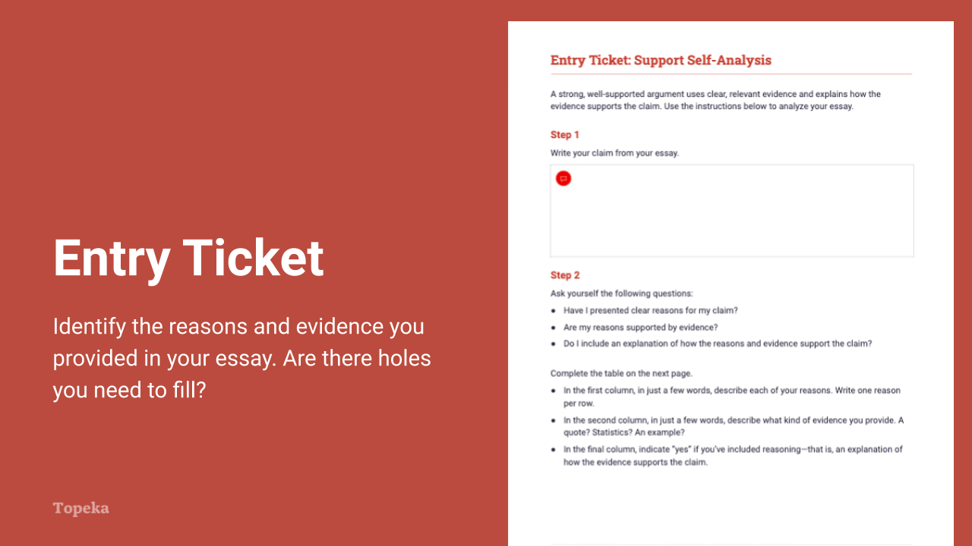
Slide 2
Teacher | Students
Teacher sets the purpose for the class with an entry ticket to activate prior knowledge. Teacher distributes entry ticket to students. Students will need access to their draft essays.  Upon completion, teacher invites students to Pair and Share with a classmate to discuss their answers.  (For information on implementing Pair and Share via remote learning, see Remote Engagement: Pair and Share or the guide to Remote Learning with Topeka.)  Take a moment to talk to your neighbor about the support and evidence you were able to identify in your own essay. Explain your answers to your partner.  Teacher circulates to offer assistance. | Students analyze their drafts of scored essays. Each student identifies the claim used, and then follows instructions to outline the support provided for the claim.

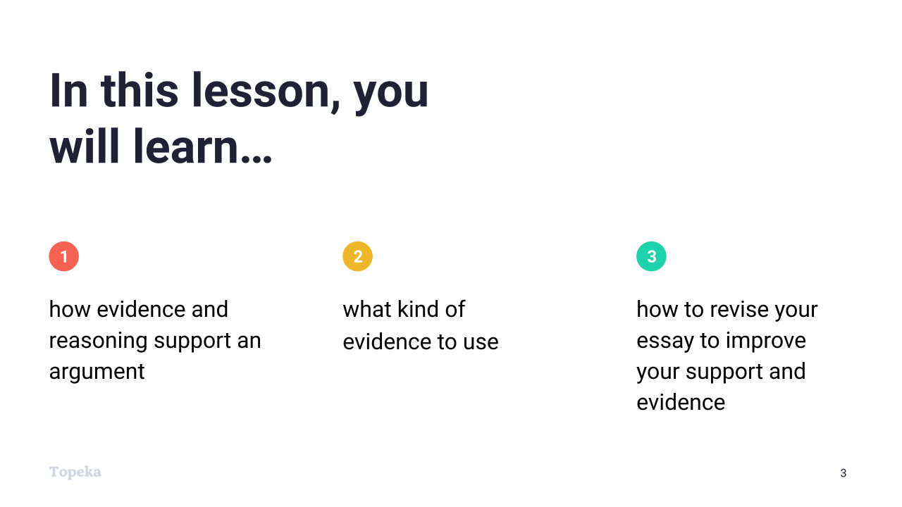
Slide 3
Teacher | Students
Teacher sets purpose for the lesson by describing what will be covered in class session.  Today we are going to revisit the concept of supporting your claim with reasons and evidence.  You’ve just completed an entry ticket that asked you to outline the support you included in your first draft. We’ll talk briefly about the concepts of reasons, evidence, and reasoning; remind ourselves of what makes good evidence; and then you’ll each plan a revision to see if you can improve the support and evidence in your essay. | Students listen and take notes.

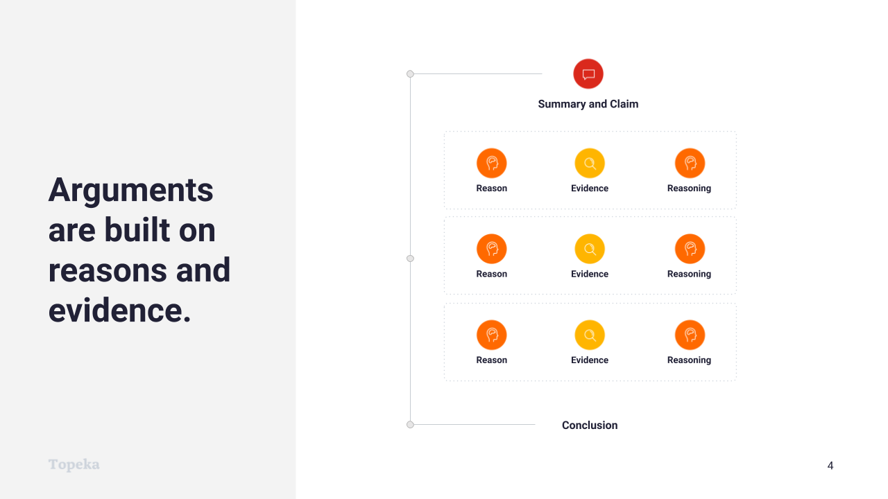
Slide 4
Teacher | Students
Teacher introduces the purpose and placement of support and evidence in an argumentative essay.  (Consider pre-recording this portion of the lesson for remote delivery. See the guide to Remote Learning with Topeka for more details.)  Arguments are built on reasons and evidence.  When you are making an argument, you are taking a position that you want others to accept or understand. That position is your claim.  But it’s not enough to just make a claim. You have to support your claim with reasons why you make the claim and evidence that proves your reasons are valid. You also need an explanation—your reasoning—describing how the evidence connects to the reason and back to the claim. Your reasoning links everything together.  Teacher explains support for a claim in the context of reviewing the entry ticket.  In the entry ticket, the first column that you filled out contained your reasons. Hopefully you were able to see how your reasons created an overall structure or organization for your essay, much like the graphic here. If not, that’s something you can work on in your next draft.  For each of the reasons in your essay, you were asked to describe one or more pieces of evidence in the second column. | Students listen and take notes.

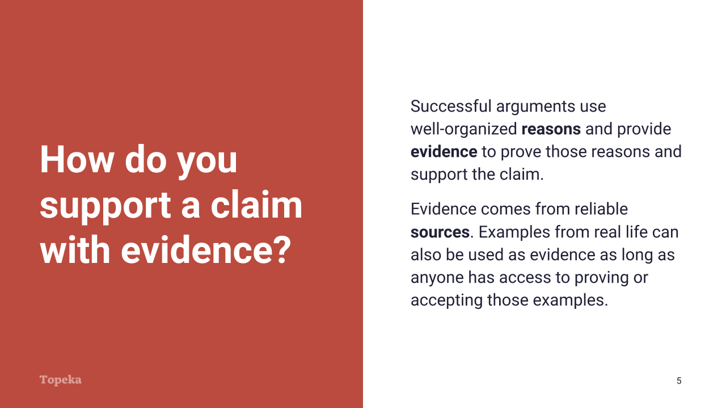
Slide 5
Teacher | Students
Teacher continues:  Successful arguments use well-organized reasons and provide evidence to prove those reasons and support the claim.  Evidence can be facts or statistics, quotations from the text, or examples from real life. Your evidence should come from reliable sources. | Students listen and take notes.

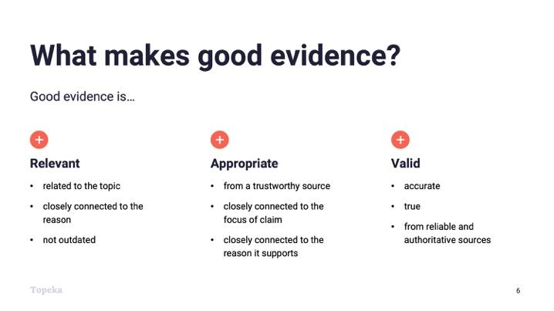
Slide 6
Teacher | Students
Teacher continues:  So what makes good evidence?  Good evidence is relevant: it is related to the topic, closely connected to the reason, and not outdated.  Good evidence is appropriate: it is from a trustworthy source, it is closely connected to the focus of the claim, and it is closely connected to the reason it supports.  Good evidence is also valid: it is accurate, true, and from reliable and authoritative sources. | Students listen and take notes.

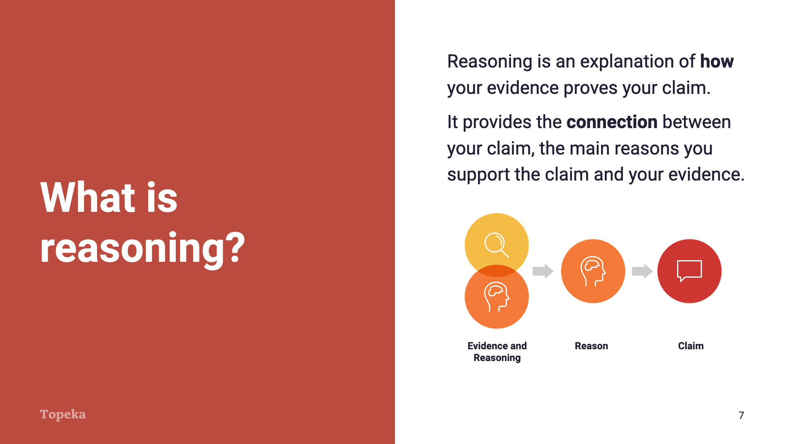
Slide 7
Teacher | Students
Teacher continues:  Reasoning is your explanation of why your reason and evidence are relevant to the claim. Reasoning connects everything together.  You can’t assume that when you provide a reason and evidence to support your claim that everyone will understand what you mean. Your reasoning is an explanation that links the pieces together and shows you know what you’re writing about. | Students listen and take notes.

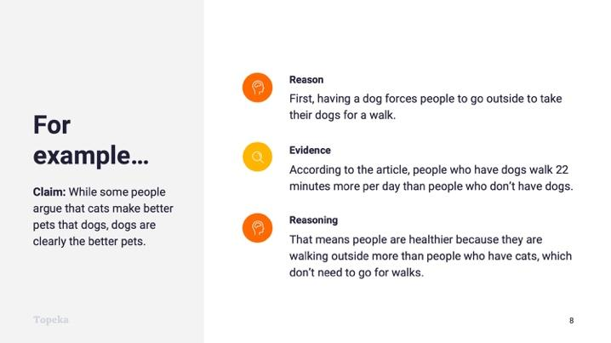
Slide 8
Teacher | Students
Teacher provides an example of support without and with evidence and reasoning.  For example, if I were making an argument about why dogs are better pets than cats, one of my reasons might be that having a dog forces people to go outside to take their dogs for a walk.  Well, it’s certainly not clear from that why dogs are better pets than cats; I’m going to need to say more about that reason. So I’ll add the evidence: “According to the article, people who have dogs walk 22 minutes more per day than people who don’t have dogs.“  OK, so now I have a statistic there, but how does this reason and this evidence connect back to the claim that dogs are better pets than cats?  That’s where the reasoning comes in: “That means people who own dogs are healthier because they are walking outside more than people who have cats, which don’t need to go for walks.”  This line of reasoning connects the evidence back to the reason and the claim.  You should not include reasons without evidence or leave evidence unexplained. | Students listen and take notes.

Step 3: Independent Revision Practice
In this step, students return to their essays and approach a revision with instruction and support selected in response to each student’s individual score report.
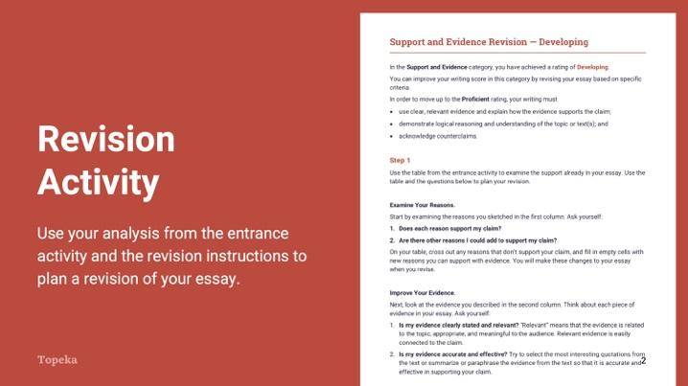
Slide 9
Teacher | Students
Teacher distributes leveled revision instructions to students according to their individual score reports.  Teacher instructs students to use the revision instructions to plan a revision of the support and evidence in their essays.  Now, using your table from the entry ticket and the revision instructions I’ll give you, you’ll plan a revision and revise your essay.  Teacher circulates to support students through their individual revisions, sandwiching areas for improvement between positive elements. For example:  You selected a great example as evidence. However, your next sentence doesn’t help the reader understand how your example connects to the main reason of your paragraph. Adding a sentence of reasoning to your evidence would make your reason more powerful. | Students receive and read the instructions specific to their original score reports.  Students revise their essays according to this leveled guidance.

