Intervention Lesson
Organization
Lesson Plan

Rationale
Post-writing interventions help teachers drill down into common challenges students face in their writing. Not all student performance will fall within the range that these interventions are intended to address, but the skills addressed in this set of activities are fundamental to good writing and will help a broad range of students improve their performance. Rubric domains and skills within them are the drivers behind each of the individual lessons and accompanying activities at each level.
Feedback and data from signal checks are a great source of information for selecting and assigning intervention lessons. See the Planning from Data Guide for additional support for using data and reports to group students, select interventions, and schedule these additional supports into instructional time.
For information on implementing this lesson and accompanying activities via remote learning, see the guide to Remote Learning with Topeka.

How to Select and Use Intervention Lessons
- Step 1: Determine Intervention Needs—Review the reports from the initial writing exercise and select an approach to intervention. See Planning from Data Guide for guidance on using reports to plan instruction. If time allows, use the complementary exemplar lesson and activities to help students understand revision strategies within the domain and to show examples of revisions applied to a sample student essay.
- Step 2: Present Intervention Lesson and Engage Students in Personalized Intervention Activities— Use the activities and instruction included in this lesson to facilitate leveled interventions for planning a revision.
- Step 3: Individual Activity—Have students apply to their own essays the leveled instructions for a revision based on criteria of an individual rubric category.

Organization
Proficiency in the category of organization is demonstrated by an organizational strategy with clear transitional words and phrases that show the relationship between and among ideas. The essay includes a progression of ideas from beginning to end, including an introduction, and concluding statement or section.

Standards Addressed in this Lesson
- Write arguments to support claims in an analysis of substantive topics or texts using valid reasoning and relevant and sufficient evidence (CCSS.ELA-LITERACY.CCRA.W.1)
- Produce clear and coherent writing in which the development, organization, and style are appropriate to task, purpose, and audience (CCSS.ELA-LITERACY.CCRA.W.4)
- Develop and strengthen writing as needed by planning, revising, editing, rewriting, or trying a new approach (CCSS.ELA-LITERACY.CCRA.W.5)

Lesson Steps

Step 1: Delivering Intervention Lessons
There are several ways to group students and provide interventions based on data. For more details on how to use Topeka reports to plan instruction, see Planning from Data with Project Topeka.

Class Level Intervention: Reteaching
At a class level, teachers may choose to reteach a skill or concept based on the class level average, focusing on the area of performance with the lowest level of achievement. For example, the class, as a whole, had the lowest rating in the organization category. The teacher reteaches these concepts at a whole class level, even though individual students may be at different starting points in terms of actual achievement.

Small Group Intervention: Performance Area Intervention
At a group level, teachers may choose to reteach a skill or concept based on the shared needs associated with a particular area of performance, while individual interventions may be at different levels.

Personalized Intervention: Performance Area Intervention
For individual students, teachers may choose to reteach a variety of skills or concepts based on the needs associated with a particular area of performance.

Pre-Intervention Level | Next Level Growth Goal
Emerging:  The essay does not have an organizational structure and may simply offer a series of ideas without any clear transitions or connections. An introduction and conclusion are not evident. | Developing:  The essay uses a basic organization structure but relationships between and among ideas are not consistently clear. The essay moves from beginning to end; however, an introduction and/ or conclusion may not be clearly evident.
Developing:  The essay uses a basic organization structure but relationships between and among ideas are not consistently clear. The essay moves from beginning to end; however, an introduction and/ or conclusion may not be clearly evident. | Proficient:  The essay incorporates an organizational strategy with clear transitional words and phrases that show the relationship between and among ideas. The essay includes a progression of ideas from beginning to end, including an introduction and concluding statement or section.
Proficient:  The essay incorporates an organizational strategy with clear transitional words and phrases that show the relationship between and among ideas. The essay includes a progression of ideas from beginning to end, including an introduction and concluding statement or section. | Advanced:  The essay incorporates an organizational structure with clear transitional words and phrases that clarify the relationships between and among ideas in a way that strengthens the argument. The essay includes a logical progression of ideas from beginning to end, including an effective introduction and concluding statement or section.

If time allows, prior to completing Step 2 below, present the exemplar lesson for the organization domain, which complements this lesson. If the entire lesson is not feasible, have students review just the annotated exemplar essay to see how revision strategies can be applied in practice.

Step 2: Focused Intervention Lesson Presentation and Activities
In this section, teacher reviews fundamental concepts and assessment criteria found in rubric. Students collaborate to practice one or more skills necessary for student revision.

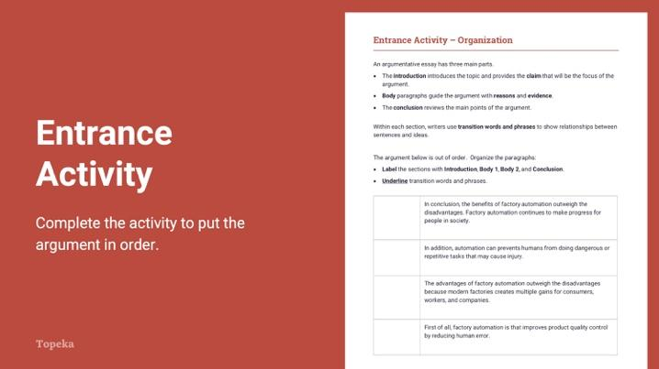
Slide 2
Teacher | Students
Teacher sets the purpose for the class with an entry ticket activity to activate prior knowledge.  Teacher invites students to Pair and Share with a classmate to discuss their answers.  (For information on implementing Pair and Share via remote learning, see Remote Engagement: Pair and Share or the guide to Remote Learning with Topeka.)  Take a moment to talk to your neighbor about the organization and transition words you identified. Explain your answers to your partner.  Teacher circulates to offer assistance. | Students read four paragraphs from a sample essay. They label the paragraphs: Introduction, Body 1, Body 2, and Conclusion. They underline the transition words that make organization clear.  Students turn to a neighbor and talk about their answers and why they chose them.

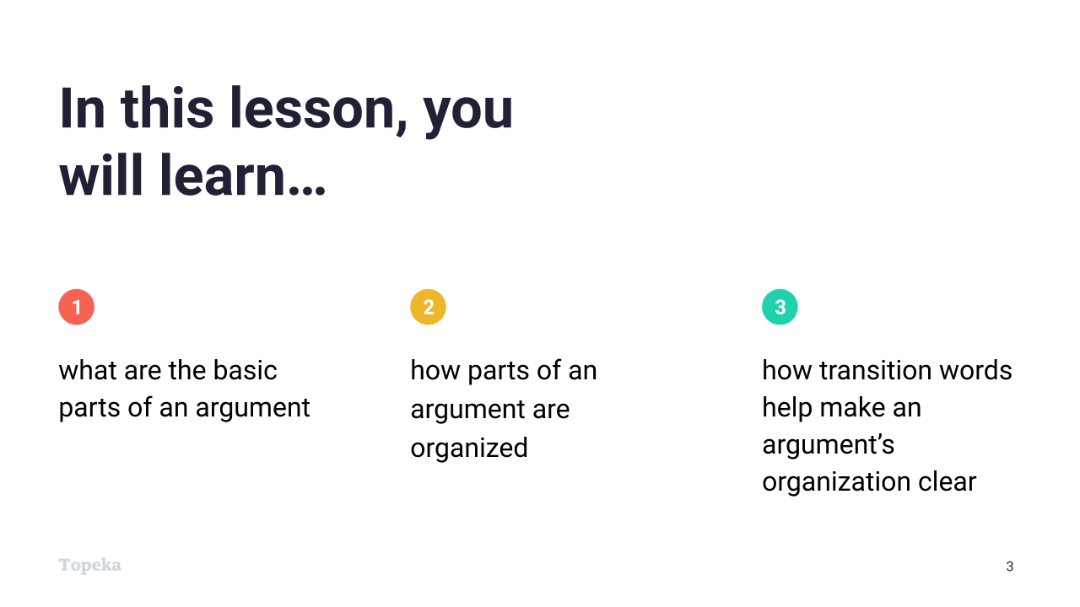
Slide 3
Teacher | Students
Teacher sets purpose for the lesson by describing what will be covered in class session.  In this lesson you will learn what are the basic parts of an argument, how those parts are organized, and how transition words help make an argument’s organization clear. | Students listen and take notes.
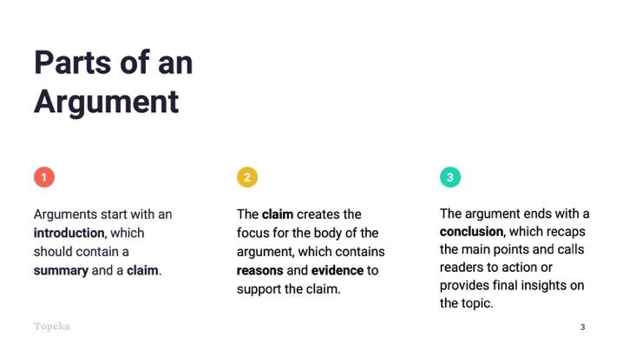
Slide 4
Teacher | Students
Teacher explains the basic parts of an argumentative essay: Introduction, Body, Conclusion. Teacher provides brief description of each part.  (Consider pre-recording this portion of the lesson for remote delivery. See the guide to Remote Learning with Topeka for more details.)  Every argument has three basic sections: the Introduction, Body, and Conclusion. Arguments start with the introduction, which should contain a summary and a claim.  The claim creates the focus for the body of the argument, which also contains reasons and evidence to support the claim.  The argument ends with a conclusion, which recaps the main points and calls readers to action or provides final insights on the topic. | Students listen and take notes.

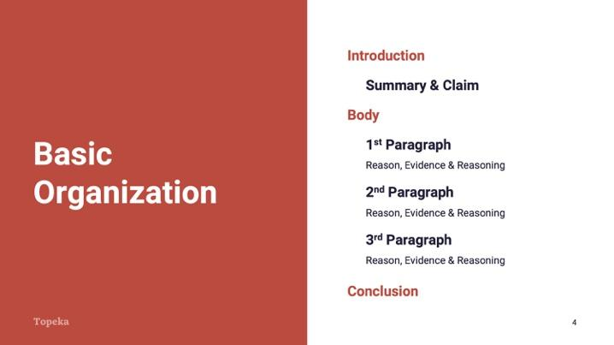
Slide 5
Teacher | Students
Teacher walks through how these parts look when placed in an outline.  This is an outline of a brief argumentative essay. At the very beginning you have the introduction, which must contain your claim, and should contain an brief explanation or summary of the “ongoing issue.”  After the introduction comes the body, which contains your reasons. Each reason paragraph should provide evidence and an explanation of how the evidence connects to the reason and claim. This explanation is your reasoning.  Finally you have a conclusion. Your conclusion should wrap up the argument. It should restate your claim and provide the brief summary of how you proved your position.  Teacher returns to the entry ticket.  Let’s return to the entry activity. The introduction to this argument is “The advantages of factory automation outweigh the disadvantages because modern factories create multiple gains for consumers, workers, and companies.” How do I know this? Because this paragraph provides the claim.  At the end of the essay is the conclusion. The conclusion sums up all of the information you have presented about your claim.  What conclusion did you identify in the entry ticket? How did you know?  In your conclusion you should restate your claim. A strong conclusion will summarize how you proved or defended your claim and encourage readers to agree or take action, or give them a final thought to take away.  What is the final thought in the sample from the activity? | Students listen, review their entry tickets, and take notes.

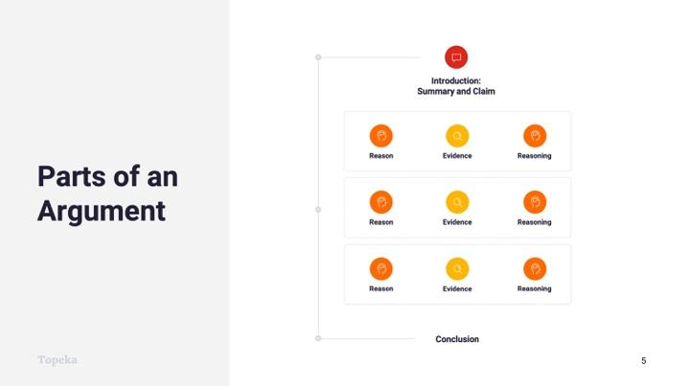
Slide 6
Teacher | Students
Teacher continues:  In between the introduction and conclusion are the body paragraphs. This is where you present the reasons and evidence for your claim and explain with reasoning how your reasons and evidence connect to the claim.  Take a look at this graphic. In a typical argument, within each of the body paragraphs, there will be a reason, then evidence from the text or quotation, and then reasoning that provides an explanation of how the reason and evidence connect to each other and to the claim. | Students listen and take notes.

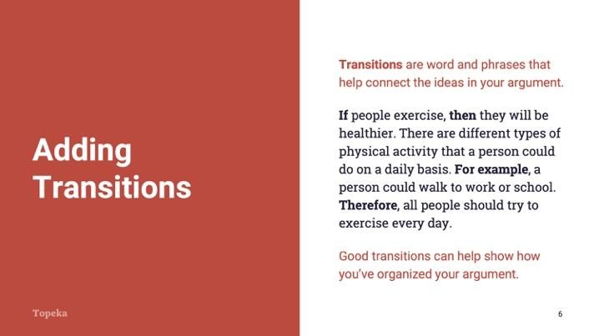
Slide 7
Teacher | Students
Teacher briefly explains transitions:  Once you have organized your essay, you can add transitions to show even more clearly how your ideas are connected. Transitions work well to connect ideas within a paragraph, as shown here. | Students listen and take notes.

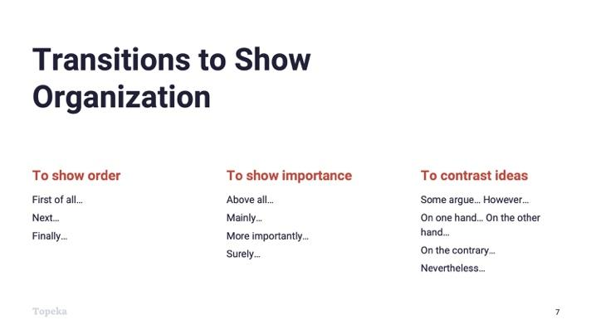
Slide 8
Teacher | Students
Teacher continues:  They can also help show the organization and connection between paragraphs. For example, in the entry ticket, the two body paragraphs began with transition words, “First of all” and “In addition,” indicating the order in which the ideas should be considered. | Students listen and take notes.

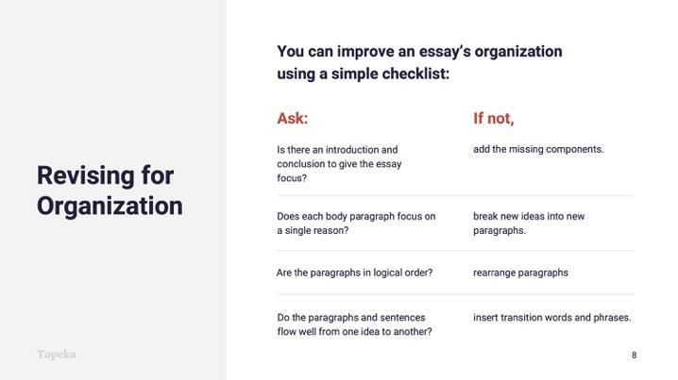
Slide 9
Teacher | Students
Teacher presents revision checklist.  In a moment you will receive instruction to help you plan a revision of your essay. Generally speaking, this is a great way to look at your essay’s organization.  You can improve an essay’s organization by using a simple checklist and asking yourself a series of questions. The answers to those questions will help you to improve your essay.  Teacher should refer to slide to present the items in the checklist. | Students listen and take notes.

Step 3: Independent Revision Practice
In this step students will return to their essay and will approach a revision with instruction and support selected in response to each student’s individual score report.

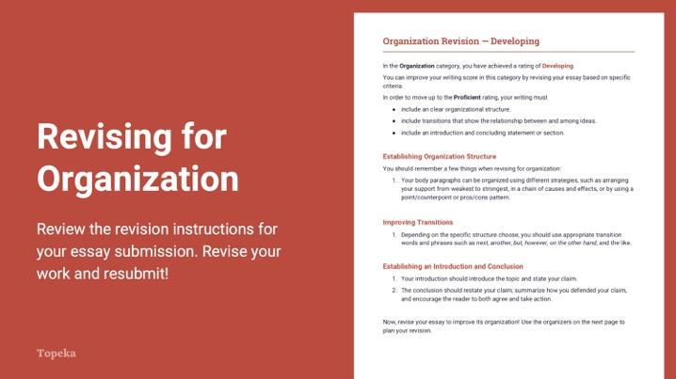
Slide 10
Teacher | Students
Teacher distributes leveled revision instructions to students according to their individual score reports.  Teacher instructs students to use the revision instructions to guide a revision of the organization of their essays.  Using your table from the entry ticket and the revision instructions I’ll give you, you’ll plan a revision and revise your essay.  Teacher circulates to support students through their individual revisions, sandwiching areas for improvement between positive elements. For example:  You selected a great example here. However, your transition doesn’t help the reader understand how the example connects to the main idea of your paragraph. Adding a strong transition to your evidence and would end up making your reason more powerful. | Students receive and read the instructions specific to their original score report.  Students revise their essays according to this leveled guidance.

Appendix A: Sample Student Responses

Entry Ticket: Organization
The argument below is out of order. Organize the paragraphs.
- Label the sections with Introduction, Body 1, Body 2, and Conclusion.
- Underline transition words and phrases.

Conclusion | In conclusion, the benefits of factory automation outweigh the disadvantages. Factory automation continues to make progress for people in society.
Body 2 | In addition, automation can prevent humans from doing dangerous or repetitive tasks that may cause injury.
Introduction | The advantages of factory automation outweigh the disadvantages because modern factories create multiple gains for consumers, workers, and companies.
Body 1 | First of all, factory automation improves product quality control by reducing human error.

