Professional Learning Guide
Supporting Revision with Effective Feedback
Using AI and effective feedback practices to maximize student growth

Overview
Feedback is essential to help students improve as writers, and it needs to be given on drafts of student work—and even pre-writing— rather than waiting for a final draft. It is also a place to build credibility with your students and nurture relationships, and Topeka offers you multiple avenues for feedback. Signal checks from the artificial intelligence (AI) in the Topeka platform, your feedback, peer revision, and self-revision can all help students to improve their writing when this feedback is coordinated. Throughout the feedback process, make sure to provide opportunities for students to lead and offer their thoughts, goals, and action items, and always listen to your students carefully.

In this guide, you will find resources to help you maximize the instructional time you spend on feedback. You’ll learn what feedback Topeka’s AI provides and how to complement that feedback with effective, personalized feedback.
This guide is divided into sections based on teacher need. Select the section that best aligns with your goals.

I’d like to…

understand how the artificial intelligence in Topeka provides feedback.

improve my feedback while reducing the time I spend giving feedback.

provide feedback for students at different proficiency levels.

model how to incorporate feedback for students

facilitate student-teacher and peer writing conferences.

How does the artificial intelligence in Topeka provide feedback?
Topeka uses artificial intelligence (AI) to analyze student writing and provide feedback to students. These Signal Checks were not designed to replace you as the teacher, but are there to help you focus on the most impactful feedback to share with your students. Signal Checks can be helpful to get students feedback quickly, but there are certain elements of writing where teachers will be better at providing effective feedback. In order for feedback to best support students, it is important to provide your feedback in conjunction with Signal Checks, and to understand what Signal Checks can and cannot do.

What do Signal Checks do, and what kind of feedback do they give students?
- When students run a Signal Check, they will almost always receive four pieces of feedback. This feedback aligns with the four rubric categories: claim and focus, organization, support and evidence, and language and style.  - The feedback that students receive with each Signal Check will change, even if they don’t make any changes to the essay. As such, students should be encouraged to incorporate all feedback before asking for another Signal Check.  - The Signal Check analyzes and provides revisions on the sentence level. It does not “understand” ideas expressed in multiple sentences or at a paragraph level. This means that Signal Checks cannot give holistic feedback to students and the AI can sometimes misidentify the purpose of a sentence.  - A Signal Check cannot identify plagiarism, even from the provided sources.  - While a Signal Check gives comments on specific sentences, it sometimes gives positive comments that can also be considered in other places within the essay. | 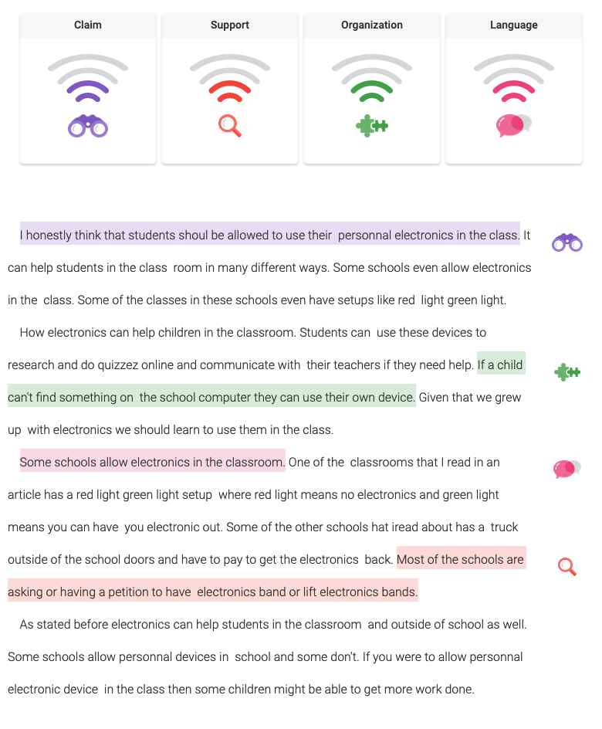
If you’d like to better understand what Signal Checks are good at giving feedback on and where you can support students, you can view examples of AI feedback based on student writing for each domain.
- Claim and Focus AI Feedback
- Support and Evidence AI Feedback
- Organization AI Feedback
- Language and Style AI Feedback
In the Guide to Using Signal Checks for Students, students are provided with similar information and questions for consideration when they receive feedback.

What kind of feedback should I give students?
To best complement the Signal Check feedback, you can support students by
- offering holistic feedback to ensure that their writing is cohesive and clear;
- focusing on the overall flow and organization of writing;
- determine whether students have correctly used and cited evidence from the provided sources; and
- teaching students to consider the feedback they are given with a critical eye, and to determine when the feedback they receive is right for their essay—sometimes the AI is wrong.

How can I troubleshoot student issues with Signal Checks?

Are students struggling to improve Signal Checks?

Don’t let students get discouraged! When improving their essays using signal checks, it might be harder to jump from 3 to 4 bars than it might be to jump from 1 to 2 bars. If students are using the argumentative writing rubric to guide their revisions, they are probably improving the overall essay, even if the signals don’t change. This is one reason that we recommend that the Signal Checks in Topeka are only used for formative assessment. Students should revise until they feel confident about their essay, but don’t have them keep revising just because the computer hasn’t given them full bars. Sometimes revising too much without paying attention to the writing rubric or making sure the whole essay still flows logically can actually make their writing weaker.

Are students not getting a Signal Check?
Signal Checks will not complete if a student’s essay is too short; sometimes this will happen for other reasons. Instruct students to follow these steps to revise their writing and ask for a new Signal Check:
- Reread their writing and decide whether it is on-topic or not.
- Proofread and check that their writing is broken into sentences with periods.
- Determine whether or not there is a clear claim statement that is its own sentence including a stance and evidence, and whether this claim statement uses language aligning to the prompt.

How can I give good feedback and reduce the time I spend giving it?

Investing in relationships is a key part of the writing process.
When providing feedback to students, it is helpful to keep relationship-building best practices in mind. Treat revision as a normal part of the writing process for all writers, not something a student does to get a better grade. An essay that hasn’t been through a revision process is not finished. However, writing is different from other academic work: emerging writers are as sensitive to feedback on their ideas as any adult who is invested in a point of view they may have shared in a civic or workplace setting. It is important to invest in these relationships at all steps in the process. Here are some specific investments to make:
Relationship Building &  The Writing Process |  | Feedback and  Evaluation
Everyday Classroom Culture: Provide opportunities for peers to engage with the content collaboratively in discussions before, during, and after drafting. |  | Train Peer Editors: Invest time in training students in peer editing, and coach peer editors in how to give feedback positively.
During Drafting: Circulate to make yourself available during the independent writing process, or schedule time with each writer on a regular basis during the writing process. |  | Provide Praise First: Focus written comments on strengths and document a single concrete area of improvement (two at most).
Evaluation and Grading: Provide opportunities for growth through multiple drafts and, where possible, use grading strategies to reward growth in addition to attainment. |  | Reward Growth: Provide opportunities for students to see you point out strengths and hear advice framed in a positive way. Allow unlimited rewrites for students who are intent on growth.

How can I reduce the amount of time I spend giving feedback?
Feedback is essential for student growth, but can be time-consuming for teachers. By employing a few tips and partnering your feedback with Topeka signal checks, you can help make feedback a more efficient process (see Flash Feedback: Responding to Student Writing Better and Faster—Without Burning Out by Matthew Johnson [Summary blog] for more ideas):
- Give targeted feedback by picking a skill or domain to focus on and just providing feedback about that particular skill or domain. Consider focusing on the domain that has the lowest signal score from Topeka.
- When commenting, don’t feel the need to comment on everything, but focus on the most important lessons that you want students to learn from your feedback. Topeka will give your students sentence level feedback, so you can focus your feedback on the overall strength and coherence of the essay. (To learn more about the kind of feedback Topeka gives, see What do Signal Checks do and what kind of feedback do they give students?)
- Use micro-conferences to have 1–2 minute conversations with each student about their Signal Checks and their action plan to resolve the feedback. This is especially important for early Signal Checks. For remote learning, this could be done synchronous in breakout rooms or asynchronously via a chat. Consider the following procedure:
  - Student lets you know when they have gotten their first Signal Check
  - Student tells the teacher the outcome of their Signal Check and what they noticed.
  - Teacher gives thoughts and fixes any misconceptions;maintain focus on what the student has identified.
  - Student identifies action items to resolve feedback.
- Another way to reduce your workload is to create a bank of feedback that you can use to address common issues you see in student writing. Learn more about feedback banks here.

How do I provide feedback for students at different proficiency levels?

Using the Topeka Rubric-Based Feedback Bank
Providing feedback to students can be a time-consuming process. Oftentimes, multiple students would benefit from the same types of feedback. In order to reduce your workload, you can use the Topeka Rubric-Based Feedback Bank as a root for your comments to students. As you use the feedback bank, make sure to
- individualize comments to students;
- try to create a feedback sandwich that starts and ends on a positive note (consider starting with a piece of positive feedback before including constructive feedback, and add a positive endnote that is specific to the student); and
- add your own comments and feedback to your personal feedback bank to include the types of feedback you give frequently give.
The feedback bank is divided into the different rubric domains. Use data about the domain your student needs the most support in to decide which feedback to use (see Planning from Data with Topeka). Remember: when giving feedback, it is helpful to focus on a single domain at a time and only on the most egregious errors that students are making so as not to overwhelm them with feedback.

Providing feedback on the Topeka platform
To access student work, go to your teacher dashboard by clicking on “My Classes.”
Click “View Class” on the class for which you’d like to review work.
Click “Give Feedback” to view student work.
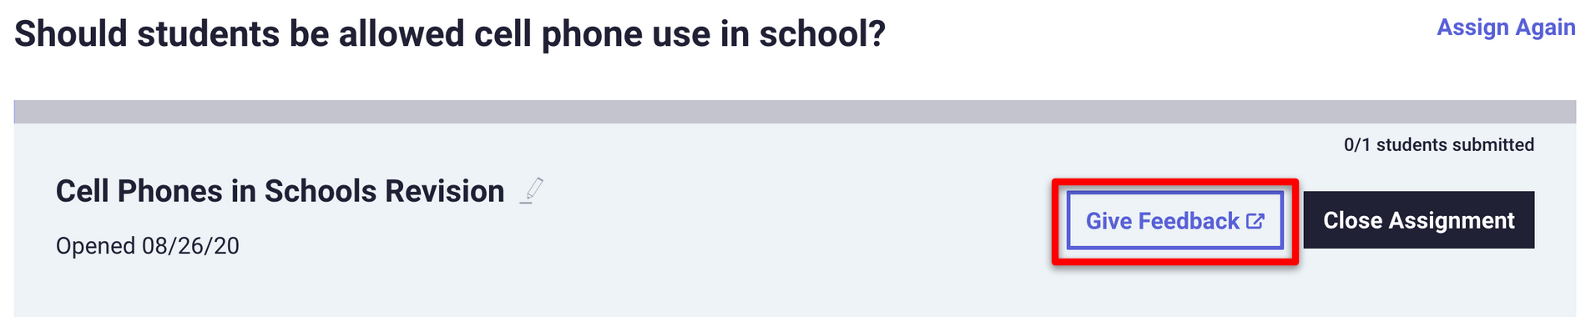

On the Topeka platform, teacher feedback can be given by sending a message to the student. Click on the “Student Work” tab.
Above the student writing, select “Send [student] a Message.” A text-box will appear where you can type a comment to the student. See Supporting Students with Effective Feedback for suggestions of domain-based feedback for students.
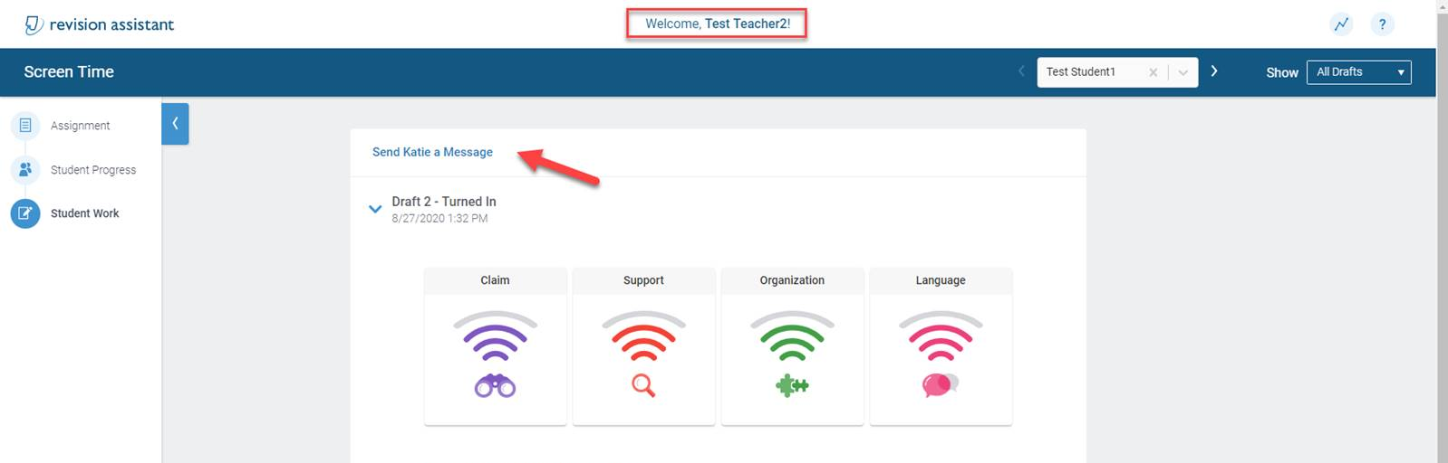

How do I model incorporating feedback for students?
When providing feedback to students, it is important to model the revision process. Modeling revision is a powerful think-aloud, giving students visibility into the revision process and reinforcing the vocabulary we use to describe text. When students witness the process of revision modeled, they can begin to understand that writers make choices and those choices create meaning. In addition, students can begin to see the value of revision for improving the effectiveness of an argument and to understand what makes “good writing” good writing.
If students have not received instruction from Topeka pre-writing lessons or the Introduction to Argumentative Writing unit, they may be unfamiliar with the vocabulary used in the Topeka Rubric. Introducing those terms is a first step in addressing growth opportunities and revision lessons are the next step. Finally, personalized instruction from a teacher is the best when it comes to writing.

Modeling the Revision Process
The Topeka writing process offers two types of revision lessons to support domain-focused revision: Domain Knowledge Review Lessons and Exemplar Revision Lessons. Use small group meetings or individual conferences to model an example of the selected revision strategy. For more information on grouping students for revision activities, see Planning from Data with Topeka.
Domain Knowledge Review Lessons strengthen domain knowledge by reteaching fundamental concepts and offering leveled activities to help students plan a revision of elements associated with a particular domain.
Exemplar Revision Lessons, on the other hand, are designed for explicit modeling of revision. Exemplar lessons use a sample student essay and revision strategies to have students analyze a piece of actual writing before and after revision. They give students the opportunity for students to see a strong model of writing: thinking aloud about the strengths and weaknesses of a piece of writing, and deciding what revision steps the writer could take. Students benefit from seeing how specific changes improve a piece of writing, and how they can apply the revision strategies to their own writing. Below is an example of a revised draft provided in the Claim and Focus Exemplar Lesson.
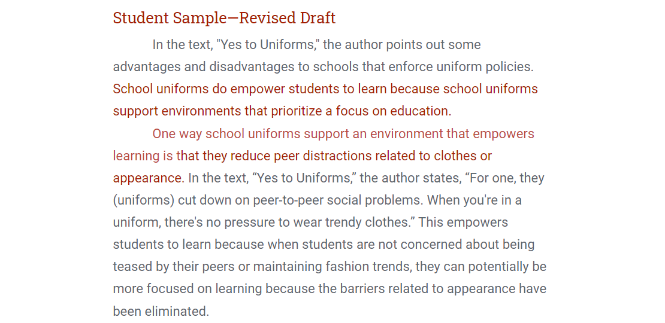

How do I facilitate student-teacher and peer writing conferences?
Writing conferences are an essential part of the writing process and give you the opportunity to share targeted feedback with students personally. The writing conferences you plan can be supported by the resources on the Topeka platform. For example, the Signal Check reports provide invaluable feedback for personalizing conferences (see Planning from Data with Topeka). If you are teaching online, Remote Learning with Topeka has specific ideas and guidance for hosting virtual writing conferences.
Writing conferences can help students to not only become better writers and improve their overall attitude toward writing, but also to build relationships with their teachers. However, writing conferences can also take up a lot of time, so it is best to prepare to make the most of the time you have with students. That said, even a five or 10-minute conversation with students to check in on their progress can help them to improve. Focus your conversations on the pieces of feedback that Topeka Signal Checks are not as good at supporting students on (see What do Signal Checks do and what kind of feedback do they give students?) and helping students to make the most of their Signal Check feedback.
In writing conferences you should do the following.
- Be prepared. Review the student’s writing before the conference and use the Conference Form for Planning and Feedback to identify strengths and areas of growth for each domain. Have students come prepared to the conference by doing the same.
- Start with the student. Begin the conference by having the student share their thoughts about the strengths and weaknesses of their writing and goals. Focus on asking questions, and clarifying and summarizing what you are hearing. Always try to give students the opportunity to be the first to suggest potential improvements, and focus on revoicing what you hear before beginning to give your feedback.
- Begin your feedback with strengths. Make sure to praise students for their work first, and describe why the work they completed is effective. Helping students to see a particular aspect of their writing as strong and to be able to name and describe the traits of that aspect equips them with the agency to be a writer who can make their own choices and intentionally repeat effective approaches and choices.
- Choose one domain for improvement. Too much feedback in too many areas can be overwhelming to students. Select one domain to focus on during the conference and for feedback. To do this, you can use data about the student’s Signal Check and ask students where they think they need the most improvement. Even within one domain, it isn’t necessary to fix everything in one draft. Focus on how students can make a few changes well and learn from them, rather than making a lot of changes without the opportunity to think deeply about them.
- Focus on grammar last. While poor grammar and mechanics can make writing difficult to understand, the first focus within your conferences should be on the substance of the paper. Then, just as you are choosing one domain for improvement, work with the student to select one convention for improvement. Writing conferences suffer when they focus too much on grammar, instead focus on holistic revision.

