Writing
Day 1: A Vocabulary for Writing Arguments
Daily Lesson Plan

Lesson Summary
In this lesson, students and teachers will uncover the basic process and vocabulary for making an argument supported by evidence.

- Step 1: Set Purpose/Activate Prior Knowledge—Students complete entry ticket analyzing an image to describe details and make a claim about ideas in the image.
- Step 2: I Do It/We Do It Together—Teacher and students describe terms for parts of an argument, and apply those terms to the entry ticket.
- Step 3: You Do It Together—Following teacher model on previous step, students collaborate to examine another image and respond to a simple prompt. Students use details from the image to support response using graphic organizer labelled with parts of an argument.
- Step 4: Independent Application—Students work independently to find additional details in the image to further support the same claim or a different claim using the graphic organizer.

Objective
Students will understand a common vocabulary for creating and discussing arguments and for application of the rubric to student writing.

Engagement Strategies
- Pair and Share: Students will turn to a partner to collaborate through discussion. See also, Remote Engagement: Pair and Share.
- Collaborating to Find Evidence: Students will work in pairs or small groups to find and evaluate evidence while practicing reasoning together. See also, Remote Engagement: Small Groups.
Links to information for remote learning are also provided in the lesson steps below. A complete list can be found in Appendix B.

Scaffolding Strategies
The scaffolding strategies listed below are optional supports included in the lesson’s activities. These tools may be used or ignored based on students’ needs.
- Vocabulary Bank: Students, particularly students who are also English Learners can use or even translate these words to note specific details in the images.
- Sentence Stem Bank: Students can use sentence stems to articulate their critical thinking about key aspects of the image.
- Thinking Critically: Students can use the organizer to deliberately record their thinking about each image or detail they plan to discuss.

Remote Learning Strategies
With careful advanced planning, Topeka lessons can be easily moved to a remote modality. Links to specific engagement strategies are included throughout this lesson plan. See Topeka’s professional learning resource Remote Learning with Topeka for additional suggestions for each stage of the typical Topeka lesson.

Key Vocabulary
- Claim
- Reasons
- Evidence
- Reasoning
- Counterargument
- Audience
- Focus
- Style
See bolded words and definitions throughout the lesson's text.

Materials
- Presentation—A Vocabulary for Writing Arguments
- Entry Ticket—Analyze an Image
- Activity—Write about an Image

Standards Addressed in this Lesson
- Write arguments to support claims in an analysis of substantive topics or texts using valid reasoning and relevant and sufficient evidence. (CCSS.ELA-LITERACY.CCRA.W.1)
- Draw evidence from literary or informational texts to support analysis, reflection, and research. (CCSS.ELA-LITERACY.CCRA.W.9)

Lesson Steps

Step 1: Set Purpose/Activate Prior Knowledge
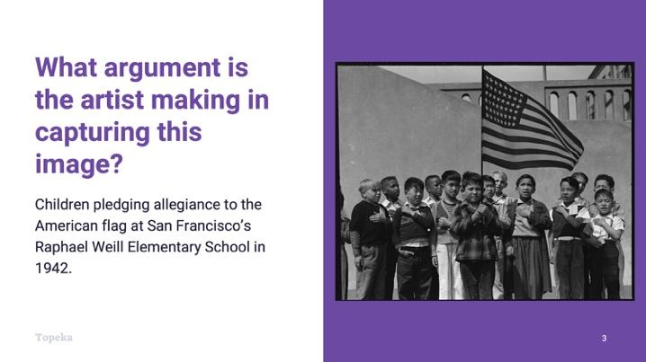
Slide 3
Teacher | Students
Have students complete an image analysis activity to activate prior knowledge of making arguments.  Project or pass out the photo “Children pledging allegiance to the American flag.”  Pass out Entry Ticket “Analyze an Image” | Examine the photo and answer the questions on the Entry Ticket.
Upon completion, teacher invites students to Pair and Share with a classmate to discuss answers.  For information on implementing Pair and Share via remote learning, see Remote Engagement: Pair and Share or the guide to Remote Learning with Topeka.  Discuss your answers with your neighbor. If you disagree, explain in greater detail how you came up with your answers. Using specific details from the image can make your answers more powerful. Remember, your interpretation is your own. | Students turn to a neighbor and compare answers.

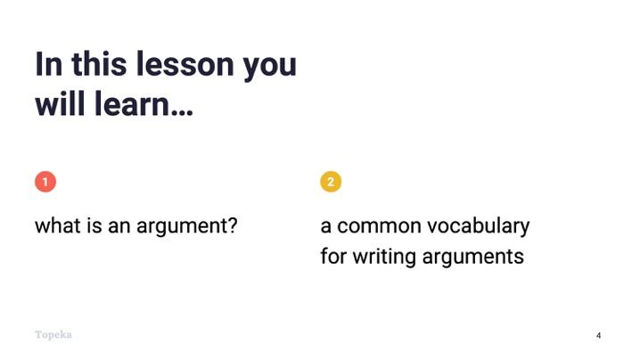
Slide 4
Teacher | Students
Teacher sets the purpose for the day by describing what will be covered.  The activity you just completed is going to help you make an argument about the photograph. In order to make a good argument, it’s helpful to understand some key terms for the components of an argument. So today, we’re going to learn first, what an argument is, and second, a common vocabulary for creating and discussing arguments. | Students listen and take notes.

Step 2: I Do It/We Do It Together
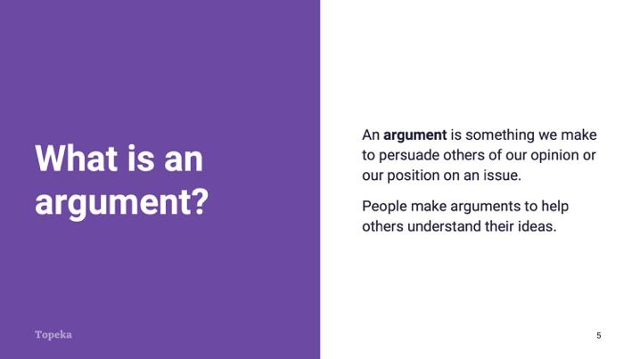
Slide 5
Teacher | Students
Teacher presents concepts in the context of a review of the Entry Ticket.  Consider pre-recording this portion of the lesson for remote delivery. See the guide to Remote Learning with Topeka for more details.  In the Entry Ticket you answered a few questions about an image. The first question simply asked you to summarize what you saw. We’ll come back to that.  The second question asked you to interpret what you saw and to make a statement describing the “emotions, thoughts, observations, or themes” in the photo. Your response to this question is an argument: you have interpreted the photo one way, but someone else might interpret it another way.  An argument is something we make—it could be an essay, a video, a song, a picture, etc.—to persuade or convince others of our position on an issue. In this case, the “issue” is the meaning of the photograph. We make an argument to help others understand our ideas. | Students listen and participate as appropriate.

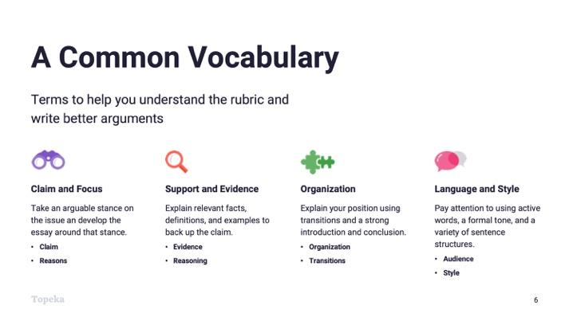
Slide 6
Teacher | Students
Teacher connects argumentation vocabulary words to rubric categories used for Revision Assistant automated scoring.  There are terms you can learn to help you think about and describe arguments that you want to make, and these same terms will help you understand the rubric that we’re working with for our argumentative essays. For example,  - For the Claim and Focus rubric category, you need to understand what a Claim is and what Reasons are in order to understand how reasons help us maintain focus on our claim.  - For the Support and Evidence category, you need to understand what Evidence is and how Reasoning is used along with evidence to prove your reasons.  This kind of vocabulary will also help you better understand organization and language and style. We will touch on these concepts today and explore them in greater depth later in the unit. | Students will listen and participate as appropriate.

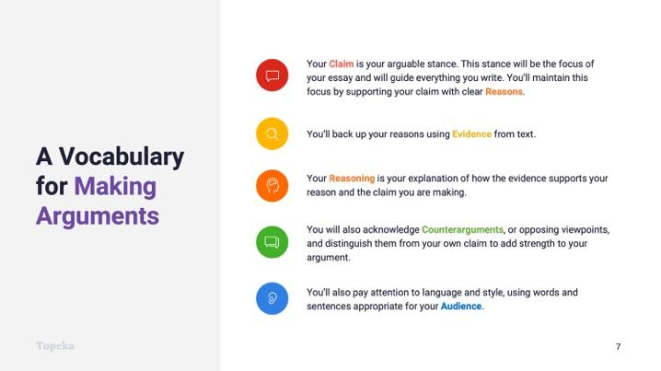
Slide 7
Teacher | Students
Teacher continues.  There is a helpful acronym that you can use to think about your arguments: CERCA, which stands for Claim, Evidence, Reasoning, Counterargument, and Audience. Think of these terms as your vocabulary for making arguments.  Teacher describes CERCA components using Slide 7 contents. | Students listen and take notes.

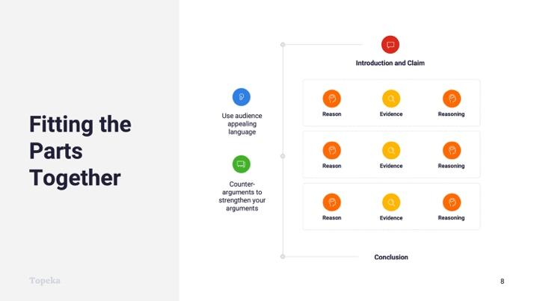
Slide 8
Teacher | Students
These parts fit together to create an argument, as you see here. A strong argument begins with an introduction and claim, is supported by multiple reasons, each with evidence and reasoning, and ends with a conclusion. Knowing our audience helps us use appropriate language and style, and acknowledging counterarguments throughout our essay helps make our argument stronger.

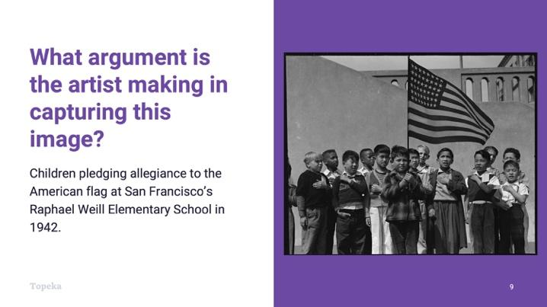
Slide 9
Teacher | Students
Teacher returns to the Entry Ticket to label the parts of the argument applied to the image.  Let’s go back to the Entry Ticket and discuss the answers you found.  First, who can share their answer to the first question? What is shown in the image?  Teacher elicits contributions describing factual details from the image, details that don’t require interpretation. For example, there are 13 children pictured. One is holding a flag. The boys are gathered around the flag. The flag has 48 stars. The clothing the boys wear doesn’t look like kids’ clothing today. | Students listen and watch teacher modeling.  Students contribute to the discussion with answers from their Entry Ticket.
Now let’s look at the second question: “What emotions, thoughts, observations, or themes is the photographer capturing in the photo?” Who would like to share their “one statement”?  Teacher calls on student or teacher models making a claim about the photo. For example, “The boys in the image are showing pride for their country during a time of war.”  This statement is the Claim. Your claim is your arguable stance that you’ll support with details from the image. Others might disagree or make a different claim.  Let’s see if we can support this claim with a reason: “The boys in the image are showing pride for their country.” One reason for this could be that the boys are all showing respect with their body language. What evidence can we point to in the text to support this reason? | Students contribute to the discussion with answers from their entry ticket.
Teacher models or calls on students to describe details in the photo to support the reason. For example:  - Boys are gathered around and facing the flag.  - Boys have hands over hearts.  - Many of the boys are looking right at the flag. | Students contribute to the discussion with details noticed in the image.
Teacher models or calls on students to provide reasoning to explain how details (evidence) support reason and claim.  From these details we can see that the boys take this ritual seriously and are paying full attention to the ceremony, not just going through the motions because they have to. | Students contribute to the discussion with reasoning connecting details to the claim.

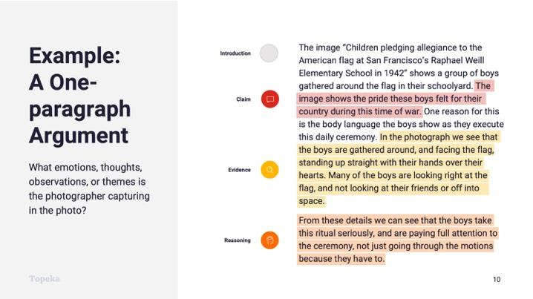
Slide 10
Teacher | Students
Teacher shows one-paragraph argument based on image to show how claim, reason, evidence, and reasoning fit together.
Let’s look at this example again. This paragraph introduces the photo with a summary of the image. The sentence highlighted in red makes the claim. The claim is supported by one reason. The details, highlighted in yellow, are the evidence, and the orange reasoning is an explanation of how the evidence connects to the claim.
Teacher calls on students in large group and asks students to make a different claim about the photograph, either new or from the entry ticket.  Can you make a different argument about the emotion conveyed in this image?  Teacher asks students to support the new claim using details from the photo and to explain how the details suggest that meaning. | Students examine the photo again or return to Entry Ticket.  Class collaborates to find additional evidence to support the new claim.

Step 3: You Do It Together
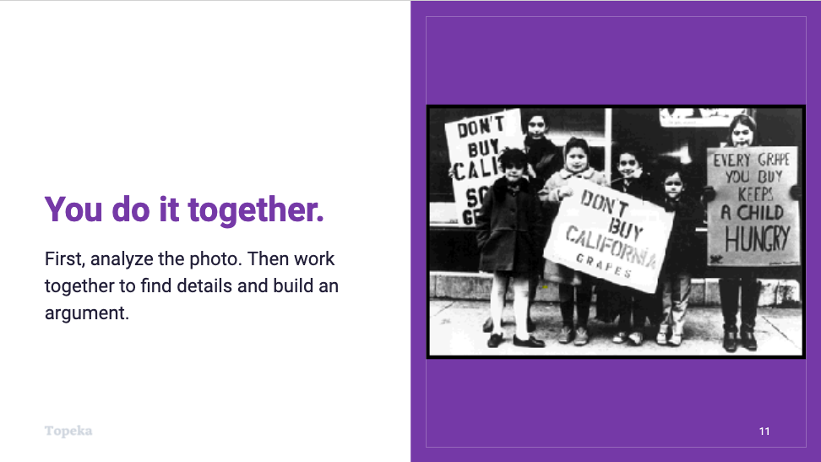
Slide 11
Teacher | Students
Teacher distributes activity and divides students into pairs or groups.  For information on implementing Small Group Collaboration via remote learning, see Remote Engagement: Small Groups or the guide to Remote Learning with Topeka.  Explain the activity.  Now we will do the same thing in groups using another image. In the first step you’ll do the image analysis, and in the second step you’ll work together to write a one-paragraph argument.  Teacher circulates to support students. | Students will complete Steps 1 and 2 of the activity.  In Step 1 they examine the new image.  In Step 2 they will build a one-paragraph argument using details from the text.

Step 4: Independent Application
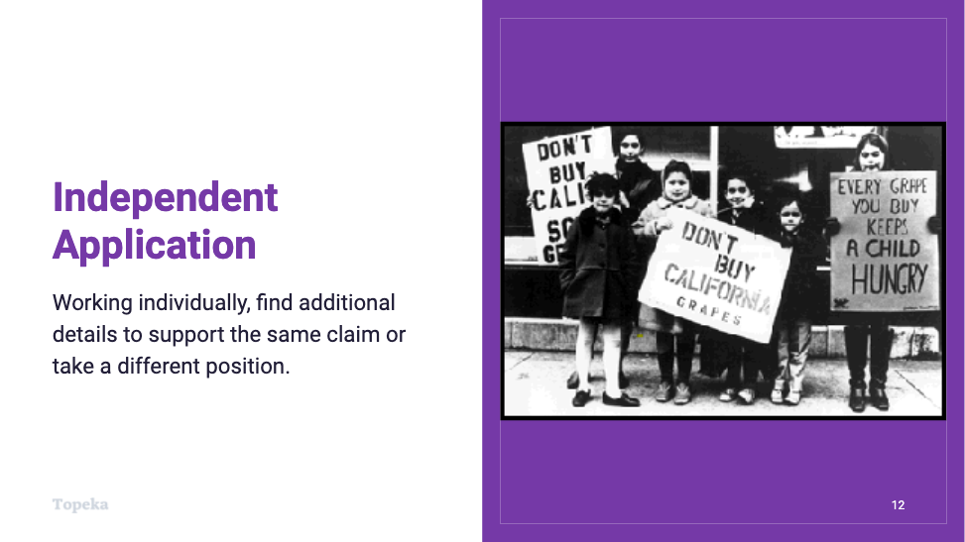
Slide 12
Teacher | Students
Teacher will direct students to work individually to write another paragraph.  Now that you’ve carefully analyzed the details in the image, find another reason that supports your claim and provide evidence. Or make a different claim about the image, and support it with a new reason and evidence.  Teacher circulates to support students. | Students will complete Step 3 of the activity, in which they write another paragraph, using either the same claim with new reason and evidence or a new claim.

Appendix A: Sample Responses

A Vocabulary for Writing Arguments—Entry Ticket
Look at the image. What does it show?

Describe what you see in the image in as much detail as possible.
Children are gathered in front of a flag pole, with their hands over their hearts. They are standing outside in a schoolyard. The group is diverse and made up of young boys. There are students who are Black, Asian, White, and Latinx. It seems like they are saying the pledge of allegiance.

Vocabulary Bank: flag, children, Pledge of Allegiance, Black, African-American, Asian-American, Latino (Latina/Latinx), White, school, yard

What emotions, thoughts, observations, or themes is the artist capturing in the image?
Write one sentence that captures a statement one could make about the purpose of this photo or image.
This image captures one of the roles American schools play in the country, where diverse groups of students are expected to become part of “one nation.”

Sentence Stem Bank:
In the photo of ____________, the people appear to ____________ suggesting ____________.
Using the image of ____________, the artist captures ____________.
Looking back through an historical lens, this image illustrates the idea that ____________, because in the picture that shows ____________.
Though some might see, ____________ another way to look at it is ____________.

Which details from the image support your answer to the question above?
Use the organizer to connect your thinking to your background knowledge and experiences. For every detail that you list, briefly describe the thought, feeling, or idea the detail has prompted for you as a viewer.
Thinking Critically
I saw...  A group of young boys are outside at their school by the flag pole with their hands over their hearts.  The group of students is very diverse, with Black, Asian, White, and Latinx students, mostly boys in the photo.  The kids are standing in a somewhat organized way around the pole, but not necessarily just posing for a picture. | Which made me think…  The kids are posing for a picture that shows them saying the Pledge of Allegiance.  This is a school full of kids of families from all parts of the world, who probably live in the same neighborhood.  The teacher asks the kids to say the Pledge of Allegiance every day.

Share your findings with a partner and develop a shared claim about the text. Record it here.
The kids in the photo are so young and seem to be saying the Pledge of Allegiance like they do every day because their school requires it, showing that part of the role schools play in the US is bringing diverse people together into “one nation.”

A Vocabulary for Writing Arguments–Activity

Step 1: Analyze the Image
What is shown in the image? Describe what you see in the image in as much detail as possible.
A group of children are protesting in front of a store. They hold up signs about the Grape Boycott to let shoppers know that they, the children, are the victims of the labor problems they are protesting. They are asking shoppers not to buy grapes. The children are dressed warmly, so it must be cold outside. The children are from different age groups. The children are smiling.

Vocabulary Bank: Children, signs, protest, grape boycott, and storefront.

What emotions, thoughts, observations, or themes is the photographer capturing in the image? Write one sentence that makes a statement about the purpose of this image.
Using the image of child boycotters, the journalist captures the true injustice faced by the families who work on the farms.
Sentence Stem Bank:
In the photo of ____________, the children ____________.
Using the image of ____________, the journalist captures ____________.
Looking back through an historical lens, this image documents ____________, because the picture shows ____________.
The image is particularly powerful because ____________.

Issues Bank:
Child Labor | The exploitation of children for cheap labor
Inequity | Unequal and unfair advantages or disadvantages
Privilege | A special right available only to some
Which details from the image support your answer to the question above? Use the organizer to connect your thinking to your background knowledge and experiences. For every detail that you list, briefly describe the thought, feeling, or idea the detail has prompted for you as a viewer.
Thinking Critically
I saw...  Children who are standing in front of a store with protest signs.  It is a black and white photo and the protest is about grapes.  One of the signs says “Don’t buy California grapes. Another says, “Every grape you buy keeps a child hungry.”  The kids are dressed warmly and are smiling. | Which made me think…  The children are representing the farm workers as part of the famous grape boycott.  The children are activists.  The fact that a child is holding the sign might make the shoppers feel more empathy.  The kids are outside on a cold day, but they are positive.

Share your findings with a partner and develop a shared claim about the text. Record it here.
The photo shows how children can be powerful advocates for a cause that affects their community.

Step 2: Write an Argument Together
Write a claim to respond to the prompt.
What is the argument of the photo?
The photo shows the power of kids in a protest that impacts families in a community.

Support your claim with one reason.
The kids are standing right in front of the stores where shoppers might go, asking those shoppers to boycott products.

Support your reason with details you found in the image.
The signs are reminders that the shoppers have an impact on these children’s lives, like the one that says “Every grape you buy keeps a child hungry.”

For each piece of evidence presented, provide an explanation of how it supports your claim. This is your reasoning. Don’t assume everyone interprets the evidence as you do. Make your thinking visible to others.
The shopper is the “you” in the sign, and shoppers have to walk past these children who are farmworkers or allies supporting the farmworkers, which makes it harder to ignore than a news headline or even an adult.

Step 3: Independent Application

Make a new argument or support the same argument with another reason and evidence.

Write your claim.
The photo shows how children can be powerful advocates for a cause that affects their community.

Support the claim with a new reason.
The various ages of the children involved in the boycott is powerful.

Support your reason with details you found in the image.
Some of the kids in the photo are really young, like the little one who is holding up the sign that says “Don’t buy California grapes.”

For each piece of evidence presented, provide an explanation of how it supports your claim. This is your reasoning. Again, make your thinking visible to others.
Using small children to share this message highlights how vulnerable the kids are who are impacted by the mistreatment of farmworkers. Shoppers may be more likely to act because they can connect this child’s face to the message about farm workers being exploited.

Appendix B: Engagement Strategies Via Remote Learning
The following links provide useful information for implementing this lesson through remote learning:
- Remote Learning with Topeka.
- Remote Engagement: Pair and Share
- Remote Engagement: Small Groups

