Writing
Day 2: Claim and Focus
Daily Lesson Plan

Lesson Summary
In this lesson, teachers and students will look closely at the attributes that make a claim strong and set the focus for the rest of an argument.

- Step 1: Set Purpose/Activate Prior Knowledge—Students will complete Entry Ticket evaluating claims. Teacher will then review concept of claims in the context of review of Entry Ticket.
- Step 2: I Do It/We Do It Together—Teacher and students will further explore how strong claims address the requirements of the writing prompt through teacher modelling and whole-class discussion.
- Step 3: You Do It Together—Students will partner to analyze a writing prompt in order to develop a strong claim.
- Step 4: Independent Application—Students will work individually to analyze a writing prompt in order to develop a strong claim.

Objective
Students will understand what attributes contribute to a strong claim and will be able to evaluate and revise claims based on attributes of strong claims. Students will understand how strong claims lead to focused arguments.

Engagement Strategies
- Pair and Share: Students will turn to a partner and collaborate through discussion. See also, Remote Engagement: Pair and Share.
- Collaborating to Find Evidence: Students will work in pairs or small groups to evaluate and revise a claim statement. See also, Remote Engagement: Small Groups.
Links to information for remote learning are also provided in the lesson steps below. A complete list can be found in Appendix B.

Scaffolding Strategies
The scaffolding strategy listed below is an optional support included in the lesson’s activities. This tool may be used or ignored based on students’ needs.
- Vocabulary Bank: Students, particularly students who are English learners, can use these definitions for additional support during activities.

Remote Learning Strategies

With careful advanced planning, Topeka lessons can be easily moved to a remote modality. Links to specific engagement strategies are included throughout this lesson plan. See Topeka’s professional learning resource Remote Learning with Topeka for additional suggestions for each stage of the typical Topeka lesson.

Key Vocabulary
- Claim
- Reasons
- Focus

See bolded words and definitions throughout lesson’s text.

Materials
- Presentation—Claim and Focus
- Entry Ticket—Claim and Focus
- Model Prompt Analysis
- Activity—Addressing the Prompt

Standards Addressed in this Lesson
- Write arguments to support claims in an analysis of substantive topics or texts using valid reasoning and relevant and sufficient evidence. (CCSS.ELA-LITERACY.CCRA.W.1)

Lesson Steps

Step 1: Set Purpose/Activate Prior Knowledge
Teacher | Students
Teacher activates prior knowledge of claims by having students complete an Entry Ticket to evaluate a series of claims according to different criteria. | Complete an Entry Ticket to evaluate claims to determine if the claims are arguable, clear, and specific.
Upon completion, teacher invites students to Pair and Share with a classmate to discuss answers.  For information on implementing Pair and Share via remote learning, see Remote Engagement: Pair and Share or the guide to Remote Learning with Topeka.  Discuss your answers with your neighbor. If you disagree, explain in greater detail how you came up with your answers. | Students will turn to a neighbor and compare answers.

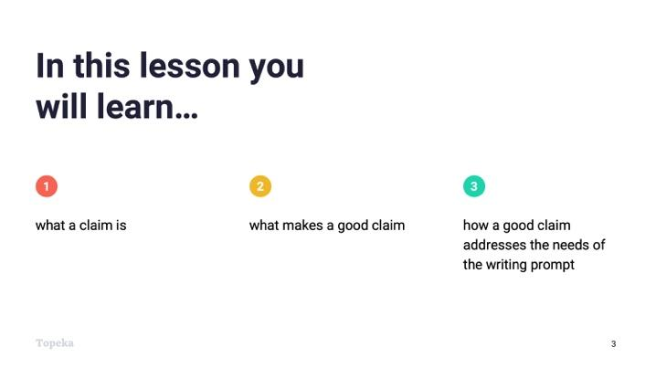
Slide 3
Teacher | Students
Teacher sets the purpose for the day by describing what will be covered.
The activity you just completed had you examine some example claims. In this lesson, we’re going to look closely at what it means to make a claim and what a strong claim looks like, and then we will discuss how a strong claim can help focus an argument. You’ll be able to practice writing a claim and making sure that claim addresses the needs of the writing prompt.

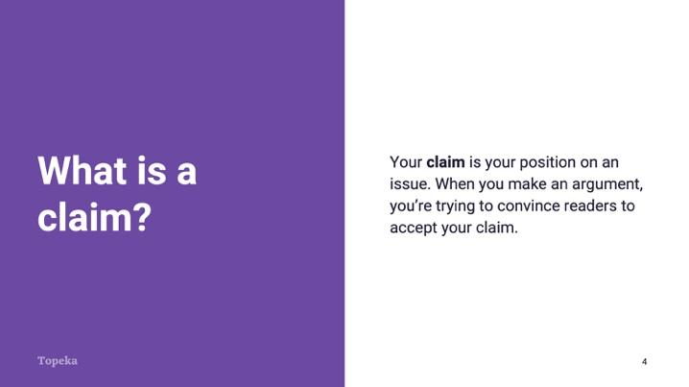
Slide 4
Teacher | Students
Teacher presents concepts in the context of a review of the Entry Ticket.  In the Entry Ticket you analyzed some statements to decide whether or not the statements could be considered strong claims. Let’s review what a claim is.  Your claim is your position on an issue in an argument. When you make an argument, you’re trying to convince readers to accept your claim. | Students listen and make notes on Entry Ticket as needed.

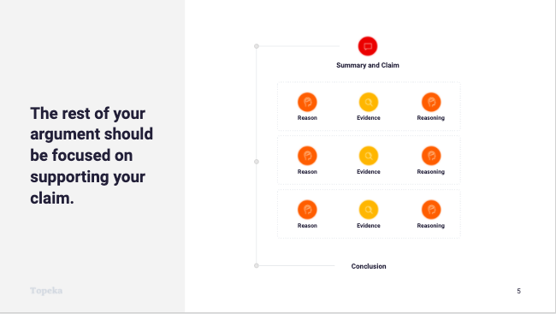
Slide 5
Teacher | Students
Teacher continues.  The rest of your argument should be focused on the claim.  Each of your reasons will provide support for the claim. Your evidence will help prove your reasons and your reasoning will explain how the evidence and reason are connected to the claim.  It's much easier to develop strong support when you have a good claim. So what makes a good claim? | Students listen and take notes.

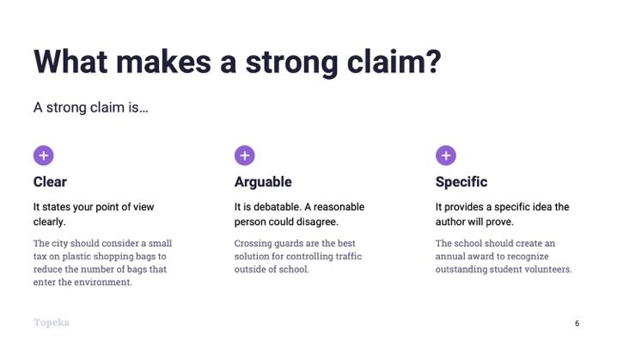
Slide 6
Teacher | Students
Teacher provides attributes of a strong claim:  A strong claim is clear: An example of a clear claim would be "The city should consider a small tax on single-use plastic shopping bags to reduce the number of bags that enter the environment." An unclear version of that might be "They should tax bags because of plastic."  Is there a claim in the Entry Ticket that’s clear?  Teacher pauses to allow student participation. | Students will listen and participate as appropriate.
Teacher continues.  A strong claim is also arguable. A fact is not arguable. A statement like "There are 100 members in the United States Senate" is true or untrue, but there aren’t different reasonable views on the question.  Let's look at this example: "Crossing guards are the best solution for controlling traffic outside of school." I might think speed bumps are better. That's a reasonable alternative position, so the claim is arguable.  In the Entry Ticket, which of the claims are arguable?  Teacher pauses to allow student participation. | Students will listen and participate as appropriate.
Teacher continues.  Finally, a strong claim is specific. A specific claim will provide enough detail that it will be obvious to readers what you are arguing for and you'll have an easier time focusing the argument around the claim. This claim is specific: “The school should create an annual award to recognize outstanding student volunteers.” A non-specific version of this might be “Someone should acknowledge volunteers.”  Which claims from the Entry Ticket could you consider to be specific?  Teacher pauses to allow student participation. | Students will listen and participate as appropriate.

Step 2: I Do It/We Do It Together
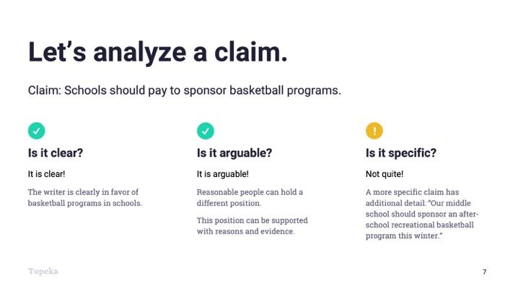
Slide 7
Teacher | Students
Teacher models the process of analyzing an example claim with student input.  Consider pre-recording this portion of the lesson for remote delivery. See the guide to Remote Learning with Topeka for more details.  Let's consider the claim "Schools should pay to sponsor basketball programs."  First, I want to ask, “Is it clear?” It's clear to me that the writer of this claim is in favor of basketball programs, so I'll say yes, this is clear.  Is it arguable? Well, reasonable people might prefer that their schools sponsor soccer programs or that school funds not be used for extracurricular activities at all.  Also, can I support this claim with reasons and evidence? Sure. So yes, it's arguable.  Is it specific? Not really. I don't know which school, which grade level, what type of program, or when it should be done. So this claim could be more specific.  For example, a more specific claim might be “Our middle school should sponsor an after-school recreational basketball league this winter.”  How else could we make this claim more specific? | Students will listen and participate as appropriate.  Students contribute details that could make the claim more specific.

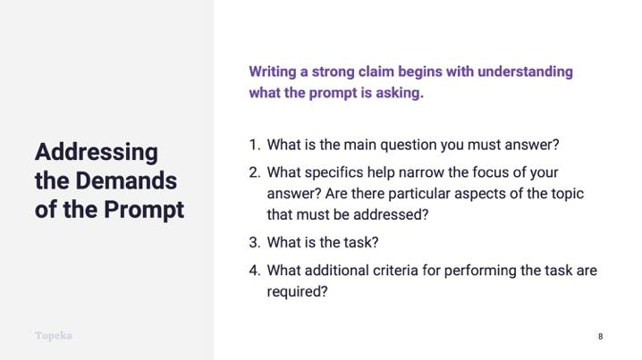
Slide 8
Teacher | Students
Teacher will explain how a strong claim in academic writing addresses the demands of the writing prompt.  When you’re making an argument in your school work, you are almost always responding to a writing prompt or an assignment. In order to know if you are answering the question, you must start by analyzing the prompt.  - What is the main question you must answer?  - What specifics help narrow the focus of your answer? Are there particular aspects of the topic that must be addressed?  - What is the task?  - What additional criteria for performing the task are presented?  So let’s see what that looks like in practice.  Teacher distributes the model prompt analysis handout.  Your handout gives instructions for asking these questions. I’ll do the first couple and then we’ll do the rest together. | Students listen and take notes.

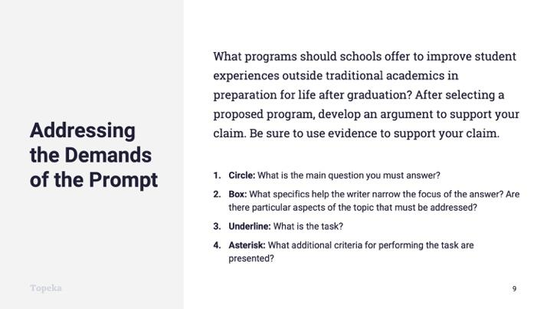
Slide 9
Teacher | Students
Teacher models answering the questions.  - Circle: What is the main question you must answer?  We need to understand what is the heart of the matter we’re being asked about. In this example prompt, the main question is the very first thing. “What programs should schools offer?” I will circle that.  Next question:  - Box: What specifics help narrow the focus of your answer? Are there particular aspects of the topic that must be addressed?  The instructions tell me to put a box around each of these specifics so that I can be sure to address each and every one. My first box would go around the very next phrase: “to improve student experiences.”  Now it’s obvious to me that I’m writing about programs to improve student experiences, as opposed to, say, test scores. | Students follow along and mark up copy of prompt.  Students follow along and mark up copy of prompt.

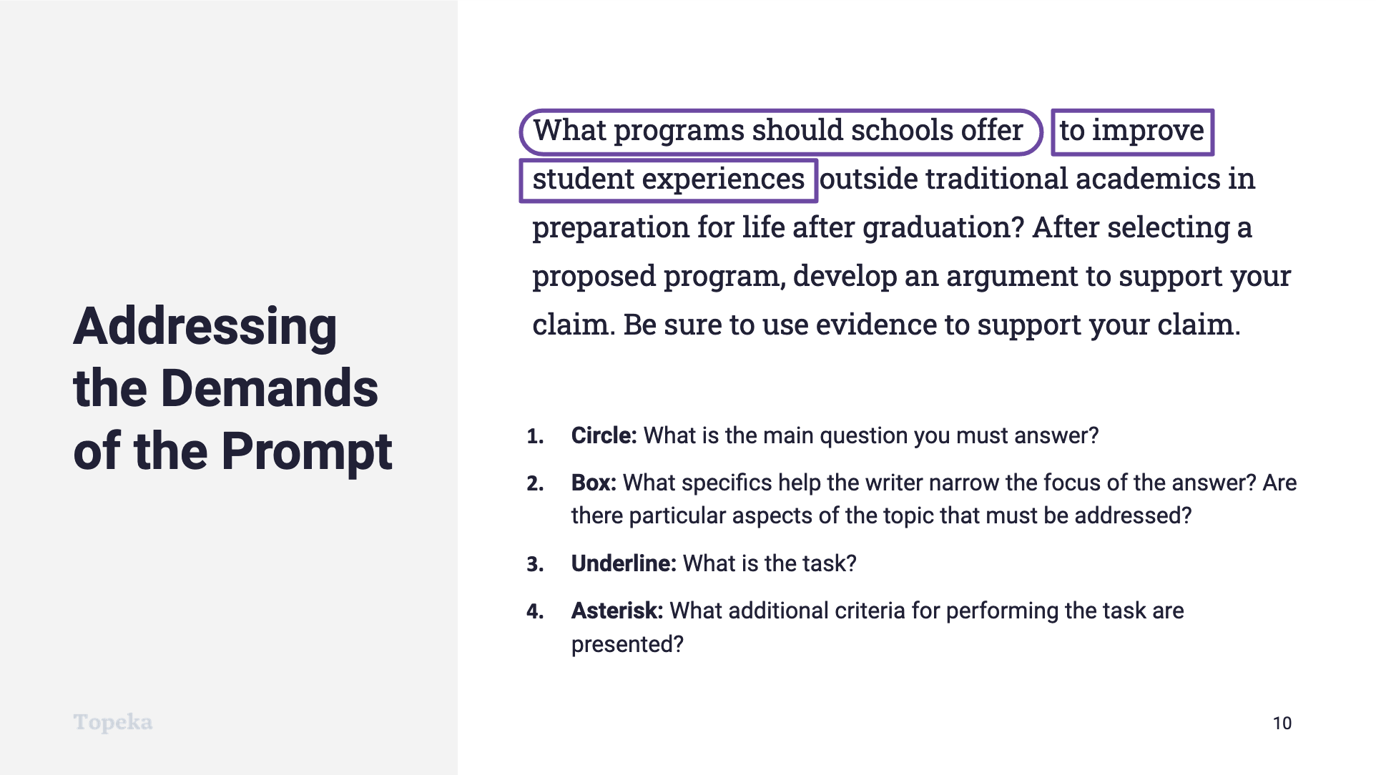
Slide 10
Teacher | Students
Teacher continues.  So now my prompt looks something like this. What other specifics can we put boxes around?  If necessary, teacher points out to students that additional boxes could be placed around specifics like “in preparation for life after graduation” and “outside of traditional academics,” further narrowing the focus of an appropriate claim.  Next we are asked to underline:  - What is the task?  The task is what you’re being told to create. What is the task in this prompt?  If necessary, teacher leads students to an understanding that the task is the sentence “After selecting a proposed program, develop an argument to support your claim.”  And finally, we put asterisks around additional details that say how we should perform the task.  - What additional criteria for performing the task are presented?  What details tell us how to perform the task?  If necessary, teacher points out to students that “use evidence to support your claim” is additional criteria that should be marked. | Students mark up their copy of the model writing prompt and offer suggestions for additional specifics.  Students mark up their copy of the model writing prompt and offer suggestions for the task at hand.  Students mark up their copy of the model writing prompt and offer suggestions for criteria for performing the task.

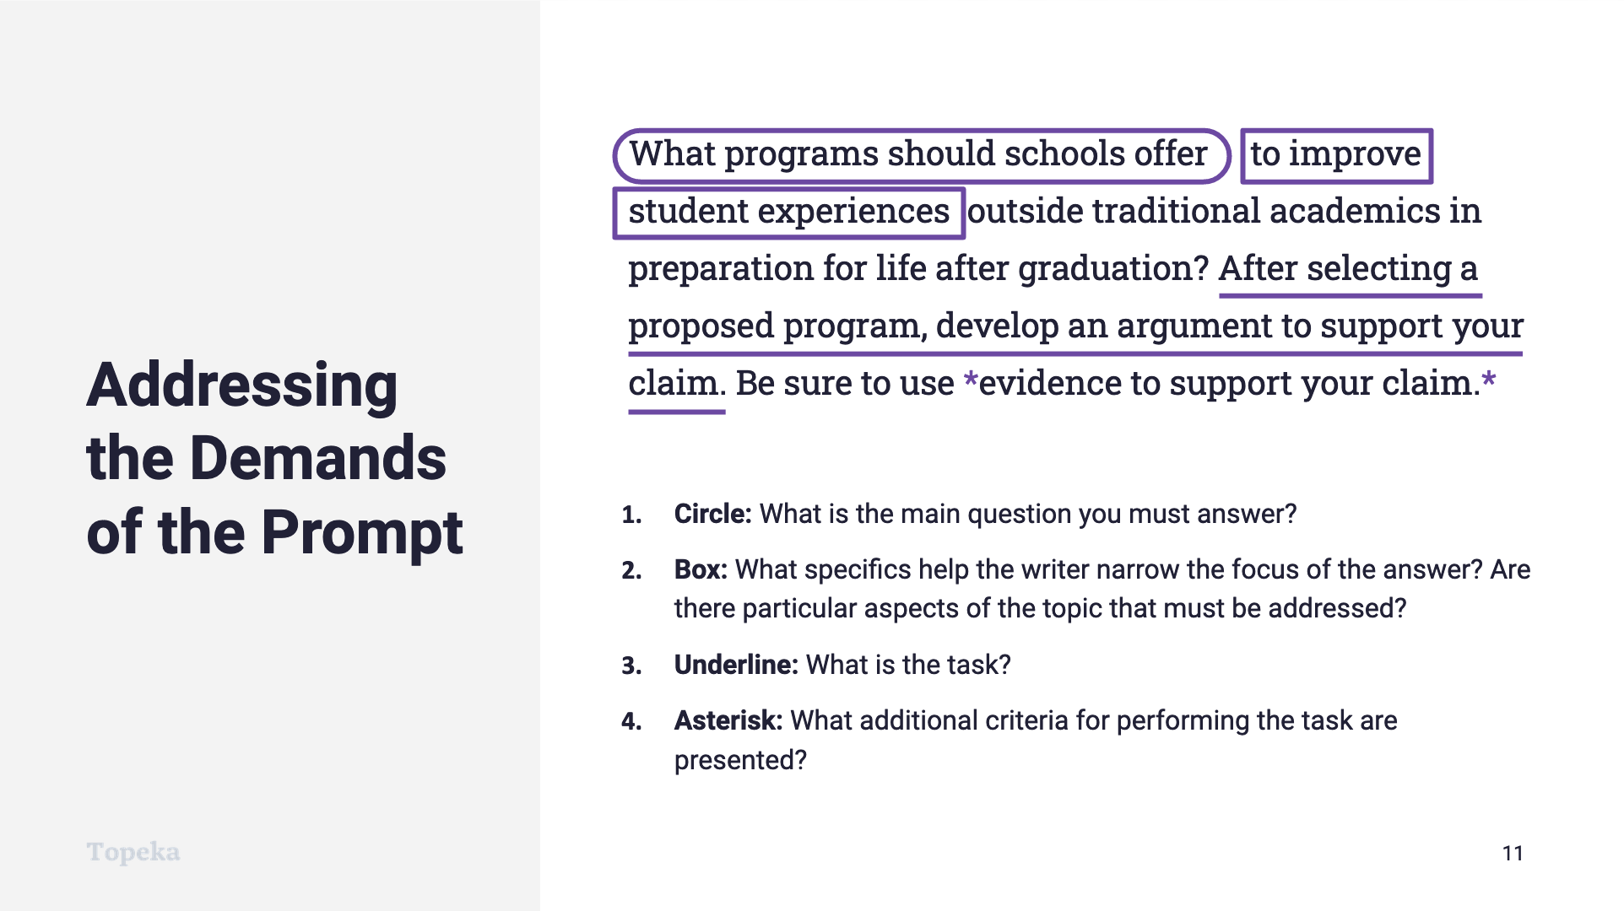
Slide 11
Teacher | Students
Teacher displays marked-up model prompt and prepares students for the task of writing a claim in response.  Having done my analysis of the prompt, I now know that I need to argue for schools to offer a program, a program that is in addition to traditional academics, and a program that will prepare students for life after graduation. And knowing these specifics, I can develop a prompt that will set me up for a well-focused essay. For example... | Students listen and take notes.

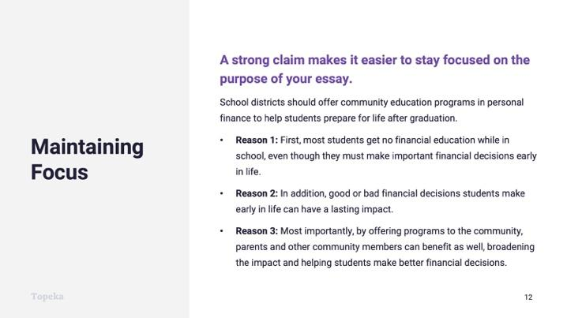
Slide 12
Teacher | Students
Let's see how a strong claim helps set up the rest of the essay.  Here's a claim one could make following from the writing prompt: "School districts should offer community education programs in personal finance to help students prepare for life after graduation."  The details provided in the claim are addressing the specifics of the writing prompt and leading directly to reasons to support the claim. For example: the prompt asks for programs outside of traditional academics, so choosing financial literacy, which is not taught in many schools, addresses that requirement, and leads to the first reason: “most students get no financial education while in school….”  Who sees another connection between the claim and the reasons?  If needed, teacher points out connections between, for example, “life after graduation” in prompt, claim, and reason two. | Students contribute to make connections between the details of the claim and the reasons provided.

Step 3: You Do It Together
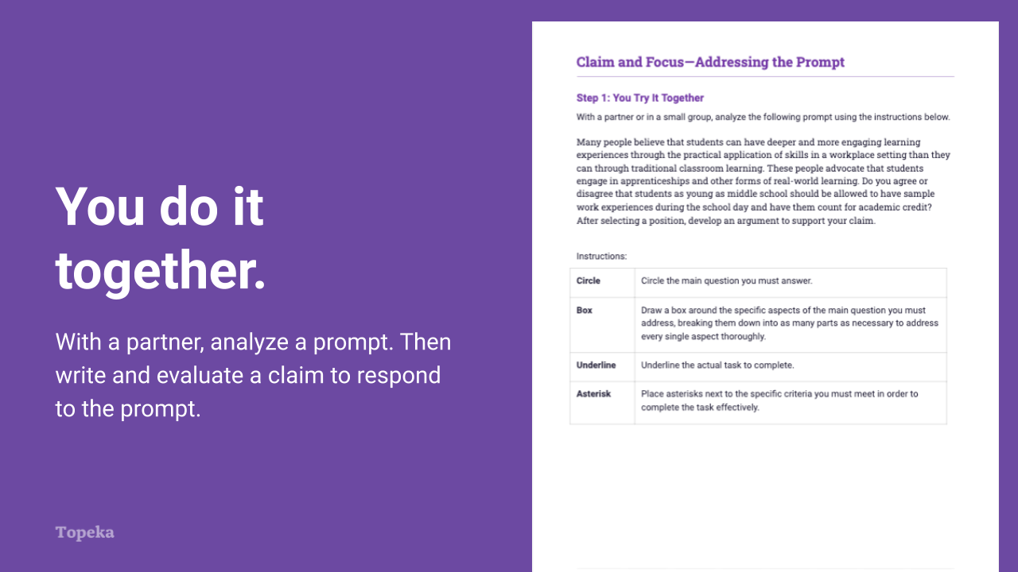
Slide 13
Teacher | Students
Teacher directs students to partner to complete Step 1 of the exercise.  For information on implementing Small Group Collaboration via remote learning, see Remote Engagement: Small Groups or the guide to Remote Learning with Topeka.  Teacher circulates to provide assistance as needed. | Students will work together to perform prompt analysis in Step 1 of the exercise in the manner just modeled. After analyzing the prompt, students will evaluate the claim that they just created and will revise as needed.
If time allows, teacher reconvenes for a full group debrief, allowing students to describe their analyses and revisions made to their claims.

Step 4: Independent Application
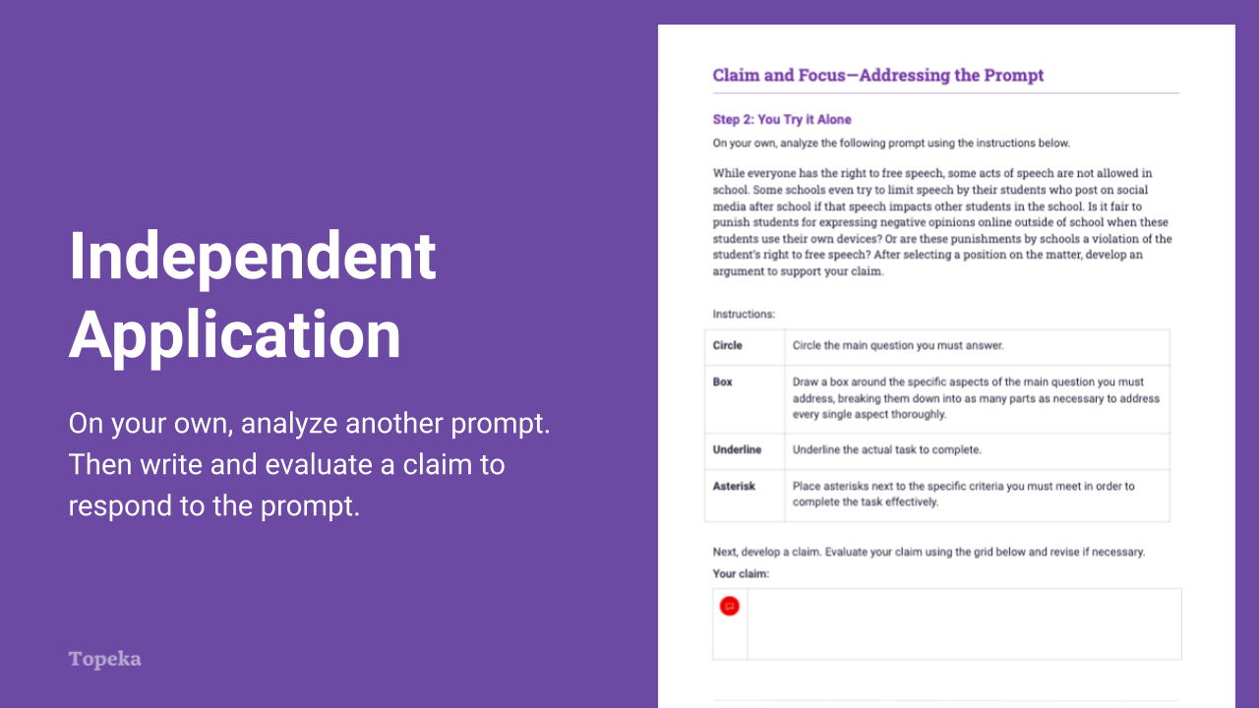
Slide 14
Teacher | Students
Teacher directs students to complete Step 2 of the exercise independently.  Teacher circulates to provide assistance as needed. | Students will work independently to perform a prompt analysis in Step 2 of the exercise in the manner just modeled and practiced. After analyzing the prompt, students will evaluate the claim that they just created, and will revise as needed.
If time allows, teacher reconvenes for a full group debrief, allowing students to describe their analyses and revisions made to their claims. | Students will participate by sharing analyses and revisions.

Appendix A: Sample Responses

Claim and Focus—Entry Ticket
Statement | Arguable | Not Arguable
Single-use plastic shopping bags are worse for the environment than more durable reusable bags. |  | Not arguable, because reusable is better than single-use.
New taxes create a burden for the poor more than they do for middle-class or wealthy families. |  | Not arguable because more costs for basic items like a grocery bag are simply harder for the poor.
The city should consider a small tax on plastic shopping bags to reduce the number of bags that enter the environment. | X
Citizens should be rewarded for their efforts to improve the local environment. | X

Claim | Clear | Specific
They should do something about traffic around the school. | Not clear | Not specific
Crossing guards are the best solution for controlling traffic outside of school. | Clear | Specific
Those are problems that should be fixed. | Not clear | Not specific

Model Prompt Analysis
Circle | Circle the main question you must answer.  What programs should schools offer to improve student experiences outside the traditional academic program in preparation for life after graduation?
Box | Draw a box around the specific aspects of the main question you must address, breaking them down into as many parts as necessary to address every single aspect thoroughly.  - What programs...  - should schools offer...  - to improve student experiences outside the traditional academic program...  - in preparation for life after graduation?
Underline | Underline the actual task to complete.  After selecting a proposed program, develop an argument to support your claim.
Asterisk | Place asterisks next to the specific criteria you must meet in order to complete the task effectively.  *use evidence to support your claim.*

Addressing the Prompt Activity: You Try It Together

Circle | Circle the main question you must answer.  Do you agree or disagree that students as young as middle school should be allowed to have sample work experiences during the school day and have them count for academic credit?
Box | Draw a box around the specific aspects of the main question you must address, breaking them down into as many parts as necessary to address every single aspect thoroughly. (Note the issues found in each.)  - Do you agree or disagree (Or do you both agree and disagree?)...  - that students (Do you agree/disagree that all students should?)...  - as young as middle school (Or just this age group?)...  - should be allowed (Should the school be able to stop this?)...  - to have sample work experiences (Are these useful?)...  - during the school day (Is this a better use of time than class?)...  - and have them count for academic credit? (Should this count as academic experience? Should there be a different reward?)
Underline | Underline the actual task to complete.  After selecting a position, develop an argument to support your claim.
Asterisk | Place asterisks next to the specific criteria you must meet in order to complete the task effectively.  After selecting a position*,  develop an argument*  to support your claim.*

Addressing the Prompt Activity: You Try It Alone

Circle | Circle the main question you must answer.  Is it fair to punish students for expressing negative opinions online outside of school when these students use their own devices? Or are these punishments by schools a violation of the student’s right to free speech?
Box | Draw a box around the specific aspects of the main question you must address, breaking them down into as many parts as necessary to address every single aspect thoroughly. (Note the issues found in each.)  - Is it fair to punish (Does it seem reasonable to do?)...  - students (As opposed to others, such as teachers, admins, or parents?...  - for expressing negative opinions (How is negative defined?)...  - online outside of school (Is expressing oneself on the internet outside of school hours something the school should control?)...  - when these students use their own devices? (When not using school property?)...  - Or are these punishments by schools (Do schools have a special right to discipline students for behavior outside of school that others do not?)...  - a violation of the student’s right to free speech? (In which spaces and times, if any, should speech be restricted?)
Underline | Underline the actual task to complete.  After selecting a position, develop an argument to support your claim.
Asterisk | Place asterisks next to the specific criteria you must meet in order to complete the task effectively.  After selecting a position on the matter*,  develop an argument*  to support your claim.*

Appendix B: Engagement Strategies Via Remote Learning
The following links provide useful information for implementing this lesson through remote learning:
- Remote Learning with Topeka
- Remote Engagement: Pair and Share
- Remote Engagement: Small Groups

