Writing
Day 3: Support and
Evidence
Daily Lesson Plan

Lesson Summary
In this lesson, students will examine how reasons, evidence, and reasoning work together to support a claim. Students will begin the session by identifying reasons that maintain focus on given claims. Later students and teacher will discuss good and bad evidence and will practice selecting evidence and explaining reasoning to support claims, both in groups and individually. The lesson will end with a full-group debate activity.

- Step 1: Set Purpose/Activate Prior Knowledge—Students will complete Entry Ticket, selecting reasons from a list with distractors.
- Step 2: I Do It/We Do It Together—Teacher and students will analyze reasons and evidence and discuss what makes some evidence strong and some weak.
- Step 3: You Do It Together—Following teacher model on previous step, students will collaborate to find additional reason/evidence/reasoning for given claim.
- Step 4: Independent Application—Students will work independently to build reason/evidence/reasoning for counterclaim.
- Step 5: Four-Corners Debate—Class will divide into four groups for a debate activity using the strongest support selected from previous student work.

Objective
Students will support claims using relevant, appropriate, and valid reasons, evidence, and reasoning.

Engagement Strategies
- Pair and Share: Students will turn to a partner and collaborate through discussion. See also, Remote Engagement: Pair and Share.
- Collaborating to Find Evidence: Students will work in pairs or small groups to find and evaluate evidence while practicing reasoning together. See also, Remote Engagement: Small Groups.
- Four Corners Debate: Students will work in four groups to build arguments using support developed by the students. Students will present resulting arguments in a debate-like round. See also, Remote Engagement: Four Corners Debate.
Links to information for remote learning are also provided in the lesson steps below. A complete list can be found in Appendix B.

Scaffolding Strategies
The scaffolding strategies listed below are optional supports included in the lesson’s activities. These tools may be used or ignored based on students’ needs.
- Vocabulary Bank: Students, particularly students who are English learners, can use these words for additional support during activities.
- Sentence Stem Bank: Students can use sentence stems to articulate their critical thinking about key aspects of the image.
- Issues Bank: Students can use the key words in the issues bank as a scaffold to developing reasoning statements

Remote Learning Strategies
With careful advanced planning, Topeka lessons can be easily moved to a remote modality. Links to specific engagement strategies are included throughout this lesson plan. See Topeka’s professional learning resource Remote Learning with Topeka for additional suggestions for each stage of the typical Topeka lesson.

Key Vocabulary
- Claim
- Reasons
- Evidence
- Reasoning
- Counterargument

See bolded words and definitions throughout the lesson's text.

Materials
- Presentation—Day 3: Support and Evidence
- Entry Ticket–Identifying Reasons
- Activity–Developing Support
- Four Corners Debate Handout

Standards Addressed in this Lesson
- Write arguments to support claims in an analysis of substantive topics or texts using valid reasoning and relevant and sufficient evidence. (CCSS.ELA-LITERACY.CCRA.W.1)
- Draw evidence from literary or informational texts to support analysis, reflection, and research. (CCSS.ELA-LITERACY.CCRA.W.9)

Lesson Steps

Step 1: Set Purpose/Activate Prior Knowledge
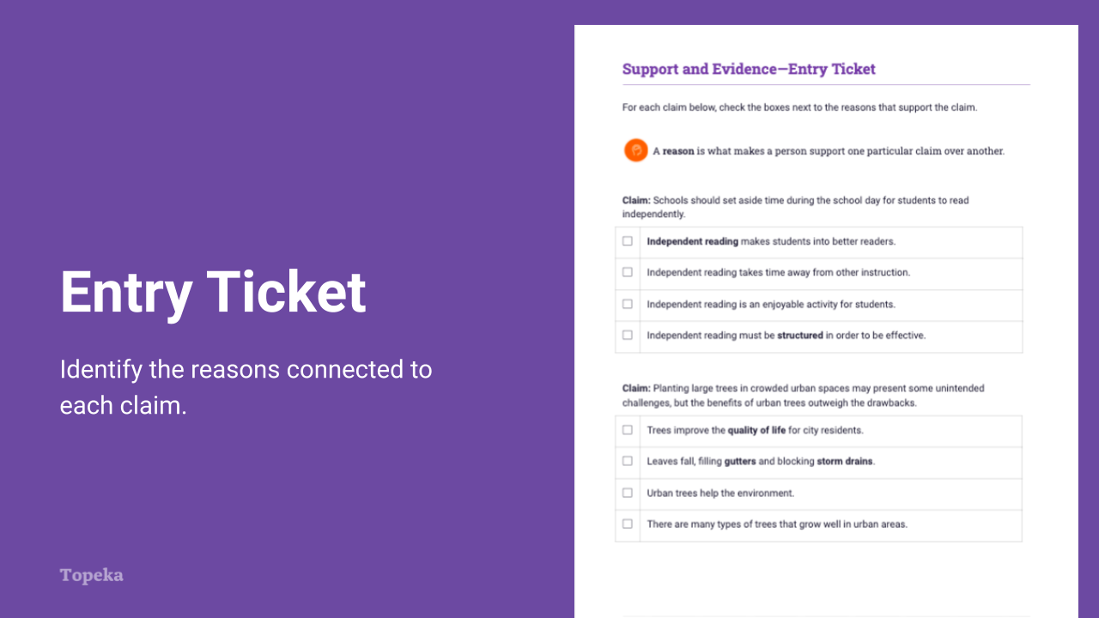
Slide 2
Teacher | Students
Teacher sets the purpose for the class with an Entry Ticket activity to activate prior knowledge of how reasons connect to claims. | Students complete the activity. For each claim offered, students will select the reasons that support the claim and maintain the focus of the argument.
Upon completion, teacher invites students to Pair and Share with a classmate to discuss answers.  For information on implementing Pair and Share via remote learning, see Remote Engagement: Pair and Share or the guide to Remote Learning with Topeka.  Discuss your answers with your neighbor. If you disagree, explain how you think the reason does or does not connect to the claim. | Students turn to a neighbor and compare answers.

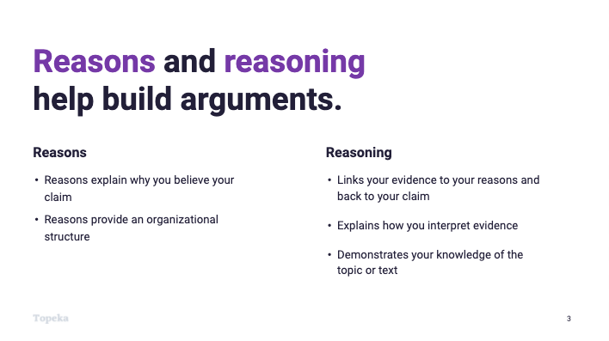
Slide 3
Teacher | Students
Teacher explains the importance of strong reasons and effective reasoning:  In the Entry Ticket activity you identified reasons that would or would not support a claim. Reasons and reasoning are very important in writing arguments—these are the building blocks of the support you’ll give to your claim. Without the reasoning to organize and explain your use of evidence, the evidence and the argument aren’t as strong.  Reasons explain why you believe your claim. For example, imagine I were making this claim: Schools should set aside time during the school day for students to read independently.  My reasons might be that independent reading makes students into better readers and independent reading is an enjoyable activity for students.  Reasoning is an explanation of how your reason (and the evidence you’ll add) connect to your claim. | Students attend to the explanation and take notes.

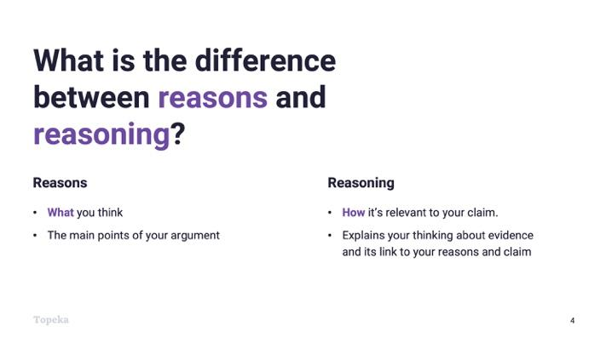
Slide 4
Teacher | Students
Teacher continues.  Reasons are what you think  Reasoning is an explanation of how your evidence is relevant to your claim. | Students listen and take notes

Step 2: I Do It/We Do It Together
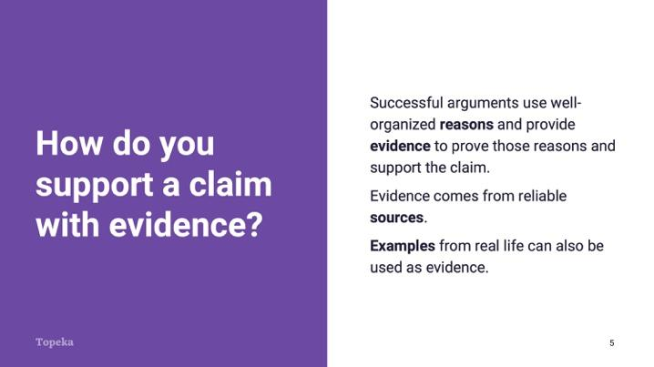
Slide 5
Teacher | Students
Consider pre-recording this portion of the lesson for remote delivery. See the guide to Remote Learning with Topeka for more details.  Teacher explains how evidence supports a claim:  When writing arguments, we use evidence to show that our reasons are valid—to prove that our argument should be accepted. | Students listen and watch teacher modeling.

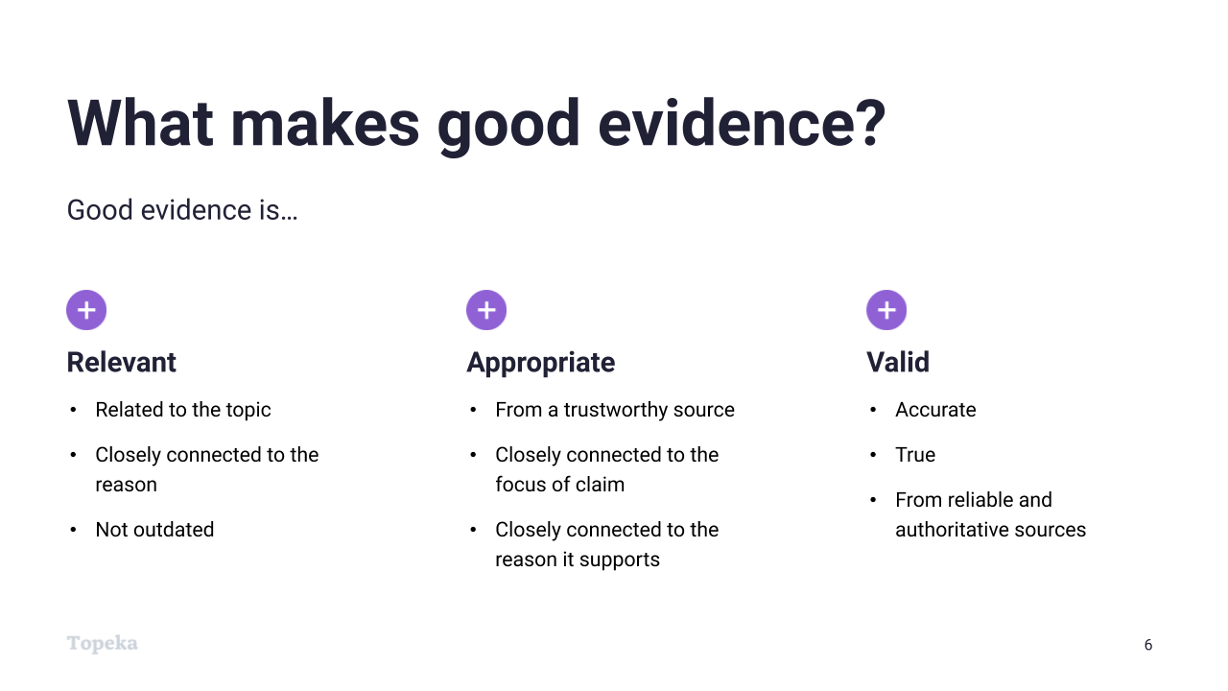
Slide 6
Teacher | Students
Teacher summarizes what makes evidence strong. See Slide 6. | Students listen and take notes as teacher models.

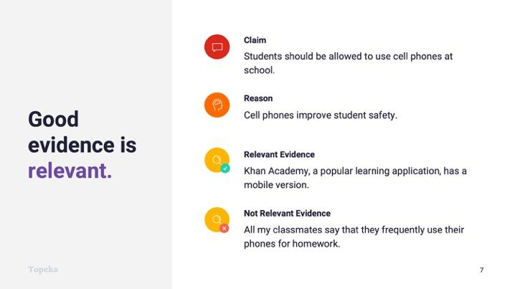
Slide 7
Teacher | Students
Teacher introduces the claim “Students should be allowed to use cell phones at school.” Ask students to contribute to a discussion of good and bad evidence:  Good evidence is relevant. It’s related to the topic and closely connected to the reason. So here our reason is, “Cell phones improve student safety.” In this example, why does one piece of evidence work, and the other does not? | Students examine the evidence and contribute to the discussion.

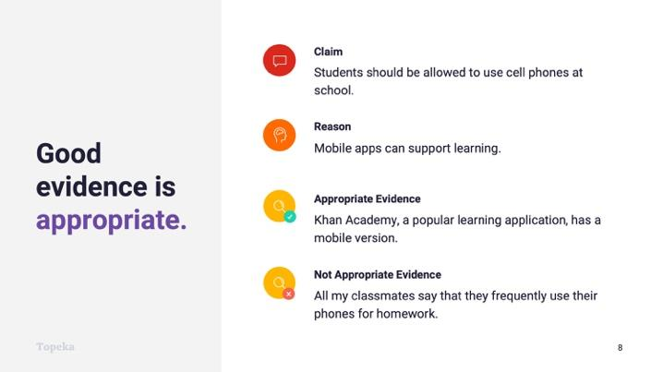
Slide 8
Teacher | Students
Teacher continues.  Good evidence is appropriate. It is from a trustworthy source and is closely connected to the claim and reason. In this example, why does one piece of evidence work, and the other does not? | Students examine the evidence and contribute to the discussion.

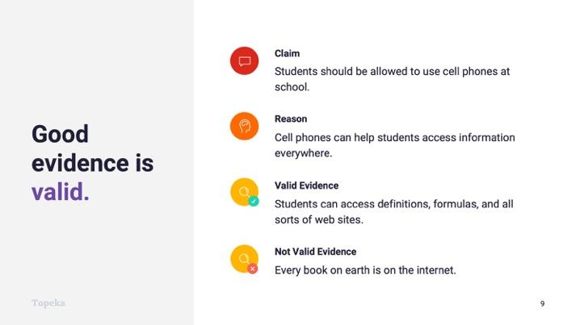
Slide 9
Teacher | Students
Teacher continues.  Good evidence is valid. It is true, accurate, and from reliable and authoritative sources. In this example, why does one piece of evidence work and the other does not? | Students examine the evidence and contribute to the discussion.

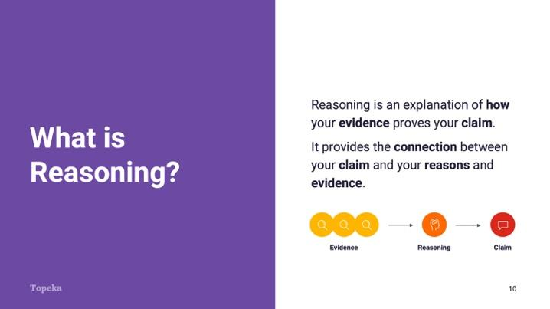
Slide 10
Teacher | Students
Teacher explains reasoning.  We touched on the difference between reasons and reasoning earlier. Reasoning is your explanation of why your reason and evidence are relevant to the claim. | Students listen and take notes.

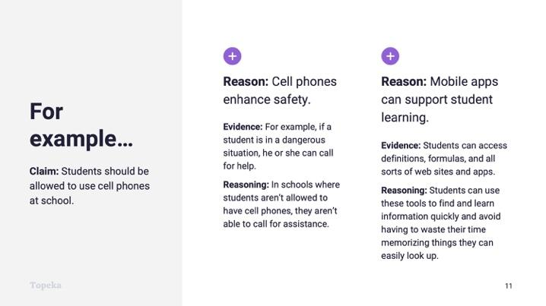
Slide 11
Teacher | Students
Teacher continues.  For example, here is the same claim and reasons we used before.  Teacher models reasoning:  If my claim is “Students should be allowed to use cell phones at school,” and my reason is “Cell phones enhance safety,” I need to prove that reason is valid. So I’ll give an example: “In a dangerous situation, a cell phone allows a student to call for help.”  Now I need to connect my evidence back to my claim. For example, “In schools where cell phones aren’t allowed, students can’t call for assistance.”  Let’s look at the second example. Here my reason is “Mobile apps can support student learning,” Again, I need to prove that reason is valid. So I’ll give an example: “Students can access definitions, formulas, and all sorts of web sites and apps.”  Now I need to connect my evidence back to my claim: “Students can use these tools to find and learn information quickly and avoid having to waste their time memorizing things they can easily look up.” | Students listen and take notes.
Teacher prompts class to repeat the process of supporting the existing claim by naming a reason, providing evidence, and then using reasoning to make the connection.  What other reasons can you think of to support cell phones in school? What evidence follows your reason? How do you explain the connection? | Based on the teacher model, the class collaborates to find another piece of evidence and to explain how it supports the chosen claim.

Step 3: You Do It Together
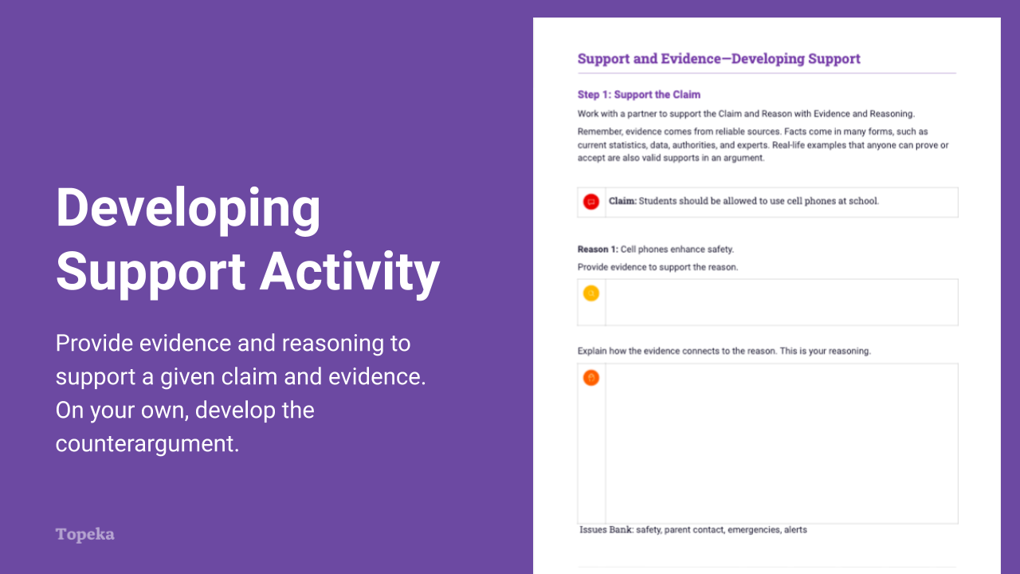
Slide 12
Teacher | Students
Using Developing Support Activity, Step 1, teacher prompts class to split into pairs or small groups to repeat the process of supporting the sample claim with a reason, evidence, and reasoning.  For information on implementing Small Group Collaboration via remote learning, see Remote Engagement: Small Groups or the guide to Remote Learning with Topeka. | Students identify one more set in a small group and share findings with the whole class.
Teacher prompts students to express their reasoning. | Groups share their evidence and reasoning.

Step 4: Independent Application
Teacher | Students
Using Developing Support Activity, Step 2, teacher prompts class to work individually to develop a reason and supporting evidence for the opposing viewpoint.  Teacher circulates to support student work. | Work individually to identify a reason that supports the opposing viewpoint and supply evidence and reasoning.

Step 5: Four-Corners Debate
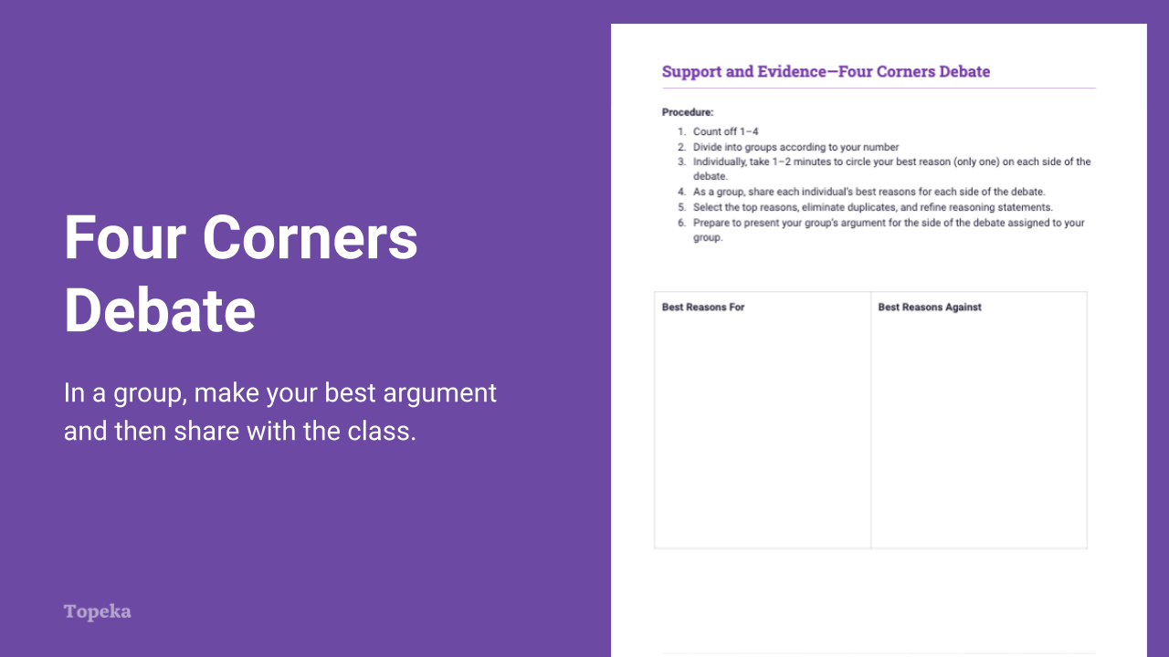
Slide 13
Teacher | Students
For information on implementing Four Corners Debate via remote learning, see Remote Engagement: Four Corners Debate or the guide to Remote Learning with Topeka.  Teacher divides the class into four groups, sending evenly divided groups to the four corners of the room. Teacher instructs students to bring their claims, evidence, and reasoning on the activity handout. | Students separate by number into the corners of the room, taking their activity handout with them.
Teacher instructs each group to construct an argument using their best three reasons with supporting evidence and explanations of their reasoning.  - Have two groups prepare arguments in favor of allowing cellphones in school.  - Have two groups prepare arguments against allowing cellphones in school. | Students collaborate to identify their team’s strongest support for the assigned claim and will select and arrange the support into an argument.
In a quick timed round, teacher has groups 1–4 present. | One or more students representing each group presents the argument constructed.
Teacher instructs students to take notes on the Four Corners Notetaking sheet as other groups present. | Students take notes on the Four Corners Notetaking sheet as other groups present.
Teacher asks the whole class to vote on which group had the best argument and invites students to provide an explanation for their vote. | Students vote on which group presented the best argument in favor. Describe reason for votes.
Teacher asks students which group had the best counterargument and invites students to provide an explanation for their choices. | Students vote on which group presented the best argument against. Describe reason for votes.

Appendix A: Sample Responses

Support and Evidence—Entry Ticket
For each claim below, check the boxes next to the reasons that support the claim.
A reason is what makes a person support one particular claim over another.

Claim: Schools should set aside time during the school day for students to read independently.
✓ | Independent reading makes students into better readers.
▢ | Independent reading takes time away from other instruction.
✓ | Independent reading is an enjoyable activity for students.
▢ | Independent reading must be structured in order to be effective.

Claim: Planting large trees in crowded urban spaces may present some unintended challenges, but the benefits of urban trees outweigh the drawbacks.
✓ | Trees improve the quality of life for city residents.
▢ | Leaves fall, filling gutters and blocking storm drains.
✓ | Urban trees help the environment.
▢ | There are many types of trees that grow well in urban areas.
Claim: High schools should require students to understand basic financial literacy before graduation.
✓ | After high school, students face an increasing number of financial decisions.
▢ | Banks offer many different products.
✓ | Financial literacy education leads to better financial decisions.
✓ | Poor financial decisions can set a young person back for many years.

Support and Evidence—Developing Support

Step 1: Support the Claim
Work with a partner to support the Claim and Reason with Evidence and Reasoning.
Remember, evidence comes from reliable sources. Facts come in many forms, such as current statistics, data, authorities, and experts. Real-life examples that anyone can prove or accept are also valid supports in an argument.
Claim: Students should be allowed to use cell phones at school.

Reason 1: Cell phones enhance safety.
Provide evidence to support the reason.
A person can call for help if there is an emergency in the building.
Explain how the evidence connects to the reason. This is your reasoning.
There are rarely phones in a school except in the main office. This means that anywhere else in the building students have no way of communicating in an emergency, which is not safe. Cell phones make contact possible, especially if students have to communicate with a parent during an emergency or if the school needs to send an alert to all students.
Issues Bank: safety, parent contact, emergencies, alerts
Reason 2: Mobile apps can support student learning.
Provide evidence to support the reason.
Mobile apps can help students take notes, record lectures, access help in math, look up information about anything, translate languages, and turn text into speech.
Explain how the evidence connects to the reason. This is your reasoning.
These examples show how helpful mobile apps can be. These are all things that students had to do before there were technologies to help them. In many cases, there were no humans available to help in a crowded classroom, especially one where students speak different languages.
Issues Bank: Information, apps, sharing, note-taking, recording

Step 2: Support the Counterclaim
Now work on your own to develop the opposing viewpoint.
Claim: Students should NOT be allowed to use cell phones at school.

Reason 1: Cell phones are dangerous.
Provide evidence to support the reason.
Cell phones can be used to bully students by secretly taking inappropriate pictures and videos of people as well as posting negative things about other students and sharing in social media.
Explain how the evidence connects to the reason. This is your reasoning.
New and more dangerous ways of bullying can happen in schools because of cell phones. With the power of social media, hurtful posts can make a single bully powerful enough to bring many onlookers to an attack.
Issues Bank: Bullying, theft, inappropriate
Reason 2: Mobile apps can distract students from learning.
Provide evidence to support the reason.
Kids simply can’t resist the alerts from their phones, no matter how engaged they might be in school.

Explain how the evidence connects to the reason. This is your reasoning.
Games, friends, social media alerts—they all come with a ping or vibration that can distract even the most engaged student. No matter how engaged they are in school, the suspense related to that alert will make their minds wander.
Issues Bank: Social media, games, music

Support and Evidence—Four Corners Debate
Procedure:
- Count off 1–4
- Divide into groups according to your number
- Individually, take 1–2 minutes to circle your best reason (only one) on each side of the debate.
- As a group, share each individual’s best reasons for each side of the debate.
- Select the top reasons, eliminate duplicates, and refine reasoning statements.
- Prepare to present your group’s argument for the side of the debate assigned to your group.
Best Reasons For  - Cell phones are important for safety.  - Cell phones help students learn more effectively.  - Cell phones brought by students save districts money on devices.  - Cell phones are small and use less power than larger devices that kids might otherwise bring. | Best Reasons Against  - Cell phones can be used for bullying.  - Students can use cell phones to cheat by texting answers and taking pictures of tests and quizzes.  - Tools that all students need for learning should not be the responsibility of students and families; districts should provide them.  - Cell phones are small so you can’t do as many things with them, like reading a text and taking notes on the same screen.  - Cell phones can be concealed more easily because they are small.

Appendix B: Engagement Strategies Via Remote Learning
The following links provide useful information for implementing this lesson through remote learning:
- Remote Learning with Topeka.
- Remote Engagement: Pair and Share
- Remote Engagement: Small Groups
- Remote Engagement: Four Corners Debate

