Writing
Day 5: Language
and Style
Daily Lesson Plan

Lesson Summary
In this lesson, students will examine the importance of considering the audience when writing, and will discover the differences between formal and informal writing.

- Step 1: Set Purpose/Activate Prior Knowledge—Students will complete an Entry Ticket to activate prior knowledge, identifying formal and informal style and explaining their decisions to neighbors.
- Step 2: I Do It/We Do It Together—Teacher and students will discuss the importance and process of considering the audience when making an argument and the elements of formal style.
- Step 3: You Do It Together—Following teacher model on previous step, students will collaborate to examine sample statements and rephrase as necessary to make more formal.
- Step 4: Independent Application—Students will work independently to identify informal writing within paragraphs and to revise to make it formal.

Objective
Students will understand why it is important to consider the audience and how audience determines the style required. Students will be able to identify attributes of formal and informal style and be able to recognize and revise word choices for formal academic writing.

Engagement Strategies
- Pair and Share: Students will turn to a partner and collaborate through discussion. See also, Remote Engagement: Pair and Share.
- Small Group Collaboration: Students will work together to identify and correct informal language.See also, Remote Engagement: Small Groups.
Links to information for remote learning are also provided in the lesson steps below. A complete list can be found in the Appendix.

Scaffolding Strategies
The scaffolding strategies listed below are optional supports included in the lesson’s activities. These tools may be used or ignored based on students’ needs.
- Vocabulary Supports: Students can use vocabulary supports for comprehension.

Remote Learning Strategies
With careful advanced planning, Topeka lessons can be easily moved to a remote modality. Links to specific engagement strategies are included throughout this lesson plan. See Topeka’s professional learning resource Remote Learning with Topeka for additional suggestions for each stage of the typical Topeka lesson.

Key Vocabulary
- Audience
- Formal
- Informal

See bolded words and definitions throughout the lesson's text.

Materials
- Presentation—Language and Style
- Entry Ticket—Language and Style
- Activity—Formal and Informal

Standards Addressed in this Lesson
- Write arguments to support claims in an analysis of substantive topics or texts using valid reasoning and relevant and sufficient evidence. (CCSS.ELA-LITERACY.CCRA.W.1)
- Produce clear and coherent writing in which the development, organization, and style are appropriate to task, purpose, and audience. (CCSS.ELA-LITERACY.CCRA.W.4)
- Apply knowledge of language to understand how language functions in different contexts, to make effective choices for meaning or style, and to comprehend more fully when reading or listening.(CCSS.ELA-LITERACY.CCRA.L.3)

Lesson Steps

Step 1: Set Purpose/Activate Prior Knowledge
Slide 2
Teacher | Students
Teacher sets the purpose for the class with an Entry Ticket activity to activate prior knowledge. | Students will read a variety of statements and use prior knowledge to determine whether statements are formal, informal, or something in between.
Teacher should invite students to Pair and Share with a classmate to discuss their answers.  For information on implementing Pair and Share via remote learning, see Remote Engagement: Pair and Share or the guide to Remote Learning with Topeka.  When you’re finished identifying formal or informal sentences, turn to a neighbor and talk about what attributes of language make something formal or informal. See if you can come up with rules for formal and informal style. | Students will turn to a neighbor and discuss what makes a sentence formal and what makes a sentence informal.

Slide 3
Teacher | Students
Teacher presents learning objectives for session.  In earlier lessons we discussed the different components of an argument and how an argument should be organized.  Today, we’re going to talk about audience and style: what an audience is, how to consider your audience when writing, and the difference between formal and informal style in academic writing. | Students listen and take notes.

Step 2: I Do It/We Do It Together
Slide 4
Teacher | Students
Teacher introduces the concept of an audience for an argument.  Consider pre-recording this portion of the lesson for remote delivery. See the guide to Remote Learning with Topeka for more details.  When you’re making an argument you’re trying to convince someone to accept your claim. That “someone” is your audience, the people to whom you’re presenting your argument. | Students listen and take notes.
Teacher asks students to name the audience for a few different arguments. For example,  - You are arguing for a longer lunch period—who would your audience be?  - You’re arguing to determine what movie to see this weekend—who would your audience be?  - You’re arguing for a raise at a job—who would the audience be? | Students participate in class discussion of audiences for different arguments.

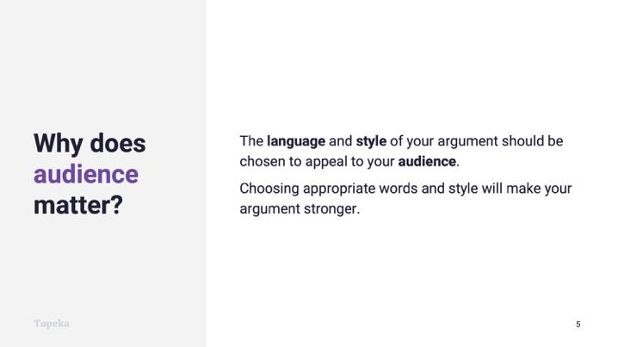
Slide 5
Teacher | Students
Teacher discusses why audience and style matter in argumentative writing.  Why do we need to understand who the audience is?  The language and style of your argument should be chosen to appeal to your audience.  Choosing appropriate language and using the right style will make your argument stronger. | Students listen and take notes.

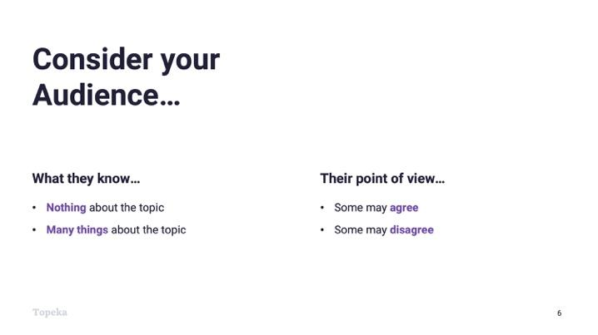
Slide 6
Teacher | Students
Teacher explains the different characteristics of an audience that go into determining style.  There are multiple factors to consider about your audience when you’re making an argument.  First, how much does your audience know about the topic? Do they know a little or a lot?  Does the audience already agree with you, and you’re trying to get them to take action? Or do they already disagree, and you’re hoping to change minds? | Students listen and take notes.

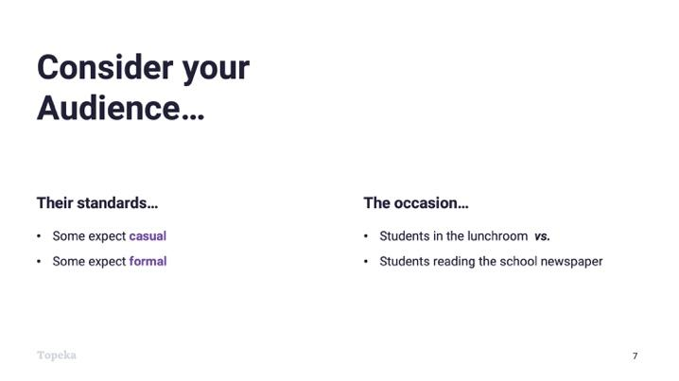
Slide 7
Teacher | Students
Teacher continues.  Does the audience have particular standards for communication? Are they casual or are they formal?  And finally, what is the occasion? What circumstances led you to develop the argument in the first place?  Say you’re making an argument about what is served for school lunch. Are you addressing the student council? Trying to convince other students in the cafeteria? Or are you writing an article for the school newspaper? Though the people are similar, the occasion is different, and each occasion demands a different style. | Students listen and take notes.

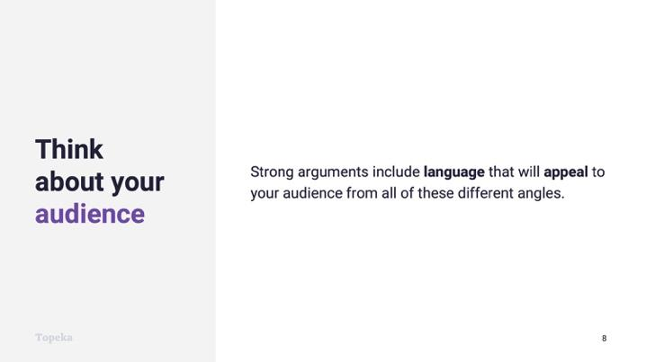
Slide 8
Teacher | Students
Teacher continues.  Strong arguments include language that will appeal to your audience from all of these different angles. Once you’ve considered your audience, you can make choices about whether to use formal or informal style. | Students listen and take notes.

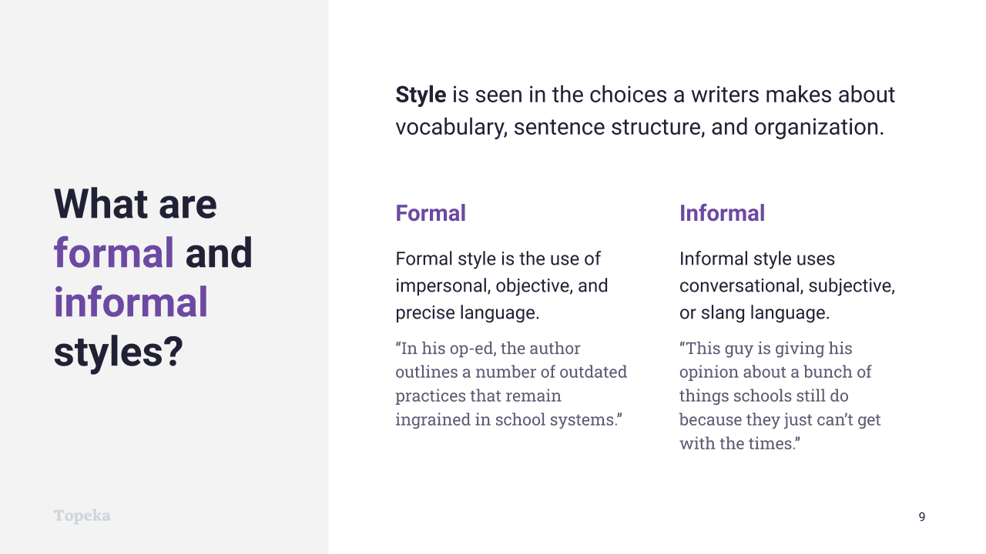
Slide 9
Teacher | Students
Teacher begins discussion of differences between formal and informal style.  Style is seen in the choices a writer makes about vocabulary, sentence structure, and organization. Your writing for school should always use formal style.  Teacher should refer to general examples on Slide 9 regarding formal vs. informal style. | Students listen and take notes.

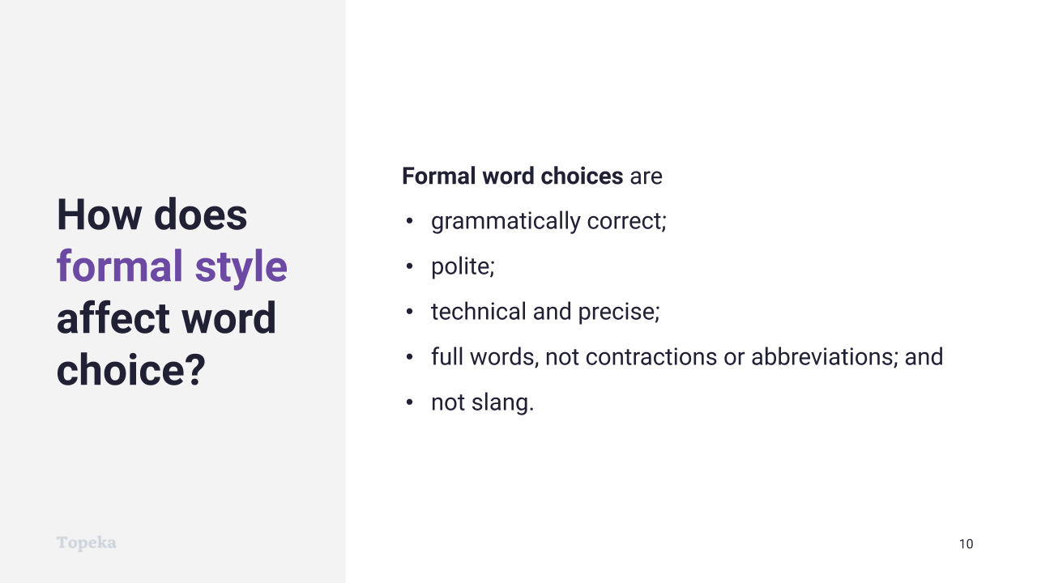
Slide 10
Teacher | Students
Teacher discusses how formal style is seen in word choices.  Formal word choices are  - grammatically correct—they follow standard conventions;  - polite—they do not use derogatory terms or insult the reader;  - technical and precise—precise words make your meaning clear (for example, in a domain such as science, words should be precise like “beaker,” versus imprecise like “thing for holding chemicals”);  - full words, not contractions or abbreviations—avoid don’t, isn’t, doesn’t, and the like; avoid emojis and texting language; and  - not slang.  With an informal style of writing, a writer or speaker would have fewer rules to follow. The writer's choice of words could be more casual and conversational, and can break the rules above. Sometimes in informal writing, writers make deliberate choices that do not follow grammatical rules. | Students listen and take notes.
In the Entry Ticket activity, did anyone identify statements as informal because of informal word choices? | Students contribute and explain answers from the Entry Ticket.

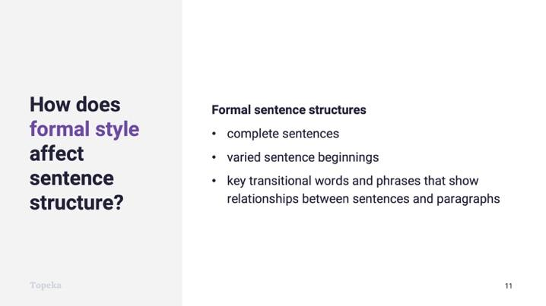
Slide 11
Teacher | Students
Teacher continues.  How does formal style affect sentence structure?  Formal sentence structure uses  - complete sentences;  - variety in the way sentences start; and  - key transitional words and phrases that show relationships between sentences and paragraphs.  With an informal style of writing, a writer or speaker would again have fewer rules to follow. The writer's sentence structure could be more fragmented, casual and conversational, and could include run-ons and other grammatically incorrect structures. | Students listen and take notes.
Teacher continues.  Is there anything in the Entry Ticket activity that you identified as informal because of informal sentence structure? | Students contribute and explain answers from Entry Ticket activity.

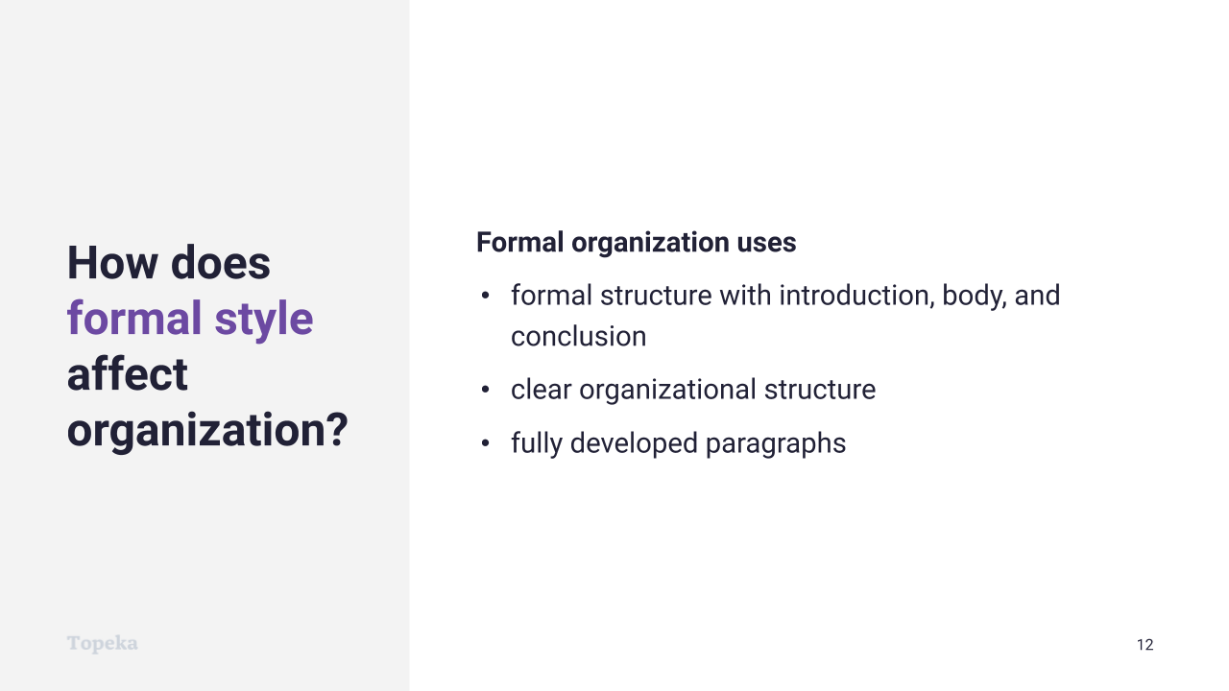
Slide 12
Teacher | Students
Teacher continues.  How does formal style affect organization?  Formal organization is the type of organization we talked about in a previous lesson. A formal argument includes an introduction, body, and conclusion. It has a clear organizational structure and fully developed paragraphs.  With an informal style of writing, the organizational patterns might use less formal structures, leaving some points less clearly developed or having less structure in the sequence or development of each point used to support the claim. | Students listen and take notes.

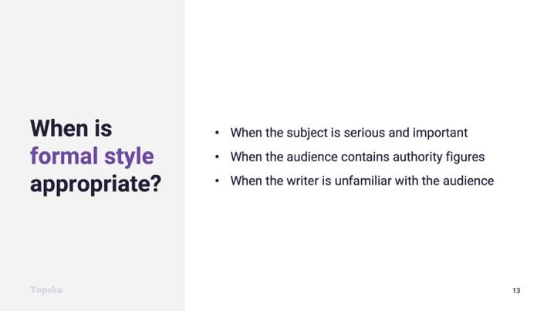
Slide 13
Teacher | Students
Teacher explains how to determine when formal style is appropriate.  When is formal style appropriate?  - When the subject is serious and important  - When the audience contains authority figures  - When the writer is unfamiliar with the audience  What does that mean for your arguments for school?  Teacher pauses for student contributions. If necessary, teacher emphasizes that arguments in academic settings should always use formal style because of all three reasons given. | Students contribute reasons why writing for school should always use a formal style.

Step 3: You Do It Together
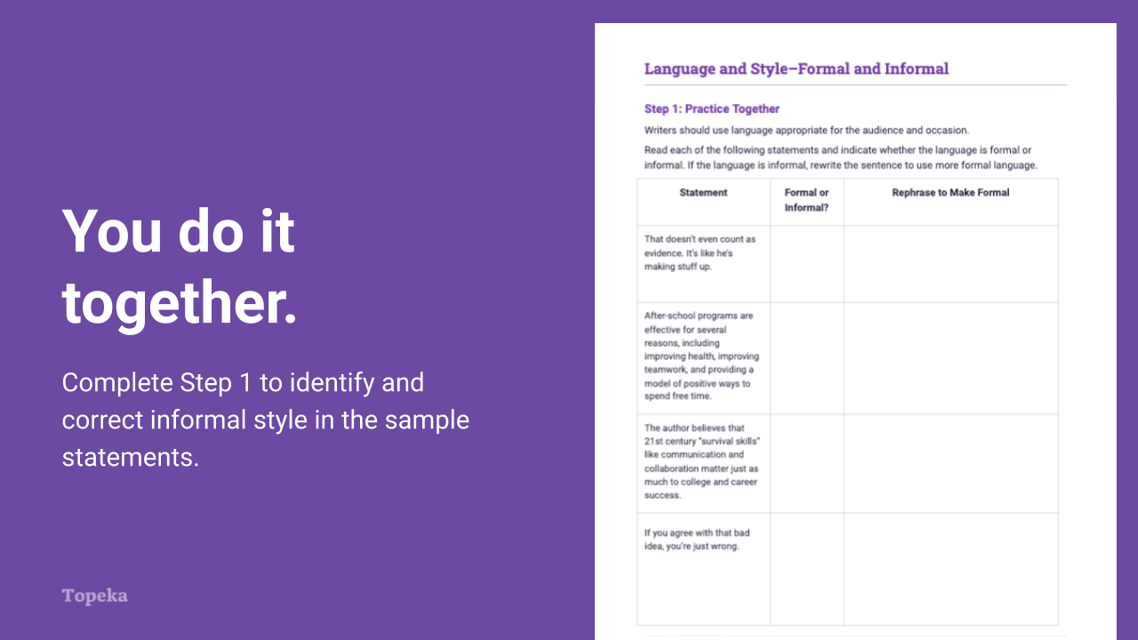
Slide 14
Teacher | Students
Teacher distributes activity: Formal and Informal. Teacher instructs students to work in pairs or small groups in order to complete Step 1, identifying informal language and rephrasing to make formal.  For information on implementing Small Group Collaboration via remote learning, see Remote Engagement: Small Groups or the guide to Remote Learning with Topeka. | Students will read statements and indicate whether the language is formal or informal. If the language is informal, students rewrite the sentence to use more formal language.
If time allows, teacher reconvenes students for full group debrief. Teacher will ask students to share and explain answers. | Students will explain which statements they identified as informal, how they knew, and how they rephrased those statements to make them formal.

Step 4: Independent Application
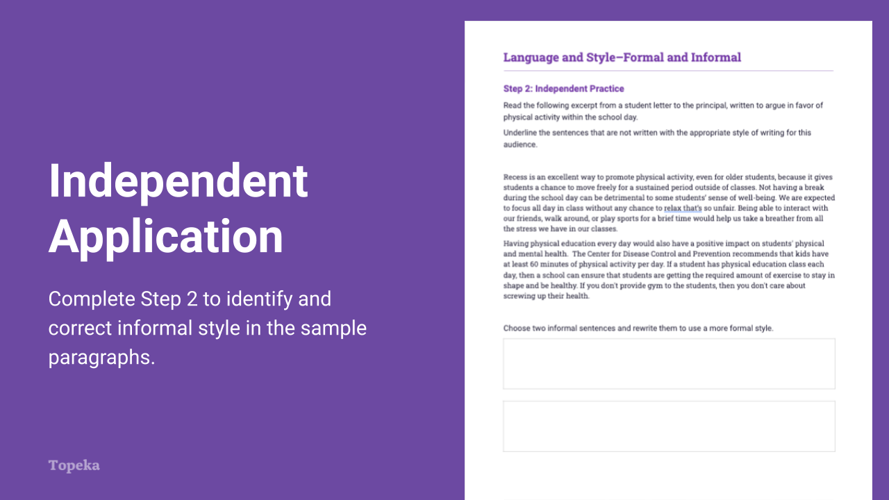
Slide 15
Teacher | Students
Teacher has students turn to Step 2 of the activity.  Now you will have a chance to practice this on your own. Step two provides two paragraphs that contain both formal and informal language. Underline the sentences that are informal, and then choose two of the informal sentences to revise using more formal language.  Teacher circulates to provide support as needed. | Individually, students will complete Step 2 of the exercise.
If time allows, teacher reconvenes students for full group debrief. Teacher will ask students to share and explain answers. | Students will explain which statements they identified as informal, how they knew, and how they rephrased those statements to make them formal.

Appendix A: Sample Responses

Language and Style—Entry Ticket
Statement | Formal or Informal?
They don’t say what they want. smh. | Informal
It is unclear from the article what alternative the writer prefers. | Formal
Of course, there are many benefits to the current, traditional curriculum. | Formal
They got their reasons for doin things like they do. | Informal
It is clear that skills like communication and critical thinking are essential for students to flourish in a 21st-century career. | Formal
I don’t know I think they just need to communicate more. | Informal
There is no reason to believe the characters are motivated by greed. | Formal
Ultimately, better communication is needed between colleges and the companies that hire graduates. | Formal
Nothing in the story about it. | Informal

Formal and Informal Activity—Step One
Statement | Formal or Informal? | Rephrase to Make Formal
That doesn’t even count as evidence. It’s like he’s making stuff up. | Informal | Based on what educated people know about what makes evidence credible, this evidence does not meet the criteria. (Note that the word choice indicates the speaker is an educated person who bases reasoning on criteria.)
After-school programs are effective for several reasons, including improving health, improving teamwork, and providing a model of positive ways to spend free time. | Formal
The author believes that 21st century “survival skills” like communication and collaboration matter just as much to college and career success. | Formal
If you agree with that bad idea, you’re just wrong. | Informal | The assumptions behind that idea are mistaken. (Note that the speaker does not use an accusatory “you” and points out the error in the idea versus the fault in the person.)

Formal and Informal Activity — Step Two
Recess is an excellent way to promote physical activity, even for older students, because it gives students a chance to move freely for a sustained period outside of classes. Not having a break during the school day can be detrimental to some students’ sense of well-being. We are expected to focus all day in class without any chance to relax that’s so unfair. Being able to interact with our friends, walk around, or play sports for a brief time would help us take a breather from all the stress we have in our classes.
Having physical education every day would also have a positive impact on students' physical and mental health. The Center for Disease Control and Prevention recommends that kids have at least 60 minutes of physical activity per day. If a student has physical education class each day, then a school can ensure that students are getting the required amount of exercise to stay in shape and be healthy. If you don't provide gym to the students, then you don't care about screwing up their health.

Choose two informal sentences and rewrite them to use a more formal style.

It is not unreasonable for students to expect an opportunity to relax given their need to focus throughout the rest of the day. (Note the writer has stated a similar idea but phrased the same idea in a more positive way, positioning the students as reasonable.)

One way to show students how much you care about their health is to provide time for them to work on it during the school day. (Note the writer has phrased the same idea in a way that appeals to the values of the principal who would be motivated to show care for student health.

Appendix B: Engagement Strategies Via Remote Learning
The following links provide useful information for implementing this lesson through remote learning:
- Remote Learning with Topeka
- Remote Engagement: Pair and Share
- Remote Engagement: Small Groups

