Introducing Concepts
Teaching the Writing Process
Lesson Plan (Minimum Time: One 45-Minute Session)

Lesson Summary
This lesson introduces students to the stages of a formal process for writing arguments in the context of Project Topeka. Through discussion and reflection on previous writing experiences, students will understand the purpose of each stage of the process, as well as the recursive nature of writing. Teachers can also use the scripted sections and related slides to introduce each new stage as students progress through the actual process.

Objective
Students will know and be able to undertake a recursive writing and revision process for writing an argumentative essay.

Engagement Strategies
- Pair and Share: Students will work with a partner and collaborate through discussion. See Remote Engagement: Pair and Share.
Links to information for remote learning are also provided in the lesson details below.

Scaffolding Strategies
The scaffolding strategy listed below is an optional support included in the lesson’s activities:
- Graphic Organizer: Optional draft planner supports organization of reasons and support during planning stage.

Remote Learning Strategies
With careful advanced planning, Topeka lessons can be easily moved to a remote modality. Links to specific engagement strategies are included throughout this lesson plan. See Topeka’s professional learning resource Remote Learning with Topeka for additional suggestions for each stage of the typical Topeka lesson.

Key Vocabulary
- Argument
- Claim
- Evidence
- Reasons
- Reasoning
- Recursive

Materials
- Presentation—Introduction to the Writing Process
- Checklist for Argumentative Writing Process
- Optional: Prompt Analysis Activity
- Optional: Draft Planner

Standards Addressed in this Lesson
- Develop and strengthen writing as needed by planning, revising, editing, rewriting, or trying a new approach. (CCSS.ELA-LITERACY.CCRA.W.5)

Teaching the Writing Process

Introduction

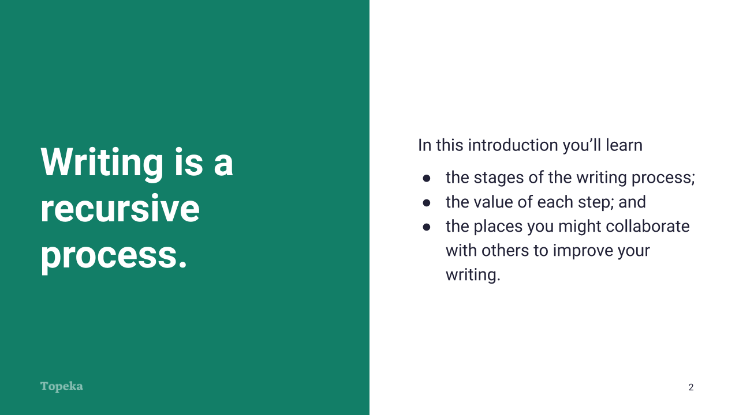
Slide 2

Teacher | Students
Teacher introduces writing as a process.  Writing is a recursive process, which means it’s a cycle that repeats. In writing, like thinking, we don’t often understand or express things perfectly the first time, and have to return to our thoughts or words over and over again before we’re happy with what we’ve produced.  You’ve probably experienced this in your past writing, and so it’s helpful to think about our own writing process and how successful it has been before we start talking about formal steps for writing. | Students listen and take notes.
Teacher invites multiple students to share input about previous writing experiences.  Can anyone describe the steps you used the last time you wrote a story, essay, or argument? Was your process effective? Were you satisfied with the outcome?  Teacher directs students to turn to a classmate and share their thoughts on past writing process experiences.  (For information on implementing Pair and Share via remote learning, see Remote Engagement: Pair and Share or the guide to Remote Learning with Topeka.) | Students listen and take notes.
Teacher continues:  Keep your past experiences in mind—whether they’ve been successful or not—as we discuss the formal steps of the writing process today. | Students listen and take notes.
Teacher sets purpose for the lesson by describing what will be covered.  In this lesson we’re going to learn about the typical stages of the writing process for argument writing. We’ll cover the value of each step to you as a writer, and we’ll talk about moments when collaborating with others can help improve your writing. | Students listen and take notes.

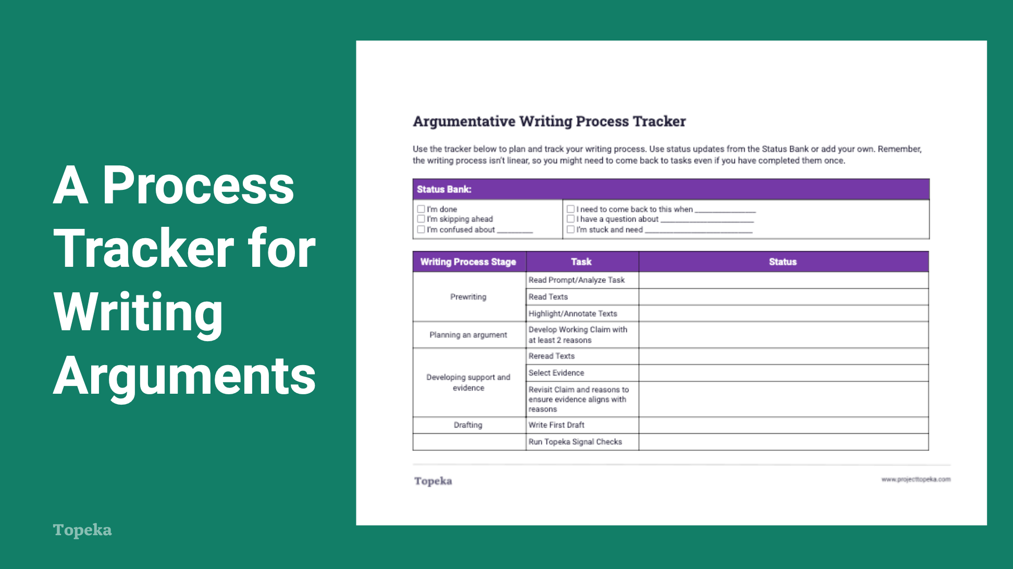
Slide 3

Teacher | Students
Teacher distributes the Checklist for Argumentative Writing Process and describes its purpose.  The writing process tracker that I just passed out gives you an outline of the stages of the process. As I said earlier, writing is a recursive process, but this list is linear, a step-by-step process, which means that you might encounter a particular step in the list more than once before you’re finished.  Use this tracker to follow along with our lesson today, and then use it to track your progress and make notes as you move through the actual writing process. These notes will be helpful to you when you reflect on your process at the end. | Students listen, attend to checklist, and take notes as needed.

Prewriting
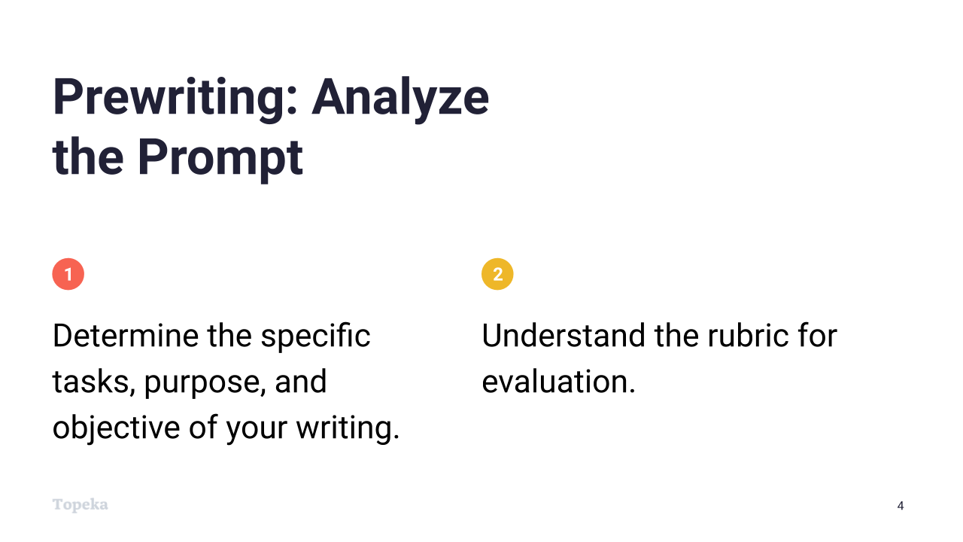
Slide 4
Teacher | Students
Teacher introduces the prewriting stage.  Before you put any words on paper, you have to understand what your purpose is for writing—that is, what the task is and how your writing will be evaluated. Investing time in planning will make the process of writing easier. | Students listen and take notes.
Teacher invites students to share past experiences with prewriting activities.  What do you think prewriting means? How have you engaged in prewriting tasks in the past? | Students share ideas and experiences related to prewriting for all writing types.
Teacher continues:  For argumentative writing, the prewriting stage is the time for doing all your groundwork. The first thing you need to do is analyze the writing prompt you’ve been given so that you understand the task ahead of you. It’s also helpful to review the rubric that you’ll be evaluated on. | Students listen and take notes.
Optional step: Teacher distributes and introduces a writing prompt from Topeka platform and Prompt Analysis Activity.  Let’s take a moment to analyze the first prompt we’re going to encounter. Follow the instructions on the handout. You’ll use your prompt analysis in the next stage.  Teacher invites students to partner with a classmate and share results of the activity.  (For information on implementing Pair and Share via remote learning, see Remote Engagement: Pair and Share or the guide to Remote Learning with Topeka.) | Optional step: Students complete prompt analysis activity.

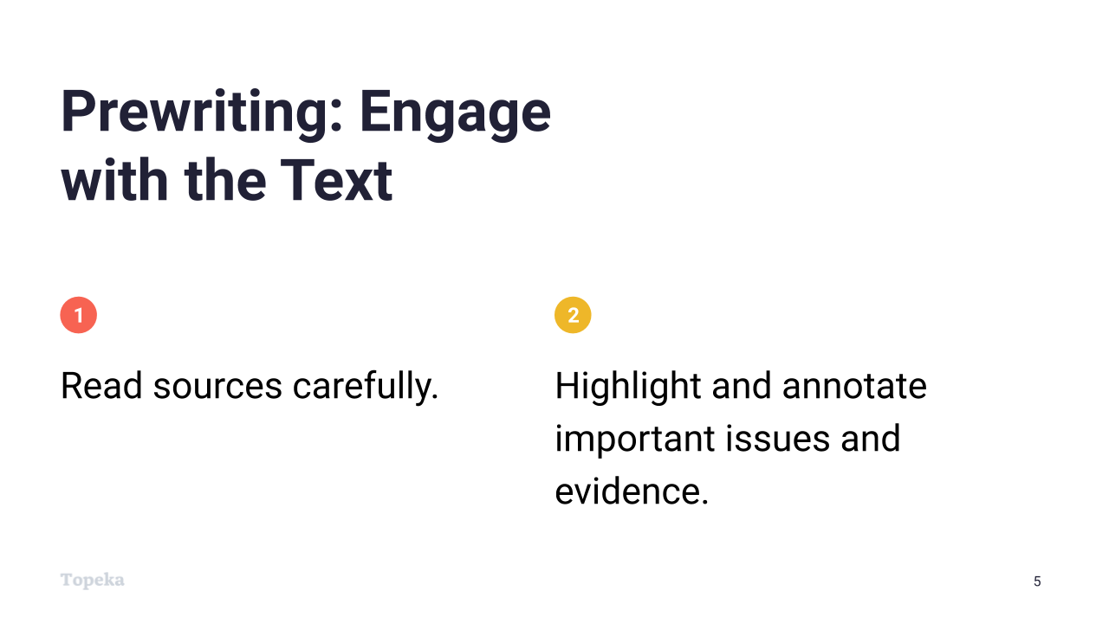
Slide 5

Teacher | Students
Teacher continues:  Once you’ve analyzed the prompt and understand the task before you, you can engage with the text.  Engaging with the text means doing your research. Read sources carefully and with a purpose, and make sure you understand the issues and vocabulary. Then highlight evidence and issues that might be important to your argument, and take notes on why the highlights are important.  Remember: if you do a good job here, you’re setting yourself up for success. | Students listen and take notes.
Teacher invites students to share past experiences engaging with text.  In your past writing experiences, how has engaging with text in this way informed your work? Why do you think this step is so important? | Students share ideas and experiences related to engaging with text prior to writing.
Optional step: If prompt analysis has been completed, teacher directs students to read Topeka source texts and highlight and annotate text as described above. | Optional step: Students read closely, highlighting and annotating text.

Planning an Argument
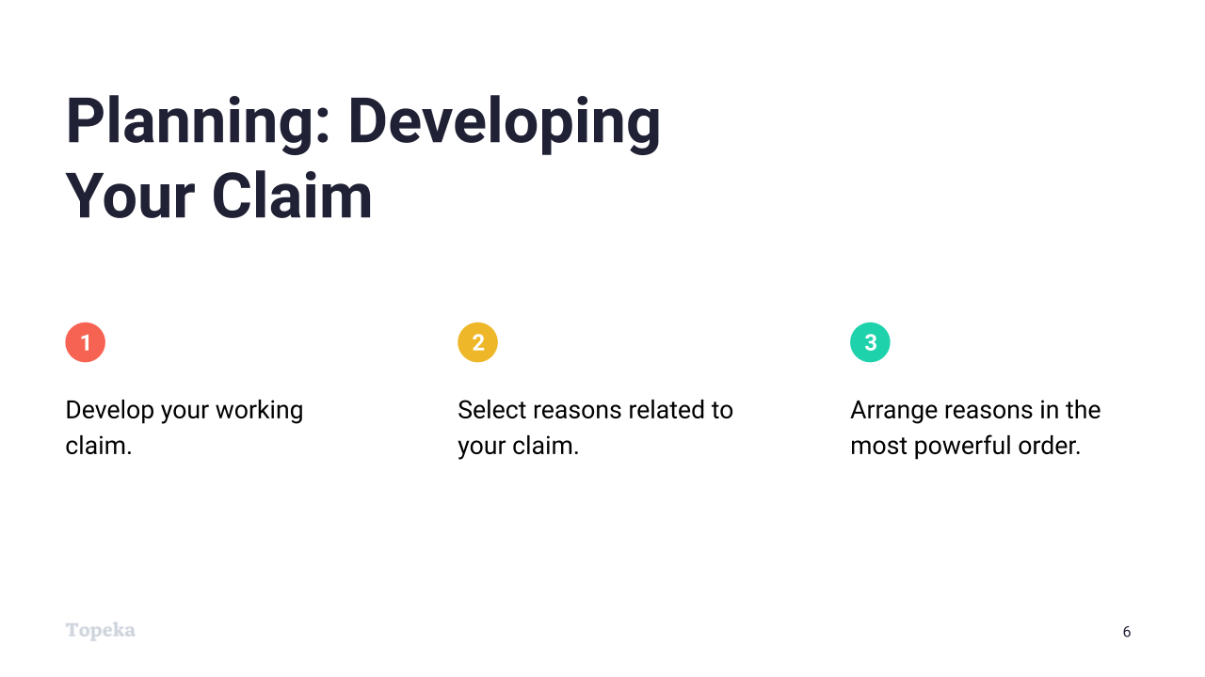
Slide 6
Teacher | Students
Teacher introduces the planning stage of the writing process.  Once you’ve analyzed the prompt and done your research, you can start the next stage of the writing process: planning an argument. | Students listen and take notes.
Teacher invites students to share past experiences with planning for writing.  What methods have you used for planning your writing in the past? Has anyone created an outline? Has anyone used a mind map to brainstorm? | Students share ideas and experiences related to planning writing.
Teacher continues:  The first step in planning an argument is to develop a working claim. You should expect that your claim will change somewhat, as you will learn more about your own thinking through the process of writing. That is why it is called a “working claim.” It gives you a place to start.  If needed, teacher briefly defines “claim” as the writer's position on the question posed by the prompt. | Students listen and take notes.
Teacher continues:  Once you have a claim, you have to think about your reasons for supporting it. Write down your general reasons to use as an outline.  Finally, think about what might be the most powerful order for presenting reasons right now. | Students listen and take notes.
Optional step: Teacher distributes Draft Planner and directs students to enter a working claim and at least two reasons in appropriate boxes. As a separate step, students should think about order of reasons and number reason boxes accordingly. | Optional step: Students complete claim and reason planning using Draft Planning Tool.

Developing Support and Evidence
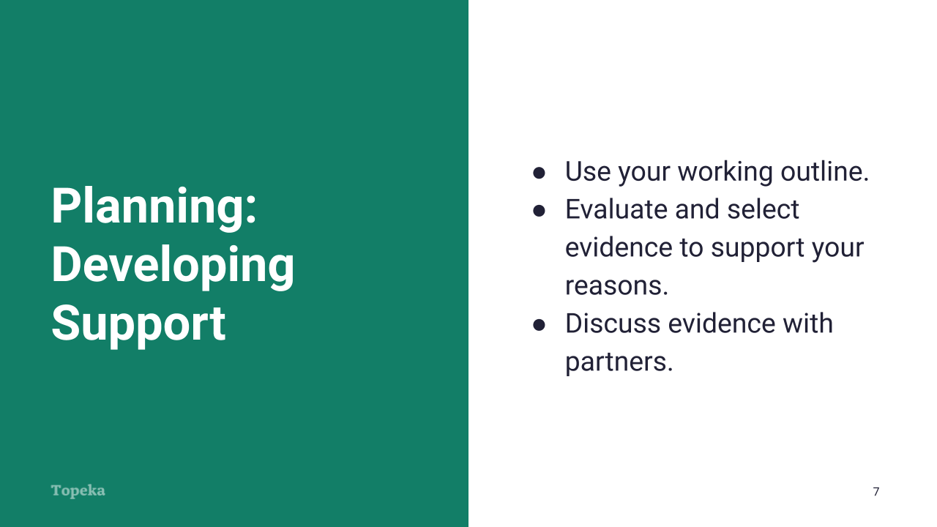
Slide 7

Teacher | Students
Teacher continues describing the next task in the planning stage: developing support.  Once you’ve got a framework created by your claim and reasons, your search for evidence can begin. This is when you’ll return to your notes from reading or reread the sources to find and select evidence that supports your reasons. If time allows, discuss your evidence with peers.  This is also a great time to refine your original working claim and the reasons you described in your outline. Remember, this is a recursive process, meaning it’s a cycle that happens repeatedly. | Students listen and take notes.
Teacher invites students to share ideas on why we refine claim and reasons.  Why do you think we refine our claim and reasons at this point? | Students share ideas on why claim and reasons are revisited at this point.
Teacher continues:  Because you’ve been thinking and reading about these issues for a while, you know more now. So you can ask yourself: Does your claim still accurately convey your position? Do you still think your reasons are in the most powerful order? Is each reason supported with strong evidence that is credible and relevant?  Finally, give some thought here to how you’ll explain the connection between your evidence, reasons, and claim. Sketch out your ideas about these connections in your outline. | Students listen and take notes.
Optional step: Teacher directs students to return to Draft Planner to add evidence from source texts and student highlights and notes, along with brief ideas about how evidence connects to claim. | Optional step: Students use the same Draft Planning Tool from the previous stage to add evidence and outline reasoning.
Optional step: Teacher distributes Evidence Checklist and directs students to evaluate evidence independently or with classmates. Note that this activity can also be delivered as a component of the Evidence Checklist Activity Lesson. | Optional step: Students use Evidence Checklist to evaluate evidence selected for essay.

Drafting
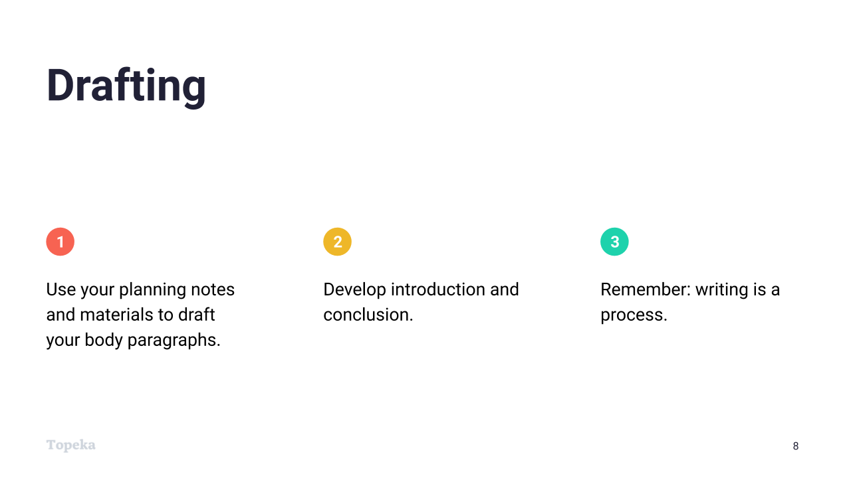
Slide 8
Teacher | Students
Teacher introduces the next stage of the writing process: drafting.  Drafting is the stage in which you create the best first draft you can on your own. We’ll do our drafting on the Project Topeka platform.  In argumentative writing, if you’ve planned carefully, it’s often helpful to start drafting with the body of your essay. Make each reason in your plan a separate paragraph. Add your evidence and clearly connect the evidence and reason back to the claim. This will help ensure your essay is focused and connected.  When the body of your essay is drafted, you can start to draft your introduction and conclusion. | Students listen and take notes.
Teacher continues:  When your entire essay is drafted, you’re ready to start revising. Remember: writing is a recursive process, meaning that it has repeating steps. | Students listen and take notes.

Revision
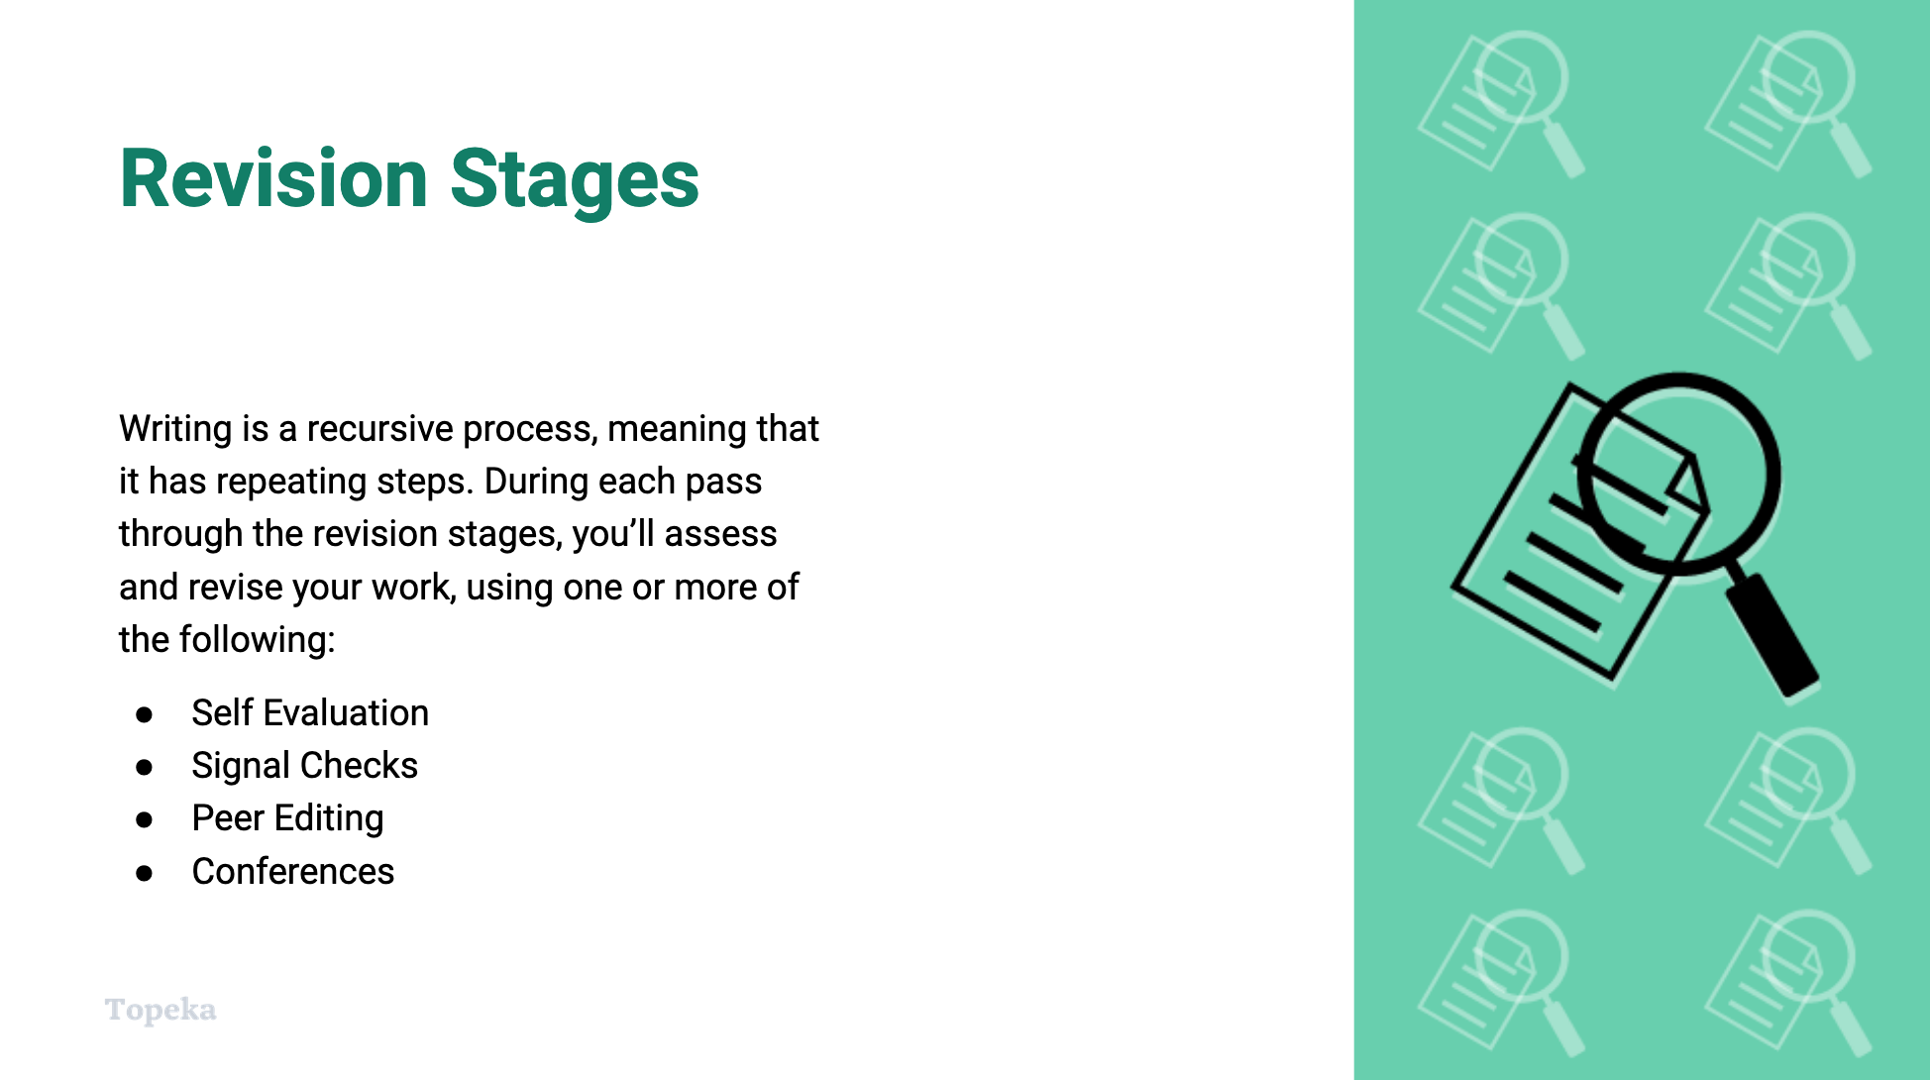
Slide 9
Teacher | Students
Teacher reminds students of the recursive nature of the writing process.  Because writing is a recursive process, during each pass through the revision stages, you’ll assess and revise your work, then you’ll assess and revise your work again.  All of the steps of the revision stages will repeat any number of times until your essay is finished. | Students listen and take notes.
Teacher invites students to share past experiences with revision stage or writing.  Have you ever used a writing process that spent time on revisions? How did you assess your writing? Do you think revising made your work better? How so? | Students share past experiences and thoughts about revision stages.

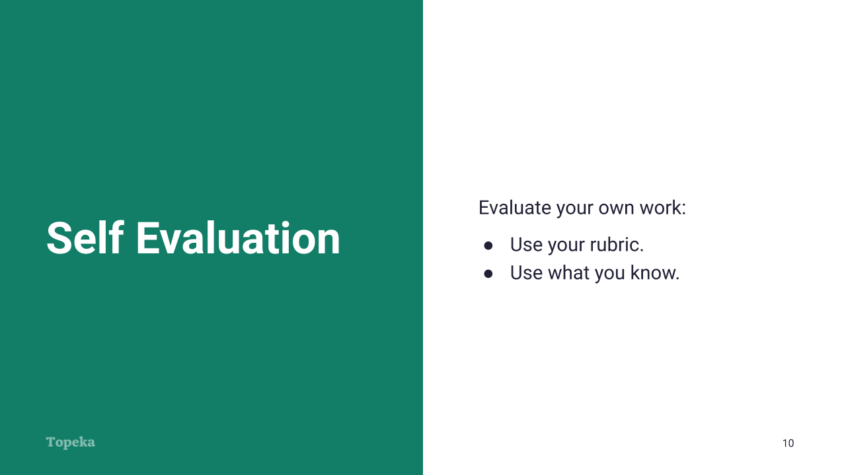
Slide 10
Teacher | Students
Teacher explains self-evaluation.  First, evaluate your own work. For academic writing, use your rubric as a tool and make sure you’ve met the requirements of the assignment.  You can also use what you know, or what you’ll learn, about argumentative writing. Read each part of your essay carefully. Have you introduced the issue and your claim? Are your paragraphs cohesive, with each sentence flowing to the next sentence with logical connections? Check that each paragraph sticks to one main idea and has a transition word or phrase illustrating the connections between one paragraph and the next. And don’t forget to pay attention to your language and style—you want to be sure your work is free of errors and uses appropriate style. | Students listen and take notes.

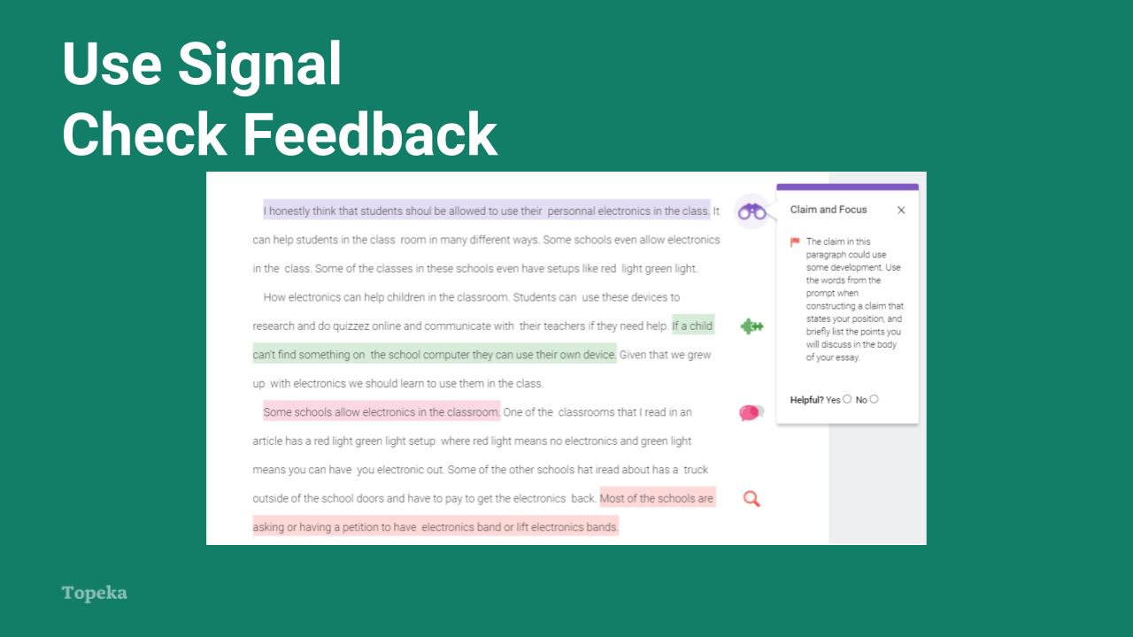
Slide 11

Teacher | Students
Teacher explains use of signal check feedback on Topeka Platform.  In addition to doing your own assessment, on Project Topeka you can review signal checks, which are messages that offer growth opportunities right within your essay. For example, on this slide you can see that signal checks are highlighting several phrases in the essay. The student has clicked on the purple highlight here to see the message explaining the growth opportunity. | Students listen and take notes.
Teacher invites students to imagine the benefits of using signal check feedback.  How do you think these types of messages will help you in your writing? | Students offer thoughts on using signal checks for self assessment.

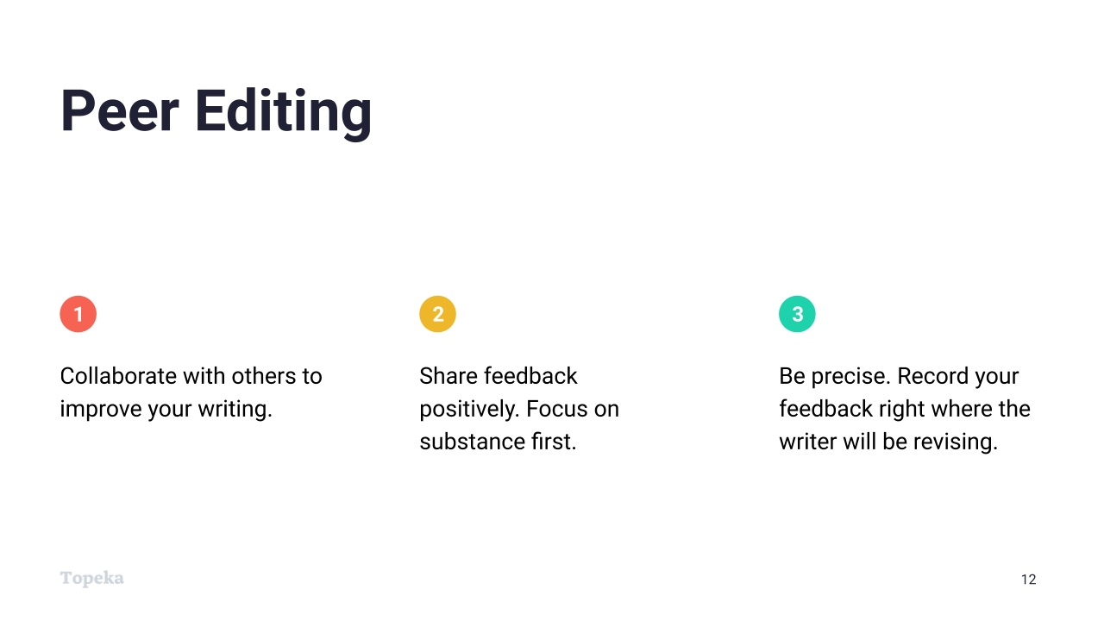
Slide 12
Teacher | Students
Teacher explains the process of peer editing.  Another way of assessing your work prior to revising is peer editing. Real reader feedback can help you improve your essay and grow your overall skills as a writer. In the peer editing stage, you’ll ask your peers to read your draft and offer constructive feedback. A fresh set of eyes can help you ensure that your argument is clear and makes sense for a reader. | Students listen and take notes.
Teacher invites students to share past experiences with peer editing.  Has anyone used peer editing in past writing experiences? What worked well? What didn’t work so well? | Students share past experiences of peer editing.
Teacher continues:  To get the most out of peer editing, allow your reader to read without interruption. They should read silently and make notations where needed, without asking you what you meant to say. They should share positive feedback, questions, and suggestions in the margins of the essay, so you can revisit the comments when you are revising. Once they’ve finished reading, answer their questions and make notes on what parts of the essay caused confusion. | Students listen and take notes.

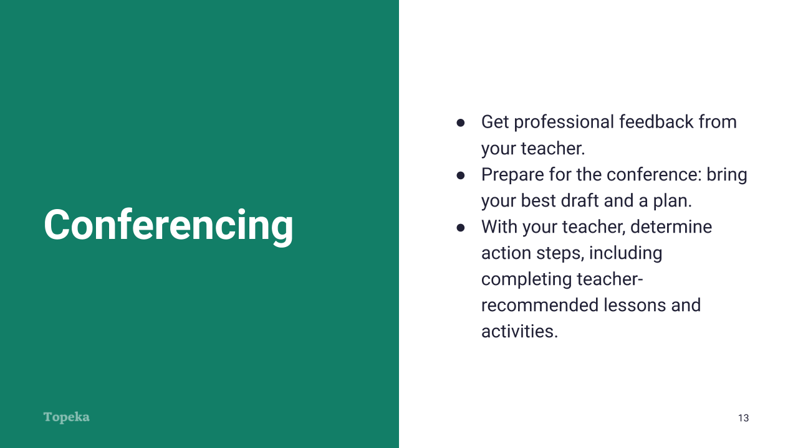
Slide 13
Teacher | Students
Teacher explains writing conferences.  In academic settings, writing conferences are a great opportunity to get professional feedback on your writing from a knowledgeable instructor. | Students listen and take notes.
Teacher invites students to share their experiences with writing conferences.  What experience have you had using writing conferences as part of your process? How did you feel about the experience? What do you think can help make this time with your teacher more valuable? | Students share thoughts on past experience with writing conferences.
Teacher continues:  Once again, to get the most growth out of the conference, it is important to go into the conference with your best work and a plan. Be sure you’ve thought through your strengths and the areas of improvement that you’d like to focus on. And use the proofreading checklist to clean up your draft, so that you and I can focus on substance, and not mechanical errors.  During our conference, we’ll determine action steps, which might include specific strategies for revision, or I might suggest you complete certain lessons and activities to help guide you through the revision. | Students listen and take notes.

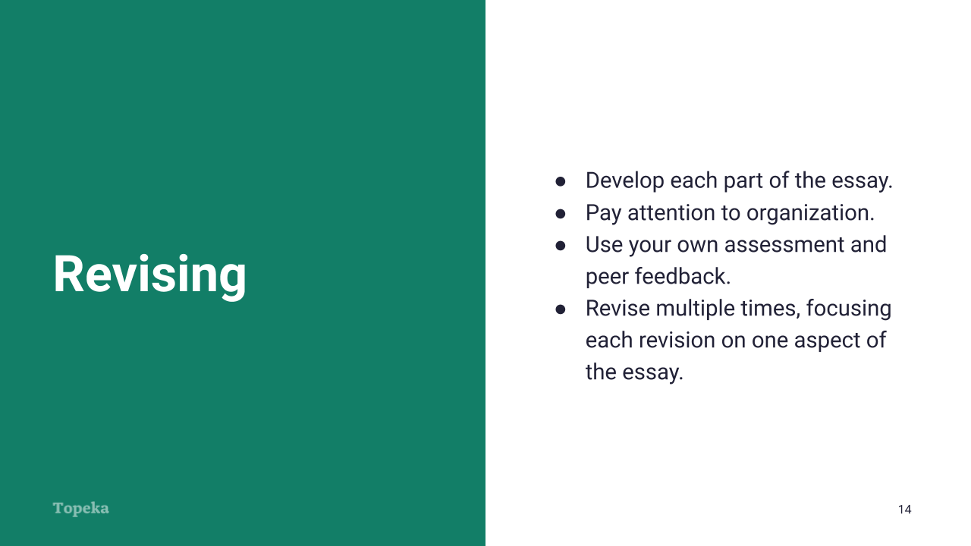
Slide 14
Teacher | Students
Teacher again emphasizes recursive nature of the process.  Through all of these revision steps you have gotten feedback from your own evaluation or signal checks in Topeka, from peer feedback, or from a writing conference with me. Fix the problems you’ve discovered, strengthen the parts that need development, and then assess again.  Revising can happen multiple times, and often writers will revise for different aspects with each revision. | Students listen and take notes.

Proofreading
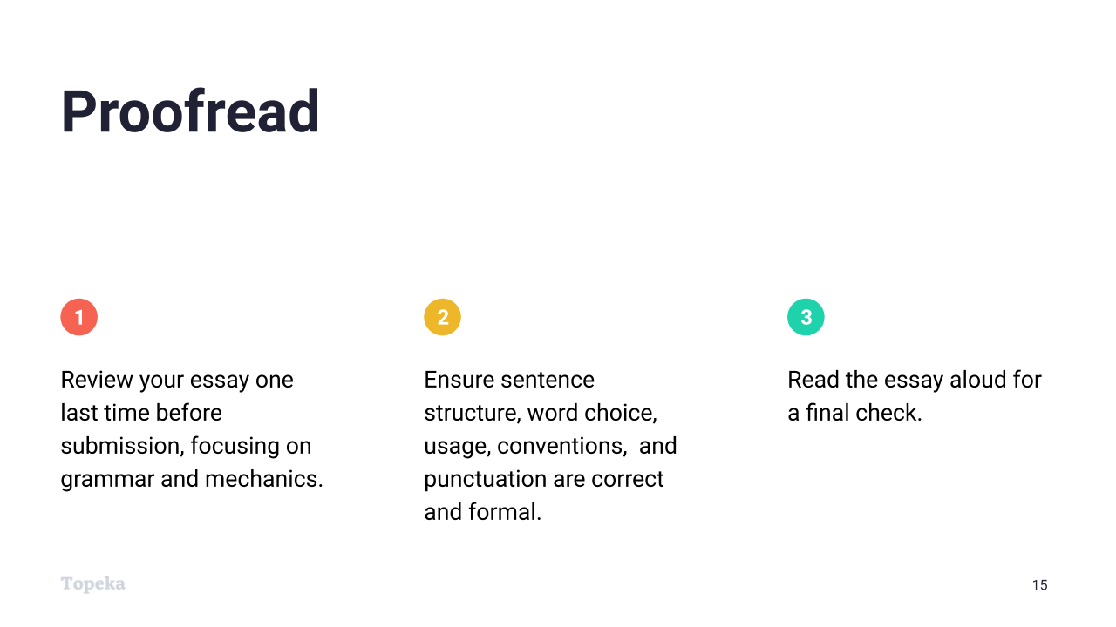
Slide 15
Teacher | Students
Teacher explains proofreading stage.  Have you ever turned something in and then discovered it was full of errors?  That’s why proofreading your paper is the final step before submission. During revision, you’ve probably addressed many initial errors, but new errors can also be introduced in each round of revisions. Use a proofreading checklist alone or with a partner to ensure sentence structure, usage, grammar, and punctuation are all correct and formal.  Then, as a final check, read your essay out loud to make sure everything sounds as it should. | Students comment on past experience, then listen and take notes.

Final Submission
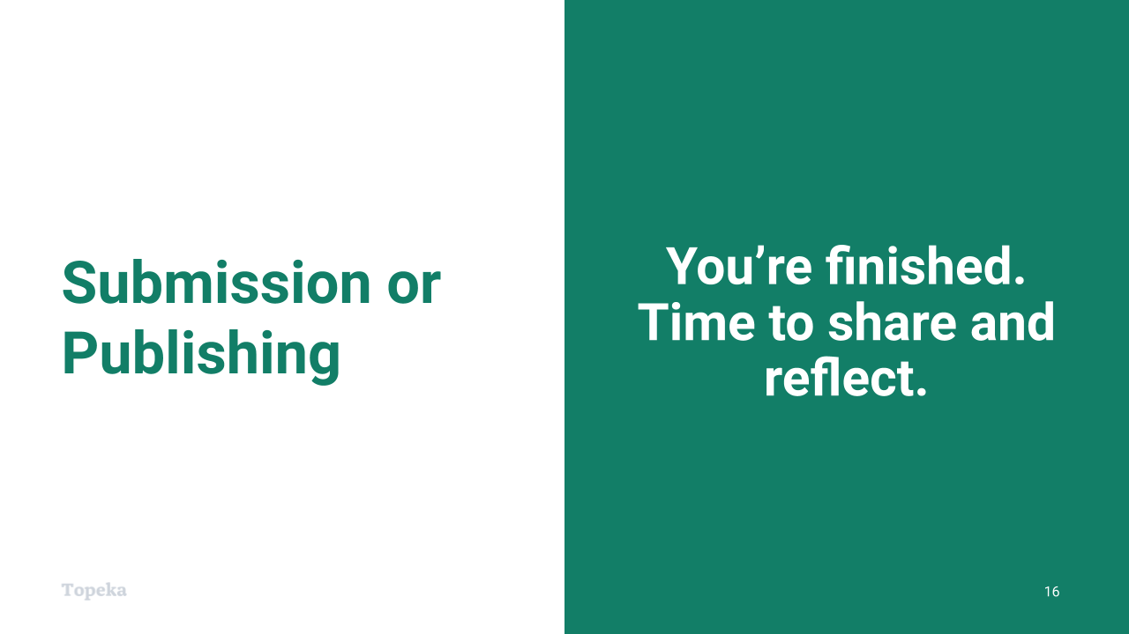
Slide 16
Teacher | Students
Teacher introduces the final stage of the process.  When you’ve decided that your piece is done, you should submit your final work for scoring on Topeka. | Students listen and take notes.
Teacher invites students to share past experience of publishing or sharing writing.  People, even kids, don’t just write for school. In what other ways can you or have you shared your writing? How has sharing your work benefitted you as a writer? | Students share thoughts on past experience.
Teacher continues:  Publishing your work or sharing it with others is an important step in the writing process. Whether it is a letter to a principal, an op-ed piece, or a blog, you should feel proud to share what you have written. Know that others will benefit from understanding your point of view, just as you benefit from understanding others. | Students listen and take notes.
Teacher concludes by explaining the benefits of reflection.  Finally, reflecting on the writing process can help you become a better writer in the long term. Think about what worked and what didn’t, where you could have spent more time and where you spent too much, and what you’ll do differently in your next writing process. | Students listen and take notes.

