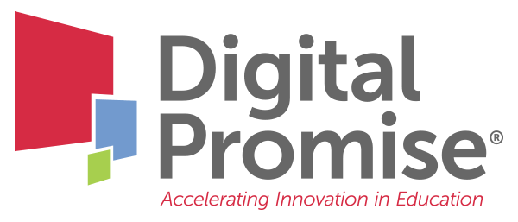

Module 3: Engaging Diverse Students
A Future-Ready Workforce: Preparing Community College Students for a Global Economy

Faculty Module 3:
Engaging Diverse Students

Faculty Guide

Funded through the generous support of 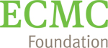

Building global competence into CTE begins with understanding your students’ diverse experiences through the lens of social justice. This module will utilize the Global Social Justice Framework for educators, provide tools to integrate student experience and learning, and address the foundation of global and technical competence within CTE programs.
Module Objectives:
- Identify components of global social justice to develop equitable learning environments;
- Recognize ways to scaffold new learning based on student background and experiences; and
- Build global competence through student career goals.
.
Audience:
This module is geared towards community college faculty to learn how to incorporate diverse perspectives through global education, as well as to learn how to internationalize instruction.

Module Outline:
- Global Social Justice Education Framework: A tool to ensure an equitable learning environment
- Global Social Justice Education Framework: Examples
- Faculty Reflection on “Who are your students?” (included in this packet for note taking)
- Review of additional tools for getting to know students
- Overview of Activating Background Knowledge
- Global Leadership Performance Outcomes: Resource for building global competencies into postsecondary instruction

Who are your students?

What cultures or cultural experiences do your students bring into your program?

How well do your students overcome obstacles and find support when they need it?

What opportunities or employment experiences have your students accessed in your career field?

Your next steps are:

- Review the Global Social Justice Education Framework.

- Think about questions related to your own student population:
- What cultures or cultural experiences do your students bring into your program?
- How well do your students overcome obstacles and find support when they need it?
- What opportunities or employment experiences have your students accessed in your career field?

- Review the student assignments that can be used to get to know your students:
- Getting to Know Your Students Questionnaire
- Conversation Questions
- CTE Journey Assignment
- Think about how you can activate your students’ background knowledge. If you like, review the Columbia University information again.

- Consider how students develop global leadership skills in your program. Review the Global Leadership Performance Outcomes and Rubrics. How can these be integrated into your program to further develop students’ global leadership skills?

- Be sure to check the Digital Promise Global CTE Toolkit for free tools and resources. Don’t forget to look at the Diversity, Equity, and Inclusion section.

When you have completed these activities, you will be ready for “Faculty Module 4: Course Planning for Internationalization.”

