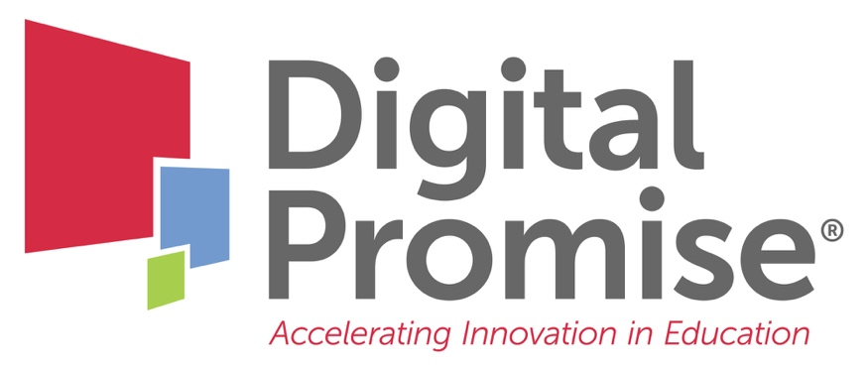

Module 4: Course Planning for Internationalization
A Future-Ready Workforce: Preparing Community College Students for a Global Economy

Faculty Module 4:
Course Planning for Internationalization

Faculty Guide

Funded through the generous support of

Now that you understand your students, the next step to internationalization is integration into your course. Today’s diverse workforce needs to be proficient in literacy and numeracy, together with strong interpersonal, technical, and problem-solving skills for a global economy. Course planning is a faculty role, yet most who teach in community colleges have received little, if any, training in how to construct mission statements and learning outcomes. This module will focus on how to systematically plan CTE learning goals and adapt to changing occupational requirements and global innovations. It will also focus on integrating academic education, technical training, and hands-on work experience to allow students, workers, and businesses to be competitive in the global economy.
Module Objectives:
- Develop internationalized, measurable learning goals for your CTE content area.
- Analyze how to integrate global learning across CTE curriculum.

Audience:
This module is geared towards community college faculty to learn how to incorporate diverse perspectives through global education, as well as to learn how to internationalize instruction.

Module Outline:
- Overview of common syllabus components
- Overview of global competence as an employability skill
- Review of Global Leadership Performance Outcome Rubrics
- Internationalizing Learning Outcomes: Manufacturing Example
- Industry Example: Sunset Manufacturing
- Internationalizing Learning Outcomes: Information Technology Example
- Industry Example: National Initiative for Cybersecurity Education
- Faculty Reflection: Internationalize Your Learning Outcome (included in this packet for note taking)
- Review of integrating global perspectives
- Davidson-Davie Community College: Pharmacy Tech Example
- Internationalizing Course Descriptions: Fundamentals of Manufacturing Methods Example
- Faculty Reflection: Internationalize Your Course Description (included in this packet for note taking)
- Syllabi Examples
Internationalize Your Learning Outcome

Using the Global Leadership Performance Rubrics’ Proficient Column for one of the four domains, consider how to internationalize one of your own learning outcomes.

Internationalize Your Course Description

Your next steps are:
- Review the Global Leadership Performance Outcomes.

- Think about the aspects of the Global Leadership Performance Outcomes that are reflected in your current curriculum:
- Identify which outcomes you see, noting the courses where you found them.
- Identify locations in your curriculum where it makes sense to add an international component based on the outcomes.
- What other opportunities are available to your students to help them reach proficiency or advanced levels of the outcomes?

- Take a learning outcome from one of your course syllabi and internationalize it using the Global Leadership Performance Outcomes Rubric.

- Review your course description and consider how to make sure that it communicates an international perspective to students. You might want to rephrase it to reflect the international components you added to your learning outcomes.

- Review ideas that other instructors have used to internationalize their learning outcomes and syllabi; check out the examples in the CTE Toolkit.
- Be sure to check the Digital Promise Global CTE Toolkit for free tools and resources.

When you have completed these activities, you will be ready for “Faculty Module 5: Internationalizing Your Instruction.”

