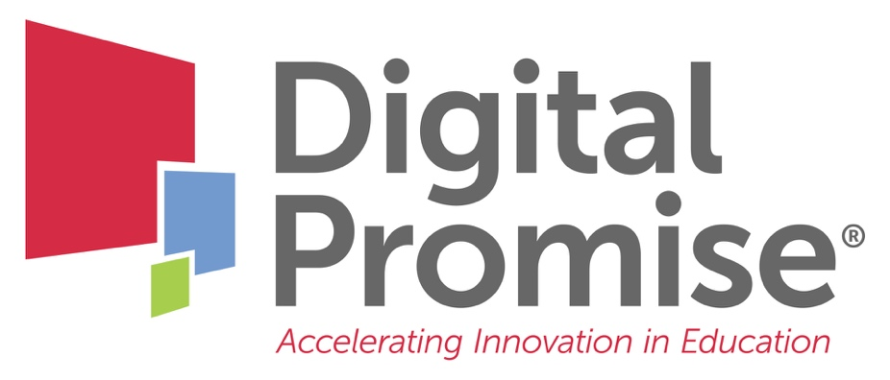

Module 5: Internationalizing Your Instruction
A Future-Ready Workforce: Preparing Community College Students for a Global Economy

Faculty Module 5:
Internationalizing Your Instruction

Faculty Guide

Funded through the generous support of 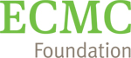

The role of faculty in learning is to serve as a facilitator, coach, and consultant to create an environment for all students to be successful. Teaching style should link instructional choices to students’ learning strategies. This module focuses on a variety of strategies for internationalizing curriculum and will provide some basic guidelines on how to select teaching strategies (work-based learning, PBL, cooperative learning, service learning, discussions, simulations, role playing, panel discussions, case studies, peer teaching, etc.) that match global learning outcomes for the success of all students.
Module Objectives:
- Connect the SAGE Framework to instructional choices to engage all students in CTE.
- Apply local-global connections to CTE curriculum.
- Utilize a variety of instructional strategies to engage students in global understanding.

Audience:
This module is geared towards community college faculty to learn how to incorporate diverse perspectives through global education, as well as to learn how to internationalize instruction.
Module Outline:
- SAGE Framework: A tool to engage students in authentic global learning
- United Nations Sustainable Development Goals (UN SDGs): Reviewing relevance to CTE content areas
- Faculty Reflection on UN SDGs (included in this packet for note taking)
- Common Career Technical Core Crosswalk to Global Competencies: Resource for additional global ideas
- Review of Instructional Strategies, including: cooperative learning, panel discussions, simulations, service learning, project based learning, work-based learning
- How to build global significance into instruction
- Faculty Reflection on Course Materials (included in this packet for note taking)

UN Sustainable Development Goals

What are one or two sustainable development goals that are relevant to your program?

Your Course Materials

Reflection:

Your next steps are:

- Review the SAGE Framework.

- Review the United Nations Sustainable Development Goals (UNSDGs) website.

- Thinking about the curriculum or curricular component that you want to internationalize, what are ways in which you can blend the SAGE process with the UNSDG’s substance to the engage your students in global learning?
- Identify several of the UN SDGs that are relevant to your program.
- Identify places in your curriculum where you could incorporate elements of the SAGE Framework to focus content on global learning.
- For at least one aspect of your curriculum, update it with an engaging activity connected to a UN Sustainable Development Goal.
- What community resources could you utilize to create globally significant, authentic experiences for your students?

- Review the G.R.E.A.T. tool, the Games 4 Sustainability website and the Common Career Technical Core Crosswalks for ideas to use or develop as in class activities to enhance your lessons with a sustainable, global focus.

- Analyze the variety of instructional strategies you currently use in the course or lesson that you are internationalizing. Consider how you might add additional instructional strategies to your instruction as you add international elements

- Be sure to check the Digital Promise Global CTE Toolkit for free tools and resources. The Classroom Projects section has sample projects aligned to the UN Sustainable Development Goals.

When you have completed these activities, you will be ready for “Faculty Module 6: Assessment for Global Understanding.”

