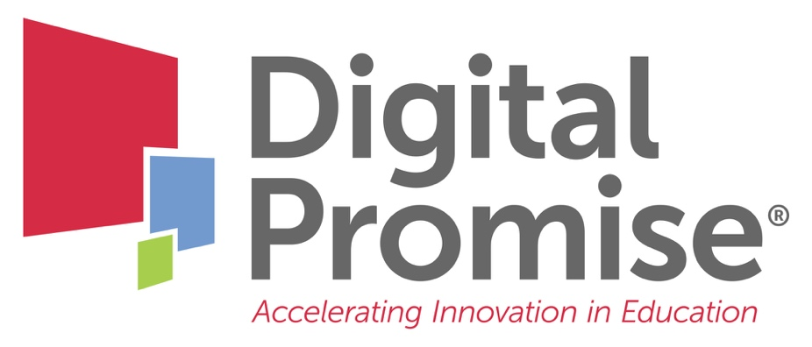

Module 7: Engaging Industry Partners for International Success
A Future-Ready Workforce: Preparing Community College Students for a Global Economy

Faculty Module 7:
Engaging Industry Partners for International Success

Faculty Guide

Funded through the generous support of

Employers are essential partners in guiding programmatic content, maintaining technology for cutting edge CTE programs, offering work-based learning opportunities, and providing opportunities for faculty to stay up-to-date in their industries. Industry partnerships and advisory boards give form and structure to stakeholder engagement, and there is no alternative to understand the knowledge and skills employees need to be successful. This module will focus on key strategies and approaches for faculty to fully engage industry partners in programmatic improvement to ensure global workplace readiness of their program completers.
Module Objectives:
- Create industry partnerships to build stronger globally-connected CTE programs.
- Utilize industry partnerships to integrate global competencies into CTE curriculum.

Audience:
This module is geared towards community college administrators, staff, or faculty who work with business & industry partners to learn how to engage partners and internationalize work-based learning experiences.

Module Outline:
- Overview of industry needs to develop a global workforce
- U.S. Chamber of Commerce overview of global competition
- Global Workforce Example: Florida Chamber of Commerce & Broward College
- Global Employability Skills Examples: Consumer Technology Association; Ford
- Faculty Reflection to connect to own field (included in this packet for note taking)
- Faculty Reflection on building a talent pipeline (included in this packet for note taking)
- Review of developing partnerships to build global career readiness
- Faculty Reflection on integrating global competencies (included in this packet for note taking)
- Global Integration Example: Hawkeye Community College

Global Employability Skills

Reflection Break

Building a Pipeline

Notes

Integrating Global Competencies

Ideas to Try

Your next steps are:

- Based on the business and industry videos in the module, reflect on what you heard about the necessity of global employability skills.
- Think about the needs of industry in your state to develop a global workforce.
- Consider how your state or local Chamber of Commerce is focused on talent development for a global economy. Review the Talent Pipeline Management (TPM) Resource Guide for CTE.

- Brainstorm a list of potential organizations or people who could serve as partners for your own pipeline. List ways you can use these industry partnerships to evaluate how your program develops students’ global employability skills.

- Learn more about the Global Agriculture Learning Center at Hawkeye Community College in Iowa.

- Research and find ways to get involved in an employer association to expand contacts with global industries in your field.

- Be sure to check the Digital Promise Global CTE Toolkit, including the Work-Based Learning section and the Student Global Competence Training Modules, for free tools and resources.

When you have completed these activities, you will be ready for “Faculty Module 8: Internationalizing Work Based Learning.”

