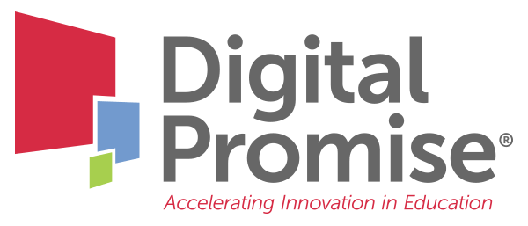

Module 8: Internationalizing Work-Based Learning
A Future-Ready Workforce: Preparing Community College Students for a Global Economy

Faculty Module 8:
Internationalizing Work-Based Learning

Faculty Guide

Funded through the generous support of 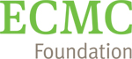

International skills and expertise will be critical to assist students in not only getting jobs, but in being able to move up the career ladder to mid- and top-tier jobs - even if they do not wish to pursue an explicitly international career pathway. Engaging work-based learning (WBL) experiences that allow students to take part in the diverse workforce and to see the interdependence of the global marketplace is the best way to develop these skills. This module will provide an overview of how interconnected we are with the global economy, successful learning components and strategies to internationalize work-based learning, and how to align the learning goals of CTE programs and international workforce needs.
Module Objectives:
- Understand how work-based learning can teach skills for global competence.
- Analyze the benefits of equitable work-based learning experiences with a global focus.
- Align CTE learning goals with workplace learning experiences to build global competence.

Audience:
This module is geared towards community college administrators, staff, or faculty who work with business and industry partners to learn how to engage partners and internationalize work-based learning experiences.

Module Outline:
- Overview of work-based learning opportunities
- Review of Global Social Justice Education Framework related to WBL opportunities
- Internationalized WBL Example: California International Trade Center
- Review of Global Industry Analysis Questions
- U.S. Department of Education WBL Framework: A toolkit for WBL programs
- Faculty Reflection of WBL Internationalization Ideas (included in this packet for notetaking)
- Internationalized WBL Example: Tulsa Community College

Work-Based Learning Framework

My Internationalization Ideas

Your next steps are:

- Talk with your industry partners, workforce development office, or international student services office to explore existing global opportunities.

- Review how all students in your program have equal access, a representative curriculum, and equitable opportunities to participate in work-based learning experiences. Consult Digital Promise’s Global Social Justice Education Framework in your review.

- Review the Global Industry Analysis Assignment. Consider how you might use this assignment in your program.

- Review the U.S. Department of Education Work-Based Learning model and then discuss your internationalization ideas with colleagues. In what ways can you use or adapt those ideas for your program?

- Align your learning goals and assessments to work-based learning skill development. Reflect on the ways global competence is included in these learning experiences.

- Be sure to check the Digital Promise Global CTE Toolkit for free tools and resources, and don’t miss the section on International Connections in Work-Based Learning.

When you have completed these activities, you will be ready for “Faculty Module 9: DIY Global Collaboration.”

