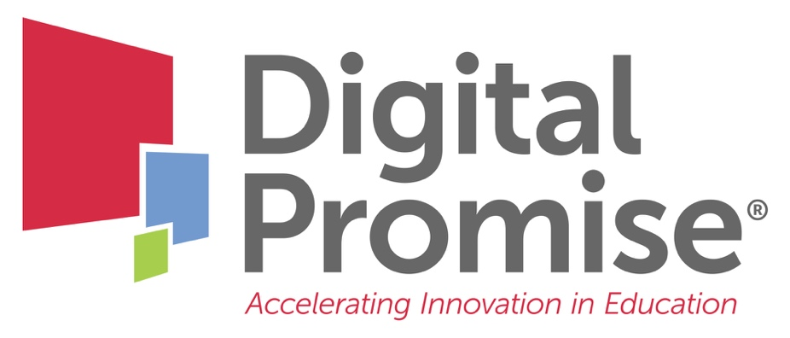

Module 9: DIY Global Virtual Exchange
A Future-Ready Workforce: Preparing Community College Students for a Global Economy

Faculty Module 9:
Do It Yourself Global Virtual Exchange

Faculty Guide

Funded through the generous support of 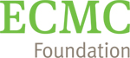

Educational technology is like any other element of good course design and using every educational tool at our disposal to give students a quality CTE experience is essential. Connecting students with international partners allows for authentic global career readiness. This module will provide faculty with “do it yourself” strategies to make international CTE program connections. Faculty will learn to utilize online resources and technology tools, how to find international partners, create lessons or projects together, and implement an international collaboration.
Module Objectives:
- Analyze technology tools for making international connections.
- Formulate strategies for embedding an international virtual connection/exchange within a CTE program.

Audience:
This module is geared towards community college or program administrators, staff, or faculty to gain a greater understanding of how to support global competence integration efforts.

Module Outline:
- Overview of Virtual Exchange
- Virtual Exchange Example: Global Solutions Challenge
- Overview of Global Collaborations
- Review of the five steps of global collaboration (International Collaboration Map included in this packet for notetaking)
  - Begin with the right mindset!
    - I Can Survey: Resource for self-reflection
  - Find and develop a partnership
  - Find curriculum connections to work on together
  - Prepare your students
  - Implement the collaboration
- Virtual Exchange Example Project: Global Solutions Challenge Student Project

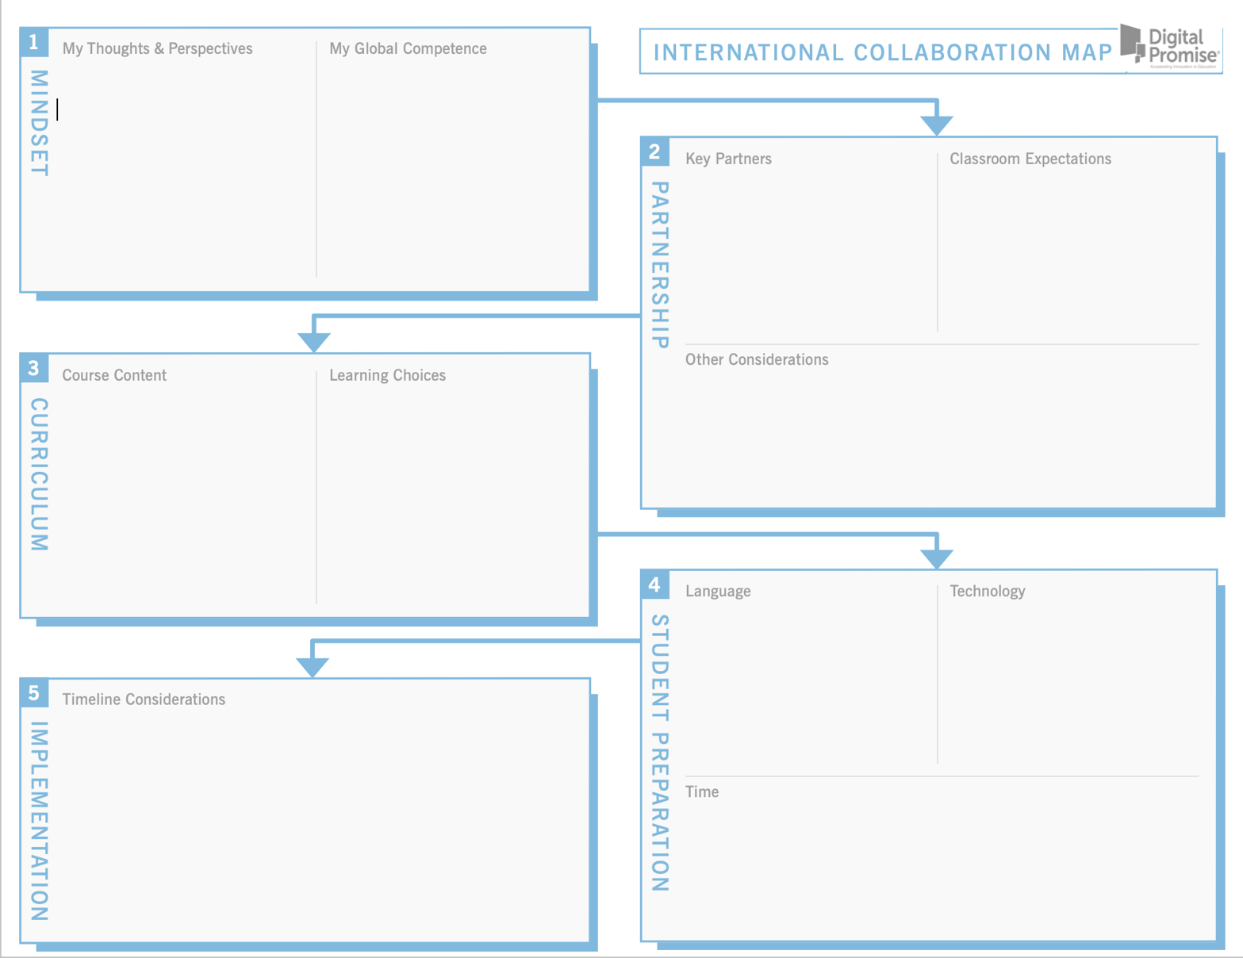

Your next steps are:

- Research programs and resources at your institution for global virtual exchanges that already exist at your institution.

- Review one or more of the ready-made collaborative virtual exchange programs to see if there is a fit with your CTE program. Find a list in the Global CTE Toolkit.

- Review your results from the global mindset tool. How might you use this tool in your program to interest students in a collaborative virtual exchange?

- Using the International Collaboration Map and all the information you’ve gained on collaborative global virtual exchange, map out a potential exchange activity for your students:
- Who are the faculty you could partner with on a collaborative global virtual exchange? Consider like institutions in other countries, check with advisory committee members whose companies do business in other countries, and don’t forget your institution’s international or study abroad office.
- What parts of your curriculum best lend themselves to a global virtual exchange? These may be the crossover areas where your curriculum and your partner’s curriculum can support each other.
- Consider the logistical concerns – will you want to (or be able to) collaborate students synchronously? How will you maintain your collaboration with the instructor(s)?
- What resources will you need in order to put this global virtual exchange into place?
- What local community resources could help make the exchange happen?

- Revisit the Postsecondary Global Leadership Performance Outcomes. How does the collaborative global virtual exchange you’ve planned help your students achieve one or more of these outcomes?

- Have your students view the Student Global Competence Training Modules before participating in virtual exchange conversations.

- Be sure to check the Digital Promise Global CTE Toolkit for free tools and resources, including the section on Virtual Exchange.

When you have completed these activities, you will be ready for “Faculty Module 10: International Connections through Social Media.”

